CSC 131: Section 1
Fall 2014
Deliverable # 3
AESA Solutions
12/16/2014

[TABLE OF CONTENTS HERE]

CSc 131
Computer Software Engineering

Fall 2014

Software Design Document (SDD)

Project Deliverable # 3

Due Date: _____________________

The Software Design Document (SDD) is a comprehensive software design model consisting of four distinct but interrelated activities: data design, architectural design , interface design, and component design. The following is a template that your team should use to complete the Software Design Document (SDD).

The SDD should include a title page that has course name, course section, team name, project title, team members, due date, and deliverable #. Also include table of content page.

NOTE: team members are expected to contribute equally to the development and the completion of the SDD.

Grading Criteria:

- SDD completeness (all sections are complete and well documented)
- SDD accuracy ( design quality and models)
- SDD quality ( quality of documentation)

Software Design Document (SDD)

- Introduction

This software requirement specification describes the functions and performance requirements allocated to the White Wave Business Suite. The White Wave Business Suite is a stand-alone system that will provide functionality White Wave Digital will need for their daily business practices. Primary functions will consist of a ticket tracking component, a database reference component, and financial statement generation component.

- Revised Requirements

List and discuss any major/minor changes in the requirements, including which requirements have been modified, added, or removed. Indicate the effect of the changes/additions

FR 3, Generate and Send Invoices, and FR 4 were modified to only calculate the payment amount due to White Wave Digital and not track payments and purchases. These requirements were modified in order to encompass business accounting done through different software more suitable and in-depth financial tracking.
FR 5, Track Deliveries, Both Received and Made, was removed from the system requirements. This change was made due to the lack of relatedness between itself and the other crucial classes of the system.
FR 6 and FR 7, Generate Internal and Customer Documentation, were removed from the system requirements. These two FRs also did not meet the relatedness necessary to keep provide the necessary cohesiveness within the crucial classes.
Another change was the mobile component. It was necessary to remove this component due to time and experience constraints. This change effects the versatility of the program since it is now bound to a PC client rather than being accessible from the field.

- Data Design

The Data Design describes structures that reside within the software. Attributes and relationships between data objects dictate the choice of data structures.

Complete the following tasks:

- Develop an ERD diagram.
- Describe the ERD entities and relationships
- Design a set of sequence diagrams for the most critical uses cases.
(The sequence diagrams will help in identifying more possible classes and operations)

Based on the use cases in the SRS, the sequence diagrams, and your SRS, list the following:

- Classes
- Operations and attributes for each class.
- Expand and update the data dictionary.
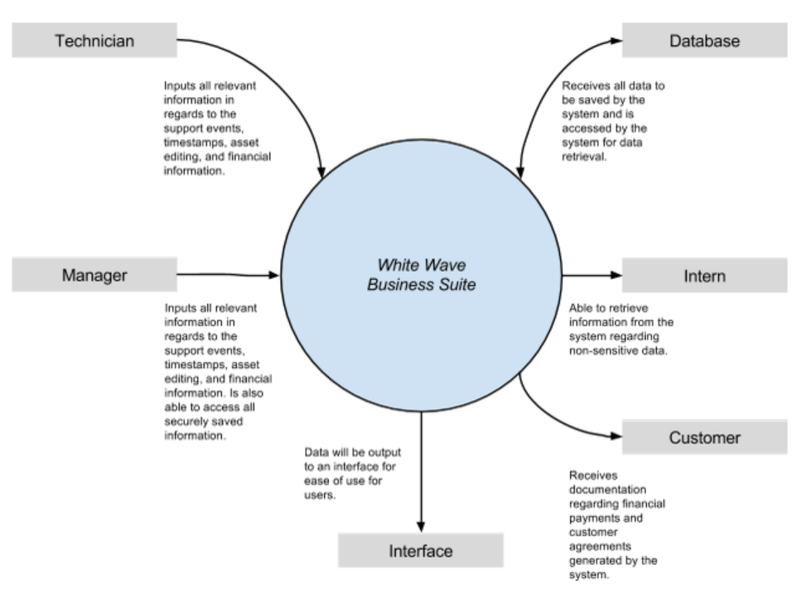
- The White Wave Business Suite will receive inputs from the technicians and managers. These individuals will be able to access the system and provide data for support events, assets, financial information, and customer information. This information will be provided by the system to the database which will allow referral to the information within. The system will also provide relevant information to internal interns and customers.

[NEED SEQUENCE DIAGRAMS]

- Architecture Design

- Design a class diagram showing all relationships/associations and multiplicities.
- Describe the class diagram.

- Detailed Class Design

- Map uses cases to various classes

For the most dynamic classes complete the following:

- Provide class processing narrative
- Class interface description
- Pseudo-code descriptions
- Any class restrictions/limitations

- User Interface Design

The Interface Design describes internal and external program interfaces. Interface designs are based on the information obtained from the analysis models. Present story boards or snapshots of the design of your major interface screens, with the necessary explanatory text.

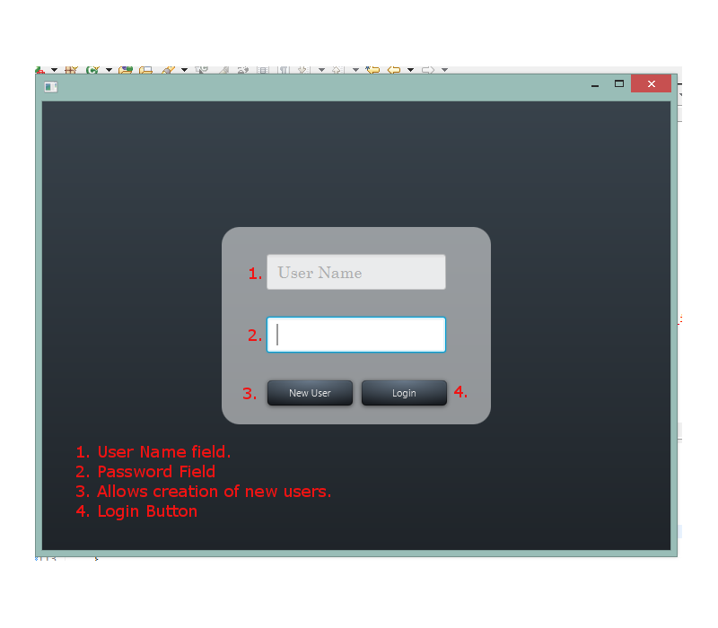
[SCREENSHOTS]

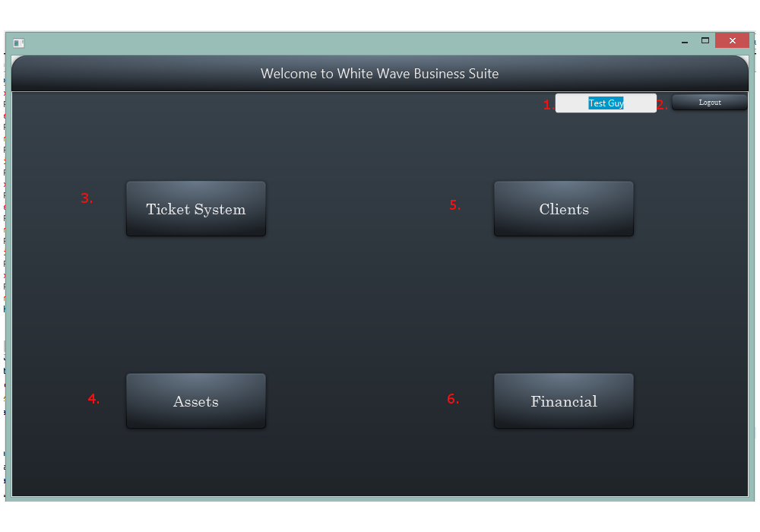
1. Current user field.
2. Logout Button
3. This button switches the screen to the ticketing system.
4. This button switches the screen to the Assets page.
5. This button switches the screen to the list of all clients.
6. This button switches the screen to the financial page.
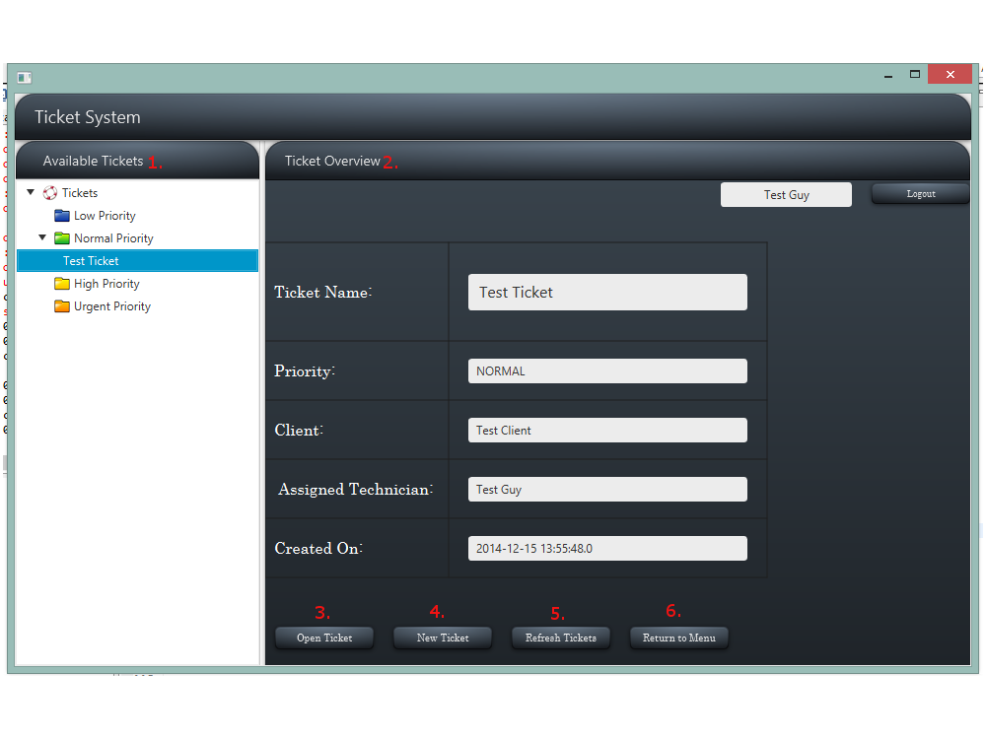
1. This is a list of all tickets in the system, sorted by priority.
2. Ticket Overview gives a quick look at several fields on a ticket to give information without requiring the ticket to be opened.
3. This button opens a popout window that gives more information about the ticket and allows support events to be added.
4. This button opens a popout window that allows for the creation of new tickets.
5. This button refreshes all the tickets in the Available Tickets Tree.
6. This button returns the user to the main menu.
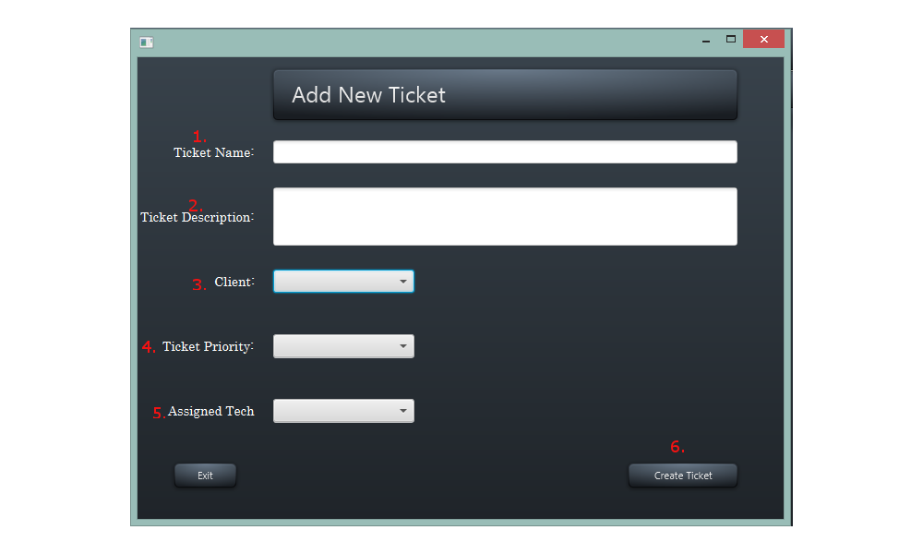
1. This field is where the name of the ticket is entered
2. This is the field where the description of the problems that require a ticket are entered.
3. This is a drop down field where pre-entered clients are selected from.
4. This is a drop down menu where one of 4 priorities is picked for the ticket.
5. This is a drop down menu where support techs can be selected to manage the ticket.
6. This is the confirmation button that actually creates the ticket once the information is properly entered.

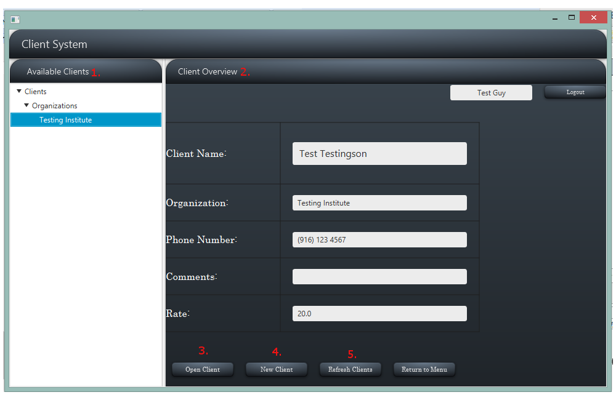
1. This tree shows all clients that are in the system.
2. Client Overview shows information about clients.
3. This button opens a popout window that shows client information.
4. This button opens a popout window that allows for making a new client for the system.
5. This button refreshes the list of clients to show any additions or changes.

- Programming/Development Tools

Which programming tools you will use and the reason for your choices

Development will be done through Eclipse as the integrated design environment. Eclipse was selected due to its accessibility and ability to integrate with both a github for development and MySQL for database management. Due to the familiarity of the development team, Java is the selected programming language for the system. MySQL will be used to create and maintain the database due to its accessibility and its ability to be integrated into Eclipse. The development github will be hosted by BitBucket. This was selected primarily from a financial standpoint as it provides a free service for small development teams.

- Restrictions, limitations, and constraints

Special design issues, which impact the design or implementation of the software, are noted here.

- References or resources used

- Team member’s Roles and Approvals

Team member’s roles in SDD

Team member’s signatures and date

