**ZBHART-MODBUS Specification**

*Rev 0.3*

*Last Updated, Sep/30/2019*

*Scanjet Macron*

*This page is left blank intentionally*.

Revision History

|  |  |
| --- | --- |
| Rev 0.3 | * Added EEPROM Reset Register (Section 5.7) * Added firmware version input register (Section 5.8) * Added running mode holding register (Section 5.9) * Added Special Condition on Address Selector 15 (Section 4) |

Table of contents

1. Objective 5

2. Introduction 5

3. Communication Parameters 5

4. MODBUS RTU Slave Address 5

5. MODBUS Registers 6

5.1. Distance 8

5.2. Level 8

5.3. Current Feedback 8

5.4. Port Status 8

5.5. Port Power 9

5.6. Response Delay 9

5.7. Reset EEPROM content 9

5.8. Firmware Version 10

5.9. Running Mode 10

1. Objective

This document aims at describing MODBUS protocol of ZBHART board.

1. Introduction

ZBHART-MODBUS acts as MODBUS RTU slave. ZBHART-MODBUS accepts requests from MODBUS RTU master and responds appropriately as specified in MODBUS RTU standard literatures and this document.

1. Communication Parameters

ZBHART -MODBUS board provides industry standard RS485 interface to communicate with MODBUS RTU masters. The communication parameters used by ZBHART -MODBUS are as follows.

|  |  |  |
| --- | --- | --- |
| Parameter | Value | Note |
| Baud Rate | 38400 BPS | - |
| Parity | No parity | - |
| Stop Bit | 1 stop bit | - |
| Data | 8 bit | - |

1. MODBUS RTU Slave Address

MODBUS RTU Slave address is set by adjusting address selector rotary switch on the board. MODBUS RTU Address is decided using the following formula.

***MODBUS RTU Address = 10 + Rotary Switch Value***

For example, if you set the rotary switch to 5, the MODBUS RTU address becomes 15.

***Rotary Switch Address 15, that is, MODBUS address 25, isn’t available for normal use. The rotary switch position is used to force the board to enter bootloader mode so that the board can be recovered from corrupted application firmware.***

1. MODBUS Registers

|  |  |  |  |
| --- | --- | --- | --- |
| Register Type | Address | Description | Multiply Factor |
| Input | 1000 | PORT-1 distance | 1000 |
| Input | 1001 | PORT-1 level | 1000 |
| Input | 1002 | PORT-1 4-20ma current feedback | 100 |
| Input | 1003 | PORT-2 distance | 1000 |
| Input | 1004 | PORT-2 level | 1000 |
| Input | 1005 | PORT-2 4-20ma current feedback | 100 |
| Input | 1006 | PORT-3 distance | 1000 |
| Input | 1007 | PORT-3 level | 1000 |
| Input | 1008 | PORT-3 4-20ma current feedback | 100 |
| Input | 1009 | PORT-4 distance | 1000 |
| Input | 1010 | PORT-4 level | 1000 |
| Input | 1011 | PORT-4 4-20ma current feedback | 100 |
| Input | 1012 | PORT-5 distance | 1000 |
| Input | 1013 | PORT-5 level | 1000 |
| Input | 1014 | PORT-5 4-20ma current feedback | 100 |
| Input | 1015 | PORT-6 distance | 1000 |
| Input | 1016 | PORT-6 level | 1000 |
| Input | 1017 | PORT-6 4-20ma current feedback | 100 |
| Input | 1018 | PORT-7 distance | 1000 |
| Input | 1019 | PORT-7 level | 1000 |
| Input | 1020 | PORT-7 4-20ma current feedback | 100 |
| Input | 1021 | PORT-8 distance | 1000 |
| Input | 1022 | PORT-8 level | 1000 |
| Input | 1023 | PORT-8 4-20ma current feedback | 100 |
| Input | 1024 | PORT-9 distance | 1000 |
| Input | 1025 | PORT-9 level | 1000 |
| Input | 1026 | PORT-9 4-20ma current feedback | 100 |
| Input | 1027 | PORT-10 distance | 1000 |
| Input | 1028 | PORT-10 level | 1000 |
| Input | 1029 | PORT-10 4-20ma current feedback | 100 |
| Input | 1030 | PORT-11 distance | 1000 |
| Input | 1031 | PORT-11 level | 1000 |
| Input | 1032 | PORT-11 4-20ma current feedback | 100 |
| Input | 1033 | PORT-12 distance | 1000 |
| Input | 1034 | PORT-12 level | 1000 |
| Input | 1035 | PORT-12 4-20ma current feedback | 100 |
| Discrete Input | 1000 | PORT-1 Status | - |
| Discrete Input | 1001 | PORT-2 Status | - |
| Discrete Input | 1002 | PORT-3 Status | - |
| Discrete Input | 1003 | PORT-4 Status | - |
| Discrete Input | 1004 | PORT-5 Status | - |
| Discrete Input | 1005 | PORT-6 Status | - |
| Discrete Input | 1006 | PORT-7 Status | - |
| Discrete Input | 1007 | PORT-8 Status | - |
| Discrete Input | 1008 | PORT-9 Status | - |
| Discrete Input | 1009 | PORT-10 Status | - |
| Discrete Input | 1010 | PORT-11 Status | - |
| Discrete Input | 1011 | PORT-12 Status | - |
| Coil | 1000 | PORT-1 Power | - |
| Coil | 1001 | PORT-2 Power | - |
| Coil | 1002 | PORT-3 Power | - |
| Coil | 1003 | PORT-4 Power | - |
| Coil | 1004 | PORT-5 Power | - |
| Coil | 1005 | PORT-6 Power | - |
| Coil | 1006 | PORT-7 Power | - |
| Coil | 1007 | PORT-8 Power | - |
| Coil | 1008 | PORT-9 Power | - |
| Coil | 1009 | PORT-10 Power | - |
| Coil | 1010 | PORT-11 Power | - |
| Coil | 1011 | PORT-12 Power | - |
| Coil | 40000 | Reset EEPROM content | - |
| Holding | 20000 | UART-0 Response Delay | - |
| Input | 30000 | Firmware Version |  |
| Holding | 32000 | Running Mode |  |

**All the 16 bit registers are in big-endian format, that is, high byte comes first.**

* 1. Distance

MODBUS input register is used to carry distance measured by radar. Its content is 1000 times the measured distance in meters.

So, if measured distance is 45.46 meters, the input register contains 45460.

If HART channel status is NOT OK (not communicating) or is powered off, hexadecimal number 0xFFFF is returned instead of real measured distance.

* 1. Level

MODBUS input register is used to carry level measured by radar. Its content is 1000 times the measured level in meters..

So, if measured level is 45.46 meters, the input register contains 45460.

If HART channel status is NOT OK (not communicating) or is powered off, hexadecimal number 0xFFFF is returned instead of real measured level

* 1. Current Feedback

MODBUS input register is used to carry 4-20ms feedback from radar. Its content is 100 times the measured current in milliampere.

So, if measured current feedback is 11.34 milliampere, the input register contains 1134.

* 1. Port Status

Port status reflects current communication status of individual port. If the radar is responding without any error to requests from ZBANA, Port status is OK. If there is any error in communication with radar, Port status is NOT OK. If the port power is turned off, Port Status is always NOT OK.

MODBUS discrete input is used to represent port status of each HART port. Logic high (1) indicates that port status is OK. Logic low (0) indicates that port status is NOT OK.

* 1. Port Power

MODBUS masters can power on/off individual HART port of ZBHART board.

MODBUS coil is used to get/set power status of individual port. Logic High (1) means the port is powered. Logic Low (0) means the port is not powered.

Power of each port can be adjusted by writing to this register and the change is applied immediately. Also the new power status value is saved to internal EEPROM so the change is preserved across power cycle. The default EEPROM content for port power status is Logic High (1), which is power on.

* 1. Response Delay

Response Delay is a feature to delay the transmission of actual MODBUS response for a specified time in millisecond after handling of a MODBUS request. The response delay value ranges from 0ms to 5000ms. The default value of response delay is 0ms.

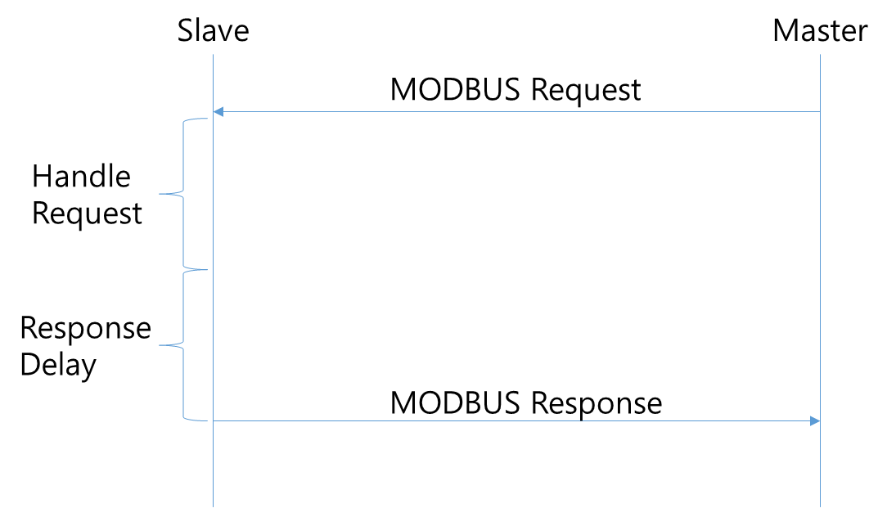

* 1. Reset EEPROM content

By writing Logic High (1) to this MODBUS coil register, MODBUS masters can reset the EEPROM content to factory default. The change is in effect immediately and all the EEPROM contents are set to factory default.

* 1. Firmware Version

Firmware version reflects current firmware version installed on the board.

Version number 234 means version “2.34”.

* 1. Running Mode

Running Mode holding register reflects current running mode of the board. There are two running modes defined. The following modes are defined.

|  |  |
| --- | --- |
| Mode | Description |
| 0 | Bootloader Mode  Bootloader mode is used to upgrade firmware. |
| 1 | Application Mode  Application Mode is normal mode and application firmware is run in this mode |

By writing to running mode register, users can change running mode.