

**PCB Stack-up and Technical Requirements**

**Pages on this document: 1**

**Our minimum specifications are as follow:**

Number of layers:                                          **4 layers**

Minimum line width (<=):                           **4mil / 0,106mm**

Minimum line spacing/gap (<=):              **4mil / 0,106mm**

Minimum Annular Ring (<=):                     **4mil / 0,106mm**

Minimum mechanical hole size (<=):     **8mil / 0,2mm**

Surface finish:                                                **ENIG**

Electrical Test: **100% Electrical Test (E-Test)**

Substrate type: **FR-4 High Tg ( >= 170ºC)**

**Stencil:**

Please quote 1 stencil (RF_STENCIL.TOP). The stencil should be **framed** and have a **frame size of 29”**. The global fiducials for the stencil are indicated on the top-left, bottom-left and bottom-right corners of the stencil files. The fiducials shall not be considered as openings for solder paste. The stencil shall be made in **stainless steel** and **laser cut**. The fiducials shall be produced in order to ensure good alignment and many production cycles. **Thickness is 5 mils**.

**PCB Stack-up and files:**

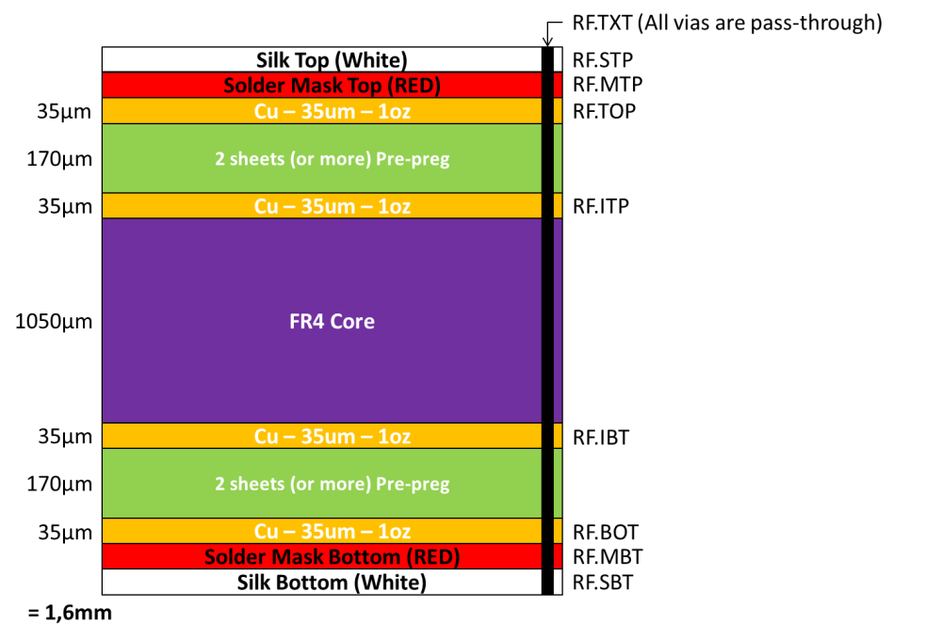

**Quantities:**

* 1 x 29” framed stencil (RF_STENCIL.TOP)
* 1998 x PCBs (333 panels)