|  |  |
| --- | --- |
| **Gather** observations | **Spread** observations |
| **Separate** mixed variables | **Unite** scattered variables |
| **Join** different datasets | |

|  |  |
| --- | --- |
| **Inner Joinhttp://r4ds.had.co.nz/diagrams/join-inner.png** | **Right joinhttp://r4ds.had.co.nz/diagrams/join-outer.png** |
| **Left joinhttp://r4ds.had.co.nz/diagrams/join-outer.png** | **Full joinhttp://r4ds.had.co.nz/diagrams/join-outer.png** |

|  |  |
| --- | --- |
| http://r4ds.had.co.nz/diagrams/join-one-to-many.png | http://r4ds.had.co.nz/diagrams/join-many-to-many.png |

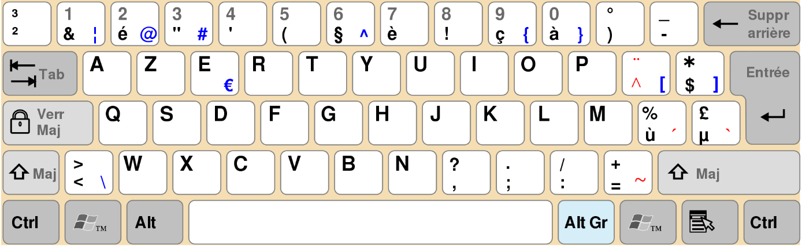

**Backtick**

**Single Quotes**