

Index
About us 3
Roles 4
Storyboard 5
Usability 11
Employee’s account 11
Manager’s account 11
Interface’s sections 11
Supported platforms 13
Server-side application placement 13
Service functioning’s responsibility 13
Scalability 13
Content Delivery Network 14
Password’s hash 14
Backup and recovery 14
Languages 15
Integration with existing services 15
Software 16
Test Driven Development 16
Frontend 16
Backend 16

Architectural Document

PCTO 2021/22

About us
Information about us
IP digital is born as a firm in the field of the production and selling of high quality filing systems distinguished by the assembling of components
produced with recycled materials and by the tested and verified durability. Our catalogue, by now, is addressed to the necessities concerned with the business world and
offers USB devices that put perfectly together reliability and a characteristic minimal yet modern design. The devices are available in the sizes of 64GB, 128GB and 256GB

The production is realised by the company through the assembly of components sent from trusted and certified external suppliers. The selling process is meant to interface with the only enterprise reality
and the delivery is entrusted to an express courier, granting the possibility of tracing the service of delivery.

What are the fundamentals of our company?
Our USB pen drivers
- They’re made with premium recycled materials
- Mainly oriented to the business world
- They’re long-lasting
- They’re fast in data transferring operations
- Their design is minimal and modern
- They’re safe
- They use the latest technology

Roles
The business’ coordination
- Azemi Kevin
  - Coordinamento del team
  - Storyboard: brainstorming
  - Storyboard: realization
  - Development: Frontend and API call
  - Setup: Server/Services
- Cadore Alessio
  - Documents: review
  - Storyboard: project
  - Documents: consultation for the technical parts
  - Setup: Server/Services
- Candian Michele
  - Documents: review
  - Storyboard: brainstorming
- El Ikhbari Ilias
  - Storyboard: brainstorming
  - Website programming: advice
  - Development: database queries
- Falasco Giosuè
  - Documents: review
  - Storyboard: brainstorming
- Pellizzon Erik
  - Documents: very first writing
  - Documents: realization of the projecting document
  - Storyboard: brainstorming
  - Storyboard: correction
  - Development: Internal API
- Rubin Francesca
  - Documents: correction and translation
  - Storyboard: brainstorming

Storyboard
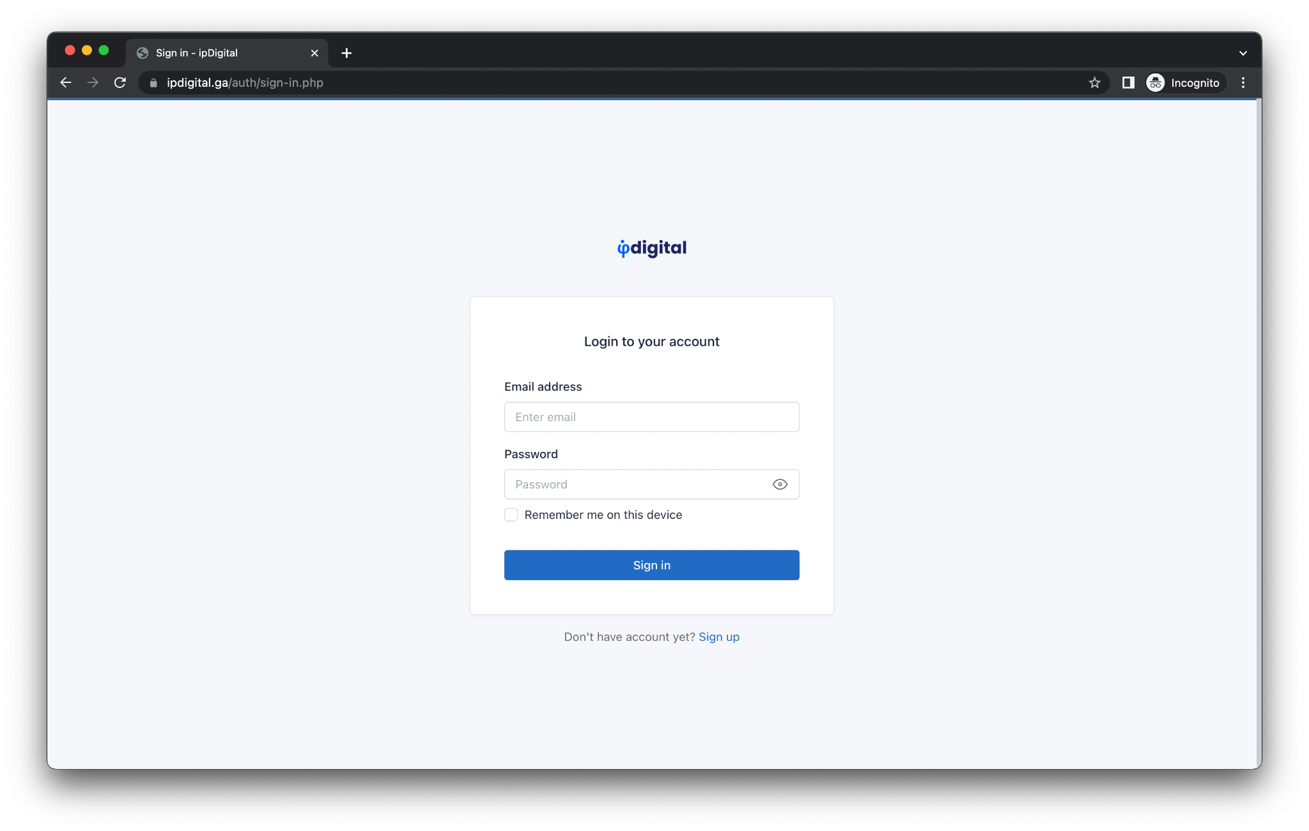
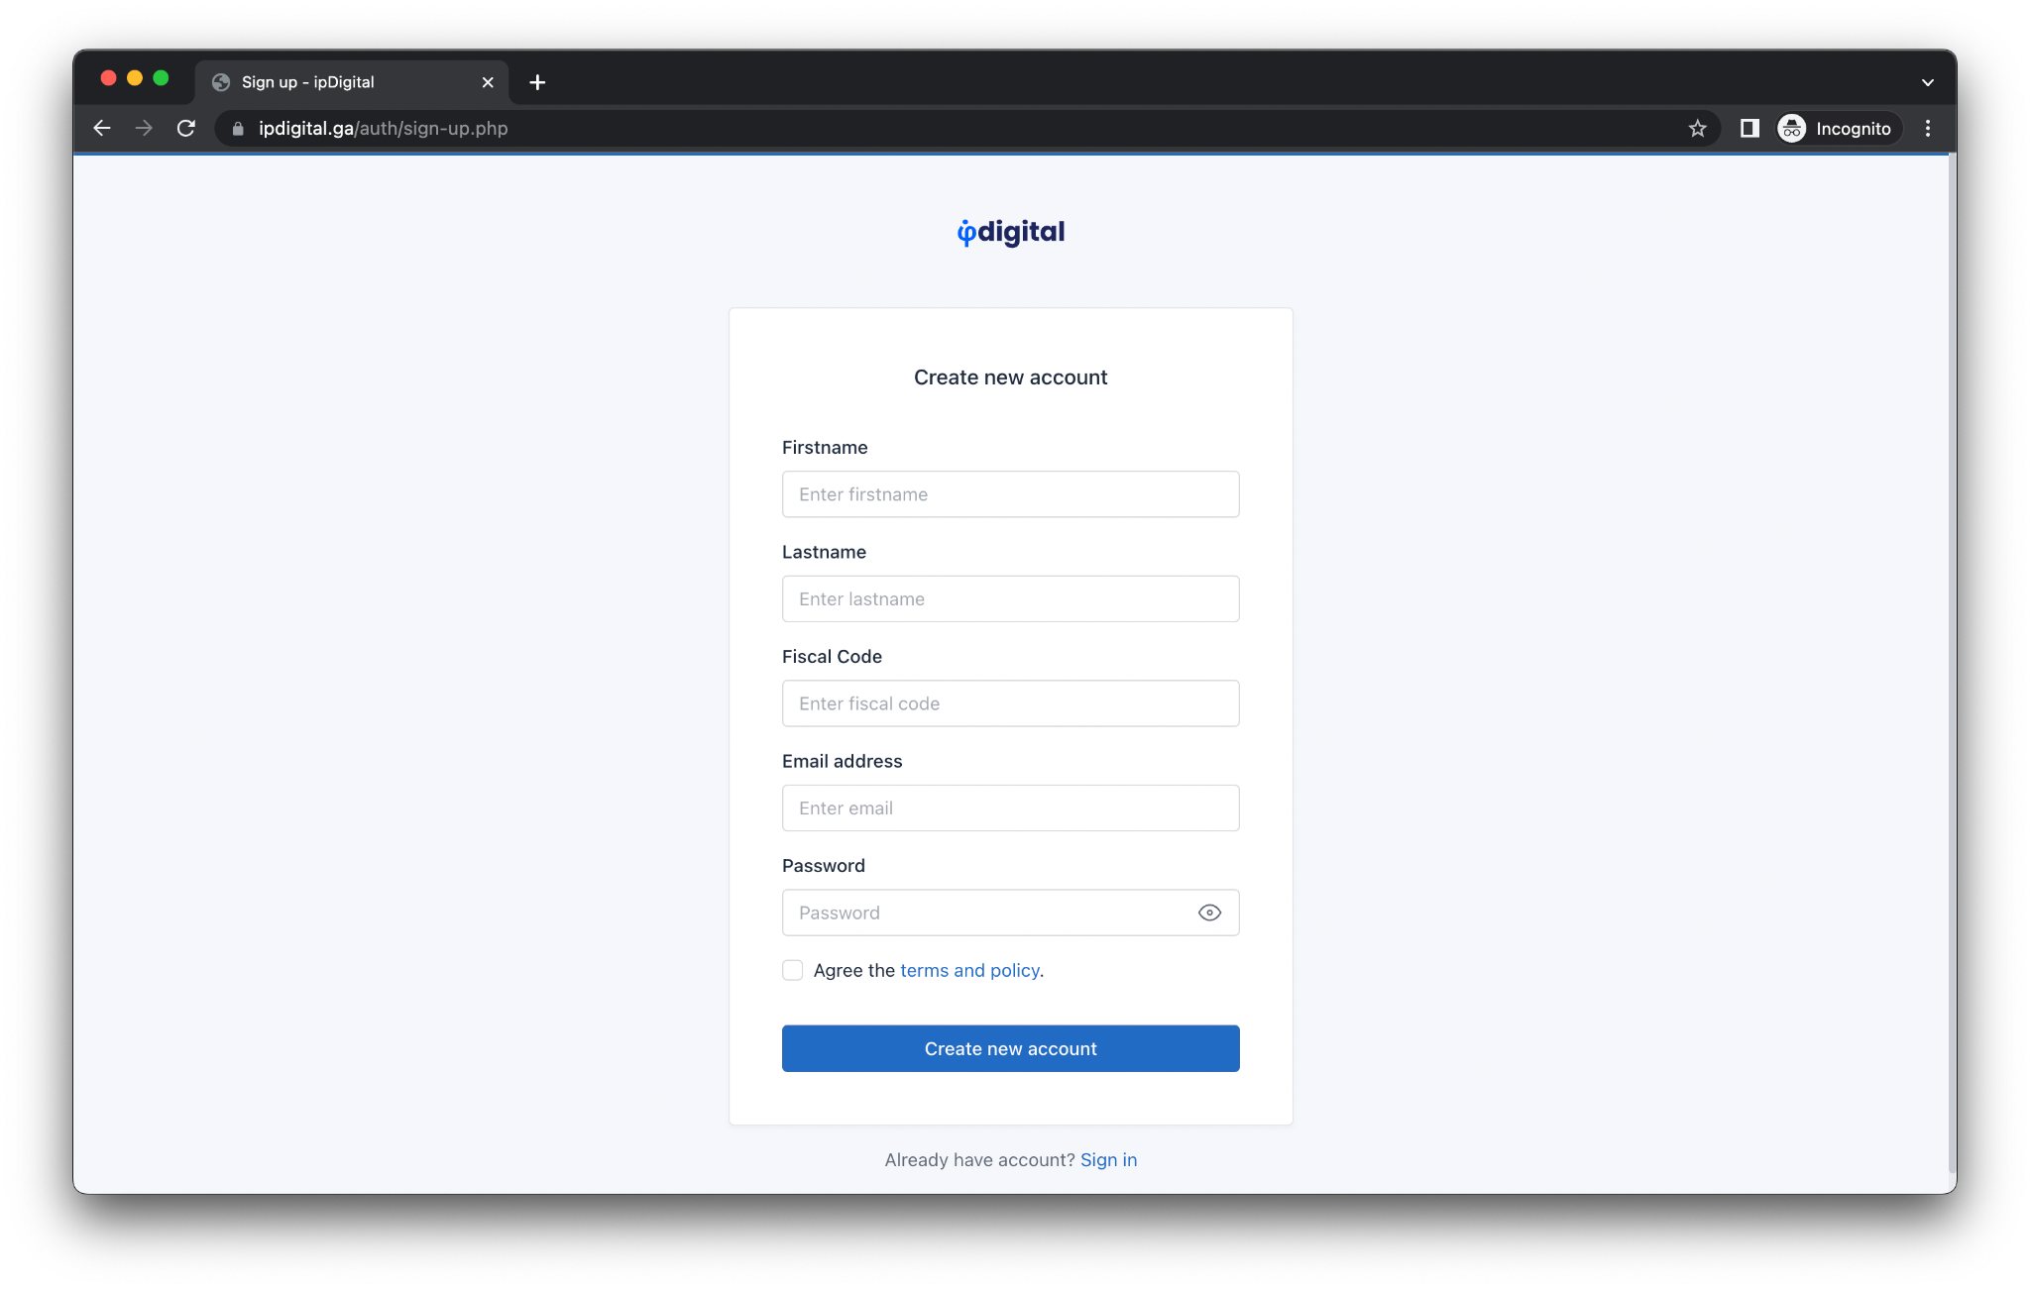

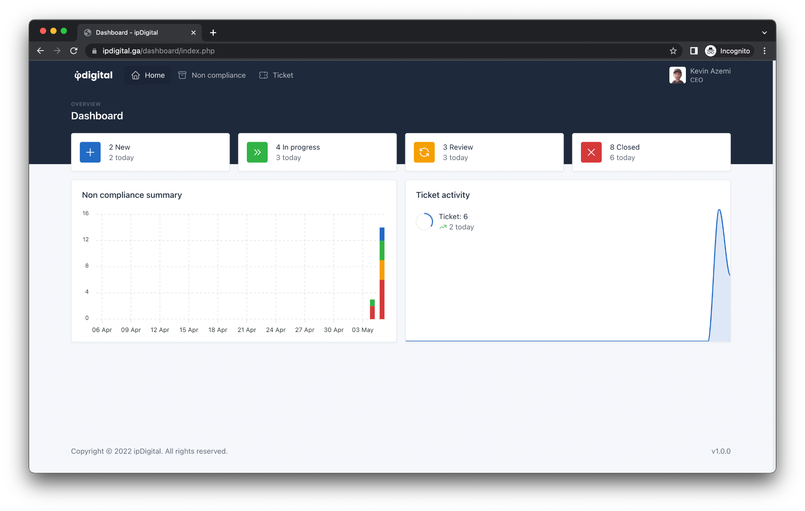
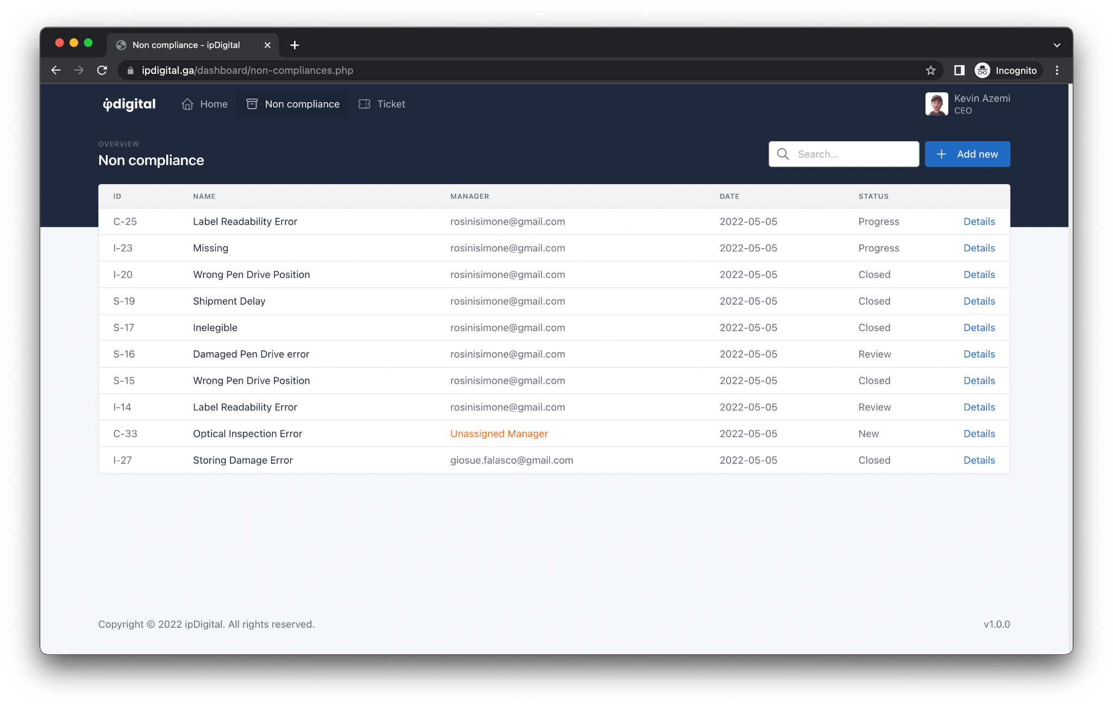

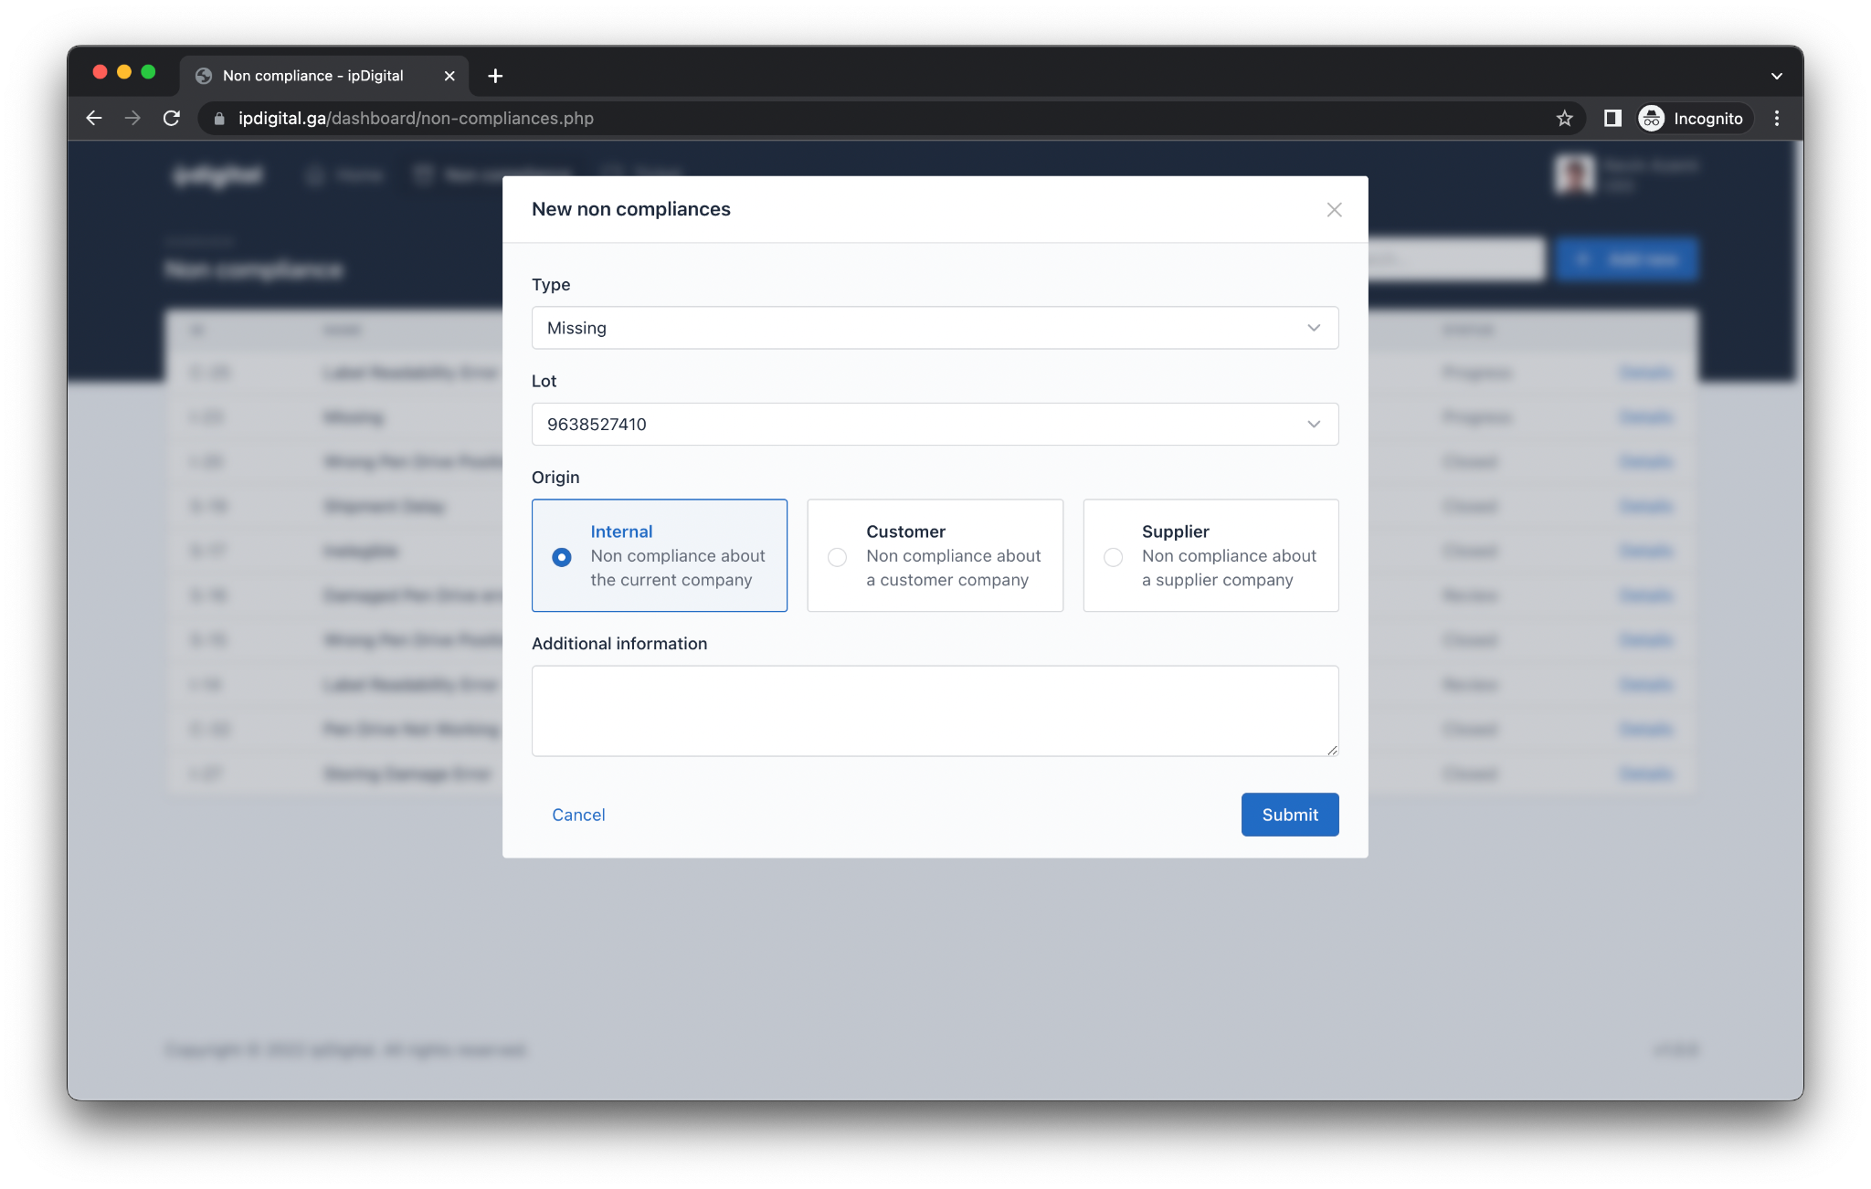
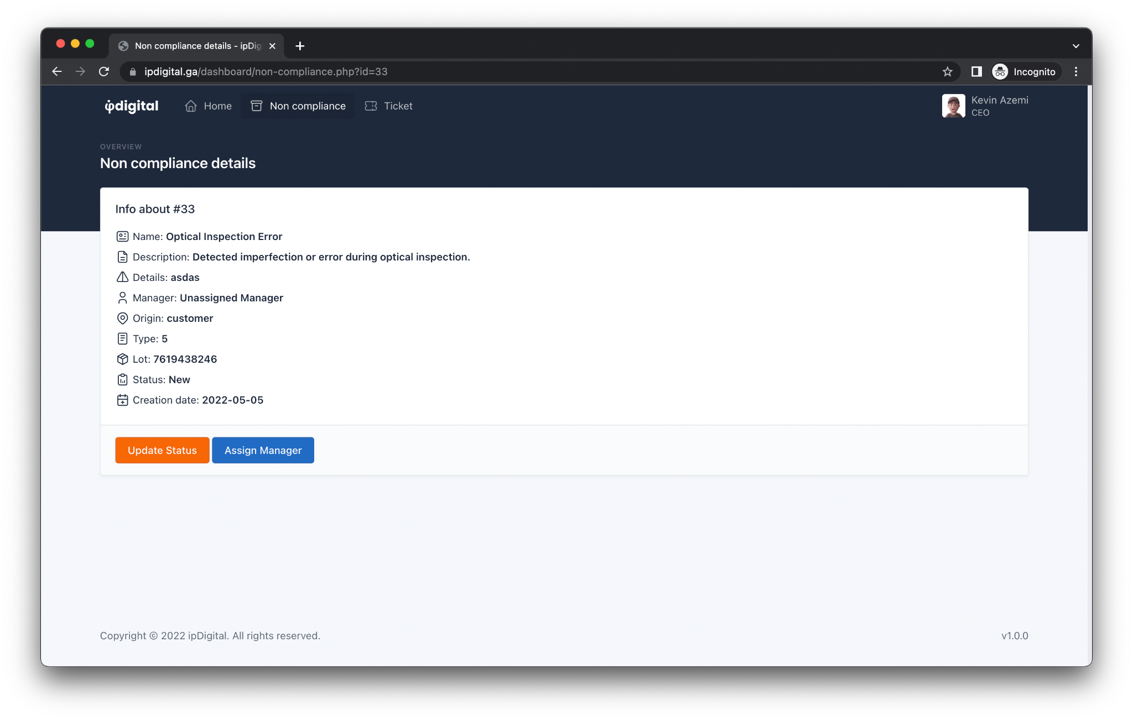

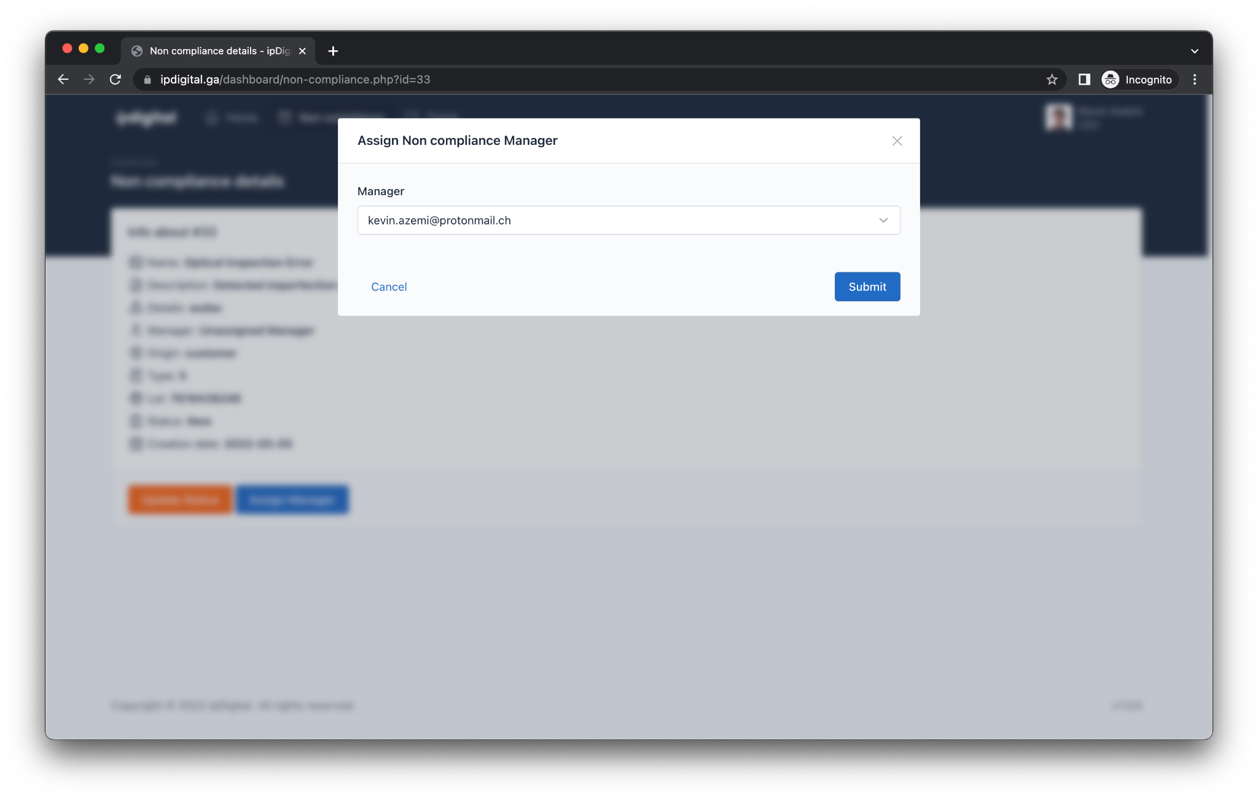
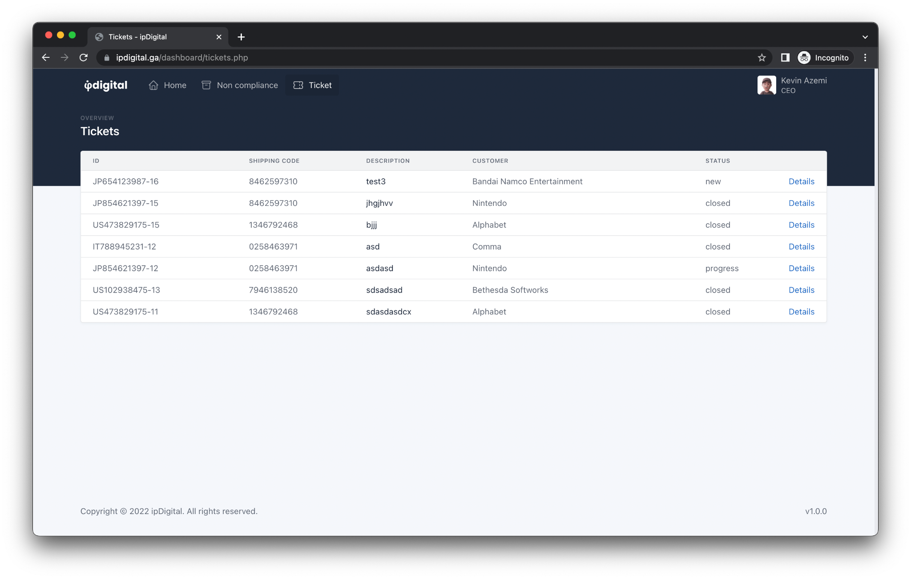

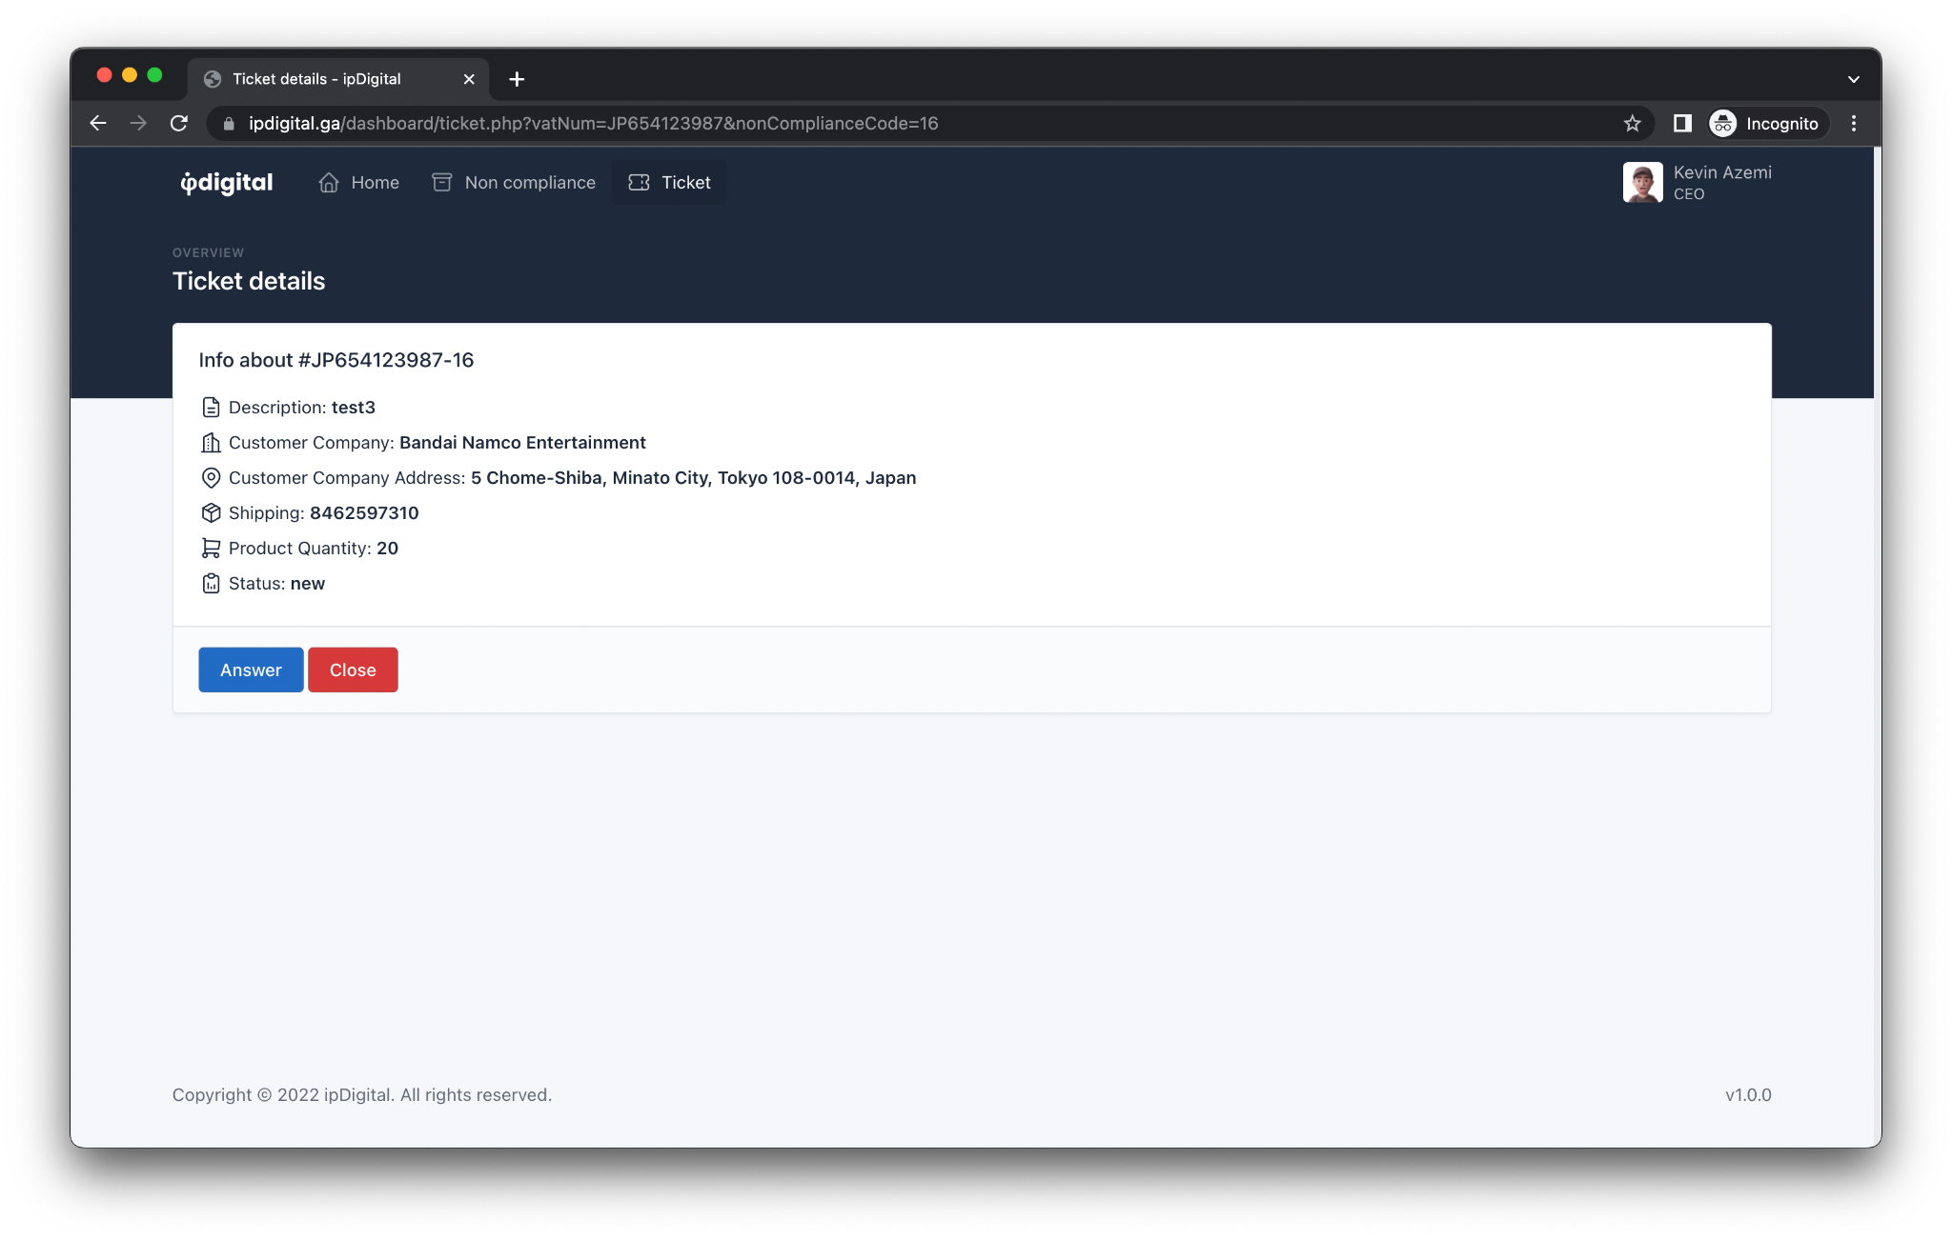
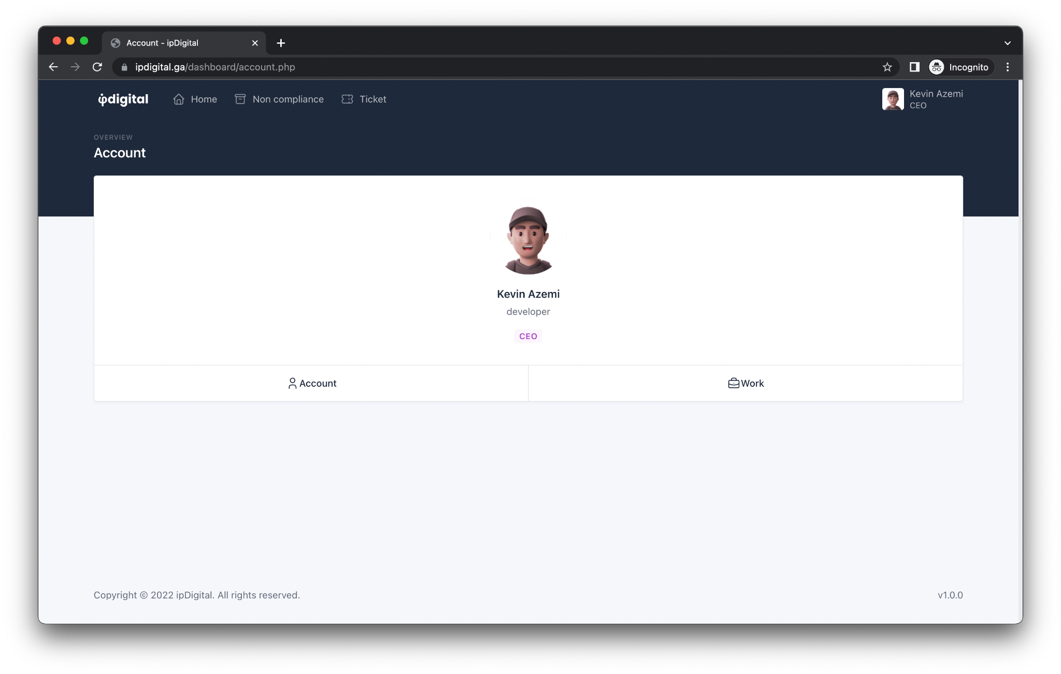

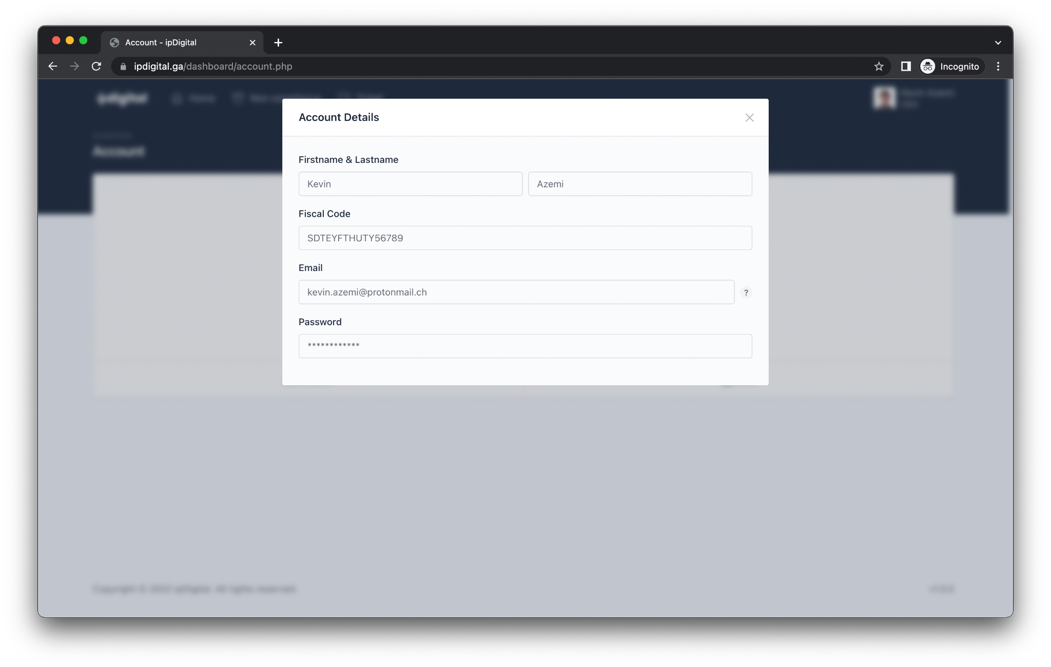
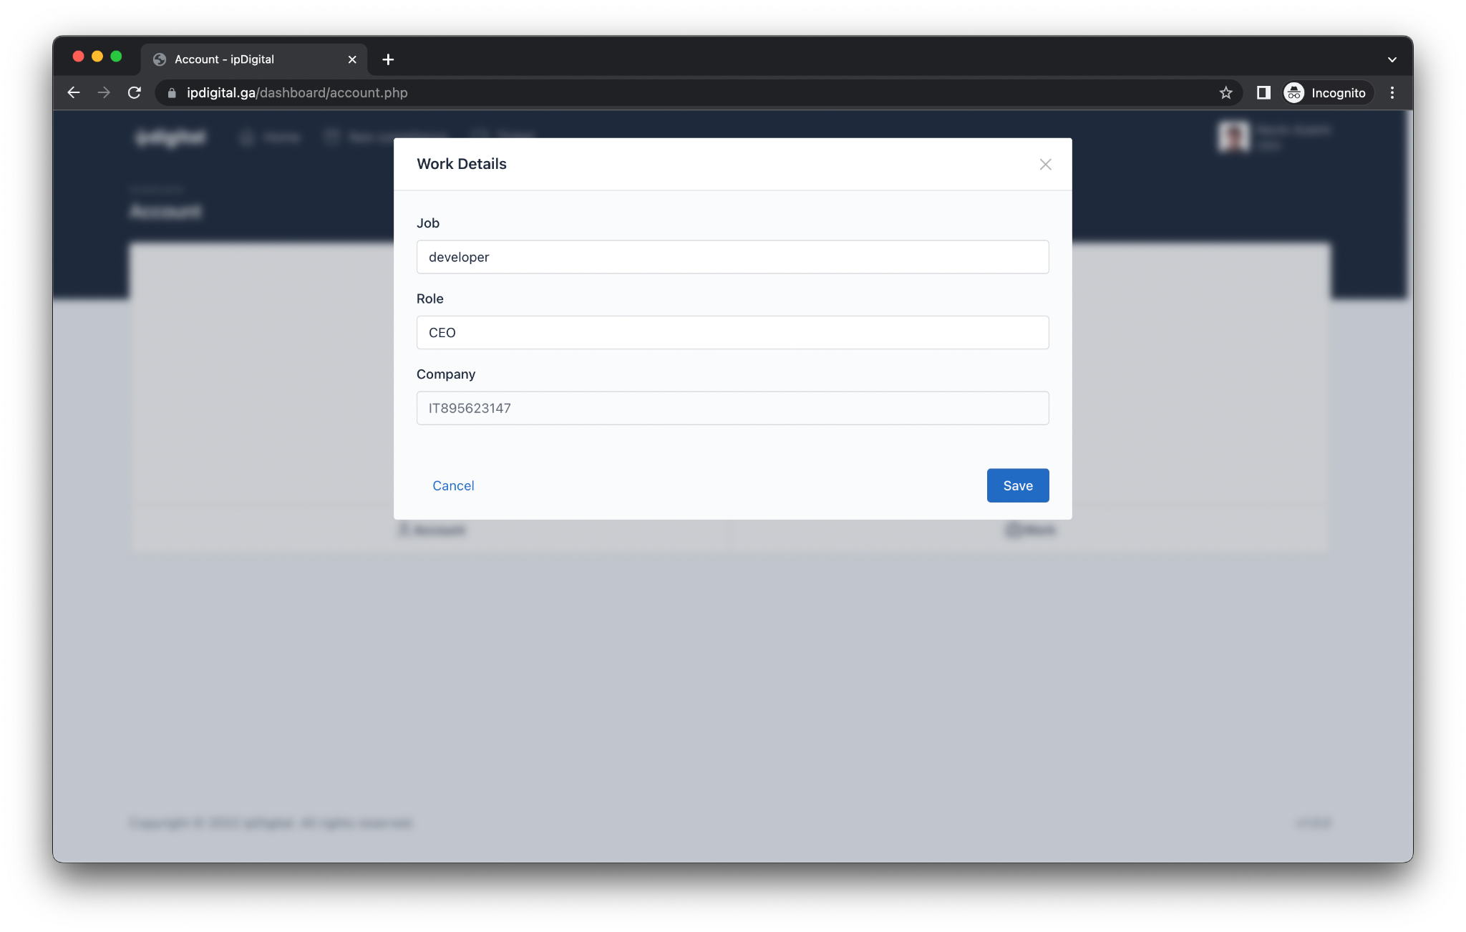

Usability
The graphic interface of the website will be characterized by a minimal and user-friendly even towards non expert users, in order to permit a smooth navigation and to limit the contacts to the assistance support concerned with the less clear sections of the application. The application presents a diversification using the criteria of different areas to grant to managers the use of the privileges assigned to them: for instance the possibility of assigning a non-compliance to a subject of them.

Employee Account
The Employee Account permits the one logging in the contemporary vision and managing of the different reports of competence through a simple and intuitive dashboard.

Manager Account
The main difference between this kind of account and the Employee account is the permission to manage every report and to assign the responsibility to the employees using a researching menu.

Interface’s sections
Login
Allows access to the platform.
Dashboard
Main page where you can find a summary of the opened, closed or in progress reports
Non-compliance list (manager/employee account)
The list contains all of the non-compliances; in the case of a Manager account it will gather all of the non-compliances of the system, where an Employee account will be only able to see the ones to verify or the ones it's charged for.
Non-compliance management (manager/employee account)
This function allows the logging user the visualization of the different details of a non-compliance with the possibility of managing the different possible results of the verifications.
Employees administration (manager account)
This function permits the possibility of editing or deleting employees' accounts, by the use of a form worth the addition.
Clients and suppliers administration (manager account)
Thi section contains the list of all of the suppliers with related certification adding a page where they can be edited or inserted.
Orders management (employee/manager account)
It contains the list of all the orders with the datas of the people requesting them.
Products management (manager/employee account)
Entry form for finished and semi-finished products.
Process management (manager account)
It allows you to insert and edit the process concerned to a product.

Supported platforms
The web application must ensure a correct functioning on the major browsers used by enterprises and employees, focusing on: Google Chrome, Mozilla Firefox and Safari.

Server-side application placement
The installation process of the application will be executed on a dedicated server rented by a company in the field of hosting on its data center. Due to the fact the server is dedicated, resources (CPU, RAM, Disk, Network card) are dedicated only to the application. The server owns a public static IP that allows the user-side access at every moment. The web server we're using is Apache.

Service functioning’s responsibility
It is necessary to appoint an employee in the hierarchy of the company that will become the expert in the configuration and maintenance of the software. The physical servers are managed by the company that installed them, because of the fact they're rented by it. In the event of downtime, the responsibility falls on the first specified company, with the obligation to restore the service. In the case of hardware components damaging the specified company must work on the substitution, without retaliating on ipDigital.

Scalability
In the case the registered users become more than the limit the server supports, MYSQL can be moved onto another machine, in order to increase the product's performance. It's possible to use a load balancer in order to deviate the users' requests to other servers having a PHP installation.

Content Delivery Network
A Content Delivery Network is a proxy that's distributed on multiple servers all around the world and that's used as a cache memory for the usual uploaded files from the users, for instance: images. The CDN is interposed from client and server in order to reduce the work the server has to do. When the static file is requested multiple times, it is saved on the nearest CDN server in order to reduce the reply time of the successive requests. The CDN ipDigital uses is Cloudflare, a leader company in this field, that offers flexible and scalable plans, including a free one.

Password hash
Due to potential database attacks, you avoid having passwords as plaintext
on it, to prevent potential hackers from gaining access to the server
obtain user passwords.
For this purpose, hash functions are used which make it impossible to obtain the initial password from the function output. In order to harden the password and prevent two passwords from generating the same hash, salt is used: a random string that is concatenated with the password before calculating the hash.
When a user logs in, the password hash will be calculated and compared
with the one stored in the database. Bcrypt was selected as the hash function
since its implementation is deemed safe and is designed to treat specifically
passwords, thus ensuring security.

Backup and recovery
We set a daily automatic backup of the datas contained in the server. They're kept for at least 30 days. Backups are saved on different physical supports in order to keep the safe in case of malfunctioning. We chose to save them on:
- Magnetic tapes, with a memory of dozens of TB, conserved in an archive.
- A server in another datacenter used just for saving backups
- Cloud server
The recovery must be executed manually by the incaricated expert, only in emergency cases such as hacker attack, data loss due to a malfunctioning or a wrong deleting of a part of the DB by the employees.

Languages
the website will be entirely in English in order to allow the use of the application to worldwide users. Other languages will be available in the future.

Integration with existing services
The possibility of integration of the product with application meant to the field of the management of the calendars is open, offering the chance to bring all of the scheduled plans and the non-compliances assigned to the employees. The interactions between users is made through the use of a messaging application similar to WhatsApp, in order to contact the employees directly.

Software

Test Driven Development
The software will be developed by following a TDD method, focusing on the tests that are fundamental in order to check the correct functioning process of the application developed by the programmers.

Frontend
The frontend interface is realized with HTML, CSS and Javascript programming languages, interacting with the backend in order to get all the data which is necessary to ensure the correct functioning process. The graphics are implemented with the use of already existing technologies, for instance Bootstrap in an effort to guarantee great results in less time.

Backend
The backend will run on a machine using a Linux-based distribution: in our case we chose Debian.
Internally there will be REST APIs written in PHP that deal with interacting with the database within the application, and that communicate with the application backend to exchange information.


