

Index
About us 3
Our principles 3
Roles 4
WBS 5
CPM diagram 6
GANTT diagram 11
Risk analysis 12
Processes 14
Possible non-compliances 15
Corrective actions 16

Project management

PCTO 2021/22

Who are we
Something about us
“ipDigital” is a company of production and selling of storage systems of premium quality, put together with only recycled materials
Currently our catalog includes solutions for other companies in the business world, with USB drives available in the three sizes of 64, 128 and 256GB.

Our USB drives are assembled in our company, with components bought from external suppliers.
The products are intended only for other companies, and the transportation is entrusted to an express courier

Our principles
Our USB drives:
- Are made of the finest premium recycled materials
- Are mainly oriented to other businesses
- Are long-lasting
- Offer data transfer speed of another level
- Have a minimalistic and modern design
- Are secure

Roles
The members of our company
- Azemi Kevin
  - Team’s coordination
  - Writing of SQL code
  - Drafting documents
  - WBS and CPM diagrams realization
- Cadore Alessio
  - Logical scheme realization
  - Risk analysis
  - Documents peer review
- Candian Michele
  - Possible non-compliance and corrective actions identification
  - Creating database records
  - Drafting and translating documents
  - GANTT diagram realization
  - Risk analysis
- El Ikhbari Ilias
  - Possible non-compliance and corrective actions identification
  - Creating database records
  - Drafting documents
  - Company processes identification
- Falasco Giosuè
  - E-R diagram realization
  - Technical vocabulary realization
  - Documents drafting, translation and peer review
  - Risk analysis
- Pellizzon Erik
  - E-R diagram realization and writing SQL code
  - WBS and CPM scheme realization
  - Converting CPM scheme into a graph
- Rubin Francesca
  - Logical scheme realization
  - Documents peer review
  - Drafting documents

Work Breakdown Structure
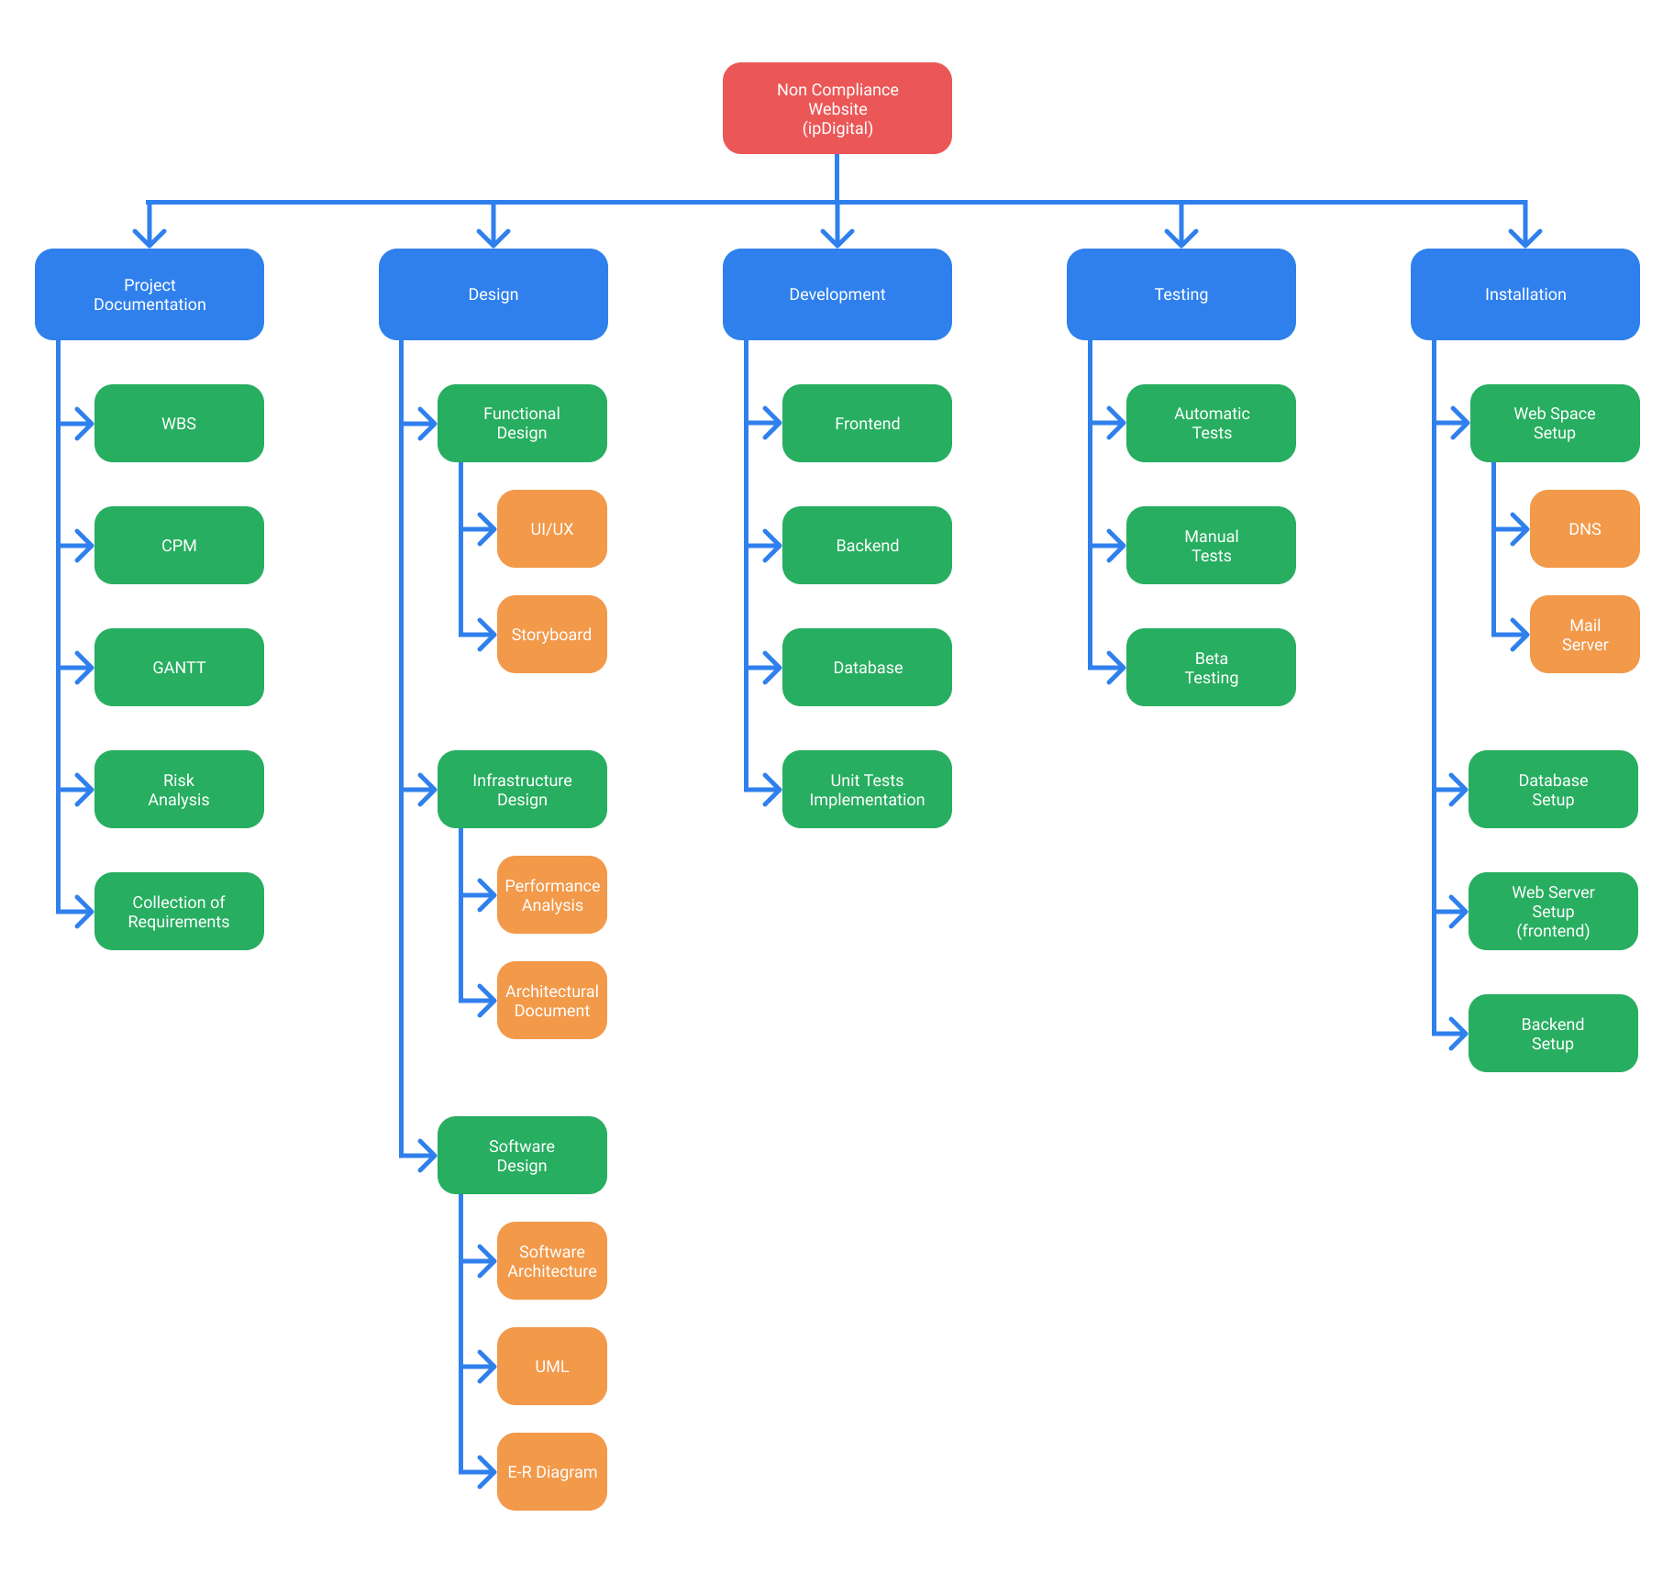

Critical Path Method
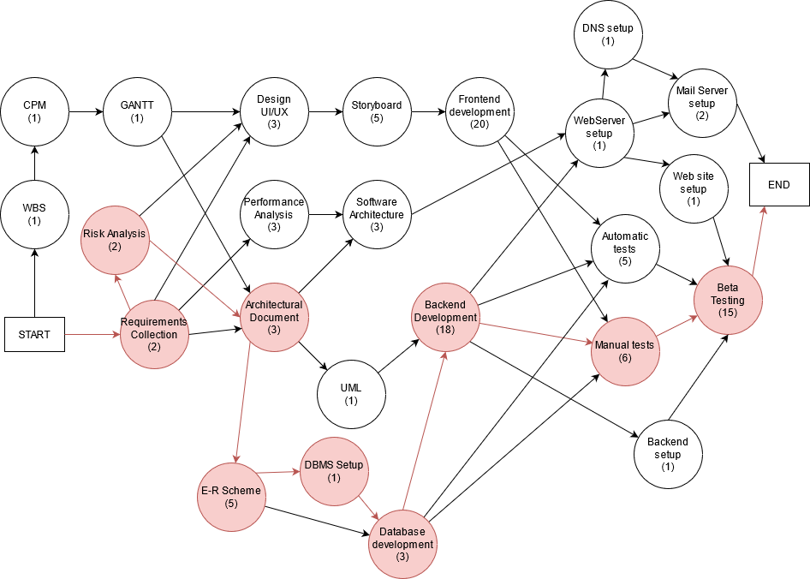

Finding all paths
We rebuilt the CPM scheme as a graph and used a dedicated online tool to calculate every possible path.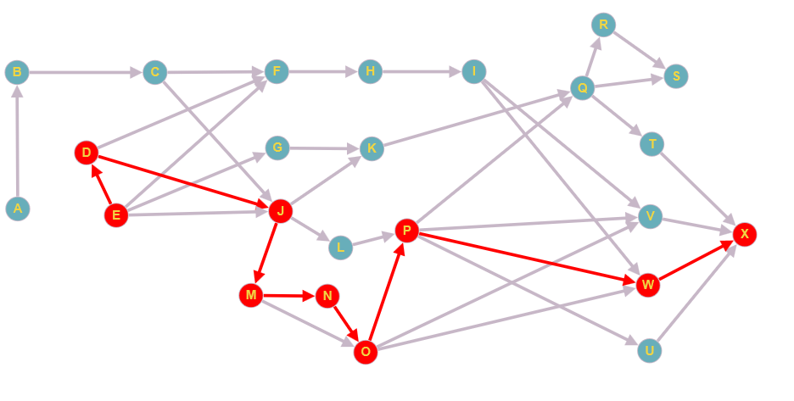

Vertices to calculate paths
- A → S
- A → X
- E → S
- E → X

It is possible to check all the 84 paths at the following link:
http://graphonline.ru/en/?graph=msPbcJnLTBvnnqJh

Calculation of the paths duration
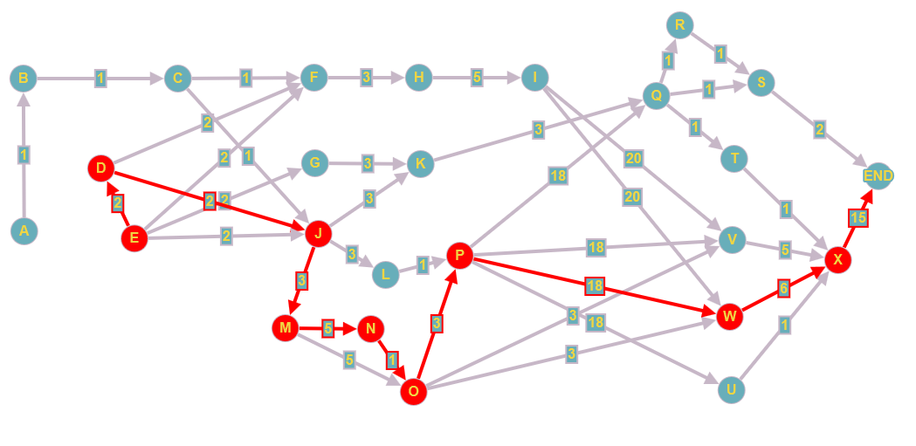

It is possible to calculate the length of the paths at the following link
http://graphonline.ru/en/?graph=zAILHaLGROxUPqrs

Critical Path:
E → D → J → M → N → O → P → W → X
Duration: 55 days

Slack calculation
ID | Activity | Dependency | Duration | Early Start | Late Start | Early Finish | Late Finish | Slack
A | WBS |  | 1 | 0 | 1 | 1 | 2 | 1
B | CPM | A | 1 | 1 | 2 | 2 | 3 | 1
C | GANTT | B | 1 | 2 | 3 | 3 | 4 | 1
D | Risk Analysis | E | 2 | 2 | 2 | 4 | 4 | 0
E | Requirements Gathering |  | 2 | 0 | 0 | 2 | 2 | 0
F | UI/UX Design | C, D, E | 3 | 4 | 6 | 7 | 9 | 2
G | Performance Analysis | E | 3 | 2 | 32 | 5 | 35 | 30
H | Storyboard | F | 5 | 7 | 9 | 12 | 14 | 2
I | Frontend Development | H | 20 | 12 | 14 | 32 | 34 | 2
J | Architectural document | C, D, E | 3 | 4 | 4 | 7 | 7 | 0
K | Software Architecture | G, J | 3 | 7 | 35 | 10 | 38 | 28
L | UML | J | 1 | 7 | 15 | 8 | 16 | 8
M | E-R Diagram | J | 5 | 7 | 7 | 12 | 12 | 0
N | DBMS Configuration | M | 1 | 12 | 12 | 13 | 13 | 0
O | Database Development | M, N | 3 | 13 | 13 | 16 | 16 | 0
P | Backend Development | L, O | 18 | 16 | 16 | 34 | 34 | 0
Q | Web Server Configuration | K, P | 1 | 34 | 38 | 35 | 39 | 4
R | DNS Configuration | Q | 1 | 35 | 52 | 36 | 53 | 17
S | Mail Server Configuration | Q, R | 2 | 36 | 53 | 38 | 55 | 17
T | Web Site Configuration | Q | 1 | 34 | 35 | 39 | 40 | 1
U | Backend Configuration | P | 1 | 34 | 39 | 35 | 40 | 5
V | Automated Tests | I, O, P | 5 | 34 | 39 | 35 | 40 | 5
W | Manual Tests | I, O, P | 6 | 34 | 40 | 34 | 40 | 0
X | Beta Testing | T, U, V, W | 15 | 40 | 40 | 55 | 55 | 0

GANTT diagram
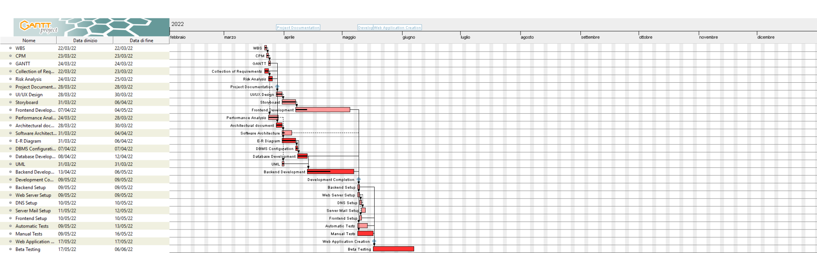

Risk analysis
Identified risks
- Absence of members of the team
- Malfunction of the services offered
  - Incompatibility of the services offered
  - Poor performance of the web application
  - Server crash
  - Loss of data
- Lengthening of production times
- Difficulty in communicating with the customer
- Difficulty in communicating between members of the group
- Incomplete or incorrect specifications
- Not user friendly application

Analysis and planning of the risks
 | Risk | Probability | Impact | Countermeasure
1 | Absence of members of the team | High | Medium-low | Smart working, assigning the work to another member of the team
2 | Incompatibility of the services offered | Medium | Very high | Updating client’s devices
3 | Poor performance of the web application | Medium-low | Medium | Reviewing the website structure
4 | Server crash | Low | High | Migrate to other backup nodes
5 | Loss of data | Low | Very high | Restore data from a backup
6 | Lengthening of production times | Medium-high | Medium | Accelerating the work, hiring more people
7 | Difficulty in communicating with the customer | Medium-low | Medium-high | Meeting with the customer
8 | Difficulty in communicating between members of the group | Medium | Medium | Team building, resolution of the conflict
9 | Incomplete or incorrect specifications | Low | Medium-high | Reviewing the document of specification of the requirements, additional meeting with the customer
10 | Not user friendly application | Medium | High | UI/UX review

Risk tracking
Risk | Indicator
Poor performance of the web application | Response time above 0,5-1s
Server crash | Average reference statistic: 1-2 crash every 6 months
Incompatibility of the services offered | Average reference statistic: 3-4 compliances per month
Difficulty in communicating between members of the group | Increases if there is poor motivation among team members
Incomplete or incorrect specifications | Difficulties in making the product
Not user friendly application | Inconsistency in the tester reports

Processes
Input
An operator checks the following components received from the providers:
- Plate of printed circuit boards, made of 14 printed circuits welded together
- Flash memory chip
- Controller
- Voltage regulator
- USB connector
- USB-drive’s shell with cap
- Packaging of silk-screened cardboard, not mounted
Internal
- Optical inspection of the PCB.
- Application of the solder paste on the contacts of the PCB.
- Mounting of memory chips, controllers and voltage regulators on the PCB
- Optical inspection of the memory chips, controllers and voltage regulators.
- Mounting of the USB connectors on the PCB.
- Optical inspection of the USB connectors.
- Welding of components in a remelting furnace, which melts the tin.
- Optical inspection to check the status of all the components.
- Division of the PCBs using a laser milling machine.
- Test to verify the correct functioning of the individual USB-drives.
- Mounting the shell on the PCB grooves.
- Test to check the correct functioning of the individual USB-drives.
- Mounting of the cap to the connector of the USB-drive.
- Application of an identification label on the individual USB-drives.
- Final check before packaging.
- Assembly of the packaging and insertion of the USB drive inside of it.
- Transferring the boxes in the warehouse.
Output
- Packing of products, according to the customer's order.
- Shipping the products to customers, entrusting the shipping lots to an express courier.

Possible non compliances
Input
The components arriving from the suppliers may result:
1a. Missing, if some parts of them isn’t there
1b. Damaged, if the shipment arrives damaged or the products ordered are not working.
1c. Ineligible, if the products received aren’t the ones ordered.
1d. Exceeding the quantity ordered.
Internal
- Flaws detected during the inspection.
- Paste applied on wrong PCB positions.
4. Flaws detected during the inspection (Caused by process 3).
6. Flaws detected during the inspection (Caused by process 5).
8. Damage detected on a component during its inspection (Caused by process 7).
10. USB drive not working (Caused by process 9).
12. USB drive not working (Caused by process 11).
13. USB drive placed in the wrong way.
14a. Not properly printed or unreadable identification label.
14b. The code on the identification label is wrong.
15. The USB drive is damaged.
17. Product damaged during the transfer of the product in stock.
Output
- Delay of the shipping caused by mistakes made during the shipping process.
- The customer received a product that is damaged or is not working.

Corrective actions
Input
1a. Asking the supplier for the missing components.
1b. Asking the supplier to replace the components.
1c. Asking the supplier a refund.
1d. Informing the suppliers about the exceeding components.
Internal
- Submit a complaint to the supplier by providing the identification codes of the defective products, requesting the return and/or a refund.
4. Discard the single faulty USB drive and locate the problem in the process 3.
6. Discard the single faulty USB drive and locate the problem in the process 5.
8. Discard the single faulty USB drive and locate the problem in the process 7.
10. Discard the single faulty USB drive and locate the problem in the process 9.
12. Submit a complaint to the supplier by providing the identification codes of the defective products, requesting the return and/or a refund.
13. Submit a complaint to the supplier by providing the identification codes of the defective products, requesting the return and/or a refund.
14a. Replace the label and find the problem in the label printing process.
14b. Replace the label and identify the problem in the code assignment process
15. Discard the single faulty stick and identify the problem in process 13/14.
17. Return the flash drive to process 15 to detect damage.
Output
- Identification and correction of organizational problems.
2a. Resend the correct products to the client.
2b. Refund the customer by adding compensation for damage caused

