## Introduction

The Toothpaste Squeezer is an inexpensive 3D-printed device that aids in the removal of toothpaste. This device may benefit those with limited hand dexterity or those who find it challenging to get the last bit of toothpaste out of the tube. The toothpaste squeezer is designed to work with most standard toothpaste tubes and helps drive their contents toward the nozzle.

## Features

The Toothpaste Squeezer consists of only one 3D-printed component. It includes a circular hole [A] for hanging the device while it is not in use and a slot [B] to slide the tube of toothpaste through during operation.

An annotated picture of a green Toothpaste Squeezer with arrow 'A' pointing to an upper circular hole and arrow 'B' pointing to the lower slot of the device.

**A**

**B**

## Usage

To use the Toothpaste Squeezer, feed the tube of toothpaste through the narrow slot. It may be difficult to slide past the end seam of the tube, so it is recommended to start at a 45-degree angle at the corner of the tube.

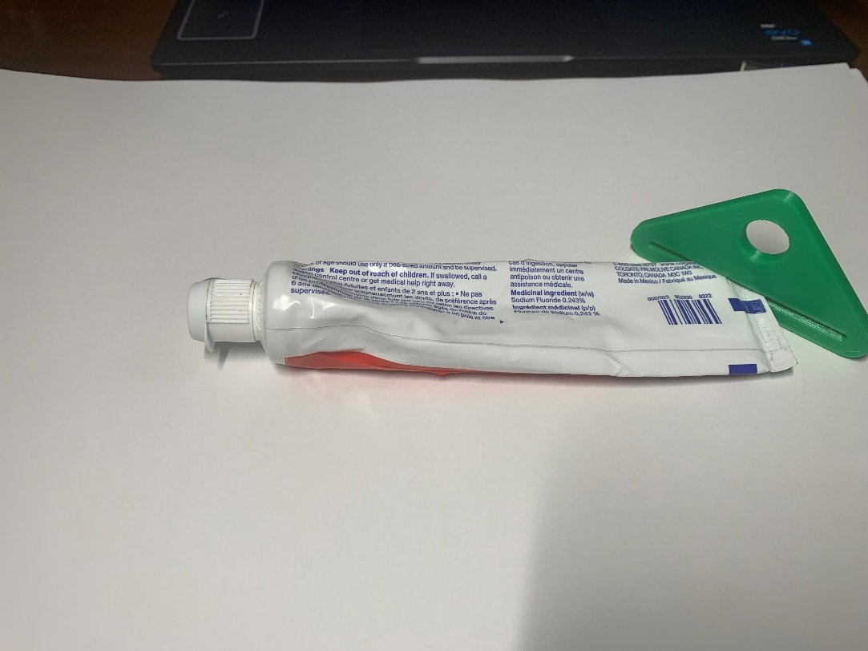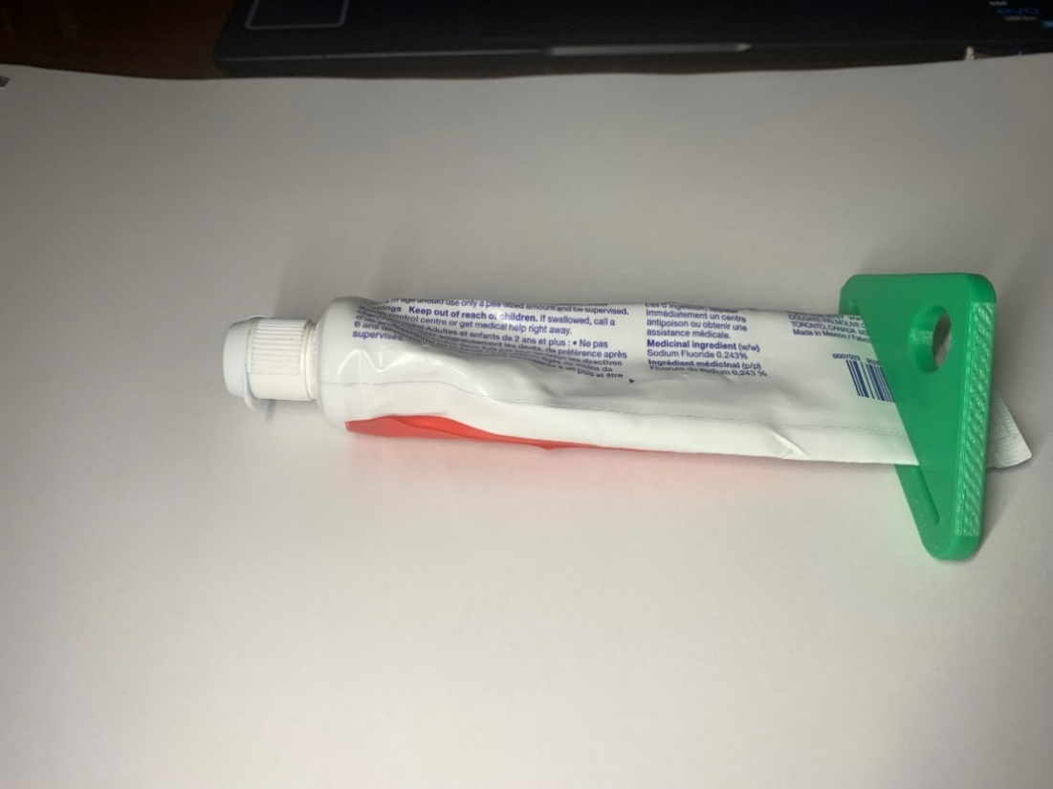

The device can be slide further along to tube to collect the remaining toothpaste for easy access.

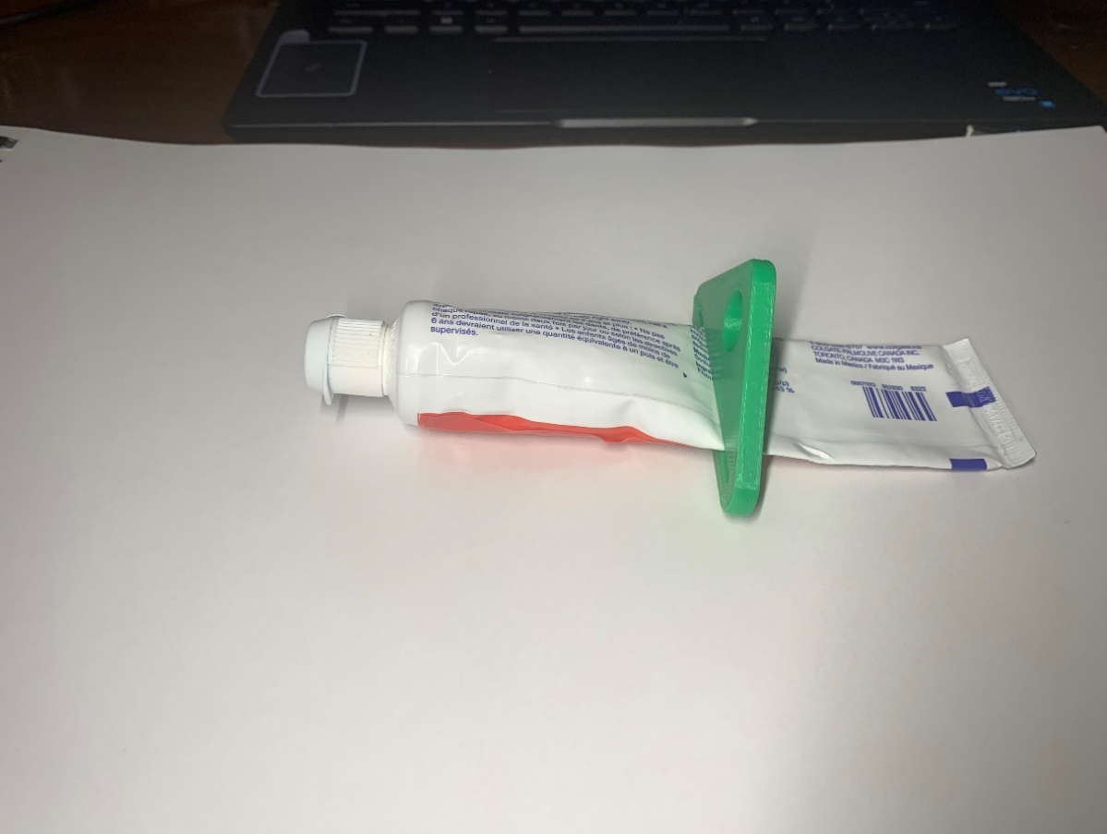

## Compatibility

This device is designed to work with most standard tubes of toothpaste. The tube must be less than 60 mm in width to fit within the squeezer.

## Specifications

|  |  |  |  |  |  |
| --- | --- | --- | --- | --- | --- |
| **Dimensions (mm)** | | | | | **Mass (g)** |
| Height | Width | Thickness | Slot Width | Hole diameter |
| 40 | 75 | 5 | 60 | 12.5 | 6 |

## Cleaning

The Toothpaste Squeezer can be wiped down with sanitizing cleaners or gently scrubbed with a soft-bristled brush and mild soapy water. Do not subject the device to high heat as this may damage the 3D-printed material.