# Introduction

The Toothpaste Squeezer is an inexpensive 3D-printed device that aids in the removal of toothpaste. This device may benefit those with limited hand dexterity or those who find it challenging to get the last bit of toothpaste out of the tube. The toothpaste squeezer will work with most standard toothpaste tubes and helps drive their contents toward the nozzle.

# Research

## Feedthrough Type

There are a variety of commercially available designs like the Toothpaste Squeezer V1.0. This design requires the user to slide the tube of toothpaste through a narrow slot which drives the toothpaste toward the nozzle. With the nozzle side of the toothpaste tube full, very minimal force is required to expel toothpaste. Overall, this makes for a very basic device with minimal print time.

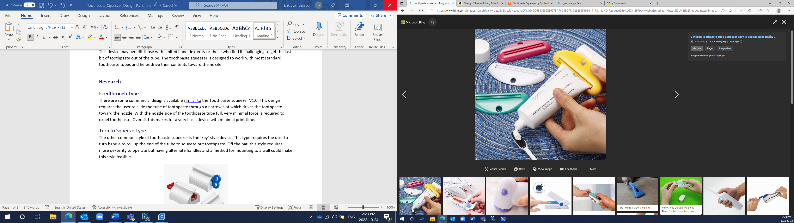

## Turn to Squeeze Type

The other common style of toothpaste squeezer is the ‘key’ style device. This type requires the user to turn the handle to roll up the end of the tube to squeeze out toothpaste. This style requires more dexterity to operate but having alternate handles and a method for mounting to a wall could make this style feasible.

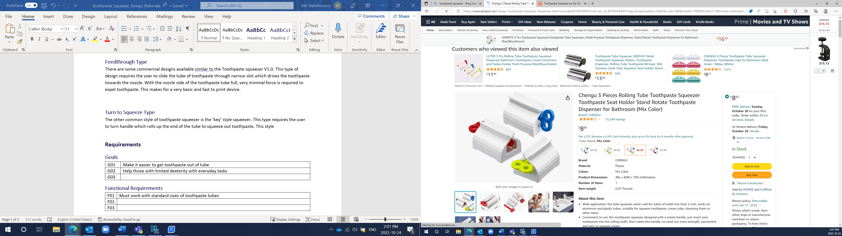

# Requirements

## Goals

|  |  |
| --- | --- |
| G01 | Make it easier to get toothpaste out of tube |
| G02 | Help those with limited dexterity with everyday tasks |

## Functional Requirements

|  |  |
| --- | --- |
| F01 | Must work with standard sizes of toothpaste tubes |
| F02 | Must require minimal force to squeeze out toothpaste |

## Non-functional Requirement

|  |  |
| --- | --- |
| NF01 | Must be easy to clean |

## Constraints

|  |  |
| --- | --- |
| C01 | Must be printable on standard maker 3d printers |

# Version 1.0

[Toothpaste Squeezer](https://www.printables.com/model/26897-toothpaste-squeezer/files) by [Spidersky1489](https://www.printables.com/social/54495-spidersky1489/about) is licensed under [Creative Commons (International License) Public Domain](https://creativecommons.org/share-your-work/public-domain/cc0/).

This design consists of a single 3D printed part. It has a 12.5 mm hole to hang the device up when it is not in use. The slot for the toothpaste tube has dimensions of 60 mm by 1.35 mm and the thickness of the device is 5 mm.

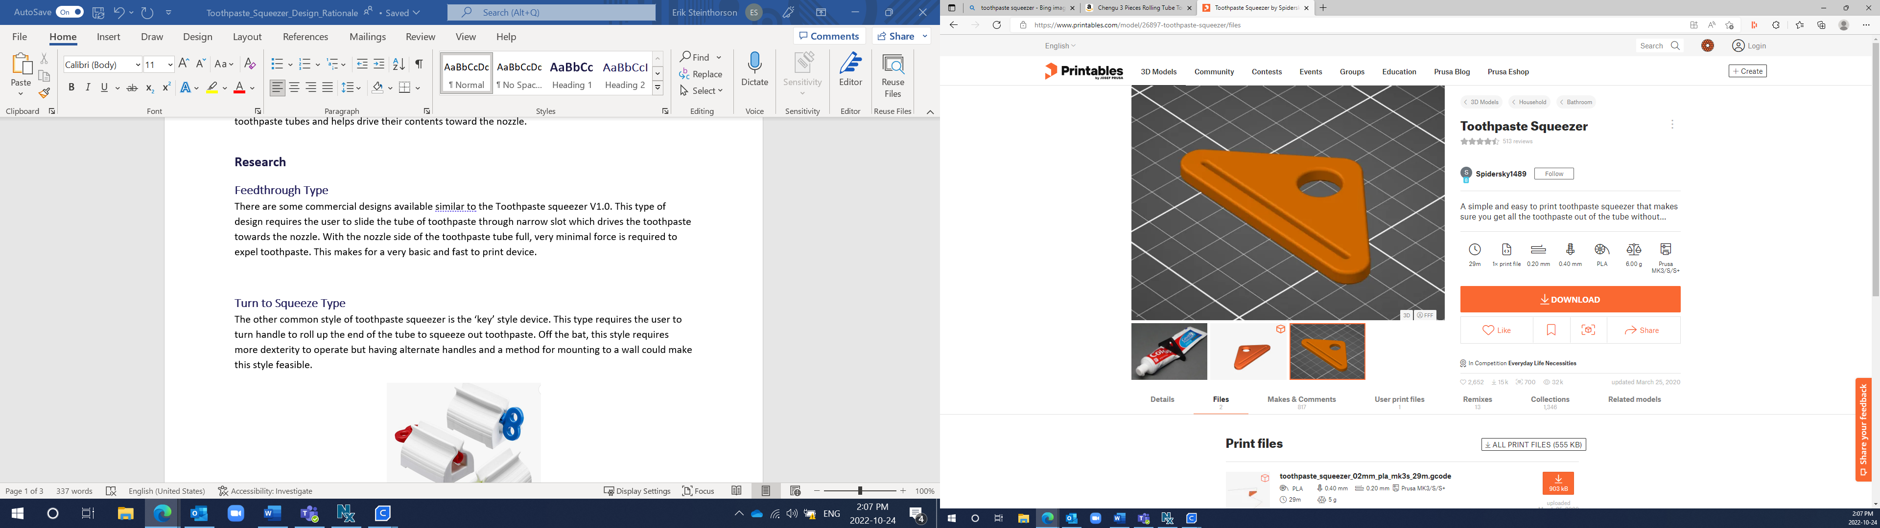

## Opportunities for Improvement

* Add a chamfer around the edges to break the edges for more comfort.
* Larger or more accessible grip for holding onto the device during use.