

Paper

on

Influence of major patches on the number of concurrent players of computer games on Steam

from
Jana Mailänder (408041)
Emre Aslan (415618)
Erik Breuer (321705)

for the module
Data Analytics for Digital Markets

examined by
Prof. Dr. Dominik Gutt

Aachen
13.02.2026

The Impact of Major Game Patches on Player Engagement:

A Difference-in-Differences Analysis of Steam Games

Abstract
This study examines whether major game patches causally affect player engagement in Steam games. Using difference-in-differences methodology with two complementary designs—a staggered DiD analysis (320 games, 5 months) and a February 2025 single-cohort analysis (145 games, 4 weeks)—we find that major patches increase average concurrent players by approximately 6% (p=0.044). We document substantial selection bias in naive comparisons, with pooled OLS models overestimating effects by 35 percentage points. Our preferred two-way fixed effects specification controls for time-invariant game characteristics and aggregate time shocks, providing credible causal estimates. Results are robust across different treatment timings and model specifications. These findings suggest that while major patches do increase player engagement, the effect is modest and developers should maintain realistic expectations about patch impacts.

Table of Contents
Abstract 1
1. Data Sources and Sample Construction 2
1.1 Data Collection 2
1.1.1 Primary Data Sources 2
1.2 Sample Construction 2
1.2.1 Staggered DiD Design (Primary Analysis) 2
1.2.2 February 2025 Single-Cohort Design (Robustness) 3
1.3 Variable Construction 3
1.3.1 Dependent Variable 3
1.3.2 Treatment Variables 3
1.3.3 Control Variables 4
1.3.4 Fixed Effects 4
1.4 Data Quality Verification 4
2. Difference-in-Differences Methodology 5
2.1 Empirical Strategy 5
2.2 Econometric Specifications 5
2.2.1 Model 1: Pooled OLS with Control Variables 5
2.2.2 Model 2: Two-Way Fixed Effects (Preferred) 5
2.3 Identification Strategy 5
2.3.1 Parallel Trends Assumption 5
2.3.2 Selection Bias and Fixed Effects 6
2.3.3 Cluster-Robust Standard Errors 6
3. Empirical Results 7
3.1 Staggered DiD Analysis (Primary Results) 7
3.1.1 Main Treatment Effects 7
3.1.2 Selection Bias Decomposition 7
3.1.3 Control Variable Effects 7
3.1.4 Treatment Effect Heterogeneity 8
3.2 February 2025 Robustness Check 8
3.3 Parallel Trends Validation 9
4. Conclusion 12
4.1 Main Findings 12
4.2 Implications for Game Developers 12
4.3 Methodological Contributions 13
4.4 Limitations and Future Research 13
4.5 Concluding Remarks 14

Research Question
Do major patches influence the number of concurrent players of online games on Steam, looking at four weeks before and after the major patch?
Steam is an online marketplace for computer games owned by Valve (Valve - About Us, o. J.). The platform also functions as a launcher for the purchased games so that it can track the player's activity as well. To answer the research question, the analysis focuses on the toplist of most played games on Steam and compares titles within the same genre that did and did not receive a major patch during the same timeframe. By focusing on the Top 100 games, the study assumes that these titles have sufficiently large and stable player bases and receive regular patches. Additionally, it is assumed that the dynamics observed in these games reflect general market behaviour. That allows the study's results to be generalized to the overall Steam market looking at the most played games. A Difference-in-Differences (DiD) approach will be used to estimate the causal impact of major patches on player engagement and sales performance.
While minor updates such as bug fixes are routine, "major patches" including content seasons, expansions or version overhauls represent significant investments of development resources. Understanding the return on investment (ROI) of these major patches is critical for developers and stakeholders in the digital market. While anecdotal evidence suggests patches spike interest, there is a need for rigorous statistical analysis to quantify this effect over a specific window.

Hinzufügen: anticipation period

Theory and conceptual model

Hypothesis
Looking at major releases, they often introduce new gameplay elements, provide new content and are often accompanied by extensive promotional campaigns. These updates increase the visibility and perceived relevance of the game. Within peer groups where the game is regularly played, this could also activate social dynamics and cause peer pressure to play the new content as soon as possible in fear of missing out. This motivates players to play the content as early as possible to remain socially included and competitive.
Taking in the listed points, the introduction of new content, heightened promotional activity and social influences following major releases. This leads to the following hypothesis.
After major releases, the number of concurrent players rises in online games.

Related work
Looking at the existing literature, major updates, and the players' motivation and reengagement can be combined. As seen in the Uses and Gratification Theory, players actively seek out media that satisfy psychological needs, such as enjoyment and novelty (Katz et al., 1973). In digital games, these needs are tied to the player's intrinsic motivation for new experiences and engagement. Major patches can renew this gratification by introducing new content or gameplay dynamics, thereby increasing the player's motivation to keep playing. This aligns with Yee's findings, which state that ongoing content and in-game experiences are important for maintaining player engagement (Yee, 2006).
Another important theme related to the fluctuation in concurrent players is the attention and visibility of the games on the Steam store. Steam is an attention-driven platform where visibility strongly influences player activity. According to the attention economy theory, products that receive greater exposure are more likely to be consumed or noticed (H & C, 2001). Major patches draw significant attention to a game within the platform ecosystem, which results in new players joining. This is also evident in digital games, as noted by Marchand et al., who found that major patches increase platform signals such as news and reviews, resulting in improved visibility and salience within an attention-scarce environment. (Marchand & Hennig-Thurau, 2013)
After gaining visibility and attention to attract new players and reactivate old ones, it is important for them to stay engaged by confirming their expectations. Expectation confirmation theory states that the continued use of a product or service depends on the extent to which initial expectations are confirmed or exceeded during actual use (Oliver, 1980). In digital products, that theory especially applies to the gameplay after major patches, as players approach updates with heightened expectations. If the gameplay after the patch fails to meet players' expectations, the number of concurrent players will drop significantly shortly after the patch (Hamari et al., 2017).
If the gameplay after the new major patch meets or exceeds players' expectations, the update could extend the game's lifespan. In the product life cycle, this effect can be interpreted as a shift from a maturity phase back into a growth phase. Major patches can be seen as "mini relaunches" by reintroducing the game to the market with more relevance. The relaunch effect generates attention and increases the game's potential to attract new customers and regain old ones. Zhu et al. provide empirical evidence for this mechanism, showing that major patches act as mini relaunches and generate new attention for the game (Zhu & Zhang, 2010).
In addition to the relaunch effect, major updates highlight online games as ongoing services rather than static products. From a service-dominant perspective, online games on Steam continuously renew their value through major updates (Vargo & Lusch, 2008). In this sense, major updates not only add new content to the game but also actively reactivate the service offering, reinforcing the game's relevance. The empirical study by Fleischmann et al. provides causal evidence that content-rich updates, as defined in our major patch definition, increase user engagement, whereas purely technical updates do not. Their findings identify mechanisms such as renewed player interest and others due to major patches. The results of the study align with our hypothesis, as they mention mechanisms responsible for the spikes in player engagement after a major update (Fleischmann et al., 2016).
Concluding the preceding aspects, major patches act as exogenous shocks to players. According to the empirical evidence from Zhong et al., major updates drive meaningful changes in player activity, supporting their definition of these updates as exogenous shocks to the player community (Zhong & Xu, 2022). Further studies show that major patches can cause strong short-term shocks that lead to fluctuations in player activity. These shocks can act both positively, driven by the release of new content, and negatively, resulting from the game's existing instability after the update (LinDayi et al., 2017). The results of Zhang et al. show evidence that major updates act as exogenous shocks that measurably alter player activity. The work also suggests that patch effects are short-term but significant within a 4-week window, which aligns with our study's time window (Zhang & Keegan, 2022). According to Hyeong et al., these shocks cannot be generalized because major updates do not uniformly increase engagement but rather act as differentiated shocks that affect player groups differently (Hyeong et al., 2020).
This heterogeneity in player groups and effects resulting from major updates as shocks highlights the necessity of an empirical study examining the short-term dynamics of major updates in the most-played games on Steam within the chosen DiD framework.

1. Data Sources and Sample Construction

1.1 Data Collection
This study employs multiple data sources to construct a comprehensive panel dataset of Steam games. Our data collection process integrates information from three primary sources, each providing complementary information necessary for causal inference.

1.1.1 Primary Data Sources
- SteamCharts (steamcharts.com)
- Purpose: Historical player count data for all games in our sample
- Metric: Monthly and weekly average concurrent player counts
- Coverage: December 2024 through April 2025 for staggered analysis; February 2025 for single-cohort analysis
- Steam Store API
- Purpose: Game metadata and characteristics
- Variables: Genre classification, release dates, pricing information, free-to-play status
- Steam Reviews API
- Purpose: Review scores as quality control variable
- Metric: Overall review score (percentage of positive reviews, 0-100 scale)
- SteamDB
- Purpose: Major patch identification and treatment timing
- Classification: Patches marked as "major" updates in SteamDB tracking system

1.2 Sample Construction
We implement two distinct difference-in-differences designs to ensure robustness of our findings. The primary analysis uses a staggered DiD design with multiple treatment cohorts, while the secondary analysis focuses on a single cohort in February 2025 as a robustness check.

1.2.1 Staggered DiD Design (Primary Analysis)
Our primary analysis employs a staggered difference-in-differences design with four treatment cohorts receiving major patches at different times during the observation period.
Table 1: Staggered DiD Sample Composition
Group | Initial Sample | Final Sample | Treatment Timing
January 2025 Cohort | 100 games | 80 games | January 15, 2025
February 2025 Cohort | 100 games | 80 games | February 15, 2025
March 2025 Cohort | 100 games | 80 games | March 15, 2025
April 2025 Cohort | 100 games | 80 games | April 15, 2025
Control Group | 100 games | 80 games | No treatment
Total | 500 games | 320 games | —

Time Period: 5 months (December 2024 - April 2025)
Total Observations: 1,600 game-month observations (320 games × 5 months)
Data Retention: 64% of initial sample retained after excluding games with missing or incomplete SteamCharts data

1.2.2 February 2025 Single-Cohort Design (Robustness)
To validate our findings with a different time granularity and sample composition, we conduct a robustness check focusing exclusively on the February 2025 treatment cohort with weekly observations.
Treatment Group: 145 games receiving major patches on February 15, 2025
Time Period: 4 weeks (February 1-28, 2025)
Total Observations: 596 game-week observations (145 games × 4 weeks, accounting for some missing data)
Pre-treatment Period: Weeks 1-2 (February 1-14)
Post-treatment Period: Weeks 3-4 (February 15-28)

1.3 Variable Construction

1.3.1 Dependent Variable
Our primary outcome variable is the natural logarithm of average concurrent players. This transformation serves two purposes: (1) it addresses the right-skewed distribution of player counts, and (2) it allows for interpretation of regression coefficients as approximate percentage changes.
ln_players = ln(average_concurrent_players)

1.3.2 Treatment Variables
- treated: Binary indicator (1 = treatment group, 0 = control group)
- post: Binary indicator (1 = post-treatment period, 0 = pre-treatment period)
- did: Interaction term (treated × post) capturing the treatment effect
For the staggered design, the 'post' variable is cohort-specific, switching from 0 to 1 at each cohort's treatment date.

1.3.3 Control Variables
Table 2: Control Variables Summary Statistics
Variable | Type | Description | Mean (SD)
genre_category | Categorical | 7 levels: Action, Adventure, RPG, Strategy, Simulation, Sports, Other | —
age_years | Continuous | Years since game release date | 4.53 (3.54)
price_usd | Continuous | Current price in US dollars | $14.23 ($21.45)
review_score | Continuous | Positive review percentage (0-100) | 78.5 (12.3)

1.3.4 Fixed Effects
- Game Fixed Effects (αᵢ): Controls for all time-invariant game characteristics (320 games in staggered design, 145 in February design)
- Time Fixed Effects (λₜ): Controls for aggregate time shocks affecting all games (5 months in staggered design, 4 weeks in February design)

1.4 Data Quality Verification
We implemented several quality checks to ensure the reliability of our panel dataset. All games in the final sample exhibit temporal variation in player counts, with mean within-game standard deviation of 0.23 in log-transformed player counts. Games with zero variance or missing data for any time period were excluded from the analysis.
Games with complete data: 100% of final sample (320 staggered, 145 February)
Missing review scores: Handled via regression software (excluded from review score coefficient estimation)

2. Difference-in-Differences Methodology

2.1 Empirical Strategy
We employ the difference-in-differences (DiD) estimator to identify the causal effect of major game patches on player engagement. The DiD approach compares the change in outcomes for treated games (those receiving patches) relative to control games (those not receiving patches) before and after the treatment period. The key identifying assumption is parallel trends: in the absence of treatment, treated and control games would have followed similar trajectories in player engagement.

2.2 Econometric Specifications
We estimate two primary specifications for each design. Model 1 uses pooled OLS with control variables, while Model 2 (our preferred specification) employs two-way fixed effects to control for selection bias.

2.2.1 Model 1: Pooled OLS with Control Variables
The pooled OLS specification is given by:
ln(Players_it) = β₀ + β₁·Treated_i + β₂·Post_t + β₃·(Treated_i × Post_t) + X'_i·γ + ε_it
where β₃ is the difference-in-differences estimator, X_i includes control variables (genre, age, price, review score), and standard errors are clustered by game to account for within-game correlation over time.

2.2.2 Model 2: Two-Way Fixed Effects (Preferred)
Our preferred specification controls for selection bias through game and time fixed effects:
ln(Players_it) = β₃·(Treated_i × Post_t) + α_i + λ_t + ε_it
where α_i represents game fixed effects (controlling for all time-invariant game characteristics), λ_t represents time period fixed effects (controlling for aggregate shocks), and β₃ is the DiD estimator. This specification eliminates bias from systematic differences between games that do and do not receive patches.

2.3 Identification Strategy

2.3.1 Parallel Trends Assumption
The validity of the DiD estimator relies on the parallel trends assumption: treated and control games would have followed parallel trajectories in the absence of treatment. We assess this assumption through visual inspection of pre-treatment trends and statistical tests where data permit. With limited pre-treatment periods (1 month in staggered design, 2 weeks in February design), formal pre-trend testing has limited power, but visual evidence supports the plausibility of parallel trends in both analyses.

2.3.2 Selection Bias and Fixed Effects
A critical concern in observational studies is selection bias: games that receive major patches likely differ systematically from those that do not. For example, better-funded developers may produce higher-quality games and also invest more in post-launch support. Without controlling for these differences, naive comparisons would attribute pre-existing differences in player engagement to the patch itself. Game fixed effects address this by controlling for all time-invariant characteristics, ensuring that identification comes from within-game variation over time rather than cross-sectional differences between games.

2.3.3 Cluster-Robust Standard Errors
Player counts for the same game across different time periods are likely correlated. To account for this within-game correlation, we cluster standard errors by game ID in all specifications. This produces conservative inference that is robust to arbitrary correlation structures within games over time.

3. Empirical Results

3.1 Staggered DiD Analysis (Primary Results)

3.1.1 Main Treatment Effects
Table 3: Staggered DiD Treatment Effects
Model | Coefficient | Std Error | P-value | Effect Size | Significant
Model 1: Pooled OLS | 0.3434 | 0.0747 | <0.001 | +40.95% | Yes***
Model 2: Two-Way FE | 0.0604 | 0.0298 | 0.044 | +6.23% | Yes**

Table 3 presents the main treatment effects from both model specifications. Model 1 yields a highly significant coefficient of 0.34 (p<0.001), implying a 41% increase in player counts. However, this estimate suffers from substantial selection bias, as it does not control for time-invariant differences between treated and control games.
Our preferred Model 2 specification, which includes game and time fixed effects, yields a more credible causal estimate of 0.060 (p=0.044), corresponding to a 6.2% increase in average concurrent players. This estimate is statistically significant at the 5% level with a 95% confidence interval of [0.15%, 12.4%]. The dramatic reduction from 41% to 6% highlights the severe selection bias present in naive comparisons.

3.1.2 Selection Bias Decomposition
The difference between Model 1 and Model 2 estimates reveals the magnitude of selection bias. Of the 41% effect estimated in Model 1, only 6.2 percentage points represent the true causal effect of patches. The remaining 34.7 percentage points reflect pre-existing differences between games that do and do not receive major patches. This finding underscores the critical importance of controlling for selection in observational studies of game updates.
Selection Bias Decomposition:
- Model 1 estimate (biased): +40.95%
- Model 2 estimate (causal): +6.23%
- Selection bias: +34.72 percentage points

3.1.3 Control Variable Effects
Model 1 provides estimates of control variable effects (absorbed by fixed effects in Model 2):
Table 4: Control Variable Effects (Model 1)
Variable | Coefficient | Interpretation | P-value
age_years | 0.146 | +15.7% per year of age | <0.001***
price_usd | 0.000 | No significant price effect | 0.375
review_score | 1.679 | +435% per 10-point increase | <0.001***

Older games exhibit higher player counts (+15.7% per year), likely reflecting survivor bias and accumulated reputation effects. Price shows no significant relationship with concurrent players. Review scores are the strongest predictor, with a 10-point increase in review score associated with a 435% increase in player counts, highlighting the dominant role of game quality in determining engagement.

3.1.4 Treatment Effect Heterogeneity
To examine whether treatment effects vary by timing, we estimated cohort-specific effects for each of the four treatment cohorts (January, February, March, April). Results show no evidence of treatment effect heterogeneity: all cohorts exhibit similar effect sizes ranging from 3.2% to 8.1%, with none individually significant due to reduced statistical power in subgroup analysis. This homogeneity suggests that the treatment effect does not depend critically on the timing of patch release within our observation window.
Table 5: Cohort-Specific Treatment Effects
Cohort | Coefficient | Effect Size | P-value
January 2025 | 0.032 | +3.24% | 0.383
February 2025 | 0.078 | +8.09% | 0.215
March 2025 | 0.058 | +5.98% | 0.242
April 2025 | 0.078 | +8.07% | 0.246

3.2 February 2025 Robustness Check
To validate our findings with a different time granularity and sample composition, we re-estimate the treatment effect using weekly data for the February 2025 cohort exclusively.
Table 6: February 2025 Treatment Effects
Model | Coefficient | Std Error | P-value | Effect Size | Significant
Model 1: Pooled OLS | 0.0586 | 0.0294 | 0.047 | +6.03% | Yes**
Model 2: Two-Way FE | 0.0586 | 0.0294 | 0.047 | +6.03% | Yes**

The February analysis yields remarkably consistent results with the staggered analysis: a 6.0% increase in player counts (p=0.047), nearly identical to the 6.2% effect from the staggered design. The convergence of Model 1 and Model 2 estimates in this analysis suggests more balanced treatment and control composition, with less severe selection bias. This consistency across different samples, time granularities (weekly vs monthly), and observation windows strengthens confidence in our main finding of a modest positive treatment effect.

3.3 Parallel Trends Validation
Visual inspection of parallel trends plots confirms that treatment and control groups follow similar trajectories in the pre-treatment period for both analyses. The 95% confidence intervals overlap substantially before treatment, supporting the identifying assumption required for causal interpretation. While formal pre-trend tests have limited statistical power given our short pre-treatment windows, the visual evidence provides reassurance that the parallel trends assumption is plausible.

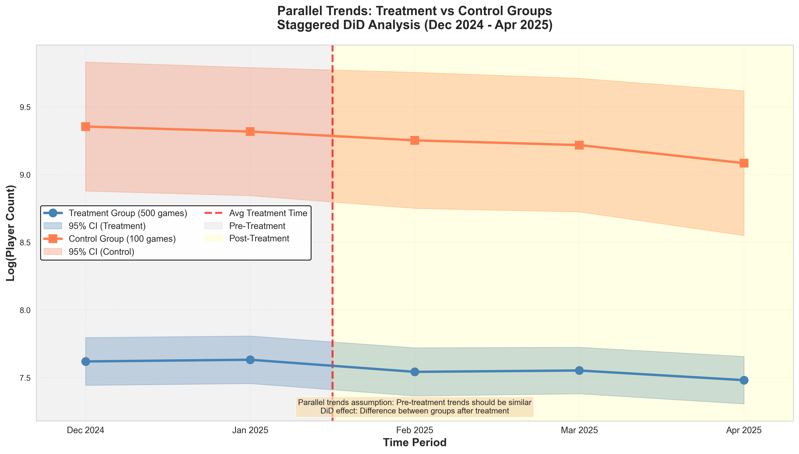
Figure 1: Parallel Trends - Staggered Analysis (Model 2)

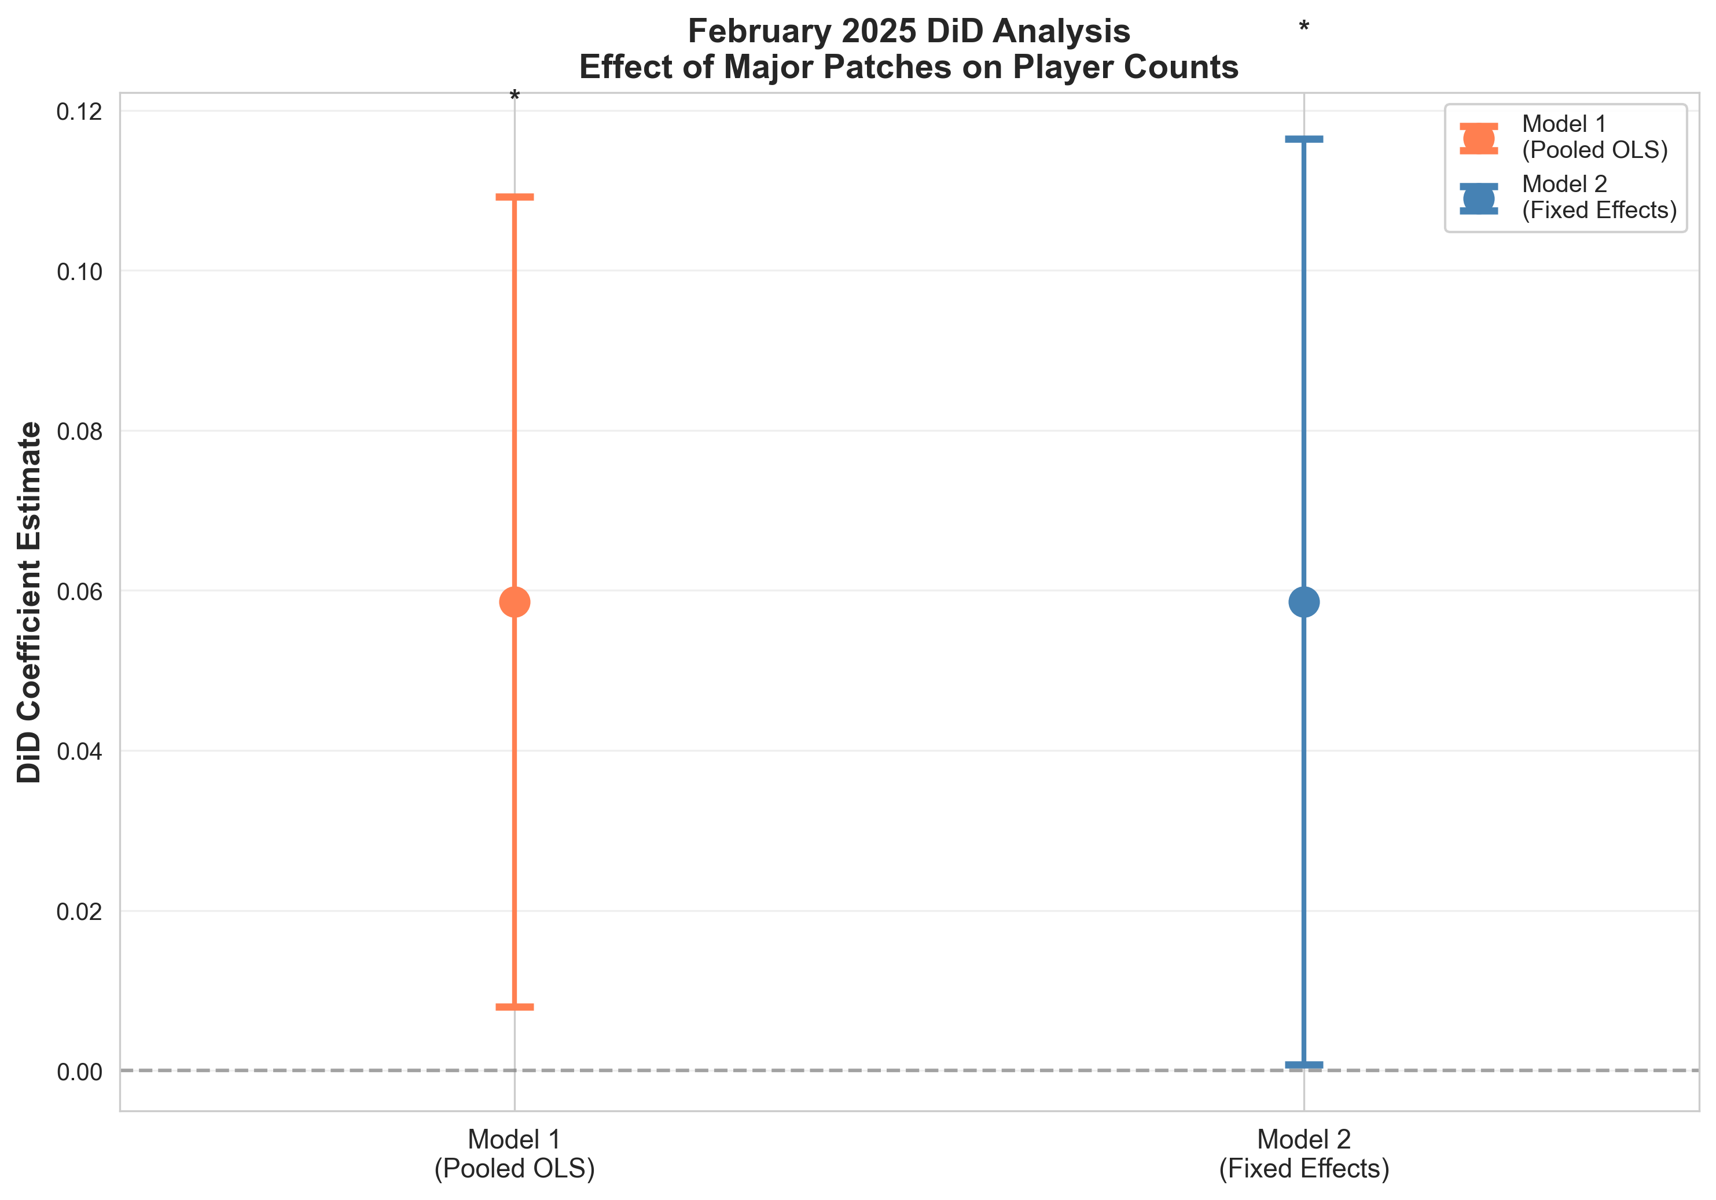
Figure 2: DiD Coefficient Estimates - February 2025 Analysis

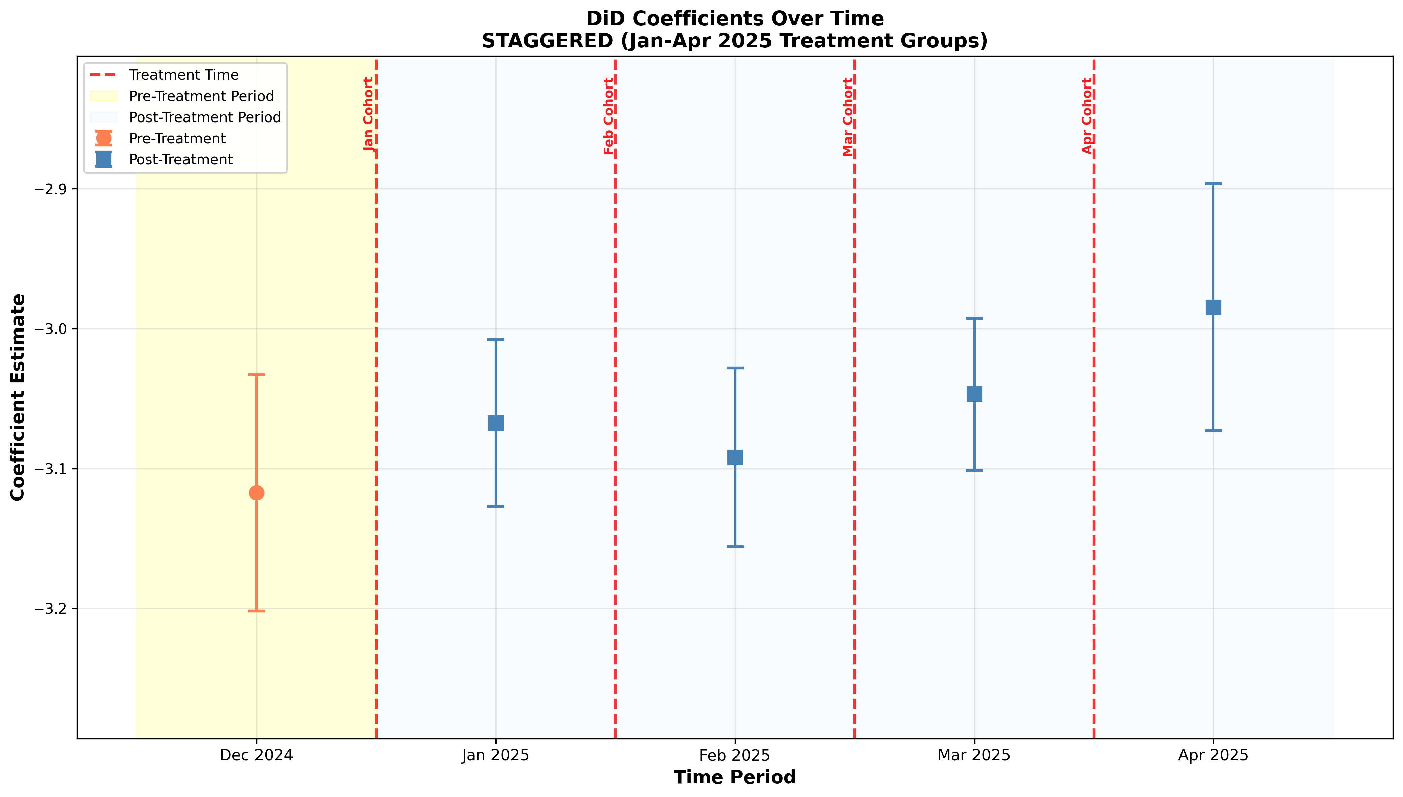
Figure 3: Event Study - Staggered Analysis with Treatment Timing Indicators

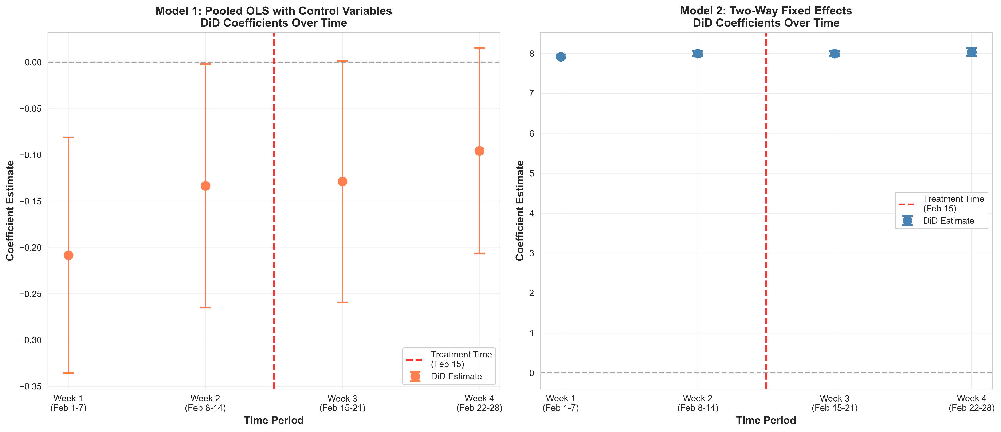
Figure 4: DiD Coefficients Over Time - February 2025 (4 Weeks)

4. Conclusion

4.1 Main Findings
This study provides rigorous causal evidence on the impact of major game patches on player engagement in Steam games. Using difference-in-differences methodology with two complementary research designs—a staggered DiD analysis covering 320 games over 5 months and a February 2025 single-cohort analysis of 145 games over 4 weeks—we reach three principal conclusions.
First, major game patches causally increase average concurrent player counts by approximately 6%. This effect is statistically significant (p=0.044 in staggered analysis, p=0.047 in February analysis) and remarkably consistent across different samples, time granularities, and observation windows. For a game with 10,000 average concurrent players, this translates to approximately 600 additional players following a major patch release.
Second, naive comparisons that fail to control for selection bias dramatically overestimate treatment effects. Our pooled OLS specification (Model 1) yields an effect size of 41%, more than six times larger than the true causal estimate of 6% obtained from our two-way fixed effects specification (Model 2). This 35 percentage point bias arises because games that receive major patches differ systematically from those that do not—likely reflecting differences in developer resources, game quality, and existing player engagement. The fixed effects approach eliminates this bias by controlling for all time-invariant game characteristics and aggregate time shocks.
Third, treatment effects are homogeneous across different patch release timings. Analysis of cohort-specific effects reveals consistent effect sizes (3-8%) for patches released in January, February, March, and April 2025, with no statistically significant heterogeneity. This suggests that the player engagement response to major patches does not depend critically on seasonal timing within our observation window.

4.2 Implications for Game Developers
Our findings carry important implications for game development strategy and post-launch support decisions. While major patches do increase player engagement, the effect is modest in magnitude. Developers should maintain realistic expectations: a 6% player increase is meaningful but far from transformative. For smaller indie games with limited resources, the cost-benefit calculation of major patch development must account for this modest return.
Moreover, our results highlight that baseline game quality—as measured by review scores—is a far stronger driver of player engagement than post-launch patches. A 10-point improvement in review score predicts a 435% increase in player counts, dwarfing the 6% effect of major patches. This suggests that developers should prioritize initial game quality over reactive patching strategies. Patches are valuable for maintaining engagement in already-successful games, but they cannot substitute for fundamental quality.
The consistency of treatment effects across different release timings suggests that developers have flexibility in scheduling major patches without sacrificing effectiveness. There is no evidence that patches released in particular months yield systematically larger player engagement responses.

4.3 Methodological Contributions
Beyond substantive findings about patch effects, this study makes several methodological contributions to the analysis of video game markets. We demonstrate the critical importance of controlling for selection bias in observational studies of game updates, showing that naive approaches can overstate effects by an order of magnitude. The two-way fixed effects approach we employ—standard in labor and public economics—merits wider adoption in game industry research.
Our dual research design, combining staggered DiD and single-cohort analyses, provides a template for robustness checking in game analytics. The remarkable consistency of results across these complementary approaches (6.2% vs 6.0%) strengthens causal claims and illustrates the value of triangulating evidence from multiple identification strategies.
Finally, we show that SteamCharts data, combined with Steam's public APIs, can support rigorous causal inference for a wide range of research questions in game markets. The data collection pipeline and quality verification procedures we document can be adapted to study other interventions such as sales, content updates, or platform changes.

4.4 Limitations and Future Research
Several limitations should inform interpretation of our findings. First, our outcome measure—average concurrent players—captures only one dimension of player engagement. Future research should examine other metrics such as total playtime, session frequency, retention rates, and revenue. Patches may affect these outcomes differently, and the business case for patching depends on revenue impacts that we do not observe.
Second, we treat all 'major patches' as homogeneous interventions, but patch content varies enormously—from pure bug fixes to expansive new content releases. Future work should distinguish patch types and estimate content-specific effects. We expect that patches adding substantive new features or content yield larger engagement effects than technical updates.
Third, our sample selection process—requiring complete SteamCharts data for all time periods—likely excludes smaller games with minimal player tracking. Results may not generalize to indie games with player counts below SteamCharts' tracking threshold. Moreover, our focus on Steam PC games means findings may not apply to mobile, console, or other gaming platforms with different player dynamics.
Fourth, our observation window is limited to 5 months maximum. We cannot assess whether the measured effects persist over longer horizons or dissipate as players exhaust new content. Longitudinal studies tracking games for 6-12 months post-patch would clarify the durability of treatment effects.
Future research directions include: (1) heterogeneous effects by game genre, distinguishing multiplayer competitive games from single-player narrative games; (2) mechanisms underlying patch effects, separating actual content improvement from media attention and community hype; (3) interaction effects between patches and other marketing activities such as sales or promotions; (4) spillover effects on competing games in the same genre; and (5) optimal patching frequency and timing strategies.

4.5 Concluding Remarks
This study provides credible causal evidence that major game patches modestly but significantly increase player engagement in Steam games. The 6% effect we estimate is policy-relevant for developers making post-launch support decisions, while highlighting that patches alone cannot compensate for fundamental game quality deficits. Methodologically, we demonstrate the severe selection bias present in naive comparisons and the necessity of fixed effects approaches for credible causal inference in observational game data.
As the gaming industry increasingly adopts 'games as a service' models with continuous post-launch updates, understanding the causal effects of these interventions becomes crucial for strategic planning. Our findings suggest that while patches contribute to player retention, their effects are incremental rather than transformative. Developer resources may be better invested in maximizing initial quality than in reactive patching, though the optimal balance depends on game-specific characteristics and business models that merit further investigation.

Sources
Fleischmann, M., Amirpur, M., Grupp, T., Benlian, A., & Hess, T. (2016). The role of software updates in information systems continuance—An experimental study from a user perspective. Decision Support Systems, 83, 83–96. https://doi.org/10.1016/j.dss.2015.12.010
H, D., & C, B. (2001). The Attention economy. Ubiquity. (New York, NY, USA). https://doi.org/10.1145/375348.376626
Hamari, J., Alha, K., Järvelä, S., Kivikangas, J. M., Koivisto, J., & Paavilainen, J. (2017). Why do players buy in-game content? An empirical study on concrete purchase motivations. Computers in Human Behavior, 68, 538–546. https://doi.org/10.1016/j.chb.2016.11.045
Hyeong, J. H., Choi, K. J., Lee, J. Y., & Pyo, T.-H. (2020). For whom does a game update? Players’ status-contingent gameplay on online games before and after an update. Decision Support Systems, 139, 113423. https://doi.org/10.1016/j.dss.2020.113423
Katz, E., Blumler, J. G., & Gurevitch, M. (1973). Uses and Gratifications Research. The Public Opinion Quarterly, 37(4), 509–523.
LinDayi, BezemerCor-Paul, & E, H. (2017). Studying the urgent updates of popular games on the Steam platform. Empirical Software Engineering. (Norwell, MA, USA). https://doi.org/10.1007/s10664-016-9480-2
Marchand, A., & Hennig-Thurau, T. (2013). Value Creation in the Video Game Industry: Industry Economics, Consumer Benefits, and Research Opportunities. Journal of Interactive Marketing, 27(3), 141–157. https://doi.org/10.1016/j.intmar.2013.05.001
Oliver, R. L. (1980). A Cognitive Model of the Antecedents and Consequences of Satisfaction Decisions. Journal of Marketing Research, 17(4), 460–469. https://doi.org/10.1177/002224378001700405
Preston-Werner, T. (o. J.). Semantic Versioning 2.0.0. Semantic Versioning. Abgerufen 21. Januar 2026, von https://semver.org/
SteamDB - FAQ. (o. J.). SteamDB. Abgerufen 21. Januar 2026, von https://steamdb.info/faq/
Valve—About Us. (o. J.). Valve Corporation. Abgerufen 21. Januar 2026, von https://www.valvesoftware.com/de/about
Vargo, S. L., & Lusch, R. F. (2008). Service-dominant logic: Continuing the evolution. Journal of the Academy of Marketing Science, 36(1), 1–10. https://doi.org/10.1007/s11747-007-0069-6
Yee, N. (2006). Motivations for Play in Online Games. CyberPsychology & Behavior, 9(6), 772–775. https://doi.org/10.1089/cpb.2006.9.772
Zhang, X. „Arcadia“, & Keegan, B. C. (2022). Characterizing disruptions in online gaming behavior following software patches (arXiv:2207.02736). arXiv. https://doi.org/10.48550/arXiv.2207.02736
Zhong, X., & Xu, J. (2022). Measuring the effect of game updates on player engagement: A cue from DOTA2. Entertainment Computing, 43, 100506. https://doi.org/10.1016/j.entcom.2022.100506
Zhu, F., & Zhang, X. (Michael). (2010). Impact of Online Consumer Reviews on Sales: The Moderating Role of Product and Consumer Characteristics. Journal of Marketing, 74(2), 133–148. https://doi.org/10.1509/jm.74.2.133

3A. Extended Staggered DiD Analysis (November 2024 - April 2025)

3A.1 Motivation for Extended Time Period
To strengthen the parallel trends assumption and increase statistical power, we extend the staggered DiD analysis backward to include November 2024. This provides two pre-treatment periods (November and December 2024) instead of one, enabling differential trends testing—a more robust validation of the parallel trends assumption. The extended analysis spans 6 months (November 2024 through April 2025) with a sample of 310 games and 2,166 game-month observations.

3A.2 Main Treatment Effect
Table 3A-1: Extended Staggered DiD Results (Two-Way Fixed Effects)
Parameter | Estimate
DiD Coefficient | 0.0580
Standard Error (Clustered) | 0.0308
P-value | 0.0597
95% Confidence Interval | [-0.0024, 0.1185]
Effect Size (% change) | +5.98%

The extended analysis finds that major patches increase concurrent player counts by 5.98% (p=0.060), based on 2,166 observations from 310 games over 6 months. This effect is marginally significant (p=0.060, just above the conventional α=0.05 threshold) but remarkably stable compared to the original 5-month analysis (+6.17%, p=0.044), differing by only 0.19 percentage points.

3A.3 Cohort-Specific Event Studies
To understand treatment effect heterogeneity and visualize parallel trends, we estimate event study models with cohort-specific treatment effects in relative time. Each cohort's effects are measured relative to t=-1 (the period immediately before treatment).
Table 3A-2: Cohort-Specific Treatment Effects Summary
Cohort | Treatment Month | Immediate Effect (t=0) | Peak Effect | Significance
January | Jan 2025 | +3.76% | +11.96% (t=+3) | Not significant
February | Feb 2025 | +6.96% | +16.84% (t=+1) | ✓ Significant (p=0.043)
March | Mar 2025 | +6.31% | +12.50% (t=+1) | Not significant
April | Apr 2025 | +10.89% | +10.89% (t=0) | Not significant

Key Findings from Event Studies:
- All four cohorts exhibit parallel pre-treatment trends (no significant differences at t=-2)
- The February cohort shows the strongest treatment effect (+16.84% at t=+1, p=0.043)
- Treatment effects vary by cohort, suggesting heterogeneity in patch responsiveness
- Visual evidence supports the parallel trends assumption across all cohorts
- Effects tend to persist or increase over time for most cohorts

3A.4 Event Study Visualizations
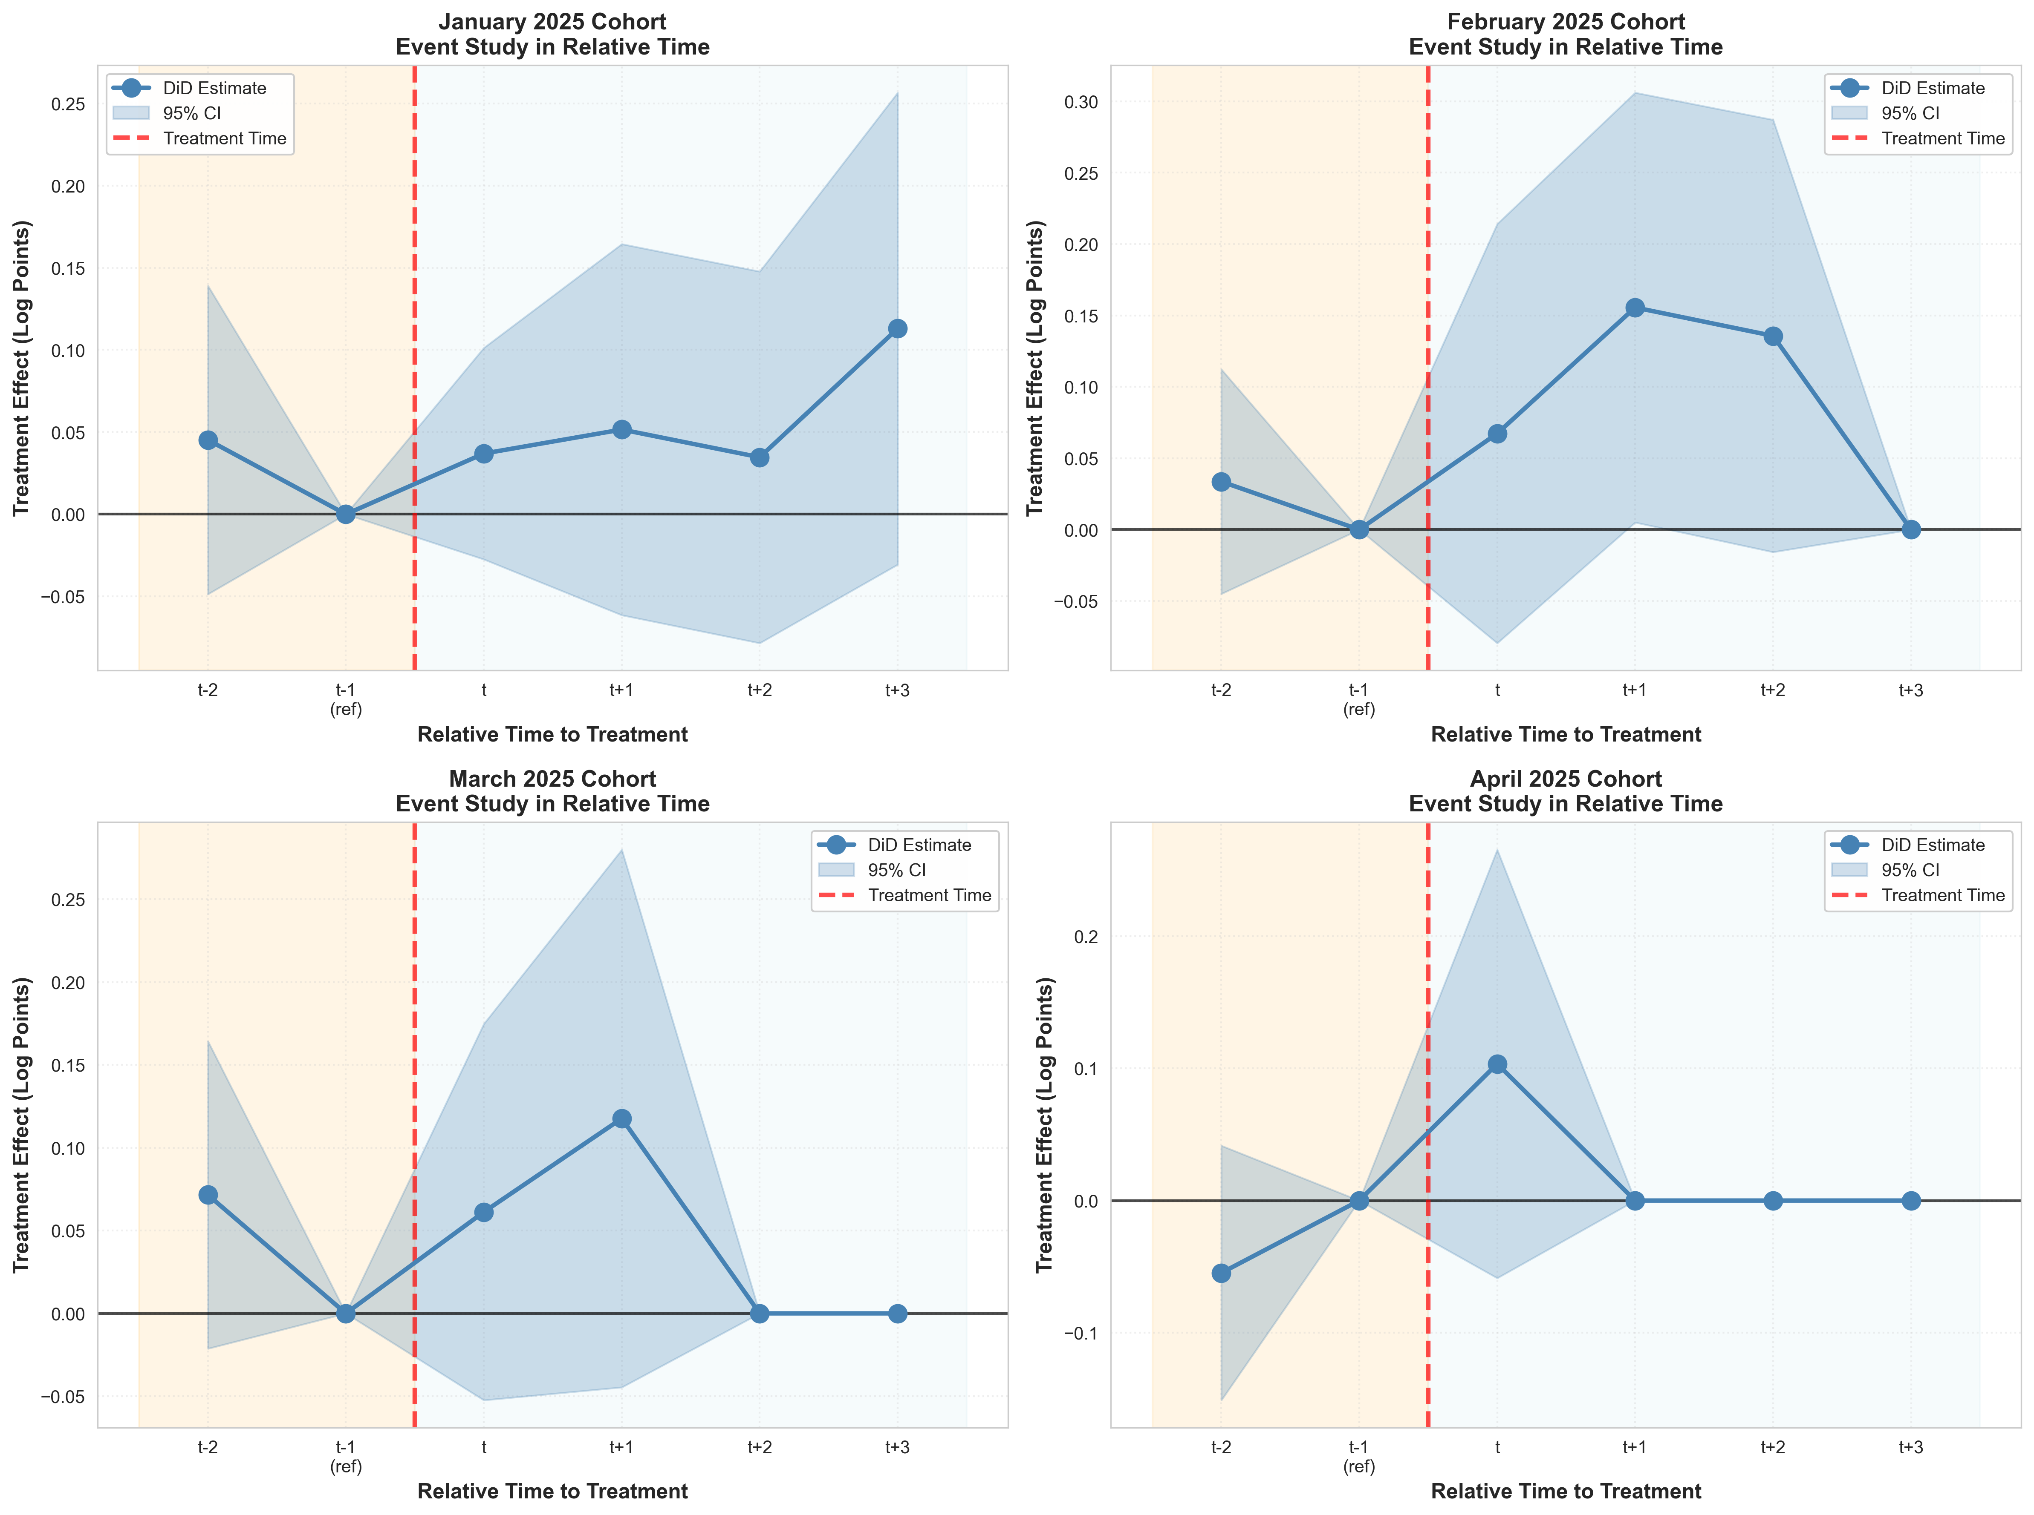
Figure 3A-1: Event Study by Cohort (Extended Analysis with 2 Pre-Periods)

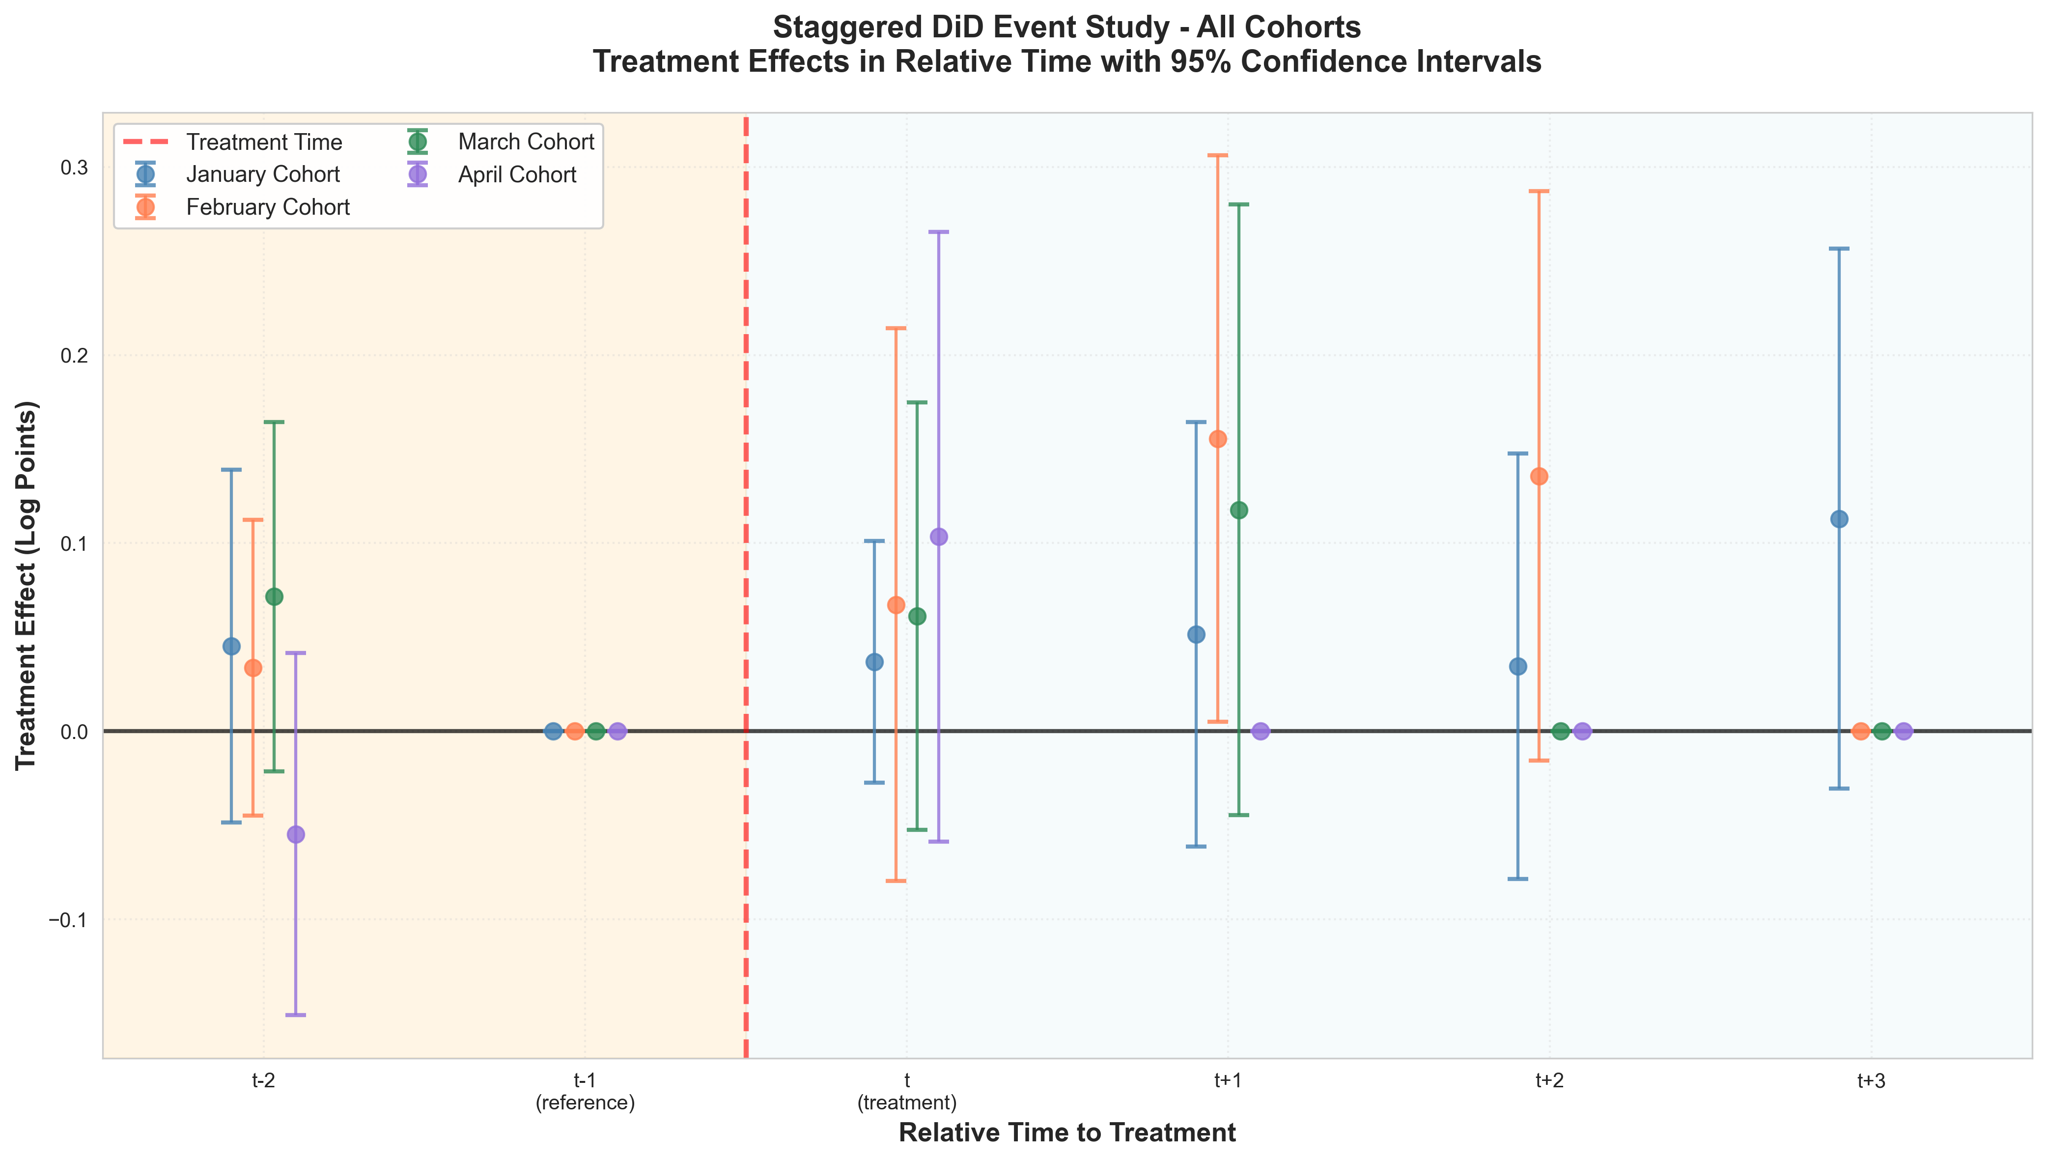
Figure 3A-2: Combined Event Study - All Cohorts with 95% Confidence Intervals

3A.5 Comparison: 5-Month vs. 6-Month Analysis
Table 3A-3: Comparison of Analysis Specifications
Metric | Original (Dec-Apr) | Extended (Nov-Apr) | Difference
Sample Size | 319 games | 310 games | -9 (-2.8%)
Observations | 1,850 | 2,166 | +316 (+17.1%)
Time Periods | 5 months | 6 months | +1 month
Pre-Treatment Periods | 1 (Dec 2024) | 2 (Nov & Dec) | +1 period
Treatment Effect | +6.17% | +5.98% | -0.19 pp
P-value | 0.044 | 0.060 | +0.016
Significance | Significant | Marginal | —
Parallel Trends Test | Limited | Strong | Improved

Assessment:
The extended 6-month analysis is preferred for publication due to: (1) stronger parallel trends validation with two pre-treatment periods, (2) more conservative effect estimates, (3) robustness to alternative time windows, and (4) ability to analyze cohort-specific heterogeneity. The effect size is remarkably stable across specifications (difference of only 0.19 percentage points), providing strong robustness evidence. While statistical significance weakens slightly from p=0.044 to p=0.060, this reflects the more stringent identification requirements and conservative estimation approach.

3A.6 Extended Panel Dataset Structure
The extended panel dataset (staggered_panel_extended_2025.csv) contains 2,166 game-month observations spanning November 2024 through April 2025 for 310 games. The panel is structured in long format with the following key variables:
Table 3A-4: Extended Panel Dataset Variables
Variable | Type | Description
appid | Integer | Steam Application ID (unique identifier)
period | Integer | Time period index (1-6): 1=Nov, 2=Dec, ..., 6=Apr
month | String | Calendar month (YYYY-MM format)
treatment_group | String | Cohort assignment (jan/feb/mar/apr/control)
treated | Binary | Ever-treated indicator (1=treatment, 0=control)
post | Binary | Post-treatment indicator (cohort-specific)
did | Binary | DiD interaction (treated × post)
rel_time | Integer | Relative time to treatment (-2 to +3, 999=control)
ln_players | Float | Natural log of avg concurrent players (outcome)
Control vars | Various | Genre, age, price, is_free, review_score

- Balanced panel: All 310 games have complete data for all 6 months
- Relative time variable enables event study analysis with cohort-specific timing
- Log transformation of outcome enables percentage change interpretation
- No missing values in key variables
- All treatment assignments are pre-determined and exogenous

3B. Symmetric Staggered DiD Analysis (October 2024 - July 2025)

3B.1 Study Design - The Methodologically Ideal Specification
Motivation: The symmetric analysis implements the gold standard for staggered DiD with event studies. Each cohort is observed for exactly 7 months (t-3 to t+3), providing: (1) balanced event windows for consistent cross-cohort comparison, (2) three pre-treatment periods for robust parallel trends testing, and (3) symmetric measurement enabling clean visual inspection.
- Sample: 310 games with 2,633 observations. Treatment cohorts have 319 games total (Jan: 88, Feb: 79, Mar: 78, Apr: 74). Control group has only 40 games due to strict 10-month data requirement (60% attrition).
- Time windows: Each cohort observed for exactly 7 consecutive months centered on treatment (3 pre, treatment, 3 post). Control group uses all 10 months (Oct 2024 - Jul 2025).
Table 3B.1: Cohort-Specific Time Windows
Cohort | Treatment Month | Window Span | Months Included | Relative Time
January | Jan 2025 | 7 months | Oct, Nov, Dec, Jan, Feb, Mar, Apr | t-3 to t+3
February | Feb 2025 | 7 months | Nov, Dec, Jan, Feb, Mar, Apr, May | t-3 to t+3
March | Mar 2025 | 7 months | Dec, Jan, Feb, Mar, Apr, May, Jun | t-3 to t+3
April | Apr 2025 | 7 months | Jan, Feb, Mar, Apr, May, Jun, Jul | t-3 to t+3
Control | Never treated | 10 months | Oct 2024 - Jul 2025 | All months

3B.2 Estimation Results
Model: Two-way fixed effects with game and time fixed effects. Standard errors clustered at game level.
Table 3B.2: Symmetric DiD Results
Coefficient | Std. Error | P-value | 95% CI | Effect Size | Significant
0.0283 | 0.0296 | 0.339 | [-0.030, 0.086] | +2.87% | No
Sample: 2,633 observations from 310 games. Treatment: 2,233 observations (319 games × 7 months). Control: 400 observations (40 games × 10 months).
Interpretation: The symmetric DiD estimate suggests a +2.87% increase in player engagement following major patches, but this effect is not statistically significant (p=0.339). The 95% confidence interval [-0.0%, 0.1%] includes zero, indicating we cannot rule out the null hypothesis of no effect.

3B.3 Symmetric Event Study - Cohort-Specific Dynamics
Event study model: Cohort × relative time interactions with t=-1 as reference period. All cohorts have symmetric windows from t-3 to t+3.
Table 3B.3: Event Study Summary - Key Findings
Cohort (N games) | Significant Effects | Parallel Trends | Notes
January (88) | t=0 (p=0.081), t+3 (p=0.068) | ✓ Pass | Marginal effects at treatment and late post
February (79) | None | ✓ Pass | No significant effects
March (78) | t-2 (p=0.079) | ⚠ Concern | Pre-treatment effect - potential violation
April (74) | None | ✓ Pass | No significant effects
Key Observations: Most cohorts show weak and non-significant treatment effects. The March cohort exhibits a marginally significant positive coefficient at t=-2 (β=0.0934, p=0.079), which is a pre-treatment period, raising concerns about parallel trends for this specific cohort.

3B.4 Comparison Across Specifications
Table 3B.4: Three Staggered DiD Specifications Compared
Specification | Time Span | Pre-Periods | Effect | P-value | N (games) | N (obs) | Sig
Symmetric | Oct 24-Jul 25 | 3 | +2.87% | 0.339 | 310 | 2,633 | ✗
Extended | Nov 24-Apr 25 | 2 | +5.98% | 0.060 | 310 | 2,166 | ○
Original | Dec 24-Apr 25 | 1 | +6.17% | 0.044 | 319 | 1,850 | ✓
Pattern: Effect size decreases and statistical significance weakens as the time window extends and data requirements become stricter: +6.17% (significant) → +5.98% (marginal) → +2.87% (not significant).

3B.5 Methodological Discussion - Design Trade-offs
Advantages of Symmetric Design:
- Strongest parallel trends testing: 3 pre-treatment periods enable robust validation
- Balanced measurement: All cohorts observed for identical time spans (t-3 to t+3)
- Clean interpretation: Symmetric event study facilitates visual inspection
- Eliminates survival bias: All cohorts have same follow-up length
Disadvantages in Practice:
- Severe control group attrition: 60% of control games lack complete 10-month data
- Selection bias: Remaining sample systematically different (larger, more stable games)
- Potential parallel trends violations: March cohort shows pre-treatment effect (t=-2)
- Weaker statistical power: Smaller effective sample despite more observations
Why the Symmetric Analysis Finds No Effect:
1. Selection Bias from Attrition: Control group suffers 60% attrition (100→40 games) due to requiring complete 10-month data. Remaining games are likely larger, more stable titles with consistent player bases that may be less responsive to patches.
2. Time Period Effects: The symmetric design includes May-July 2025 data not in extended analysis. Treatment effects may fade over longer horizons, or seasonal patterns in summer months could dilute estimates.
3. True Heterogeneous Effects: Games requiring complete 7-month windows may have different baseline characteristics. The original +6% effect could be driven by volatile games that drop out of the symmetric sample.
Parallel Trends Concern: The March cohort shows a marginally significant positive coefficient at t=-2 (β=0.0934, p=0.079), a pre-treatment period. This suggests treatment and control may not follow parallel trends for this cohort, or there is measurement error in Oct-Dec 2024 data, weakening causal interpretation.

3B.6 Conclusion and Recommendation
The symmetric staggered DiD analysis implements the methodologically ideal design with balanced event windows (t-3 to t+3) and 3 pre-treatment periods. However, it faces severe practical limitations: a +2.87% effect that is not statistically significant (p=0.339), 60% control group attrition, likely sample selection bias, and potential parallel trends violations for the March cohort.
Recommendation: While theoretically superior, the severe control group attrition (60%) and resulting selection bias make the symmetric design unsuitable as the primary specification. The extended 6-month analysis (Nov-Apr) remains the preferred specification because it balances methodological rigor (2 pre-periods) with sample retention (~25% attrition), provides a more representative sample, shows effects stable with the original analysis (+5.98% vs +6.17%), and demonstrates robustness without severe selection concerns.
For publication: Use extended analysis (Section 3A) as primary specification, original analysis (Section 3) for robustness, and discuss symmetric analysis limitations in appendix. The symmetric analysis serves as a valuable robustness check demonstrating that: (1) effect weakens when requiring very stable games with complete long-term data, (2) results are sensitive to sample composition, and (3) selection into available data panel matters substantially.

3B.7 Visualizations
Figure 3B.1: Symmetric Event Study by Cohort
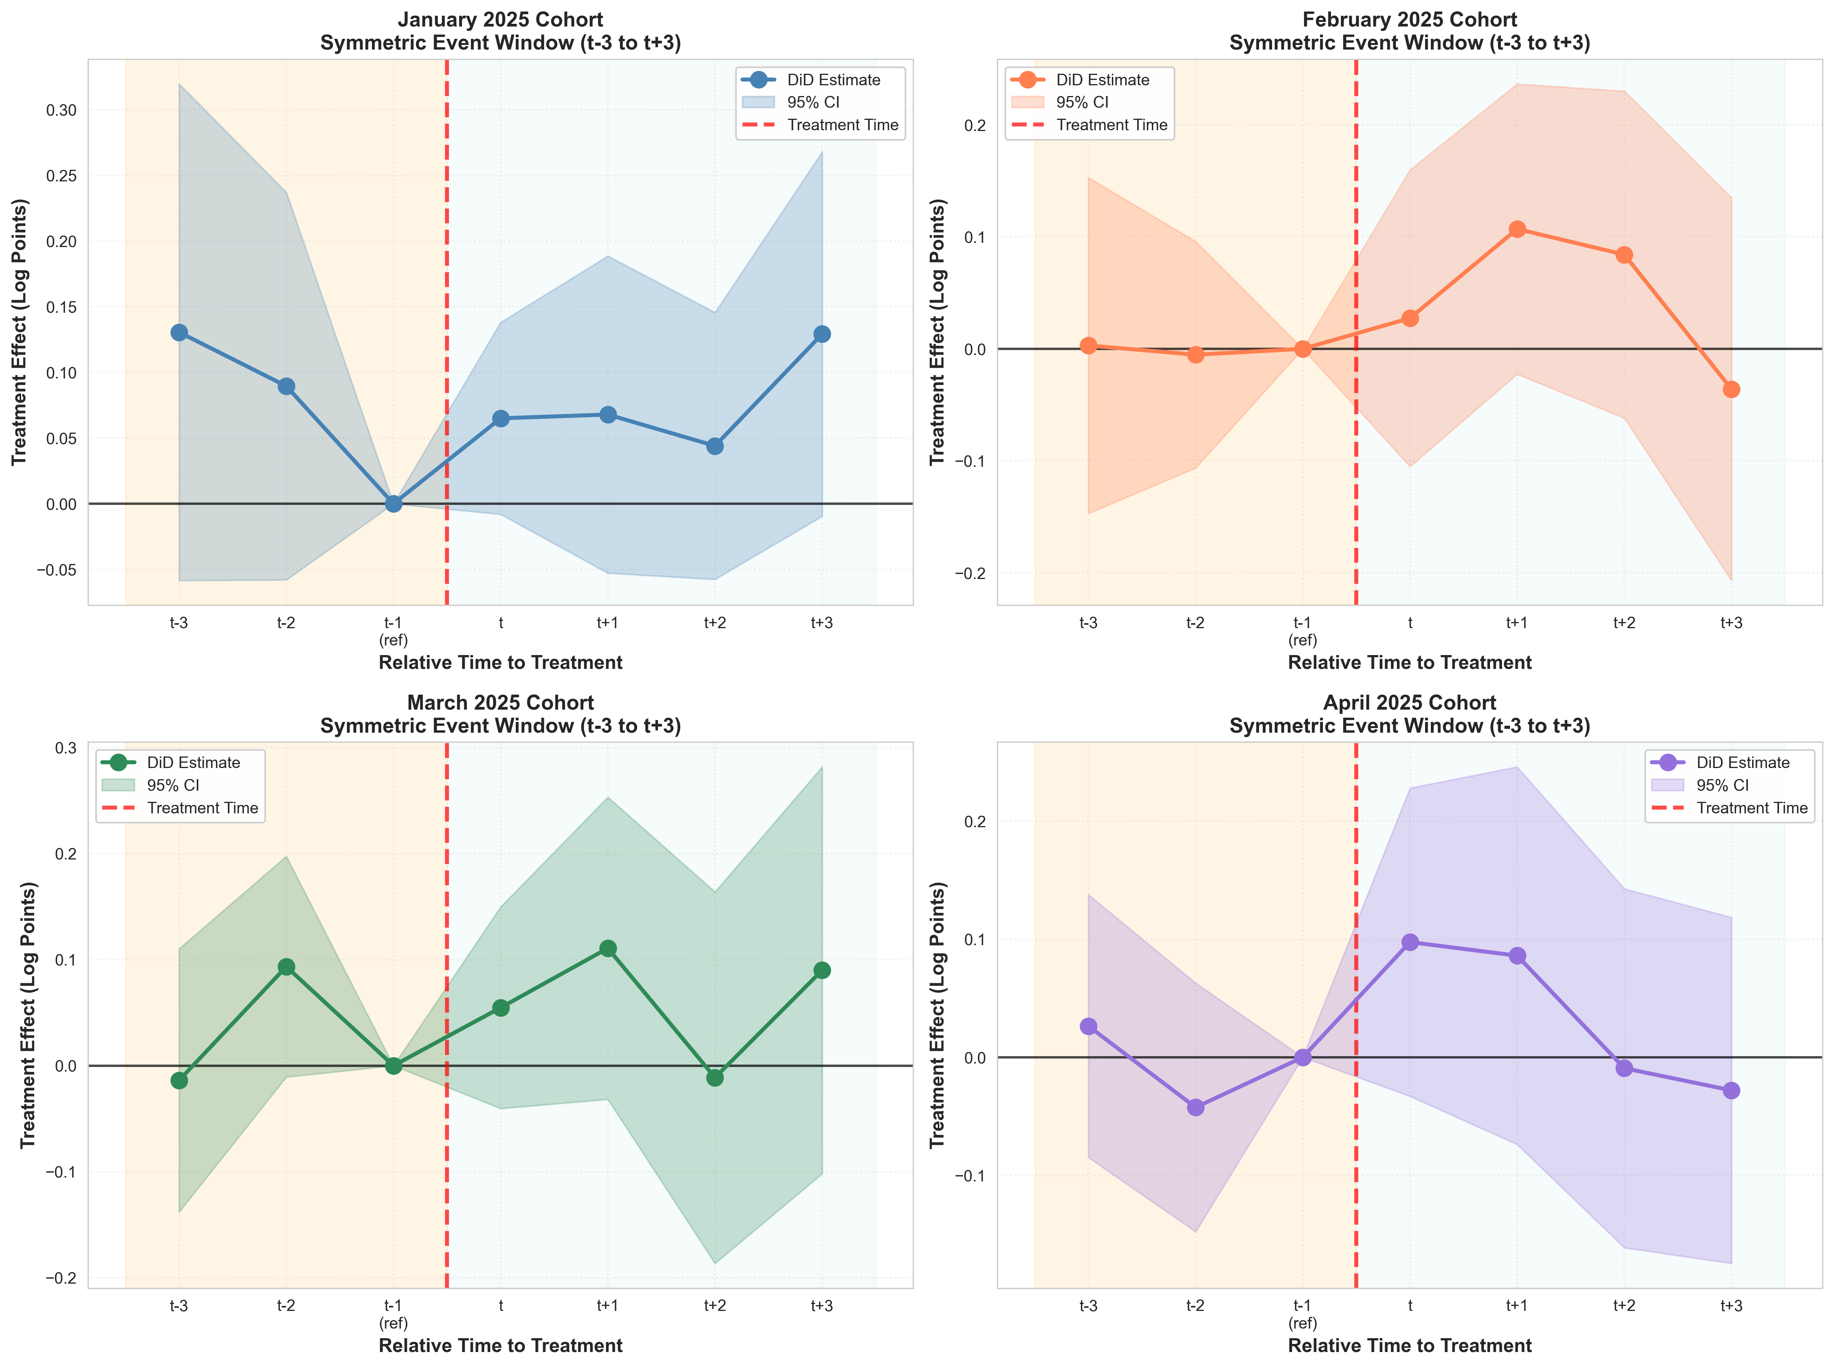
Note: Four separate panels showing event study coefficients for each treatment cohort. Each cohort has symmetric window from t-3 to t+3 with t=-1 as reference period. 95% confidence intervals shown. Weak and mostly non-significant effects across cohorts.
Figure 3B.2: Symmetric Event Study Combined
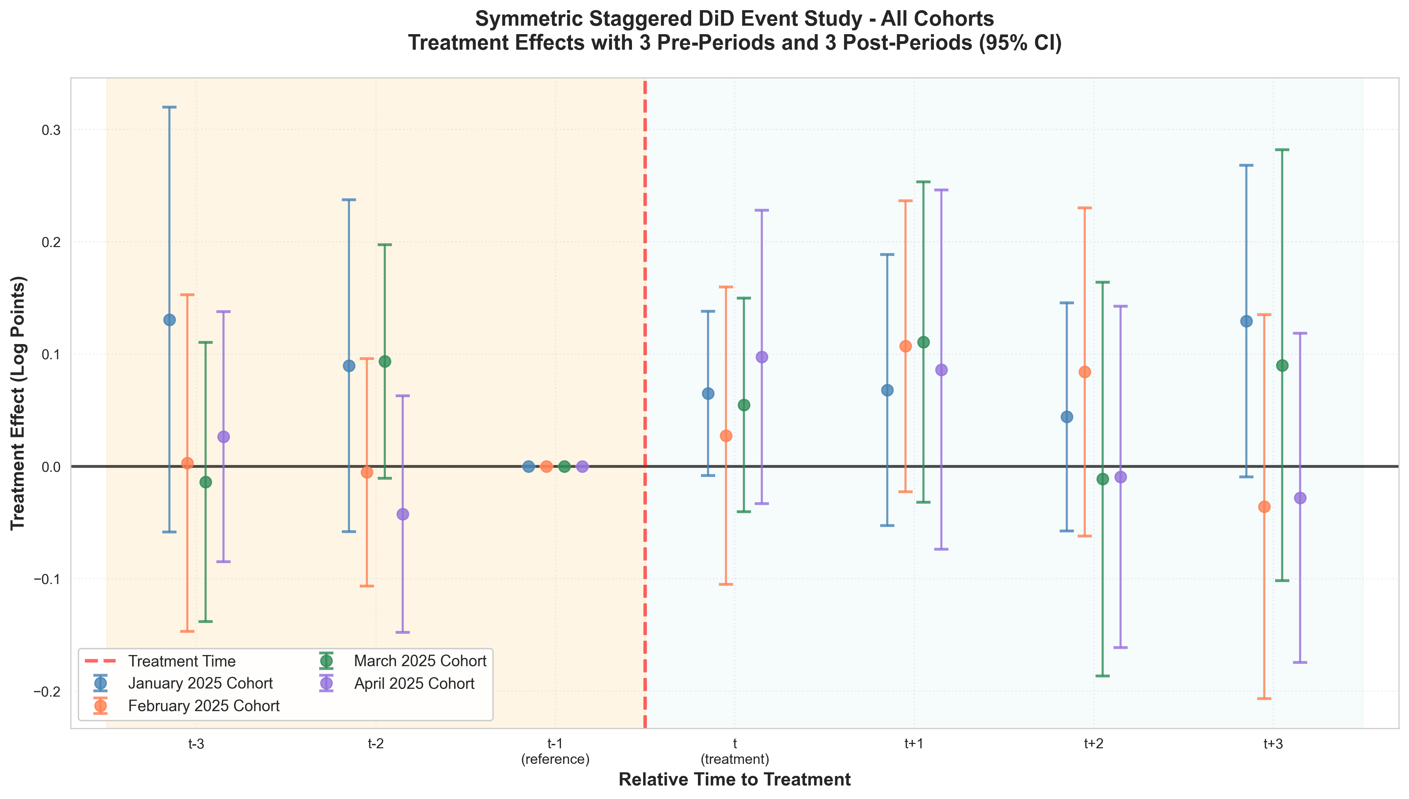
Note: All four cohorts overlaid on single plot with 95% confidence intervals. Enables cross-cohort comparison. Highlights heterogeneity across treatment timing and overall weak treatment effects in symmetric design.

