Automation of Complex Power Systems

Project report on Simulation and test of microgrid dynamics

Authors:
Breuer, Erik (Matrikelnummer) | Space for signature (if mandatory) | 7/13/2025
Tasca, Francesco (471962) | (table lines to be removed) | 7/13/2025
Tursunbekova, Assel (419077) |  | 7/13/2025

Contents
Introduction 3
Relevant data from project assignment 4
Assumptions and limitations 6
Assumptions on maximum parameters variations allowed for microgrid operation 6
Assumptions on realistic modelling of LCL filter 6
Simplifications on steady-state analysis 6
Project model 8
Preparatory setup 8
Droop control 8
Voltage and current control 8
Current control loop 8
Voltage control loop 9
Building the Simulink model 9
Real grid modelling 9
Voltage sources control scheme 10
Droop control scheme 10
Conclusions 10
Attachments 11

Introduction
This document is meant as complement of the files:
- MATLAB Live Script (file name)
- Simulink model (file name)
Purpose of this document is to explain the procedure and design choices that have been made.
Chapter “Relevant data from project assignment” reports the relevant model parameters and data, along with schematic illustrations.
Chapter “Assumptions and limitations” explains the assumptions on missing model parameters and related limitations. This chapter contains also motivations for such assumptions, that have been checked and validated from the Automation of Complex Power Systems’ (ACS) course team during the meeting of 10/07/2025, that took place virtually on Microsoft Teams, complemented with e-mails exchange.
Chapter “Project model” deals with the construction of the model, and is structured in a step-by-step format, hence starting from the theoretical preparation, to the real Simulink modelling.
Chapter "Conclusions” ends the document with main findings, supported with relevant pictures from simulations performed.

Relevant data from project assignment
The project is based on the microgrid scheme represented in Figure 1.
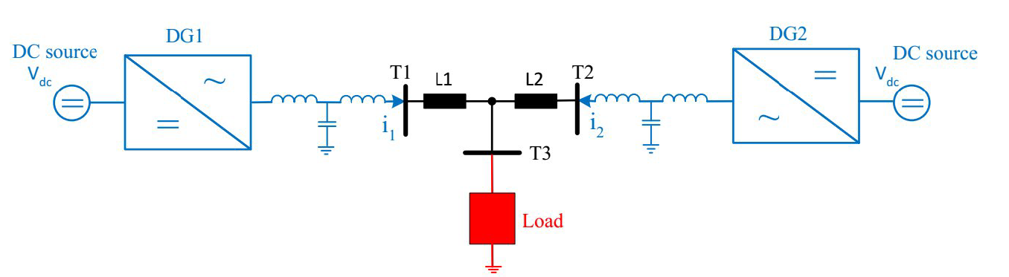
Figure 1: Microgrid architecture
The microgrid architecture, starting from the outside and going through the inner, is composed by:
- Two local energy sources, represented by a constant DC voltage of 750 V
- Two three-phase converters, operating at 10 kHz switching frequency and implementing the control actions
- Two LCL filters with:
  - Inductance at converter side: 3 mH
  - Capacitance: 10 μF
  - Inductance at grid side: 1.5 mH
- A grid with rated voltage 220 V (phase voltage) and rated frequency 50 Hz and:
  - Two lines represented by
    - Inductance: 10 mH
    - Resistance: 1 Ω
  - One variable resistive load. The load has an initial value of 50 Ω, and is then changed to 40 Ω to trick the control action
The two three-phase converters in Figure 1 are represented by the nested loop architecture of Figure 2.
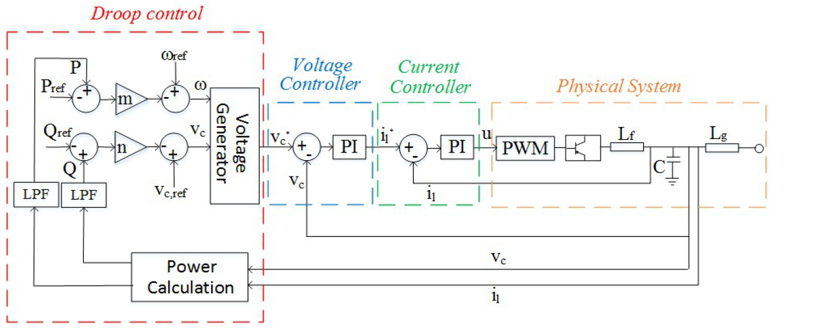
Figure 2: Nested loop architecture of three-phase converter
All the data presented in this chapter have been summarized in the Table 1 below.
Parameter | Project  variable name | Value | Unit
DC source voltage | V_dc | 750 | V
Converter’s switching frequency | f_s | 10 000 | Hz
LCL inductance converter side | L_f | 3 | mH
LCL capacitance | C_f | 10 | μF
LCL inductance grid side | L_g | 1.5 | mH
Grid voltage | V | 220 | V
Grid frequency | f_n | 50 | Hz
Line inductance | L_line | 10 | mH
Line resistance | R_line | 1 | Ω
Initial resistive load | R_load | 50 | Ω
Final resistive load | R_load_final | 40 | Ω
Table 1: Summary of Project’s assignment data

Assumptions and limitations
As complement to the Project data summarized in chapter before, some assumptions are needed:
- Assumptions on maximum parameters variations allowed for microgrid operation
- Assumptions on realistic modelling of LCL filter
- Simplifications on steady-state analysis

Assumptions on maximum parameters variations allowed for microgrid operation
In order to effectively design the droop control coefficients for the converters, values for maximum frequency and voltage variations are needed. Those values are therefore assumed, according to the reference standard for low voltage operation (EN 50160).
Those values are:
- $Δf_{max}= 1.0 Hz$
- ${ΔV}_{max}=10.0V$ (Peak to peak)

Assumptions on realistic modelling of LCL filter
In order to design a filter to stabilize the system, including damping and harmonic control functions, it is needed to include a passive resistance. After a consultation with the ACS team, it has been decided to model the LCL inductances with an inner, parasitic, resistance resembling this function. The value for such resistance, suggested by the ACS team is about 2% of the equivalent inductive reactance so:
$$R_{f}=0.02*X_{f}$$
Where:
$$X_{f}=ω_{f}*L_{f}$$
And L_f is the grid side inductance.
This assumption can represent a contradiction, as the same question, posed to the ACS team through the RWTH Moodle course platform, highlighting different need, received a different answer. Such answer suggested to avoid any stray element, so to model the LCL filter with ideal components, but this poses an issue occurring during the filter design, as the transfer function, derived through Laplace transformation, will then miss a parameter.

Simplifications on steady-state analysis
In order to tune the droop control effectively, the steady-state power analysis is needed to finally calculate droop coefficients. To run the steady-state power analysis, the simplified circuit in Figure 3, resembling only the 220 V grid is considered.

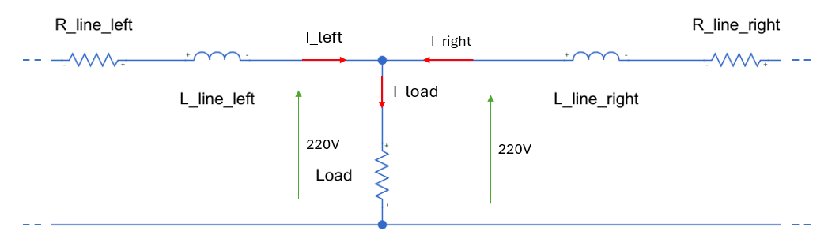
Figure 3: Simplified circuit for steady-state analysis
This circuit does not consider the LCL design, that does represent the major power consumption of the circuit, and hence is simplified from the representation.
The steady state analysis considers a constant voltage measured at the load, equal to the nominal voltage of the grid, hence 220 V.
With this fixed value, it is possible to calculate the current flowing in the load:
$$I_{load}=\frac{V}{R_{load}}=4.4 A$$
The current is equally split between the “left” and “right” lines as perfectly balanced therefore:
$$I_{left}=I_{right}=\frac{I_{load}}{2}=2.2 A$$
Once all the currents in the current are calculated, it is possible to proceed calculating the power absorbed by the equivalent grid:
$$P_{steady}=P_{load}+2*P_{line}≈1000 W$$
$$Q_{steady}=Q_{load}+2*Q_{line}≈50 Var$$
Where specific power have been calculated using basic electrotechnics laws.
This power is shared equally between the two DC voltage sources, so the design of each converter can be adapted for half the power. In this case, after the power split, an additional design positive margin of 50% is taken:
$$P_{converter}≈750 W$$
$$Q_{converter}≈50 W$$
With these indications, it is finally possible to assume the maximum rating power of each voltage converter:
$$P_{max}≈1500 W$$
$$Q_{max}≈100 W$$

Project model

Preparatory setup
This subchapter contains the needed theoretical insights for the model. It includes the design of both the droop characteristics and the nested voltage and current control loops for each voltage source inverter (VSI).
The tuning of the control structure has been performed according to the steps described in ACS Exercise Session number 4, and ACS Lecture number 5.

Droop control
The droop control is implemented to allow decentralized power sharing between the two voltage source inverters. The droop equations used are:
$ω=ω_{ref}-m_{p}\left(P-P_{ref}\right)$ ; $v_{c}=v_{c,ref}-n_{q}(Q-Q_{ref})$
The droop coefficients $m_{p }$ and $n_{q}$are calculated based on the allowed maximum deviations and the rated power values. The general formulas are:
$$m_{p}=\frac{{Δω}_{max}}{{2*P}_{max}}$$
$$n_{q}=\frac{{Δv}_{max}}{{2*Q}_{max}}$$
These coefficients define how much the inverter’s output frequency and voltage are allowed to vary as a function of the delivered active and reactive power. The factor of 2 in the denominator accounts for symmetric deviations around the nominal values.

Voltage and current control
Each VSI uses a nested control structure, consisting of an outer voltage control loop and an inner current control loop. Both are implemented in the rotating d-q reference frame. The voltage reference is aligned with the d-axis, and the q-axis reference is set to zero.

Current control loop
The current control loop is designed as a first-order system with the closed-loop transfer function:
$$G_{cl}\left(s\right)=\frac{1}{τ_{i}s+1}$$
The time constant $τ_{i}$ is selected based on the switching frequency, typically using:
$$τ_{i}=10*f_{s}$$
This results in a sufficiently fast current response to allow separation from the slower voltage loop dynamics.

Voltage control loop
The voltage control is designed to shape the closed-loop response into a second-order system:
$$G_{cl}\left(s\right)=G_{PF}\left(s\right)*G_{cl}\left(s\right)=\frac{k_{i}}{s^{2}+\left(\frac{k_{p}}{C_{f}}\right)s+\frac{k_{i}}{C_{f}}}$$
Where:
- $C_{f}$is the LCL filter capacitance
- $k_{p}$ and $k_{i}$ are the PI controller parameters
There parameters are calculated using the standard second-order system design method:
$k_{p}=2ζω_{n}C_{f}$, $k_{i}=ω_{n}^{2}C_{f}$
The damping ratio $ζ$ and natural frequency $ω_{n}$ are design parameters. To ensure decoupling between the control loops, the voltage controller time constant $τ_{v}$ is chosen as:
$$τ_{v}=5*τ_{i}$$
From which $ζ$ can be computed as:
$$ζ=\frac{1}{ω_{n}τ_{v}}$$
The grid voltage $v_{grid}$ is assumed to be zero during the control design phase to simplify the model, as discussed in Exercise 4. Furthermore, the delay introduced by the PWM is approximated using a first-order filter approximation.

Building the Simulink model
Once the needed parameters are calculated, it is possible to build the Simulink model. The Simulink model is composed of:
- The real grid resembling the microgrid with physical components
- The controllers schemes for voltage sources
- The droop control implemented in the inverter

Real grid modelling
The real grid modelling has been performed using components of the standard Electrical MATLAB library, plus some components of the Specialized Electrical Systems library. For such reason, a particular component that allows to interconnect different elements of different libraries was needed and hence introduced.
Figure 4 in the Attachments shows the representation of the circuit, symmetrical by definition, and containing the voltage sources, the DC/AC converters, the LCL filters and the variable resistive load.
Since the control scheme requires measurements taken directly from the real grid model, measurement instruments like the Amperometer and Voltmeter have been inserted. Those measurements, performed for each phase, and for both left and right sides, are then converted into the dq0 Park representation, and further used to perform the control actions.

Voltage sources control scheme
Figure 5 in the Attachments shows the

Droop control scheme
Figure 6 in the Attachments shows the droop control scheme introduced in the Inverters of the Figure 5. Such representation has been derived reworking the original design shown in Figure 2, and is contained in a “Subsystem” of Simulink representation. The main actions performed include the calculation of power set points, the comparison with actual measurements, and introduction of Voltage and Current control to the PWM.

Conclusions
Aa

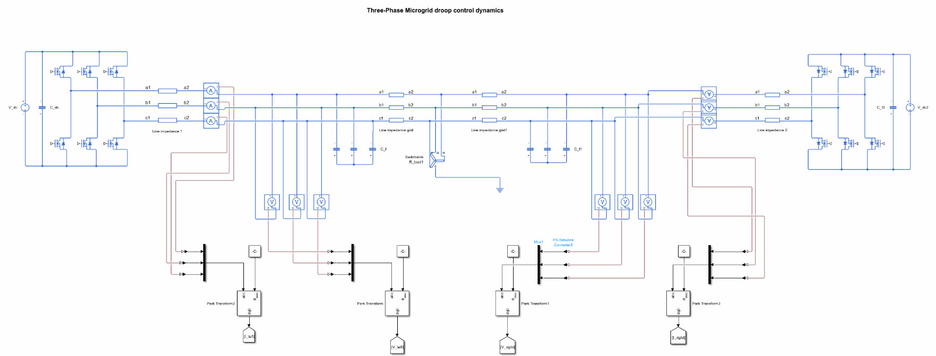
Attachments
Figure 4: Microgrid model

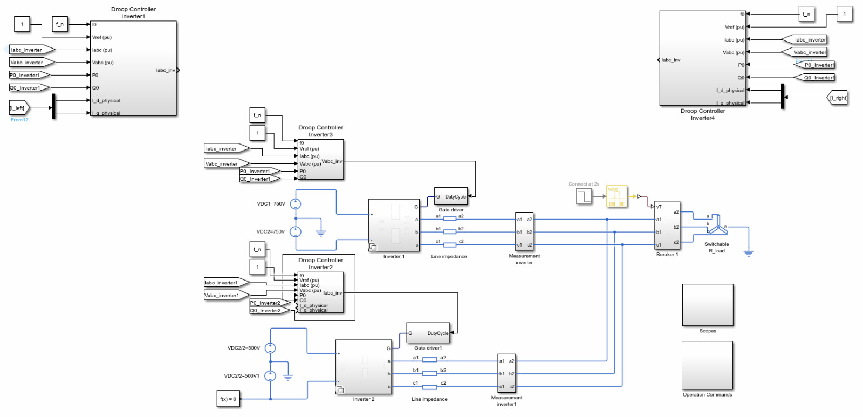
Figure 5: Voltage Sources control scheme

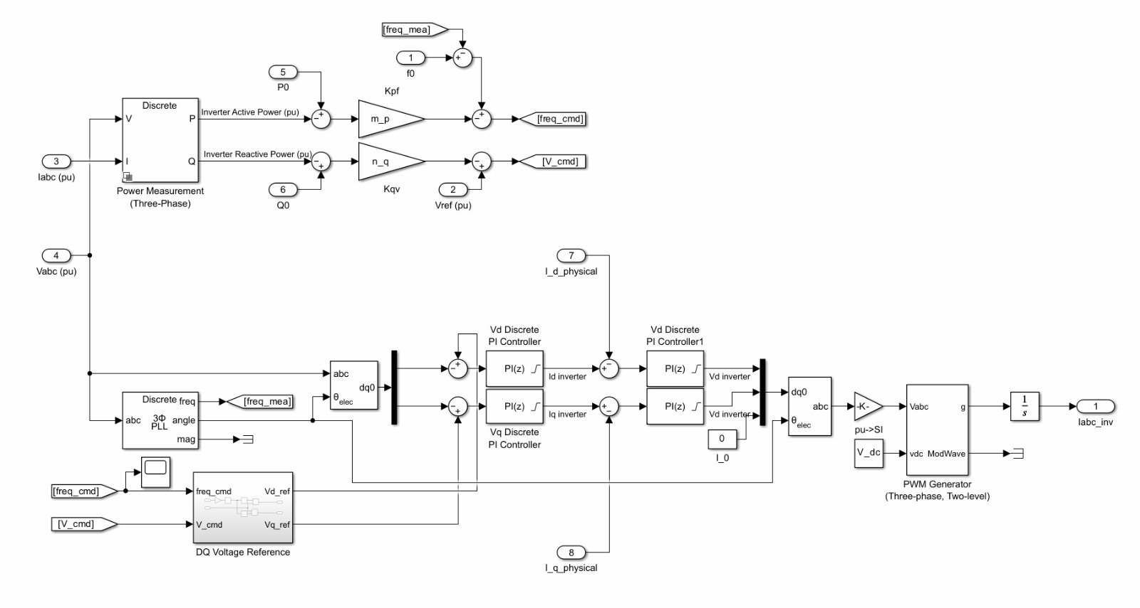
Figure 6: Droop control scheme

