AngularJS
- Conceptual Overview


- Data Binding
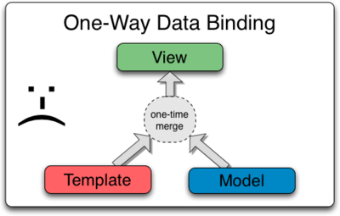
Classical

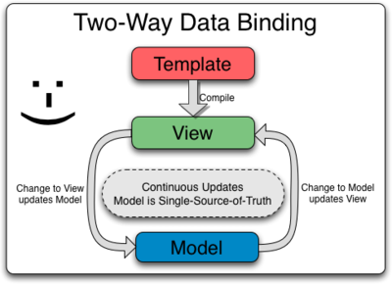
Angular

- Controllers
Use controllers to:
#1 Set up the initial state of the $scope object.
#2 Add behavior to the $scope object.

Do not use controllers to:
#1 Manipulate DOM — Controllers should contain only business logic. Putting any presentation logic into Controllers significantly affects its testability. Angular has databinding for most cases and directives to encapsulate manual DOM manipulation.
#2 Format input — Use angular form controls instead.
#3 Filter output — Use angular filters instead.
#4 Share code or state across controllers — Use angular services instead.
#5 Manage the life-cycle of other components (for example, to create service instances).

