Where is Waldo?
Assignment 2

Erik Zorn-Wallentin
0864583
CIS*4720 - Image Processing

Introduction
Assignment 2 for CIS*4720 gave us several tasks to that we could choose and complete using intermediary image processing techniques. The task I chose was “Where is Waldo?” and Waldo is based on a book series by Martin Handford. Waldo is recognized by the red and white pattern sweater, black hair, glasses, smiling face, and skinny looking, and usually carrying a book or using a cane. [10]
The task for “Where is Waldo?” is to write an algorithm that would successfully find Waldo in any of the unique Waldo images. Each of the Waldo images are varying in size with different degrees of “difficulty” on finding Waldo. There are usually “dopplelgangers” in every image that look similar to Waldo and make finding Waldo harder.

Waldo
Waldo has a few key characteristics that stay roughly the same throughout every image [10].

Figure 1: Waldo [10]

Red and white sweater/hat
Waldo’s first major identifying characteristic is his red and white outfit. It covers his entire body, and is the easiest way to find Waldo is by looking for this red and white stripped outfit. With this key identifier, the first algorithm should be created to filter out all of red and white colours in an image to help find Waldo. (Figure 1)

Facial Recognition
Waldo has a unique face, but the face shape changes in different images, the colour tone of the face changes and the size of the image making it difficult with smaller images also make it harder to perform facial recognition. The hair colour is difficult to analyze because it is black and that’s a good filtering colour, and the black colour would also be any lines in the image which doesn’t help as much in the end to find Waldo. Decided that the best and consistent way to perform some type of facial recognition is based off the colour tone in the face and try to filter out all colours of the image that don’t have the facial tone colour range.

Held Items
Waldo usually holds an item, which may be a book or a cane. This could be used as a way to assist with finding Waldo by looking for a person using these type of items. Since it changes and is not consistent it is not the best identifier to look for when looking for Waldo.

Algorithms
Since Waldo has a few consistent unique identifiers that help assist in finding him, there are algorithms that could be created to also find Waldo by taking advantage of the unique identifiers.
Figure 2 is an example of a normal image where you are tasked to find Waldo. The algorithms I use will show examples of how they performed on this image.
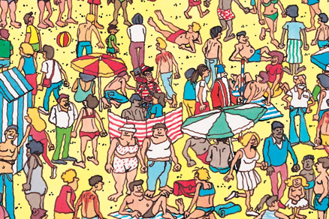
Figure 2: Finding Waldo “1.jpg” [6]

Red and white colour filtering
The first algorithm used was taking advantage of Waldo’s red and white stripped outfit. After using 8 different testing images, the red and white colour range was created based on analyzing the red and white colours of those images.

Use an image where you need to find Waldo

Filter out all Red colours using the RGB range of:
Lower bound RGB: 50, 0, 0
Upper bound RGB: 255, 100, 100

Filter out all White colours using the RGB range of:
Lower bound RGB: 170, 180, 160
Upper bound RGB: 255, 255, 2

Using each of the filtered colours as their own mask. Combine them both and entire output image will only contain these colours.

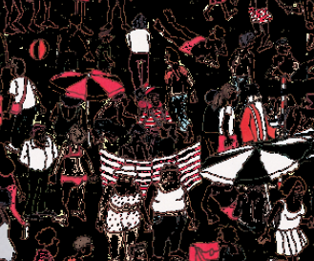
Figure 3: Red and White Filtering “1.jpg”

An analysis of the red and white filter and the other filters will be performed later in this report.

Face tone filtering
The second algorithm used was an attempt at some type of facial recognition. This algorithm was based on filtering out the colour range of familiar facial tones that Waldo has. After using 8 different testing images, the facial tone colour range was created based on analyzing the facial tone colour range of Waldo in those images.

Use an image where you need to find Waldo

Filter out all facial tone colours using the RGB range of:
Lower bound RGB: 160, 125, 60
Upper bound RGB: 255, 240, 240

Using filtered colour range, remove all other colours and only display the filtered colour range.

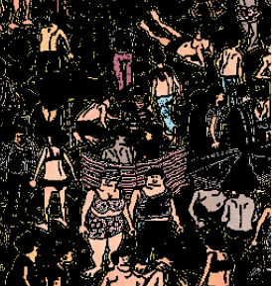
Figure 4: Facial tone filtering “1.jpg”

Template matching
The last algorithm used was taking advantage of knowing the testing image before finding Waldo, so using some form of “Waldo Template” which is only Waldo and it will search pixel by pixel in the normal image to match the “Waldo Template” [9]. See the “Template” images in the project folder for reference.

Use an image where you need to find Waldo

Use the corresponding template image.

Using template image as a mask to find exact match of Waldo.

Create a border around Waldo to show where he is in the image.

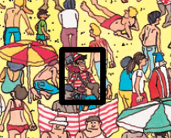
Figure 5: Template Matching “1.jpg”

EXPERIMENTS
I performed an analysis of each of the 3 filter styles used above and tested them against 8 different testing images of finding Waldo. Here I will decide if the experiment was a success or failure depending on the results and comparing the results of each filter against all 8 of the testing images.

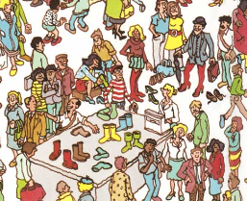
Figure 6: Finding Waldo Again “4.jpg” [2]
When discussing each filters and their successes I will reference them to this image, but tests were performed on all of the 8 images.

Red and white colour filtering
Overall the red and white colour filtering took some testing to get the correct colour range in the red and white colours without picking up anything else. The overall result was a success in helpful in finding Waldo, and should always be used to help you in finding Waldo.
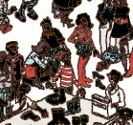
Figure 7: Red and White Filter “4.jpg”
There was some major problems with the red and white colour filter where it would pick up the background a lot as the background is usually close to white and could pick up a lot of the lighter red colours in peoples clothing. As said above I do still believe it is a success in the end with the red and white colour filtering to find Waldo.

Facial tone filtering

At the beginning I thought this would be a good idea to filter out the colour tones and easily find Waldo based on his colour tone and shape of the head from the colour tone outline, but in the end this was pretty big failure. The filtering worked well with only a few cases as shown below, but most the time it would not be able to pick up Waldo properly, or it would pick up the entire image as most colours are very bright so the filtering could not be done properly.
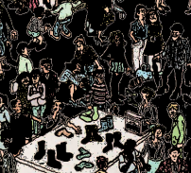
Figure 8: Facial Tone Filter “4.jpg”
Figure 8 image shows a minimal success in finding Waldo, the viewer can eventually find them but it would not really help to use this algorithm. Below is another test where this algorithm was mostly a failure.
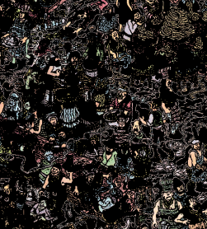
Figure 8: Facial Tone Filter “7.jpg”
Figure 7 image shows this algorithm failing where it actually makes it harder to find Waldo. I literally could not find him without looking at the original image to assist me.

Template Matching
Template matching at the beginning surprised me, I was skeptical where I thought it may take a long time to process or maybe would fail in some cases but it was a 100% success in finding Waldo perfectly in all the 8 testing images and showing a nice result to the user.
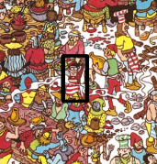
Figure 9: Template Matching “7.jpg”
Figure 9 image shows Waldo would be a challenge to find in this image but the algorithm clearly shows where Waldo is to the user making this the best algorithm out of the 3.
There is one clear disadvantage to this algorithm, where if you don’t have the “Template” image beforehand of Waldo this algorithm will 100% fail every time, and in this case would make the algorithm the worst out of all of them. See the “Template” images in the project folder for reference.

Conclusion
After performing the analysis with 3 different algorithms on 8 testing images, I can clearly see now which algorithms performed better than the rest. If you have the template image of Waldo beforehand the template matching algorithm would be the best choice, but otherwise always use the red and white colour filter to find Waldo.
If more time was provided, I would continue to add more unique algorithms where I would test the overall shape of Waldo’s head as the next algorithm, or maybe look for canes/book items in the scene as another possible algorithm. There are many more algorithms that could be used to find Waldo.
In the end I am happy with my results, this was a great learning experience and I am impressed with the results of my algorithms. The testing results were provided in the project directory under “Testing Results” folder. Also see “a2.py” to perform more of an analysis on each of the images.

Acknowledgment
Python libraries: Numpy, OpenCV, Imutils making the task of finding Waldo easier.
OpenCV official documentation greatly assisting a few code samples. [9]

References
- (n.d.). Retrieved from https://s-media-cache-ak0.pinimg.com/originals/2e/36/57/2e365762708e4d28916fc75fcab949c3.jpg
- (n.d.). Retrieved from http://i.imgur.com/OTfytjA.jpg
- (n.d.). Retrieved from http://i.imgur.com/e8gNYDI.jpg
- (n.d.). Retrieved from http://imgur.com/gallery/NI3w8
- (n.d.). Retrieved from http://i.imgur.com/x8jZ7PQ.jpg
- (n.d.). Retrieved from https://static.independent.co.uk/s3fs-public/thumbnails/image/2011/11/12/19/48-Where's-Wally-WALKER-BOOKS.jpg
- (n.d.). Retrieved from cadersil.com.br/site/wp-content/uploads/2015/11/wally8.jpg
- (n.d.). Retrieved from https://images-na.ssl-images-amazon.com/images/I/B1jskVy%2BwvS.jpg
- OpenCV: Template Matching http://docs.opencv.org/3.2.0/d4/dc6/tutorial_py_template_matching.html
- (n.d.). Retrieved from https://courselink.uoguelph.ca/d2l/home/454932

