TBMI26 – Computer Assignment Reports  
Boosting

Deadline – February 26 2018

Author/-s:

Erika Anderskär (erian605)

Eric Herwin (erihe068)

In order to pass the assignment you will need to answer the following questions and upload the document to LISAM. If you meet the deadline we correct the report within one week after the deadline. Otherwise we give no guarantees when we have time.

1. **Plot how the classification accuracy on training data and test data depend on the number of weak classifier (in the same plot). Be sure to include the number of training data (non-faces + faces) and the number of Haar-Features.**

We used 2000 training samples and 100 Haar-features.

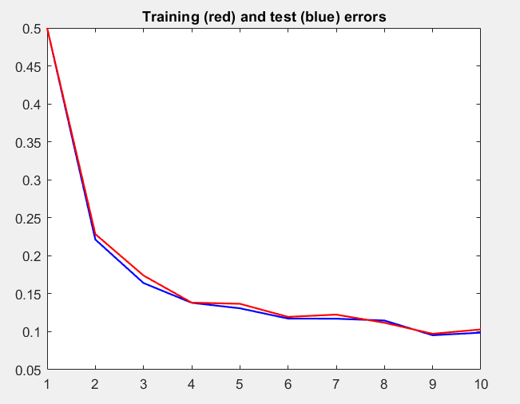

The test error is lower than the training error.

1. **How many weak classifiers did you chose before testing the data?**

When we implemented the algorithm, we used 10 weak classifiers. When we tested on the test data we saw that we needed fewer weak classifiers.

1. **How many weak classifiers did you use for final strong classifier? Why?**

We used 5 weak classifiers in the end. It turned out that after a while the weights converge and does not update after each run. This means that it is unnecessary to try more classifiers than then.

1. **What is the accuracy on the test data after applying the optimized strong classifier?**

The test accuracy is 0.9012

1. **Plot some of the misclassified faces and non-faces that seem <hard to classify correctly.**

The classifier classified all faces correctly in the test data, but some of the non-faces got classified as faces:

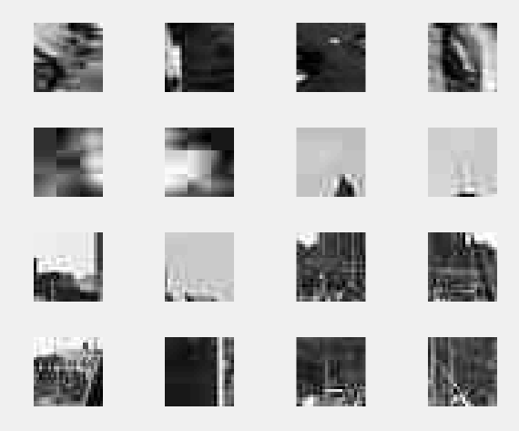

1. **Defend your results. Are they reasonable?**

We got a good test accuracy, which is due to the number of weak classifiers. The weak classifiers keep getting more optimized to classify the training data, since they use earlier classifiers weights. From the result of the test accuracy, we can conclude that this is a good classifier.

1. **Can we expect perfect results?**

Maybe for the training data, but then the model wouldn’t be generalizable.