***PROGRAM 1***

Create a program that will open the  file numbers.txt and check each line if the sum of the given string digit numbers is palindrome

If the given numbers are 10,20,30,17 then you have to add the numbers (77) then the number is said to be sum palindrome.

Example Output:  
Line 1: 10,20,30,17 (sum 77) - Palindrome  
Line 2: 1,2,3,4,5   (sum 15) - Not a palindrome

***Source Code: Output:***

***PROGRAM 2***

Create a program that will translate a given date format in mm/dd/yyyy to more human readable format like January 1, 2023

Example Output:  
Enter the date (mm/dd/yyyy): 02/02/2023  
Date Output: February 2, 2023

***Source Code:***

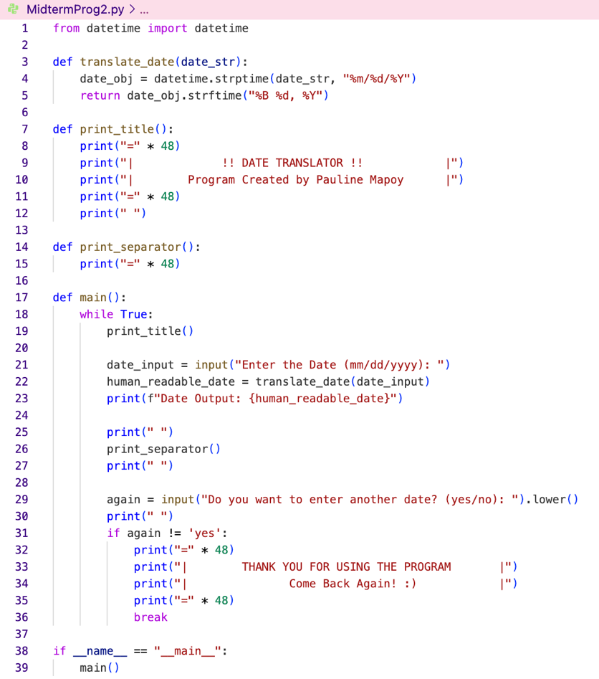

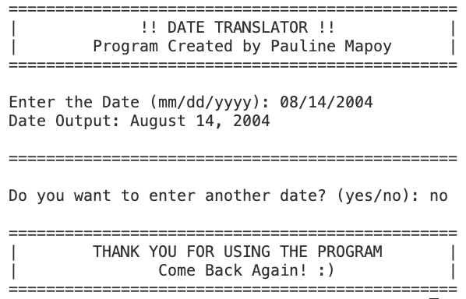***Output:***

