Erika Vanderhoff

5/3/2022

Assignment 10.3

# Create database whatabook



# Create user for whatabook and grand all privileges associated with whatabook

CREATE TABLE wishlist(wishlist_id INT NOT NULL AUTO_INCREMENT, PRIMARY KEY(wishlist_id), user_id INT NOT NULL, CONSTRAINT fk_user FOREIGN KEY(user_id) REFERENCES user(user_id), book_id INT NOT NULL, CONSTRAINT fk_book FOREIGN KEY(book_id) REFERENCES book(book_id));

# Creating tables user, book, wishlist, and store

## Confirming table creation

# Inserting a store into table store

I don’t include store hours yet because the assignment said, “create appropriate tables to match the ORD you defined in Module 10.2 Assignment”

# Inserting nine books into table book

## 1.

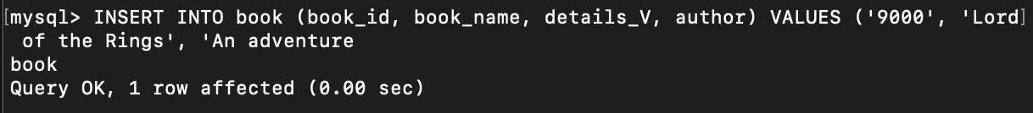

## 2.

## 3.

## 4.

## 5.

## 6.

## 7-8.

## 9.

## Results:

## Results:

# Inserting one wishlist book into each user’s wishlist

