Erika Vanderhoff

csd 310

Assignment 8.2

4/14/2022

# For this assignment, I demonstrated that I completed all the steps within the checklist. In other words I only redid the code within db_init.sql in the terminal if it was explicitly asked for within the checklist.

# Connecting VS Code to MySQL:

## Altering root user so that my password is accepted with visual studio code:

I was getting a connection error so I had to make sure I had the correct password associated with the root user.

## Screenshot demonstrating successful connection to MySQL:

# MySQL: Python Driver (pip):

## Installing mysql-connector-python:

# MySQL: Python Connector Test:

## Output from vsc of created file. File itself can be viewed on GitHub:

MySQL: CLI Scripts:

## Displaying tables created after running CLI script:

# For steps MySQL: Create User – MySQL: Drop Table, I completed them first in my terminal, deleted the tables I created in the terminal “team” and “player”, and then ran the CLI script above which redoes these steps to ensure that I would not be duplicating code.

# MySQL: Grant User Privileges:

# MySQL: Drop User:

## Deleting user “pysports_user” if it exists:

# MySQL: Create Table:

## Creating tables “player” and “team”, adding “team_id” foreign key to “player” table:

# MySQL: Foreign Key Constraints:

# MySQL: Drop Table:

## Deleting table “player” if it exists:

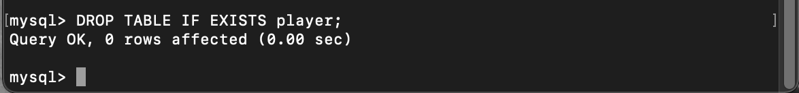

# MySQL: Select Statements:

