Capstone Project Paper — Remindly Collaborative Reminder Management System
Author: Erik Badalyan (​​erik_badalyan@edu.aua.am)
Supervisor: Arman Asryan (arman.asryan@aua.am)
This capstone project presents the design and implementation of Remindly, a collaborative reminder management web application developed using modern backend and frontend technologies. The project was not intended to introduce revolutionary algorithms or novel scientific contributions. Instead, its primary objective was educational and engineering-oriented: to understand how modern production-ready web systems are architected, implemented, secured, deployed, and maintained using contemporary software engineering practices.
The project focuses on the complete lifecycle of a modern distributed web application, including backend architecture, frontend development, database modeling, asynchronous task processing, authentication and authorization mechanisms, notification systems, deployment infrastructure, containerization, and maintainable code organization.
The backend was implemented using Python and FastAPI, following Clean Architecture principles and layered system design. PostgreSQL was used as the relational database, while Redis and Celery were integrated for asynchronous task execution and scheduled notifications. The frontend was developed using React and TypeScript. Docker Compose was used to orchestrate all services locally in a production-like environment.
During the development of the project, significant attention was dedicated to system modularity, scalability, maintainability, separation of concerns, asynchronous programming, role-based access control, collaborative workflows, and deployment readiness. The implementation process provided practical experience in designing robust backend systems similar to those used in modern enterprise applications.
The project demonstrates how modern software systems combine multiple technologies and architectural patterns into a cohesive platform capable of handling real-world collaborative interactions.

1. Introduction
Modern web applications are significantly more complex than traditional monolithic systems developed in earlier generations of software engineering. Contemporary systems often integrate asynchronous processing, distributed services, background workers, authentication layers, frontend frameworks, relational databases, task queues, notification systems, and deployment orchestration.
The purpose of this capstone project was not to invent a completely new software solution, but rather to gain practical experience in building a realistic production-style web application using technologies currently used in industry.
The project developed during this capstone is called Remindly — a collaborative reminder management system. The application allows users to:
- create personal reminders,
- manage collaborative reminder groups,
- assign reminders to other users,
- maintain friendships,
- receive scheduled notifications,
- acknowledge reminders directly from email,
- track reminder statuses collaboratively.
The application combines concepts commonly seen in modern productivity systems such as collaborative task managers and project management tools.
The educational value of the project lies primarily in understanding:
- how backend systems are architected,
- how REST APIs are structured,
- how frontend and backend communicate,
- how asynchronous tasks are processed,
- how authentication and authorization are implemented,
- how databases are modeled,
- how distributed components interact,
- how applications are containerized and deployed.
The project, therefore, serves as a practical implementation of modern software engineering concepts rather than a purely theoretical study.

2. Project Goals and Objectives
The main objective of the project was to design and implement a realistic full-stack application using modern backend technologies and deployment practices.
The project aimed to achieve the following goals:
- Learn how modern backend systems are architected.
- Understand layered application design and Clean Architecture.
- Implement asynchronous REST APIs using FastAPI.
- Design relational database schemas using PostgreSQL.
- Implement JWT-based authentication and authorization.
- Integrate asynchronous background workers using Celery and Redis.
- Learn how scheduled tasks and notifications work.
- Implement collaborative features with role-based permissions.
- Create a modern frontend using React and TypeScript.
- Understand containerized deployment using Docker Compose.
- Build a system that resembles real production applications.
The project also aimed to improve the understanding of maintainability, modularity, scalability, and separation of concerns in software systems.

3. System Overview
Remindly is a collaborative reminder management platform where users can create personal reminders or collaborative reminders inside groups.
The system supports:
- user authentication,
- friend relationships,
- collaborative groups,
- reminder assignments,
- scheduled notifications,
- email callbacks,
- reminder acknowledgment workflows.
The application architecture consists of multiple independent services working together:
- FastAPI backend,
- PostgreSQL database,
- Redis message broker,
- Celery worker,
- Celery Beat scheduler,
- React frontend.
These services are orchestrated using Docker Compose.
The project was intentionally designed to resemble modern production-ready systems.

4. Technology Stack

4.1 Backend Technologies
The backend of the system was implemented using Python and FastAPI.

FastAPI
FastAPI is a modern asynchronous web framework built on ASGI standards. It provides:
- asynchronous request handling,
- automatic OpenAPI documentation,
- dependency injection,
- high performance,
- integration with Pydantic validation.
FastAPI was selected because it reflects modern Python backend development practices.

SQLAlchemy 2.0
SQLAlchemy was used as the ORM layer for interacting with PostgreSQL. The async implementation allowed the application to use asynchronous database sessions efficiently.

PostgreSQL
PostgreSQL served as the primary relational database due to:
- reliability,
- transactional guarantees,
- strong relational modeling,
- enterprise-level capabilities.

Celery and Redis
Celery was integrated as a distributed task queue system.
Redis acted as:
- Celery broker,
- task queue,
- temporary asynchronous communication layer.
These technologies enabled:
- scheduled notifications,
- asynchronous email sending,
- delayed reminder processing.

JWT Authentication
JWT tokens were used for stateless authentication.
The system implemented:
- access tokens,
- refresh tokens.

4.2 Frontend Technologies
The frontend was implemented using React and TypeScript.

React
React was chosen because it is one of the most widely used frontend frameworks for modern web applications.

TypeScript
TypeScript improved:
- type safety,
- maintainability,
- developer experience.

Tailwind CSS
Tailwind CSS simplified responsive UI development using utility-first styling.

4.3 Infrastructure Technologies

Docker and Docker Compose
Docker enables isolated service containers.
Docker Compose orchestrated:
- backend,
- database,
- Redis,
- Celery workers,
- frontend.
This deployment structure closely resembles real development environments used in industry.

5. System Architecture
The backend follows a four-layer Clean Architecture design.
The layers are:
- Presentation Layer
- Application Layer
- Domain Layer
- Infrastructure Layer
The request flow is:
Client Request
↓
FastAPI Router
↓
Pydantic Schema Validation
↓
Service Layer
↓
Repository Layer
↓
SQLAlchemy Models
↓
PostgreSQL

This architecture was selected to ensure:
- separation of concerns,
- maintainability,
- scalability,
- testability.
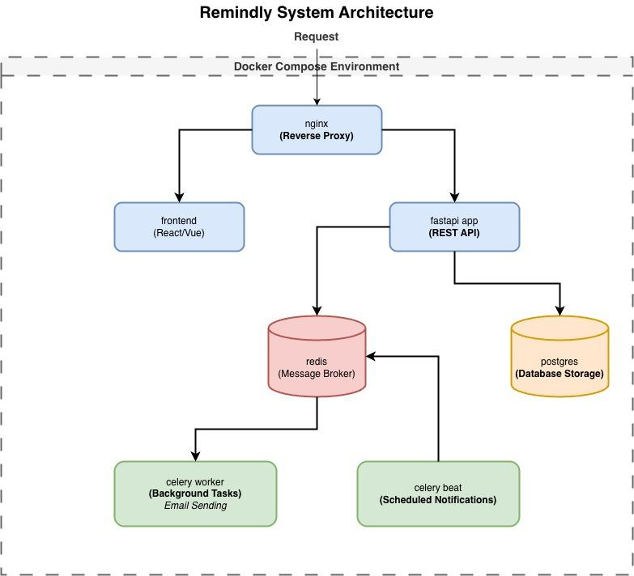

6. Backend Layer Design

6.1 Presentation Layer
The presentation layer consists of FastAPI routers.
Responsibilities:
- receiving HTTP requests,
- validating request schemas,
- authentication,
- returning responses.
Each router represents a domain area:
- users,
- reminders,
- groups,
- friendships,
- reminder assignments.

6.2 Service Layer
The service layer contains business logic.
Responsibilities:
- reminder assignment rules,
- role validation,
- collaborative workflows,
- notification triggering,
- reminder lifecycle management.
The service layer does not directly interact with HTTP requests.
This separation significantly improved maintainability.

6.3 Repository Layer
The repository layer abstracts database access.
Responsibilities:
- SQLAlchemy queries,
- inserts,
- updates,
- deletes.
Using repositories prevented business logic from being tightly coupled to database implementation.

6.4 Domain Layer
The domain layer contains entities and enums representing business concepts.
Examples:
- UserEntity,
- ReminderEntity,
- GroupEntity,
- FriendshipEntity.
This layer represents pure business structures independent of infrastructure.

7. Database Design
The system uses PostgreSQL as the primary relational database.
The schema was designed around collaborative relationships.
Key tables include:
- users,
- reminders,
- reminder_assignees,
- groups,
- group_members,
- friendships,
- notification_recipients.
The database design supports:
- many-to-many relationships,
- collaborative assignment tracking,
- role-based access control,
- asynchronous notification workflows.

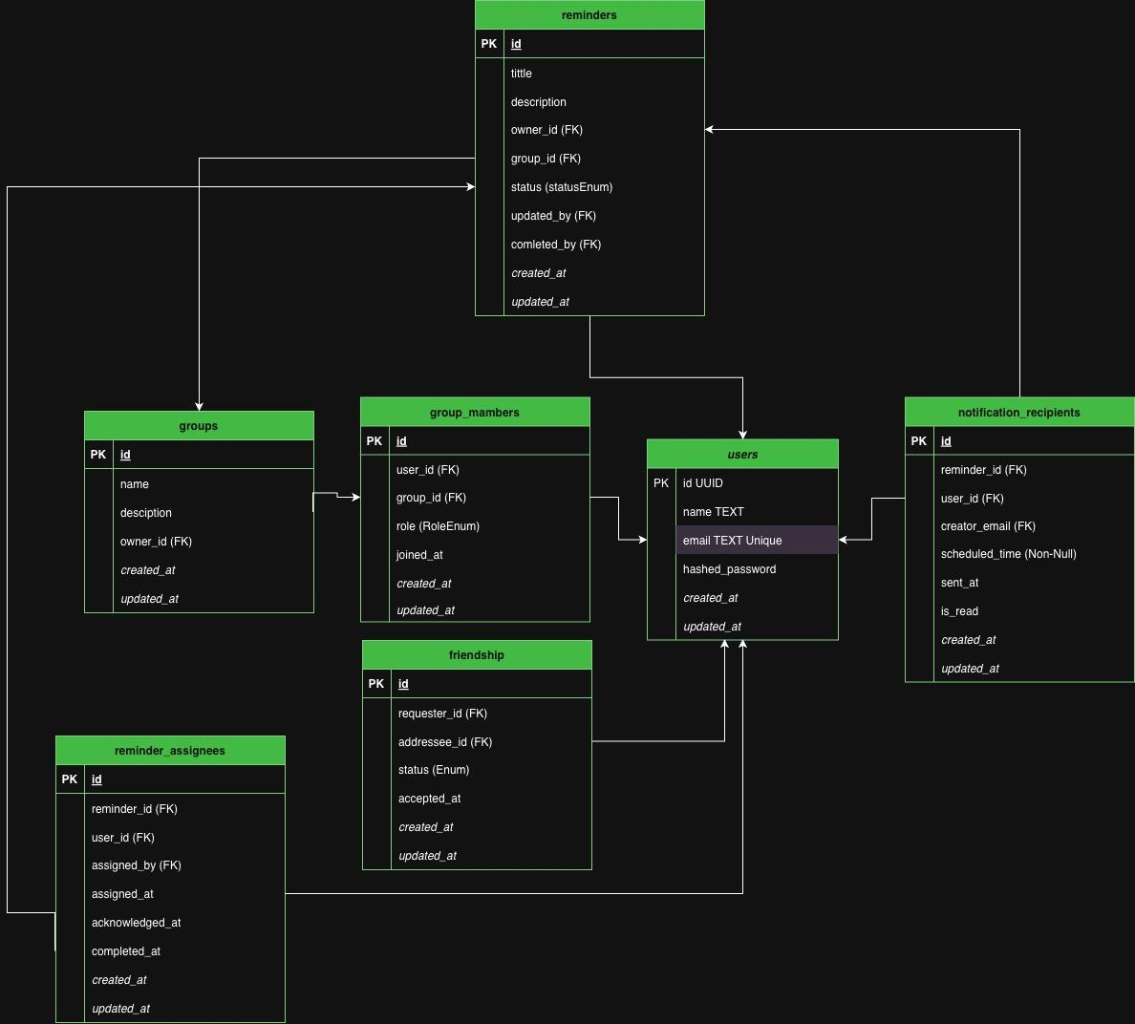

8. Authentication and Security
Authentication was implemented using JWT Bearer tokens.
The system uses:
- access tokens,
- refresh tokens,
- signed callback tokens.
Passwords are hashed using bcrypt.
The project also implemented:
- role-based authorization,
- group membership validation,
- protected endpoints.
This provided a practical understanding of modern web security practices.

9. Notification System
One of the most technically interesting parts of the project was the asynchronous notification system.
The notification system works as follows:
- The user creates a reminder.
- Reminder generates notification entities.
- Celery schedules notification processing.
- Redis stores queued tasks.
- Celery worker queries the notification_recipients table for new notifications.
- At the scheduled time, Celery will send the notification.
- Email is sent asynchronously.
The system supports:
- immediate notifications,
- scheduled notifications,
- acknowledgment callbacks,
- reminder completion tracking.
The callback functionality allowed users to acknowledge reminders directly from email links.

10. Frontend Architecture
The frontend was implemented using component-based architecture.
The structure includes:
- API clients,
- reusable components,
- routing,
- state management,
- page-level components.
Protected routes ensure authenticated-only access.
The frontend communicates with the backend using REST APIs and JWT tokens.

11. DevOps and Deployment
The application was designed to be deployment-ready.
Docker Compose orchestrates all services:
- backend,
- frontend,
- PostgreSQL,
- Redis,
- Celery Worker,
- Celery Beat.
This structure simulates modern cloud-native deployments.
The project provided practical understanding of:
- service orchestration,
- environment configuration,
- dependency management,
- container networking,
- deployment pipelines.

12. Design Patterns Used
Several software engineering patterns were implemented.

Repository Pattern
Used to isolate database access logic.

Factory Pattern
Used for repository creation and service initialization.

Dependency Injection
Implemented using FastAPI Depends().

Clean Architecture
The entire backend follows layered Clean Architecture principles.
These patterns improved modularity and maintainability.

13. Challenges Faced During Development
Several engineering challenges were encountered:
- designing collaborative reminder workflows,
- handling asynchronous scheduling,
- implementing secure callback links,
- role-based authorization,
- database relationship modeling,
- frontend/backend synchronization,
- notification timing logic.
Solving these challenges significantly improved the understanding of production-level software engineering.

14. Knowledge and Skills Gained
This project provided extensive practical experience.
The main learning outcomes include:

Backend Architecture
Understanding how modern backend systems are structured.

Asynchronous Programming
Learning async request handling, background workers, and task queues.

Database Design
Designing normalized relational schemas with SQLAlchemy and PostgreSQL.

Authentication and Authorization
Implementing JWT authentication and RBAC systems.

Containerization
Deploying multi-service systems using Docker Compose.

Frontend Integration
Connecting React frontend with FastAPI backend.

Deployment-Oriented Thinking
Designing software not only to work locally but also to be deployment-ready.
The project significantly improved the understanding of enterprise backend development.

15. Limitations and Future Research
Although the Remindly project successfully achieved its primary educational and engineering objectives, the implemented system still contains several limitations and areas for future improvement. Since the main goal of the project was to learn modern backend architecture, distributed systems design, and deployment practices, certain advanced production-level features were intentionally simplified or postponed.

15.1 Current Limitations

Limited Production Scalability
The current deployment model primarily targets small-scale usage and demonstration environments. Although the system architecture was designed with scalability principles in mind, the implemented deployment uses a single Amazon EC2 instance with Docker Compose orchestration.
This approach simplifies deployment and maintenance but introduces several limitations:
- single point of failure,
- limited horizontal scalability,
- reduced fault tolerance,
- infrastructure dependency on one virtual machine.
For large-scale production environments, more advanced orchestration systems such as:
- Amazon ECS,
- Kubernetes,
- managed container services
would be more appropriate (discussed in the next section).

Lack of Email Verification Functionality
The current implementation allows users to register using any email address without verifying ownership of that email account. While this approach simplified development and accelerated the implementation process, it introduces several practical and security-related limitations.
Without email verification:
- users may register using invalid or non-existent email addresses,
- notification delivery reliability cannot be guaranteed,
- malicious or fake accounts may be created more easily,
- password recovery workflows become less secure,
- collaborative invitation systems may be abused.

Basic Notification Infrastructure
The notification system currently supports email-based reminder delivery using SMTP. While functional, this implementation has several limitations:
- dependency on external SMTP providers,
- limited delivery guarantees,
- no real-time push notification support,
- no mobile notification integration.
Additionally, the current system does not yet support:
- native iOS push notifications,
- Android push notifications,
- WebSocket real-time notification delivery.

Lack of Mobile Application
The current implementation is web-based only. Although the frontend is responsive and accessible through mobile browsers, there is no dedicated native mobile application.
A native mobile application could significantly improve:
- user experience,
- offline support,
- push notification integration,
- device-level background processing.
Future work may involve development using:
- Swift for iOS,
- Kotlin for Android,
- or cross-platform frameworks such as React Native or Flutter.

Simplified Security Model
The authentication and authorization system uses JWT-based security and role-based access control, which is sufficient for educational and small-scale production environments. However, several advanced security features are currently absent:
- multi-factor authentication (MFA),
- OAuth social login integration,
- account recovery workflows,
- rate limiting,
- advanced intrusion monitoring,
- audit logging,
- session revocation management.
Additionally, the current email callback token mechanism, while secure for the project scope, could be further enhanced with more advanced replay protection and token invalidation systems.

Limited Real-Time Collaboration
The system currently relies primarily on HTTP request-response interactions and asynchronous email notifications. Collaborative functionality is therefore not fully real-time.
Modern collaborative systems often use:
- WebSockets,
- Server-Sent Events (SSE),
- event-driven architectures,
- live synchronization protocols.
Currently, changes made by one user are not instantly reflected for other connected users without page refreshes or polling.

Simplified Search and Recommendation Features
The current search functionality uses relatively straightforward database queries. More advanced systems could implement:
- full-text search engines,
- recommendation systems,
- prioritization algorithms,
- AI-assisted scheduling,
- intelligent reminder grouping.
Such functionality was outside the scope of the current educational objectives.

Limited Testing Coverage
While the project follows clean architectural principles and maintainable design patterns, automated testing coverage remains limited.
A fully production-ready implementation would require:
- unit testing,
- integration testing,
- end-to-end testing,
- load testing,
- security testing,
- CI/CD pipeline automation.
Testing infrastructure could be significantly expanded in future iterations.

15.2 Future Research and Development Directions
Despite its limitations, the project establishes a strong foundation for future development. Several potential directions for future research and system expansion were identified during implementation.

Cloud-Native Infrastructure Migration
One of the most important future improvements would involve migration from the simplified EC2 deployment model toward fully managed cloud-native infrastructure.
A future production architecture could include:
- Route 53 for DNS,
- CloudFront CDN,
- S3 static frontend hosting,
- Application Load Balancer,
- ECS or Kubernetes orchestration,
- RDS PostgreSQL,
- ElastiCache Redis.
Such migration would improve:
- scalability,
- reliability,
- fault tolerance,
- deployment automation.
This would also provide valuable research opportunities in distributed systems engineering and cloud-native application deployment (discussed in the upcoming section).

Native Mobile Application Integration
Future work could involve development of native mobile applications with integrated push notification systems.
This would include:
- Apple Push Notification Service (APNs),
- Firebase Cloud Messaging (FCM),
- background synchronization,
- offline reminder caching.
Such functionality would significantly improve the practical usability of the platform.

Real-Time Communication Layer
An important future improvement would involve implementing real-time collaborative synchronization using:
- WebSockets,
- Redis Pub/Sub,
- event streaming systems.
This would allow:
- instant reminder updates,
- live collaboration,
- real-time status changes,
- online presence indicators.
This area could also become an interesting research topic in distributed asynchronous communication systems.

Advanced Notification System
The notification infrastructure could be expanded to support:
- Telegram integration,
- SMS delivery,
- mobile push notifications,
- in-app notifications,
- notification prioritization,
- reminder escalation policies.
Future versions could also implement user-configurable notification preferences and intelligent scheduling optimization.

Artificial Intelligence Integration
A future research direction could involve integrating AI-assisted reminder management.
Potential features include:
- intelligent reminder prioritization,
- automatic scheduling suggestions,
- natural language reminder creation,
- deadline prediction,
- behavioral productivity analytics.
This could transform the system from a simple reminder manager into a more intelligent productivity platform.

Advanced Analytics and Monitoring
Future implementations could integrate:
- Prometheus,
- Grafana,
- centralized logging systems,
- distributed tracing,
- performance analytics.
This would improve observability and operational monitoring of the platform.

Multi-Tenant SaaS Architecture
Currently, the system operates as a single application environment. Future development could investigate a multi-tenant SaaS architecture where multiple organizations could use isolated collaborative workspaces.
This would require:
- tenant isolation,
- billing systems,
- subscription management,
- advanced permission systems.

15.3 Final Reflection on Future Improvements
These limitations are common in educational and initial production systems. But they are also great learning experiences that may serve as starting points for future development by engineers.
The most important thing is that the project provided an excellent architectural foundation that could be easily expanded without significant reengineering. The modularity and separation of concerns used during the development make further integration possible.
The project taught us that developing scalable systems is not only about writing efficient code, but also about:
- maintainability,
- extensibility,
- infrastructure planning,
- security,
- deployment strategies,
- distributed system communication.
As such, despite the fact that the current implementation is still relatively simple compared to other enterprise-scale applications, it manages to achieve its goal in an educational sense while providing a solid starting point for further development.

16. Production Deployment Architecture (Cloud-Native AWS Infrastructure, for production)
Although my project was primarily developed and tested locally using Docker Compose on a single machine, an important part of the capstone research involved understanding how modern applications are deployed in real production cloud environments. Since I have passed Introduction to Cloud in AUA and got the AWS Certified Cloud Practitioner certificate, I decided to use that knowledge to design the best-fitting architecture if it decided to deploy into the cloud.
The proposed production architecture follows the flow:
Route53
↓
CloudFront CDN
↓
S3 Static Frontend Hosting
↓
Application Load Balancer
↓
ECS Containers (FastAPI + Celery Services)
↓
RDS PostgreSQL
This design reflects modern cloud-native deployment practices and introduces concepts such as content delivery networks, container orchestration, managed databases, scalability, and high availability.

16.1 Route 53 — DNS Management
The first layer of the infrastructure is Amazon Route 53.
Route 53 is AWS’s managed DNS (Domain Name System) service. Its responsibility is to map a human-readable domain name (for example, remindly.com) to the cloud infrastructure hosting the application.
In the proposed architecture:
- Route 53 directs frontend traffic to CloudFront,
- API requests are routed toward the backend infrastructure.
This layer represents the public entry point of the application.
The use of managed DNS is important because it allows:
- domain registration,
- traffic routing,
- failover strategies,
- latency-based routing,
- scalable global accessibility.

16.2 CloudFront CDN
After DNS resolution, requests are handled by Amazon CloudFront, AWS’s global Content Delivery Network (CDN).
CloudFront is responsible for:
- caching frontend assets globally,
- reducing latency,
- improving performance,
- reducing direct load on backend services.
The frontend application (React + Vite build artifacts) would be hosted inside Amazon S3 as static files. CloudFront caches these files across edge locations worldwide.
This approach is considered industry standard for modern frontend deployment because:
- frontend files are static,
- CDN distribution is extremely efficient,
- scaling becomes nearly automatic,
- bandwidth costs are reduced.
CloudFront also provides:
- HTTPS support,
- SSL termination,
- DDoS mitigation through AWS Shield integration.

16.3 S3 Static Website Hosting
The frontend itself would be hosted in Amazon S3.
After the React application is built, the generated static assets:
- HTML,
- JavaScript bundles,
- CSS,
- images
would be uploaded to an S3 bucket.
S3 acts as:
- static file storage,
- frontend hosting layer.
The advantages of this architecture include:
- low operational complexity,
- low cost,
- virtually unlimited scalability,
- seamless integration with CloudFront.
This deployment model reflects how many modern frontend applications are hosted in production environments.

16.4 Application Load Balancer (ALB)
Backend API traffic would be routed through an AWS Application Load Balancer.
The ALB sits between external traffic and the backend container services.
Responsibilities include:
- distributing incoming traffic,
- health checking backend services,
- SSL termination,
- routing requests to ECS tasks,
- balancing load between multiple containers.
The load balancer becomes especially important when scaling horizontally.
Instead of directly exposing backend containers to the internet, the ALB provides:
- centralized traffic management,
- improved security,
- automatic failover,
- scalability.

16.5 ECS — Elastic Container Service
The backend application would run inside Amazon ECS (Elastic Container Service).
ECS is AWS’s managed container orchestration platform.
The FastAPI backend, Celery workers, and Celery Beat scheduler would all run as independent Docker containers managed by ECS.
Example ECS services:
- FastAPI API service,
- Celery worker service,
- Celery Beat scheduler service.
The benefits of ECS include:
- automatic container management,
- service scaling,
- health monitoring,
- rolling deployments,
- simplified infrastructure management.
Compared to the local Docker Compose setup, ECS represents a production-ready orchestration environment capable of handling significantly larger workloads.

16.6 RDS PostgreSQL
The database layer would be migrated from a local PostgreSQL container to Amazon RDS PostgreSQL.
RDS is AWS’s managed relational database service.
Using RDS provides:
- automated backups,
- high availability,
- monitoring,
- replication,
- managed updates,
- improved reliability.
In production systems, using managed databases is generally preferred over self-hosted database containers because it significantly reduces operational complexity and increases reliability.
The backend ECS services would communicate with RDS securely inside a private VPC network.

16.7 Redis and Celery in Production
Redis would also be deployed in a production-ready configuration, potentially using:
- ECS-hosted Redis,
- or Amazon ElastiCache Redis.
Celery workers would consume asynchronous tasks such as:
- scheduled notifications,
- email delivery,
- reminder processing.
This asynchronous architecture separates long-running tasks from HTTP request handling, improving:
- responsiveness,
- scalability,
- reliability.

16.8 Benefits of the Cloud-Native Architecture
Compared to the simpler single-EC2 deployment used during development, the AWS production architecture offers several important advantages.

Scalability
The system can scale horizontally by increasing ECS task count.

Reliability
Managed services such as RDS reduce operational failures.

Performance
CloudFront CDN improves frontend loading speed globally.

Security
The architecture separates:
- public services,
- backend services,
- databases
into isolated network layers.

Maintainability
Containerized deployments simplify updates and versioning.

Fault Tolerance
Load balancing and managed infrastructure improve uptime.

16.9 Educational Importance of the Deployment Design
Even though the complete AWS infrastructure was not fully deployed during the capstone implementation phase, designing this architecture was an important educational component of the project.
It provided practical understanding of:
- cloud-native infrastructure,
- scalable backend deployment,
- container orchestration,
- CDN systems,
- managed databases,
- production traffic routing,
- enterprise deployment strategies.
This architectural planning significantly expanded the scope of the project beyond simple application development and introduced real-world DevOps and cloud engineering concepts commonly used in modern software companies.
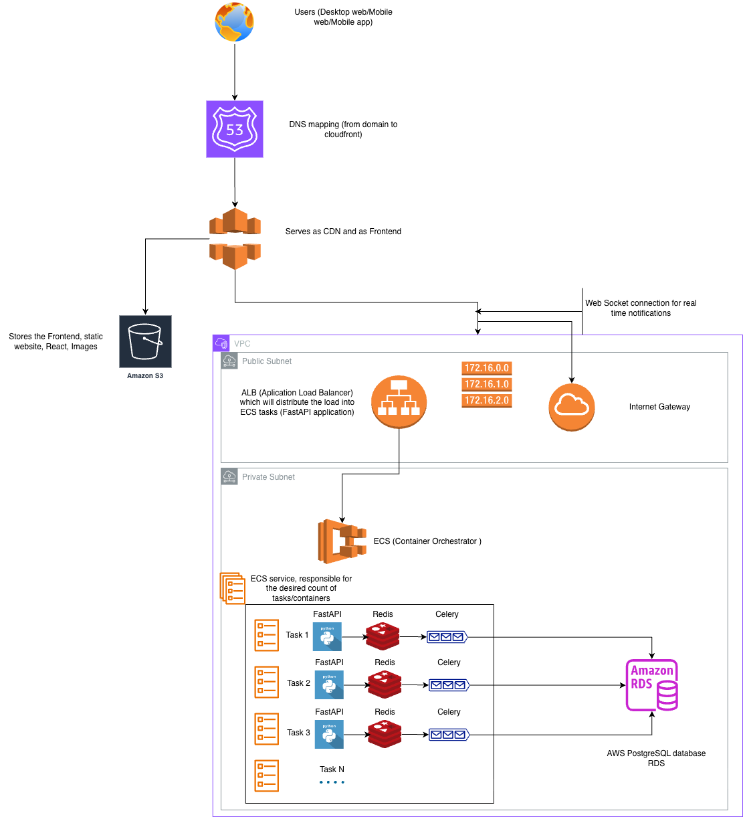

17. Conclusion
The Remindly project successfully achieved its educational and engineering objectives.
Although the project does not introduce fundamentally new scientific algorithms or revolutionary technologies, it serves as a comprehensive practical implementation of modern web application architecture and software engineering practices.
The project provided hands-on experience with:
- backend architecture,
- asynchronous systems,
- distributed task processing,
- frontend integration,
- relational database modeling,
- authentication systems,
- collaborative workflows,
- containerized deployment.
Most importantly, the project demonstrated how multiple independent technologies can be integrated into a cohesive, scalable, and maintainable system.
The experience gained from this capstone project established a strong practical foundation in modern backend development and deployment practices commonly used in the software industry today.

