Project Proposal

Team Name: M.E.N.D (Group 5)

Chosen Topic: Creating a visualization of potholes in the San Diego area base on data we collect with our phones.

Link to Data: We are collecting our primary data using our smart phones and an application called Gauges.

Screenshots:

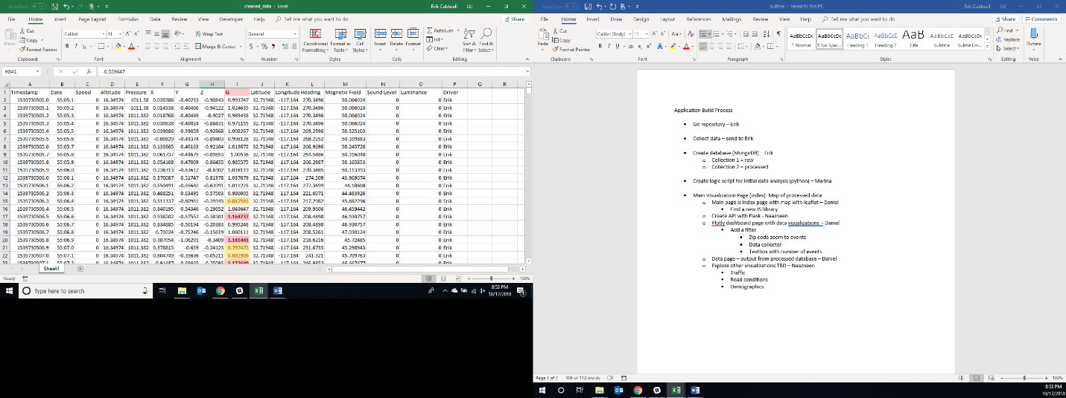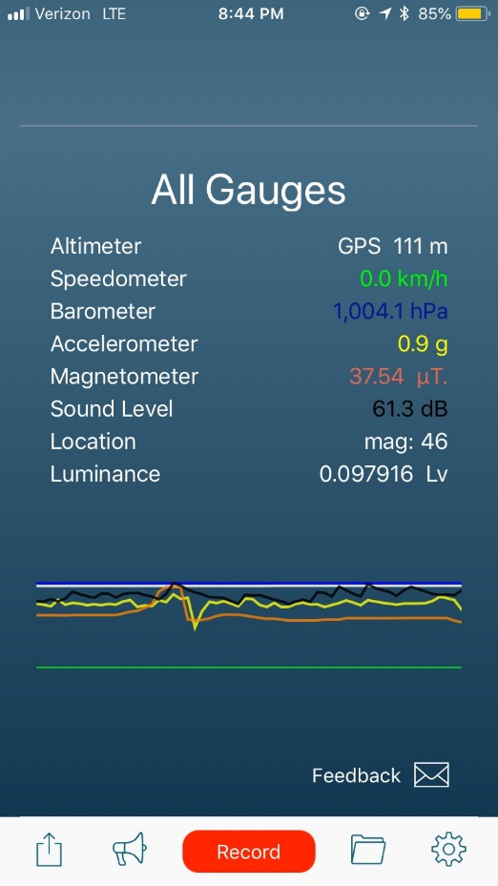

* Collect data using the Gauges application and exporting from our phones as a CSV file
* Importing the CSV files into a new MongoDB database
* Create logic script for initial data analysis. This script will identify pothole events within the data collected. The refined data will be stored within a new collection in MongoDB.
* Create a series of visualizations hosted by flask including:
  + Main page with map of potholes detected
  + Plotly dashboard page with data visualizations including user interactions such as filters
  + Data page – jsonified output from processed database
  + Potential visualizations for integration into the pothole data such as:
    - Traffic conditions
    - Road conditions
    - Demographics