Guided Practice - Monstrous Adaptability Lab Report
Use this template to document your work as you complete your assignment.

Your Information
Your Name: Eric Mckinzy
Assignment Title: SDC260 Module 2.3
GitHub Repository: https://github.com/Erimck0810/SDC-260

Development Summary
Briefly describe the work you completed. In your response, mention the creature cards you added and where you stored the image files.

I added three monsters to the program, gave gave them specific strengths and weaknesses, I also added pictures for each one

Code Evidence
Insert screenshots that show the completed code for this assignment. Make sure your screenshots are legible and contain the computer system date and time.

Screenshot 1: Completed HTML code
Paste your screenshot below this line:

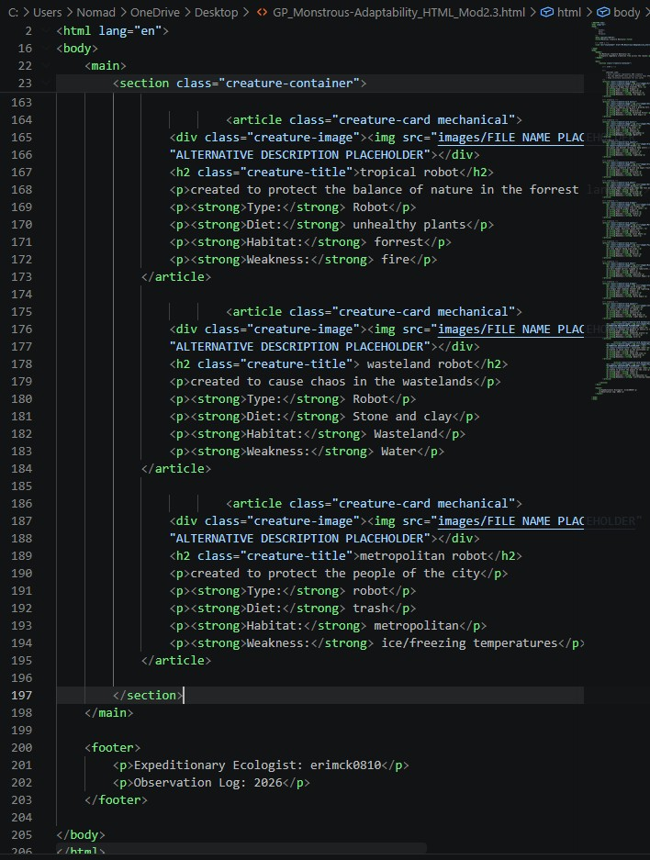

Screenshot 2: Completed CSS Code
Paste your screenshot below this line:
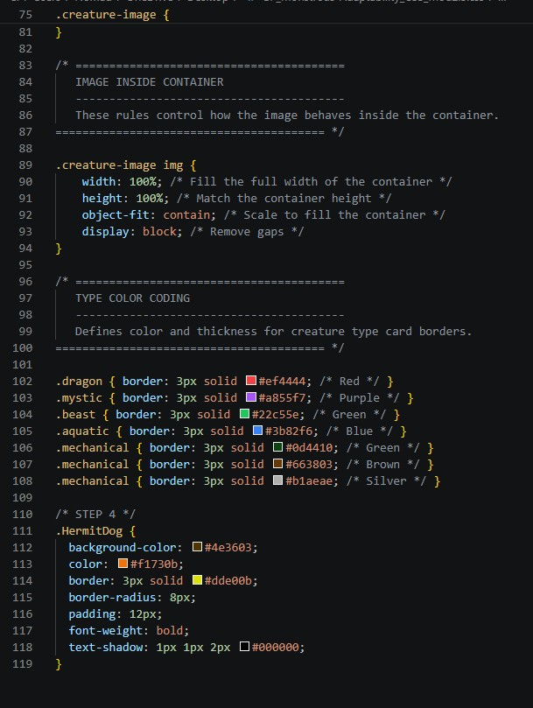

Image File Evidence
List the image files you added to the images folder. The file names listed here should match the file names used in your HTML image paths.
Creature Name | Image File Name | Alt Text Summary
Metropolitan Robot |  | “a Silver C3P0 walking through the halls of the death star”
Wasteland Robot | 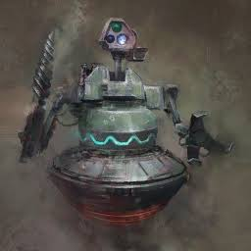 | “Metallic robot in the midst of a dusty wasteland”
Tropical Robot | 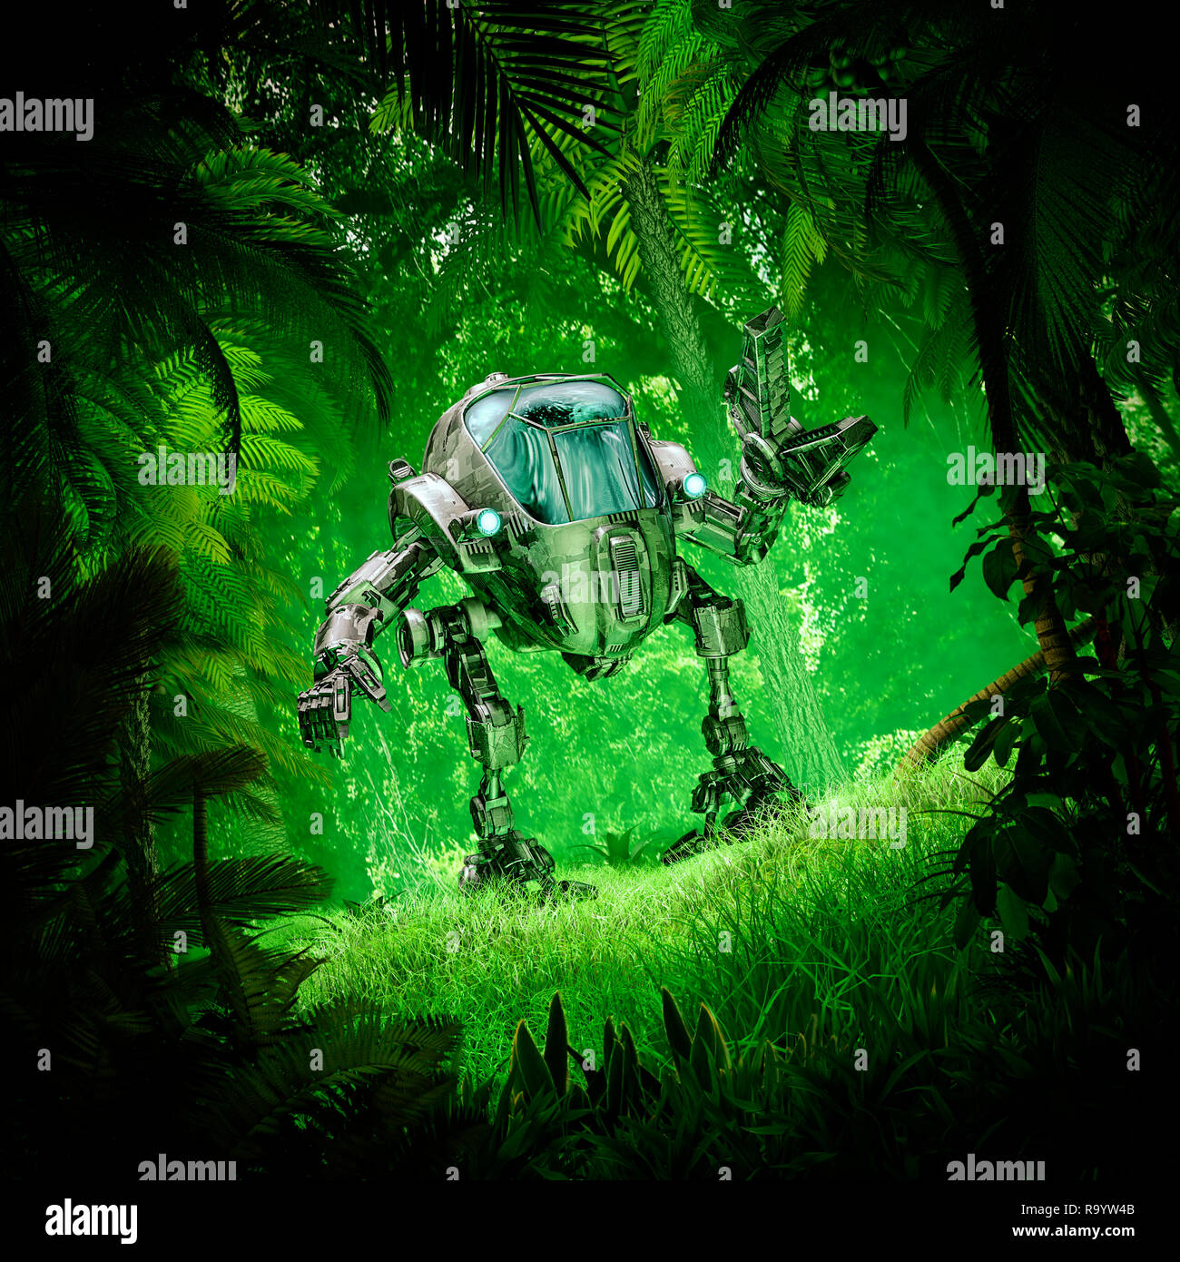 | "Metallic tropical robot covered in vine moss standing in a lush rainforest"

Rendered Web Page Evidence
Insert a screenshot of the completed web page as it appears in your browser. The bestiary should show the new creature cards, visible images, and a flexible layout that wraps or centers appropriately.

Screenshot 3: Rendered Web Page
Paste your screenshot below this line:

Reflection
- How did Flexbox properties such as gap, flex-wrap, and justify-content help organize the bestiary layout?

Flexbox lets content drop into new rows automatically as the size of the container changes. Keeping the content organized and preventing overcrowding

2. Why is it important for each creature image to have an accurate file path and meaningful alt text?

Accurate file path is a must because when you’re describing what it is in the code and you describe it wrong. You’re putting forth the wrong idea. Also it prevents broken images, because the system depends on all parts of the code being in alignment. Alt text uses descriptions to search engine queries, so it improves search engine optimization. It also allows the text to be read out loud.

