Guided Practice - Build-A-Page Workshop Lab Report
Use this template to document your work as you complete your assignment.

Your Information
Your Name: Eric Mckinzy
Assignment Title: Guided Practice Mod 1.5 Build A Page
GitHub Repository: SDC - 260

Development Summary
Briefly describe what you added to the starter HTML file and how it changed the content of the page.

Customization options, and preferences were added. Along with todays date and my student ID.

Semantic HTML Elements Used
Complete the table by identifying five semantic elements you used and explaining their purpose on the page.
Semantic Element | Where You Used It | Purpose / Accessibility Benefit
<header> | Step 1 | Opening the page
<nav> | step 2 | Offers options for navigating the pages
<section> | Step 4 | Provides options for customizing different elements of the website
<p> | Step 8 | Provided date and time of creation
<footer> | Step 9 | Closing the page with my information

Code Evidence
Insert screenshots that show the completed code for this assignment. Make sure your screenshots are legible and contain the computer system date and time.

Screenshot 1: Completed HTML code in Visual Studio Code
Paste your screenshot below this line:

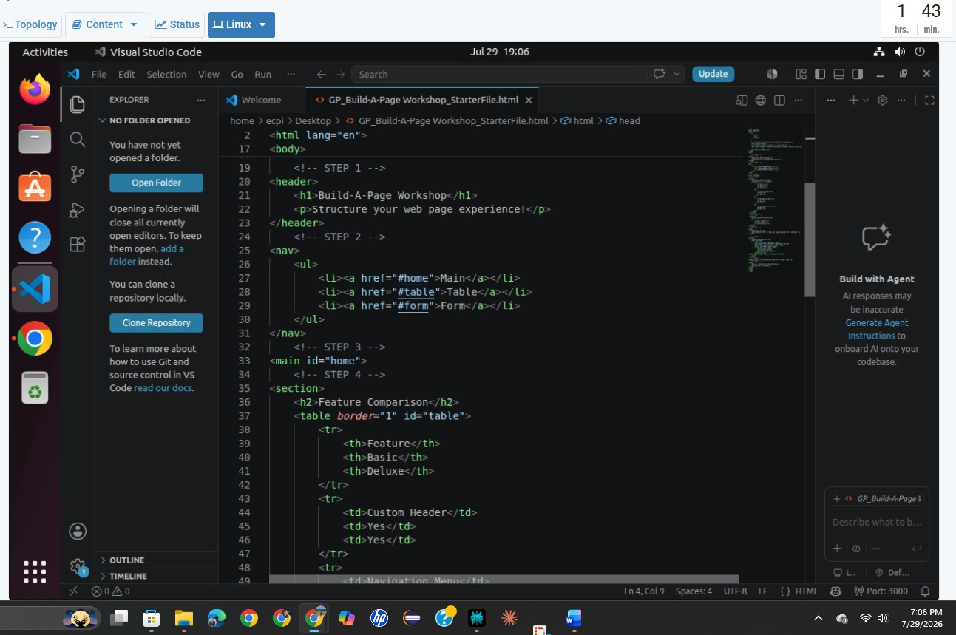

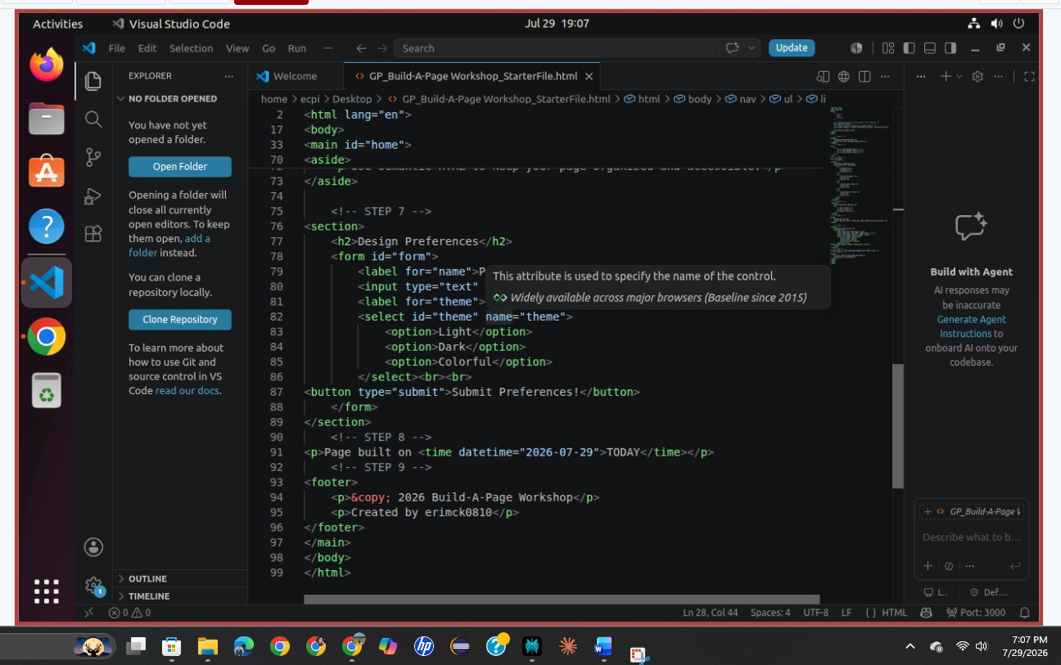

Screenshot 2: Rendered web page in a browser
Paste your screenshot below this line:
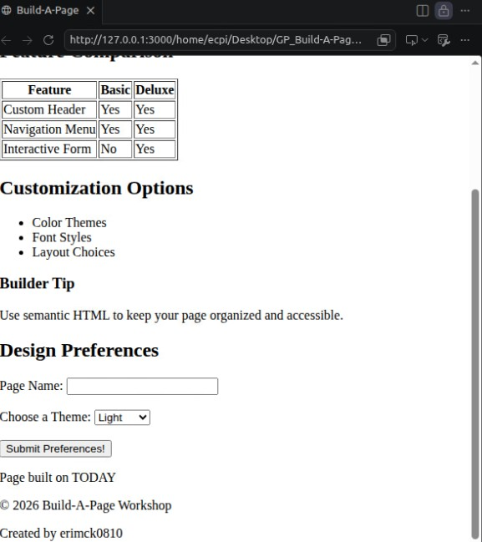

Reflection
In 2-3 sentences, explain how semantic HTML helps organize a web page or improve accessibility.

Semantic HTML uses meaningful tags—like <header>, <nav>, and <main>—to clearly define the structure and purpose of different parts of a web page. This structural clarity allows screen readers and assistive technologies to easily navigate and interpret content for visually impaired users. Additionally, search engines and browsers can better process the page's layout and content hierarchy, improving SEO and overall user experience.

