Guided Practice - Legendary Layouts Lab Report
Use this template to document your work as you complete your assignment.

Your Information
Your Name: Eric Mckinzy
Assignment Title: SDC260 Mod 2.4
GitHub Repository: https://github.com/Erimck0810/SDC-260

Development Summary
Briefly describe the work you completed. In your response, mention the quest listings you added.
I have expanded the job board by three additions. I have also added a layer of style onto it by adding a graph type of organization to have better use of the space on the page

Quest Listing Evidence
List the three new quests you added to the job board.
Quest Title | Quest Description Summary | Reward | Difficulty
Build a Repair Depot | Build a multi frequency repair depot | 2,000 Gold | Hard
Build a trading post | Build a multi faction trading post | 2,000 Gold | Hard
Build up your camp | Build atleast three structures to expand your base | 1,500 Gold | Medium

Screenshot 1: Completed HTML Code

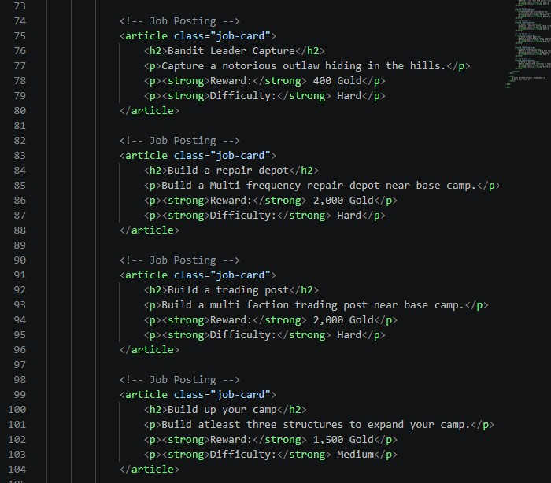

Screenshot 2: Completed CSS Code
Paste your screenshot below this line:
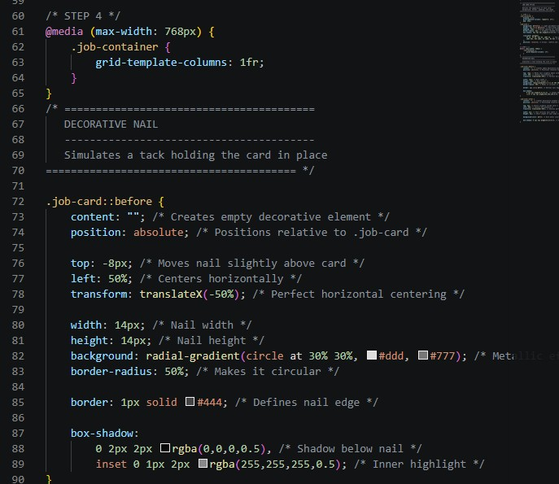

Rendered Web Page Evidence
Insert screenshots of the completed web page as it appears in your browser. Include one screenshot at a wider desktop size and one screenshot after resizing the browser window to a smaller/mobile width.

Screenshot 3: Desktop/Fullscreen Layout
Paste your screenshot below this line:
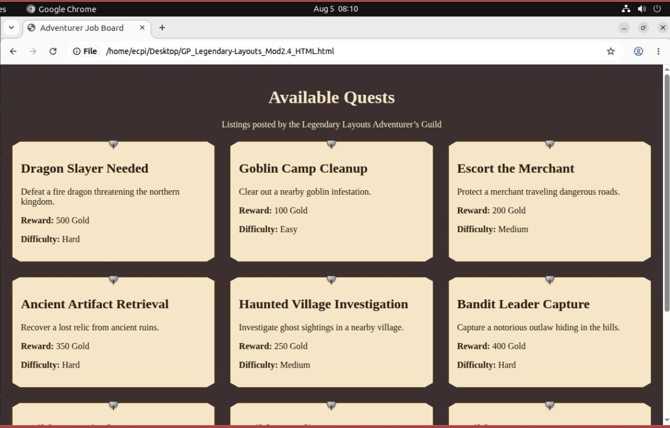

Screenshot 4: Mobile/Windowed Layout
Paste your screenshot below this line: 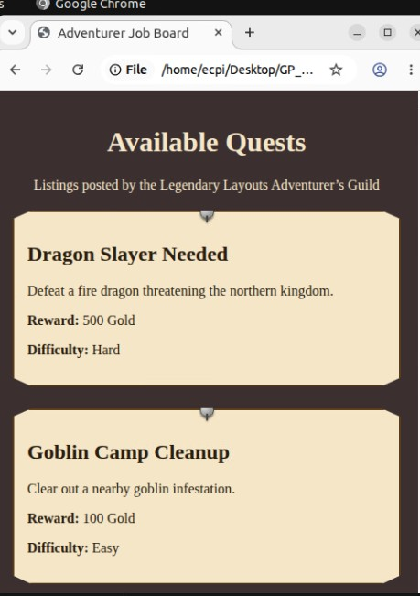

Responsive Design Check
1. What changed when you resized the browser window below the media query breakpoint?
When I resized the browser the content went from 3 columns to one in order to fit into the window.

2. Why does changing grid-template-columns to 1fr improve readability on smaller screens?.
Instead of leaving some of the content off screen, you can simply scroll down to read everything. Its more natural that way, people are less likely to miss anything when they have to scroll down than scrolling left or right.

Reflection
1. How does CSS Grid organize features on a web page?
The CSS grid organized everything into a grid-like pattern that lets you control both dimensions of alignment simultaneously.
2. What causes media queries to activate?
When the size of the window changes, it restructures automatically.

