Guided Practice – Styling Starter Pack Lab Report
Use this template to document your work as you complete your assignment.

Your Information
Your Name: Eric Mckinzy
Assignment Title: Mod 1.6 – Styling Starter Pack
GitHub Repository: SDC260-Week1

Development Summary
Briefly describe the work you completed. In your response, mention how you used inline CSS, internal CSS, and an external stylesheet.

For this assignment, we created an example of each method of CSS. Inline, internal, and external. Each with slightly different context in its box.

Code Evidence
Insert screenshots that show the completed code for this assignment. Make sure your screenshots are legible and contain the computer system date and time.

Screenshot 1: Completed HTML code
Paste your screenshot below this line:

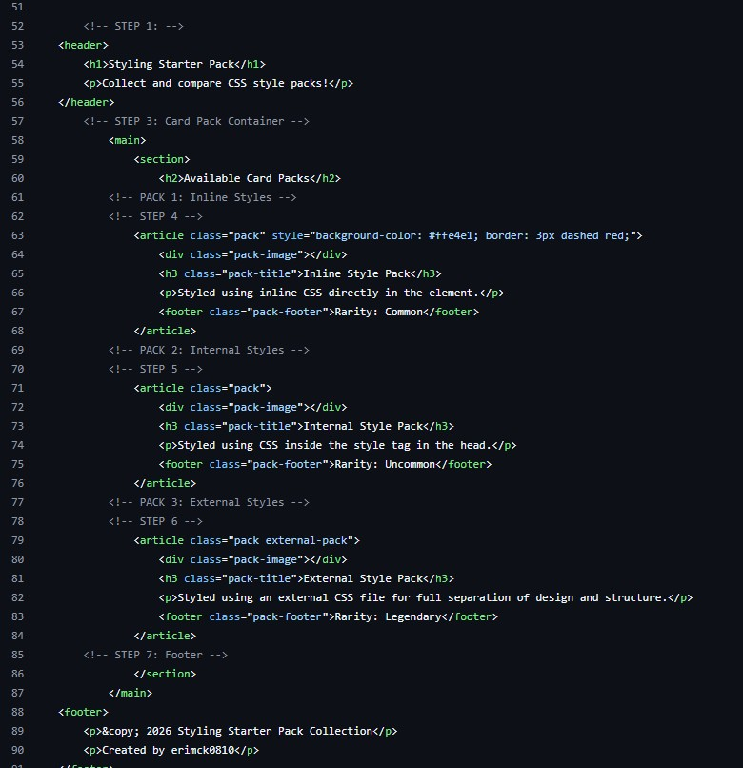

Screenshot 2: Completed CSS Code
Paste your screenshot below this line:
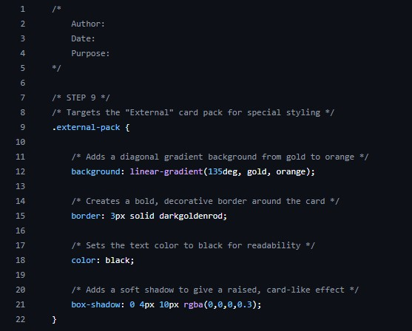

Rendered Web Page Evidence
Insert a screenshot of the completed web page as it appears in your browser. The three card packs should display different stylings.

Screenshot 3: Rendered Web Page
Insert a screenshot of the completed Styling Starter Pack page in the browser.
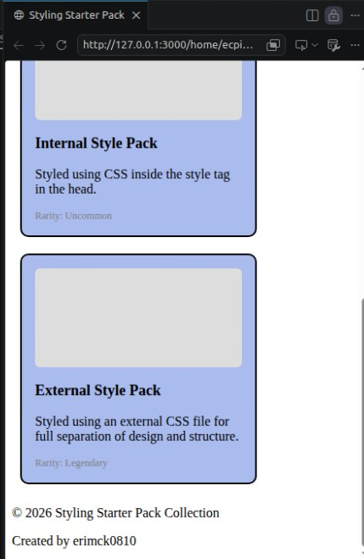

Reflection
Answer the questions below in complete sentences.
- Which CSS method did you find easiest to understand: inline, internal, or external? Why?
I find the External CSS method to be the easiest because it seems the most straight forward one. Everything else kind of jumps around or uses different kinds of syntax almost like theyre different languages.

- Why is an external stylesheet often preferred for larger websites?

Well there feels like a lot of redundancy in internal, having to repeat a lot of the same stuff for the different sections of the same page, and inline is a lot closer to external but there’s still a lot of extra fat that external trims off the code. External style sheets are a world easier than the rest of them

