Guided Practice – Cookie Collection Lab Report
Use this template to document your work as you complete your assignment.

Your Information
Your Name: Eric Mckinzy
Assignment Title: Module 4.3
GitHub Repository: https://github.com/Erimck0810/SDC-260

Development Summary
Briefly summarize the work you completed for this guided practice. Include the files you edited, how cookies are used to store cart data, and how JavaScript updates the cart on the page.

For this guided practice I added the links to the external files, characteristics for the shopping cart, three new products to the const products, an event listener, a number of functions to the JS code, and attempted to test the cookies on the live page.

Code Explanation
Answer each prompt in complete sentences.
- Explain how the cart data is saved in a cookie and why this allows the cart to remain after the page is refreshed or reopened.
When items are added to the cart, js converts the data into a string text and writes it into the browsers doc.cookie. The browser saves it and sends it back to the web page whenever the information needs to be reloaded.
- Explain how JavaScript updates the product grid, cart item list, cart count, and total on the webpage.
JS updated the page by selecting SOM elements and changing the context based on the data. It loops through the grid and cart and injects the HTML strings into the container elements. Cart count is calculated and updated via textContent.
- Describe what appeared when you typed document.cookie in the browser Console. What did the stored data show?
When you type document.cookie into the browser console, it returns a string with the key-value pairs stored for the site, separated by semicolons.
- Explain why JSON.stringify() and JSON.parse() are needed when storing and loading the cart array.
JSON.stringify() converts the JavaScript cart array into a plain text string because cookies can only store text data, and when reloading the page, JSON.parse() converts that saved text string back into an active JavaScript array so your code can work with it again.
- Describe one accessibility or usability feature included in the cart or product display, such as meaningful alt text or aria-labels.
One accessibility feature is the meaningful alt text on product images. This provides users with a clear description for the visually impaired and shows descriptive fallback text if the image doesn’t load.

Code Evidence
Insert screenshots that show the completed code for this assignment. Make sure your screenshots are legible and contain the computer system date and time.

Screenshot 1: Completed HTML code
Paste your screenshot below this line: 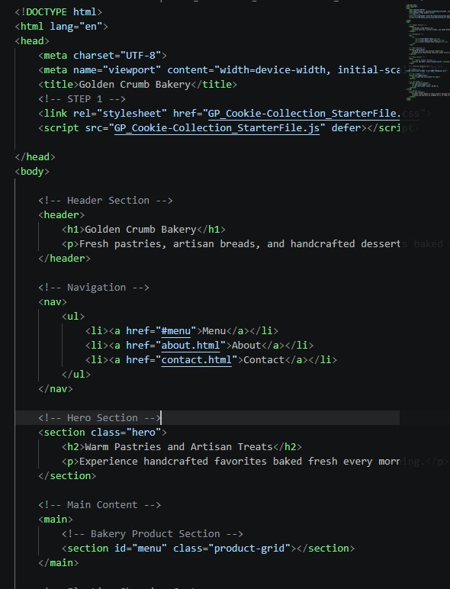

Screenshot 2: CSS Code
Paste your screenshot below this line: 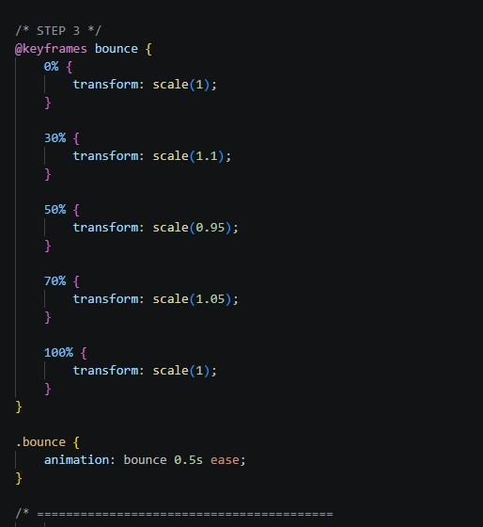

Screenshot 3: JavaScript Product and Cart Code
Paste your screenshot below this line: 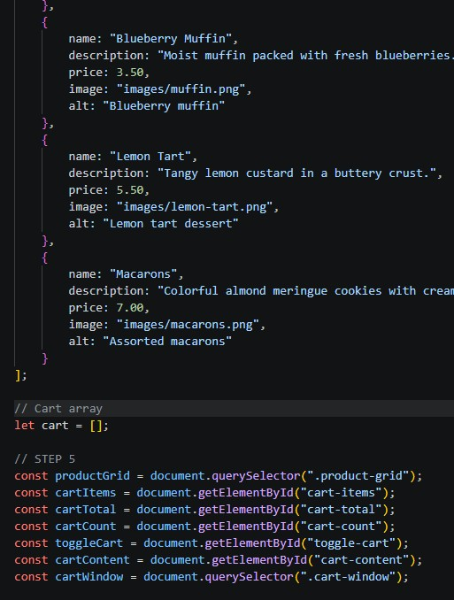

Screenshot 4: Cookies Save and Load Code
Paste your screenshot below this line: 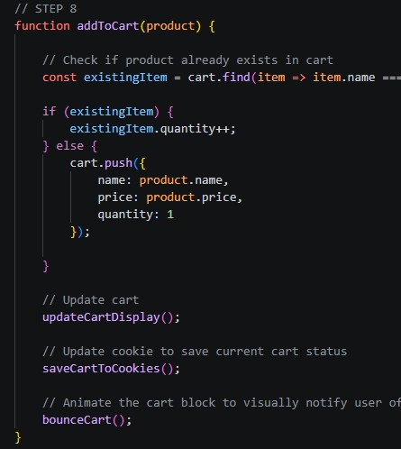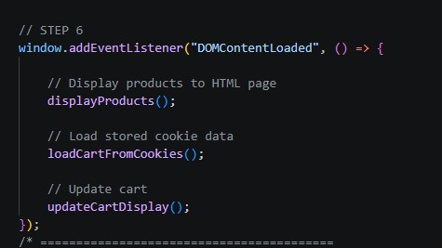

Screenshot 5: Browser Console Cookie Data
Paste your screenshot below this line: Attempted to load the cookies. No pictures loaded. Kept the cookies from showing.

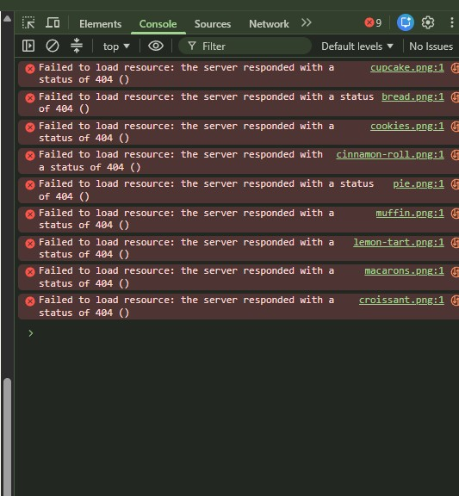

Screenshot 6: Rendered Web Page in Browser
Paste your screenshot below this line:
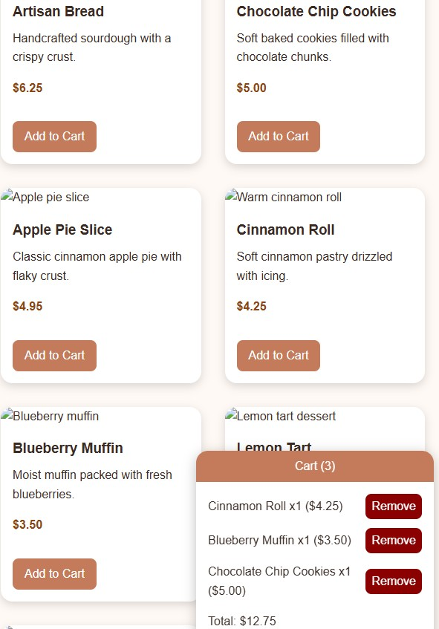

Reflection
In a few sentences, describe what part of persistent cart storage was easiest to understand, what was most challenging, and how checking the Console helped you confirm that the cookie was working.

The easiest part to for me was the JSON.stringify() and the JSON.parse.(). Conveerting back and forth between the JS objects and text similar to a kind of loop. The most challenging part of this for me was trying to get the cookies to display in the console, as you can see I struggled with that right up until the end.

