NOMAD LIFE GALLERY
Website Proposal
A division of Nomad Life LLC

Executive Summary
A functional online storefront where independent artists' original work and prints can be discovered, reviewed in detail, and purchased. The site is scoped as a focused, four-page build — Store Homepage, Browse, Product Detail, and Checkout — completed over a four-week timeline using static HTML, CSS, and JavaScript. No backend, live payment processor, or blockchain integration is included at this stage; the goal is to establish and validate the core site structure, page flow, and purchasing experience before any additional functionality is layered on.

Purpose
Nomad Life Gallery is the retail storefront division of Nomad Life LLC, giving independent artists a place to sell original artwork and prints directly to buyers. Independent artists frequently lack a dedicated, professional online storefront that presents their work with the same clarity and trust as an established gallery. This project addresses that gap with a purpose-built site: one place where a buyer can browse a curated collection, get complete information about a specific piece, and check out without friction.
This proposal outlines a functional four-page website that demonstrates the store's core structure: discovery, product detail, and checkout. The site is built with static HTML, CSS, and JavaScript, using a static product data set, scoped to be delivered within a four-week build. This scope is intentional — it proves out navigation, layout, and purchase flow first, so that backend, payment, and any future blockchain-based ownership features can be added later without reworking the site's foundation.

Business Model
Business type: An online art store, operating as a division of Nomad Life LLC, selling original artwork and limited prints from independent artists.
Products offered: Original pieces and limited-edition prints, each listed with an image, title, description, medium, and price.
Target audience: Art buyers and collectors seeking original or limited-run work from independent artists, along with general shoppers browsing for a unique piece.
Purchasing workflow: A buyer browses the collection on the Browse page, selects a piece to view on its Product Detail page, and proceeds to Checkout, where they enter shipping and payment information and receive an order confirmation.

Product Data Model
Each product is stored as a structured record so it can be displayed consistently across the Browse, Product Detail, and Checkout pages.

Required Fields
Field | Type | Description
Product ID | String | Unique identifier for the item
Title | String | Name of the artwork
Artist name | String | Name of the creating artist
Description | Text | Short description of the piece
Medium | String | e.g. oil on canvas, print, mixed media
Dimensions | String | Physical size of the piece
Price | Number (USD) | Sale price
Image URL | String | Path or link to the product image
Availability | Enum | Available / Sold

Simulated Example Records
Product ID: NLG-0001 | Title: "Signal Drift" | Artist: Jordan Reyes | Medium: Mixed media on canvas | Dimensions: 36in x 48in | Price: $4,200 | Availability: Available
Product ID: NLG-0002 | Title: "Nomadic Hours" | Artist: Priya Anand | Medium: Archival pigment print | Dimensions: 18in x 24in | Price: $325 | Availability: Available

Site Map & Navigation Flow

Store Homepage
The entry point to the site. Introduces the Nomad Life Gallery brand, presents a hero section with a clear call to action, and previews a small selection of featured works to draw visitors deeper into the collection.

Browse
Displays the full product collection as a grid, pulled from the static product data set. Each item links directly to its own Product Detail page, giving visitors a fast way to scan available work.

Product Detail
Shows complete information for a single product — title, artist, description, medium, dimensions, price, and image — along with a clear path to Checkout for that item.

Checkout
Collects shipping and payment information for the selected item, displays an order summary, and submits to a Confirmation page that completes the purchase flow.
Navigation path: Homepage → Browse → Product Detail → Checkout → Confirmation. The Homepage also links directly to Browse and to featured items on their Product Detail pages, and a persistent navigation bar on every page links back to Homepage and Browse, so a visitor can exit the purchase flow and return to browsing at any point.

Assumptions & Constraints
- Product data is static for this build; there is no live database or content management system
- Checkout collects shipping and payment information but does not process real transactions
- No user accounts, order history, or persistent storage are included in this scope
- The site is designed and tested for standard desktop and mobile browser widths
- Smart contract, blockchain, and NFT-based ownership features are part of the broader Nomad Life Gallery roadmap, not this build

Success Criteria
This build is considered complete when the following are true:
- All four required pages exist and are reachable through the site's navigation
- A visitor can move from Homepage through Browse, Product Detail, and Checkout without a broken link or dead end
- Product information displayed on Browse and Product Detail pages is pulled from the shared static data file, not hard-coded per page
- The checkout form validates required fields before allowing submission
- Visual styling is consistent across all pages, using the shared external stylesheet and defined brand palette

Brand Identity & Visual Style
The visual identity sits between fine-art permanence and digital trust: dark, warm tones rather than a bright storefront palette. Deep ink backgrounds evoke depth and permanence, parchment tones nod to certificates and provenance, and brass carries a sense of value and craftsmanship.
Color | Hex | Use
Ink | #16181D | Primary dark background (nav, hero, footer)
Parchment | #F5F1E8 | Primary light background
Charcoal | #24262B | Body text on light backgrounds
Brass | #B8863B | Primary accent — buttons, CTAs
Slate | #8A8D93 | Secondary/muted text



Development Roadmap
The build is planned across four weekly milestones, each with a defined feature set and implementation tasks.

Week 1 — Store Homepage
- Build homepage layout: nav bar, hero section, brand introduction
- Add featured-works preview section pulling from static product data
- Wire up navigation links to Browse and other pages
- Responsive layout check across screen sizes

Week 2 — Browse & Product Detail Pages
- Build the static product data file (title, artist, price, description, image, etc.)
- Build the Browse page, rendering the full product grid from that data
- Build the Product Detail page template with dynamic content per item
- Link product cards on Browse to their corresponding Product Detail pages

Week 3 — Checkout Page
- Build the checkout form: shipping and payment fields
- Add an order summary showing the selected product and price
- Implement client-side form validation for required fields
- Add a “Place order” action that triggers a confirmation state

Week 4 — Confirmation, Polish & Submission Prep
- Build the confirmation page with an order recap
- Run a cross-page styling consistency pass (spacing, colors, typography)
- Fix any broken links or navigation issues between pages
- Final review and packaging for delivery
Week | Milestone | Target Completion
1 | Store Homepage | End of Week 1
2 | Browse & Product Detail | End of Week 2
3 | Checkout Page | End of Week 3
4 | Confirmation, Polish & Submission | End of Week 4

Project Structure
The site is organized as a set of static, linked HTML pages sharing a single external stylesheet:
- index.html — Store Homepage
- browse.html — Browse page
- product.html — Product Detail page
- checkout.html — Checkout page
- confirmation.html — Confirmation page
- Nomad Life Gallery Styles.css — shared stylesheet
Keeping styling in a single external file, and product data in a single static file, means the site can later be connected to a real backend or content management system without restructuring the pages themselves.

Technology & Scope
- HTML5, CSS3 (external stylesheet), and vanilla JavaScript
- Static product data — no backend, database, or payment processor
- No smart contract, blockchain, or NFT integration in this build

Example

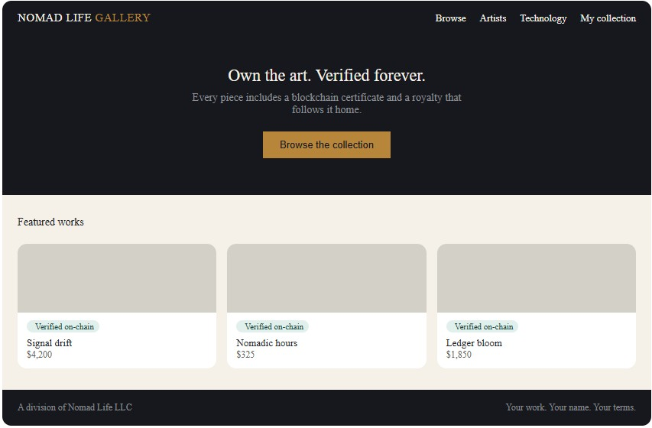

Conclusion
This proposal defines a scoped, functional demonstration of the Nomad Life Gallery storefront concept: a four-page site covering discovery, product detail, and checkout, built to be completed within a four-week timeline. It establishes the navigation structure, product data model, and visual identity needed to support the store's purpose, while intentionally deferring backend, payment, and blockchain integration to a later phase of the broader Nomad Life Gallery roadmap.

Github Repo. https://github.com/Erimck0810/SDC-260

