Assessment – Flow Control Lab Report
Use this template to document your work as you complete your assignment.

Your Information
Your Name: Eric Mckinzy
Assignment Title: Module 3.5
GitHub Repository: https://github.com/Erimck0810/SDC-260

Development Summary
Briefly describe what you completed for this assessment. Include a summary of the control structure used to recommend trails based on user selections.
I created a website that recommends a specific path to take depending on your circumstances and experience. The main thing used here was conditional statements, for loops, and an event listener. The first two to cycle through the statements and continuously provide results that meet the criteria, and the listener to render the form for processing.

Trail Recommendation Testing
Test each condition and record the result that appeared in the Results area. Mark Pass only after the expected trail appears.
Test Case | Expected Recommendation | Actual Result | Pass
Pets: Yes; Experience: Low | River Walk | River Walk | Pass
Pets: Yes; Experience: Medium | Forest Loop | Forest Loop | Pass
Pets: Yes; Experience: High | Forest Loop | Forest Loop | Pass
Pets: No; Experience: Low | Lake Side Path | Lake Side Path | Pass
Pets: No; Experience: Medium | Forest Loop | Forest Loop | Pass
Pets: No; Experience: High | Rock Ridge Trail | Rock Ridge Trail | Pass

Code Evidence
Insert screenshots that show the completed code for this assignment. Make sure your screenshots are legible and contain the computer system date and time.

Screenshot 1: HTML Code
Paste your screenshot below this line:
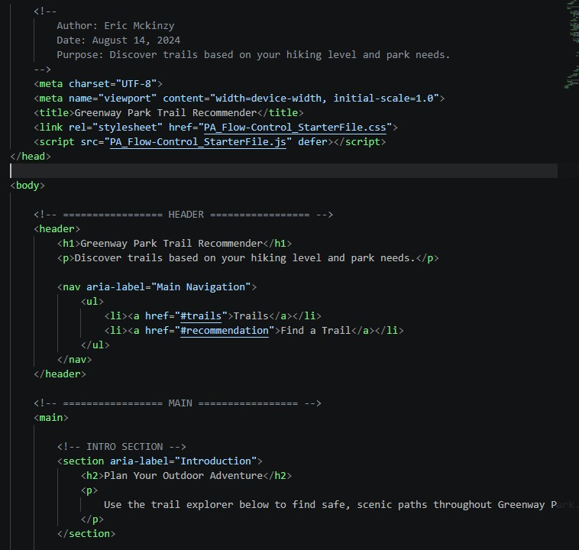

Screenshot 2 – JavaScript Code
Paste your screenshot below this line:
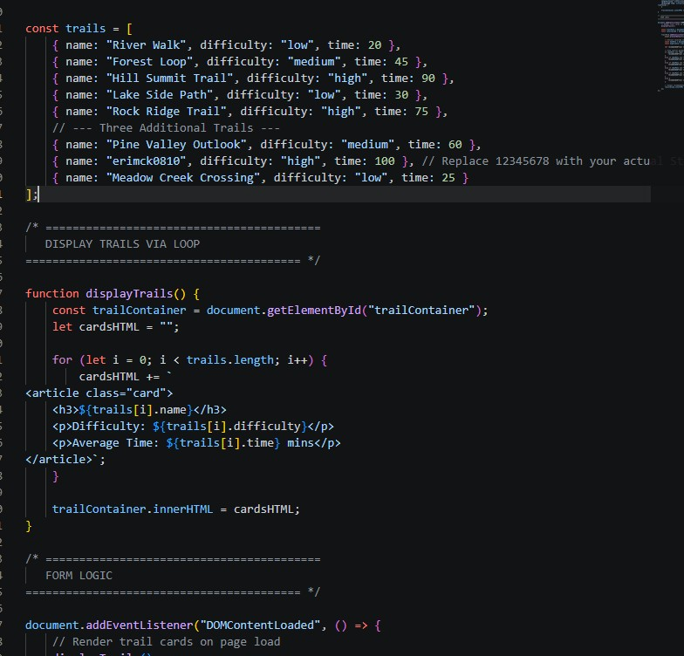

Screenshot 3 – Rendered Webpage
Paste your screenshot below this line:
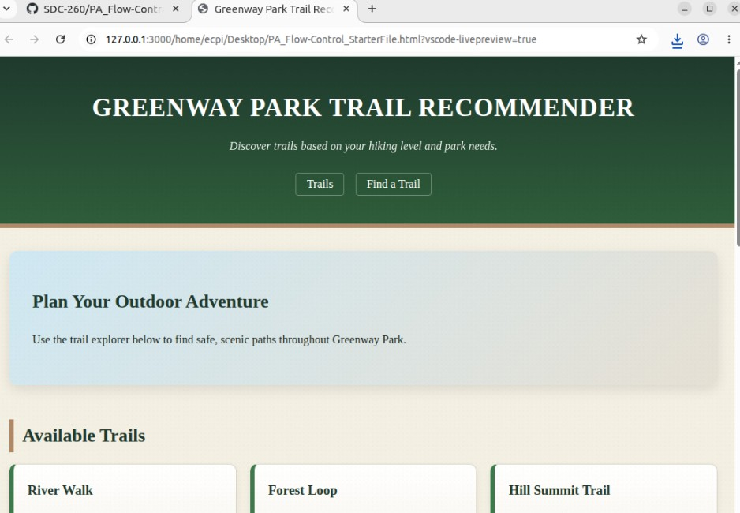

Reflection
- How did your loop display the trail cards on the page?
When the information is put into the inquiry at the bottom, the information is iterated through the trails array and then put into a template literal string that matches the card structure.
- Which conditional statement was the most important for the trail recommendation tool, and why?
The if statement was the most important because it evaluated the inputs, which directly determined the path of execution.
- Describe one issue you encountered or one part of the code you checked carefully.
I’ve had issues with the if statements in the path so I was careful while putting them together, and tried to make them as clean as possible.

