Assessment – Responsive Recipes Lab Report
Use this template to document your work as you complete your assignment.

Your Information
Your Name: Eric Mckinzy
Assignment Title: Module 2.5
GitHub Repository: https://github.com/Erimck0810/SDC-260

Development Summary
Briefly describe the work you completed. In your response, mention the potion recipes you added and whether you used Flexbox or CSS Grid.
Created additional potions and added their recipes to the program

Potion Recipe Evidence
List the three additional potion recipes you added to the webpage. Each recipe should include a unique name, a brief effect description, and an ingredient table with quantities.
Potion Name | Effect Description Summary | Ingredients Included | Quantity Details Included?
Terraform Potion | Ability to modify terrain | Mercury, Shadow essence, Aurora Light | Yes
Speed Potion | Increased speed | 1000 watts of electricity, tears of a roadrunner, whistling jackal spirit | yes
Flight Potion | Ability to fly | Ghost Leaf, Shadow Essence, Feather | yes

Layout and Responsiveness Evidence
- Did you use Flexbox or CSS Grid for the main layout? Explain why that layout method was appropriate for this recipe page.

I used CSS grid because I find that it’s easier to work on a program that has everything in front of you

- What layout or spacing changes occur at the 768px breakpoint?
At the 768px breakpoint, stacked single-column mobile layouts expand into multi-column designs while margins, padding, and gaps increase to fit larger tablet screens.
- What layout or spacing changes occur at the 1024px breakpoint?
At the 1024px breakpoint, layouts transition from tablet views to full desktop designs by expanding into 3–4 column grids, revealing persistent sidebars, and increasing padding and max-container widths for wide displays.
- How did you confirm that the page remained readable across mobile, tablet, and desktop screen sizes?
By changing the sizes of the viewport and watching how the system reacts. It was still readable throughout the process.
By changing the size of the preview window from maximum size, to half that size, and then half that size again. After making these adjustments I was able to determing that these three types of devices are compatible with how I put the code together.

Code Evidence
Insert screenshots that show the completed code for this assignment. Make sure your screenshots are legible and contain the computer system date and time.

Screenshot 1: Completed HTML Code
Paste your screenshot below this line:
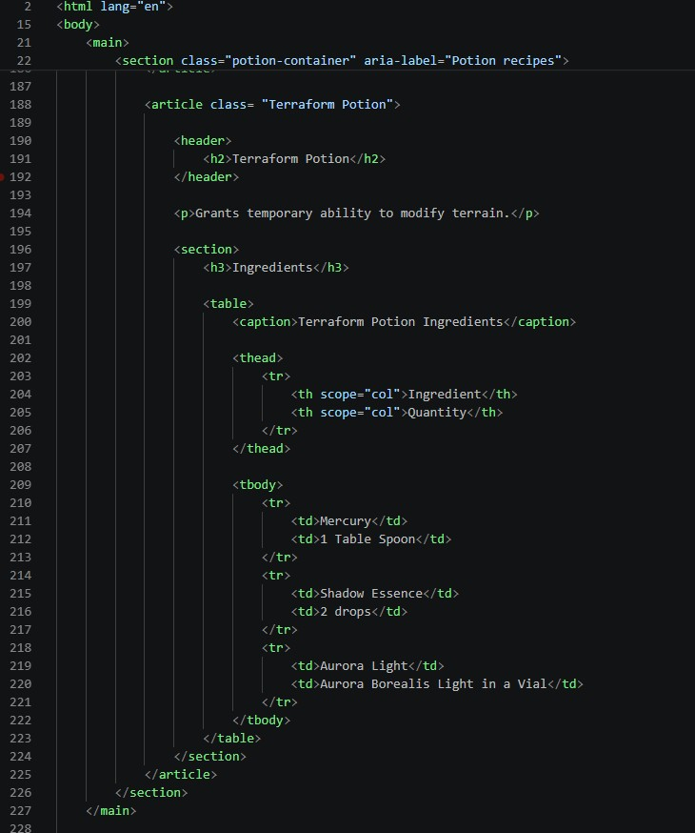

Screenshot 2: Completed CSS Code
Paste your screenshot below this line:
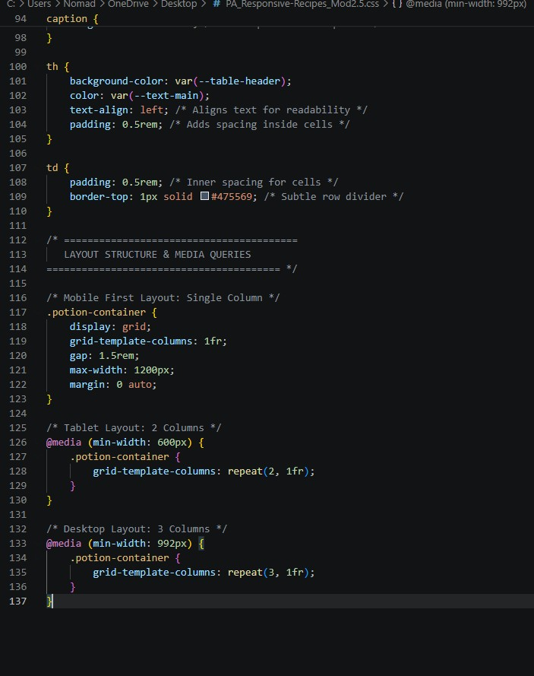

Rendered Web Page Evidence
Screenshot 3: Mobile/Small Windowed Layout
Paste your screenshot below this line:
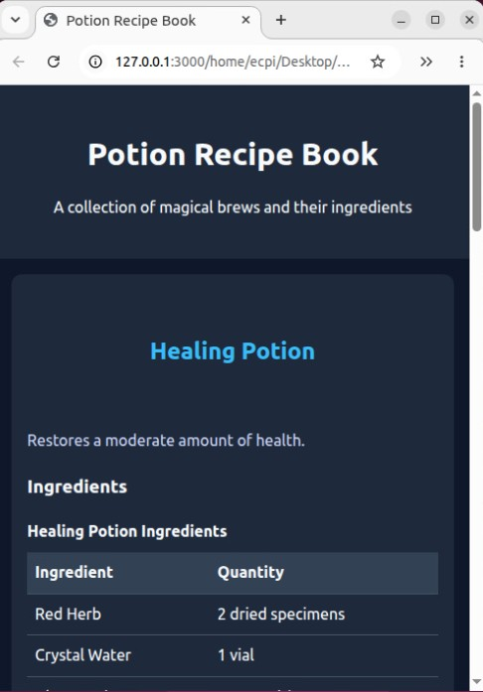

Screenshot 4: Tablet/Medium Windowed Layout
Paste your screenshot below this line:
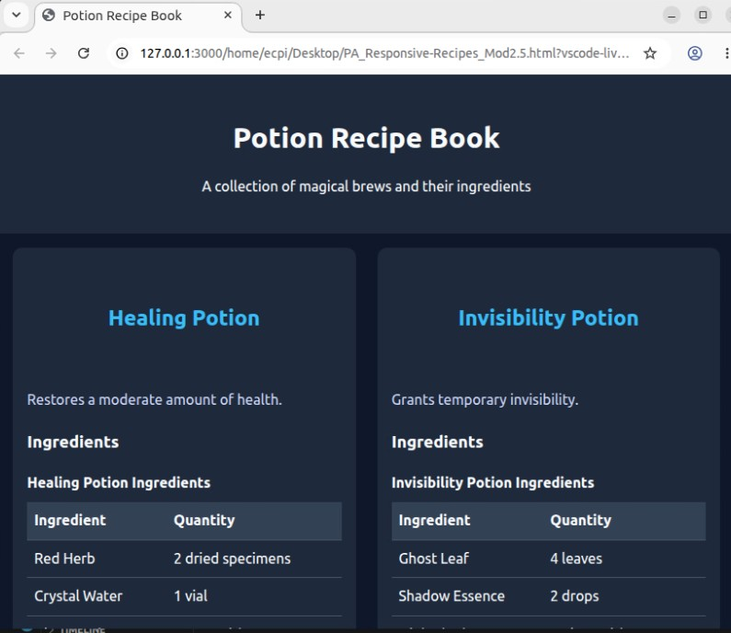

Screenshot 6: Desktop/Fullscreen Layout
Paste your screenshot below this line:
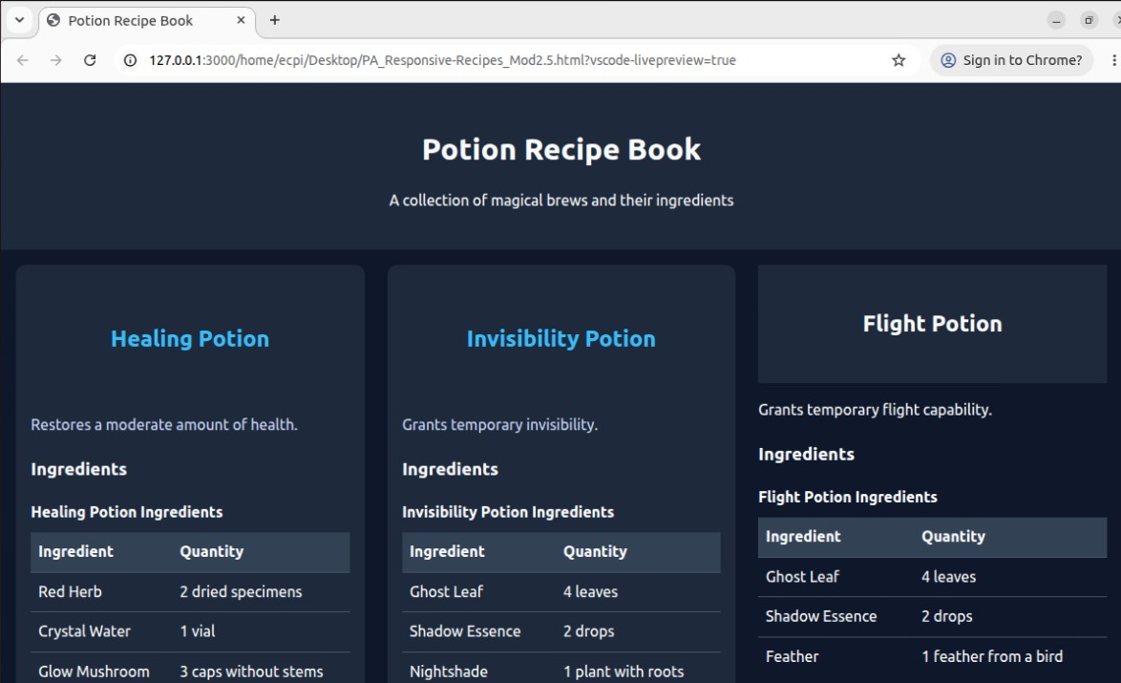

Reflection
In 2-3 sentences, answer the reflection questions below.
1. What was the most challenging part of making the recipe page responsive?
Well there was one point where I was struggling to link the page due to technical difficulties. First my VCastle wouldn’t work. Then once I got in, no matter what I did the previews wouldn’t work. Then once I got the preview to work, I discovered that my code was missing a very small and apparently very important piece of syntax.
2. What would you improve about the page if you had more time?
If I wanted to improve the page, I would offer different potions among different categories. Like ability amplification, external manipulation, transformation, etc.

