Assessment – Box Model Inventory Lab Report
Use this template to document your work as you complete your assignment.

Your Information
Your Name: Eric Mckinzy
Assignment Title: Box Model Inventory
GitHub Repository: SDC260-Week1

Development Summary
Briefly describe the web page you created. Mention the semantic elements you added, the type of figurine inventory data included in your table, and how you used CSS box model properties to organize the page.
I created a page that contains a table that maintains an inventory, and properly stores figurines to protect from wear and long term damage. <section> describes the purpose and subject of the table. The <article> gives a description of the products, and <aside> describes the physical case the figurines will be stored in. All of these are organized using inline for the footer, internal stylesheet for the box model rules, and semantic elements for the content.

Requirement Summary
Complete the table below to identify how your page meets the assignment requirements.
Requirement | What I Added | Where It Appears
Four additional semantic HTML elements | - Header  - Body  - Section  - Article | - 44-46  - 42-104  - 56-60  - 62-90
Inventory table with at least three rows and three columns | Figurine name, Series, and Condition | Lines 67-86
Internal stylesheet with box model properties on at least three elements | Nav: Margin, Padding, Border  Table: width, margin, border-collapse  Section: margin, padding, border | Lines 11-38
At least two inline footer styles | Border-top, and Padding | Line 100

Code Evidence
Insert screenshots that show the completed code for this assignment. Make sure your screenshots are legible and contain the computer system date and time.

Screenshot 1: Semantic HTML and Inventory Table
Insert a screenshot showing your added semantic HTML elements and figurine inventory table.
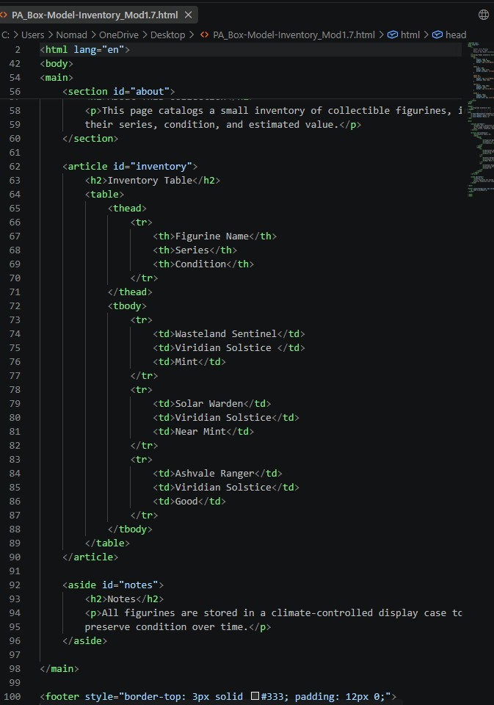
Screenshot 2: Internal CSS and Inline Footer Styles
Insert a screenshot showing your internal stylesheet with box model properties and your footer with at least two inline styles.
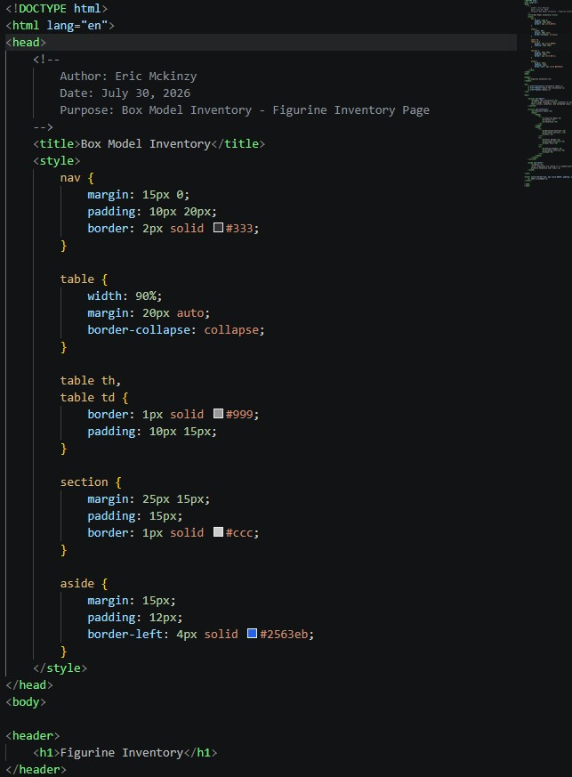

Rendered Web Page Evidence
Insert a screenshot of the completed web page as it appears in your browser. The page should be logically structured, visually organized, and free of visible stray tags.

Screenshot 3: Rendered Web Page
Insert a screenshot of the completed Box Model Inventory page in the browser.
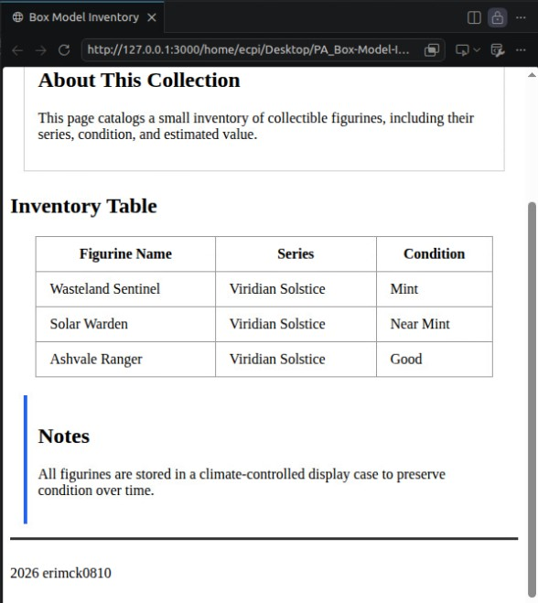

Reflection
Answer the questions below in complete sentences.
- What semantic HTML elements could you add to further organize the page?
I could add a <figure> semantic to add pictures of the figurines, or maybe a <summary> to go further into detail about their condition or what they would look like in general.
- What box model properties could you include, and how would it improve the layout or readability of the page?
Well usually when I do stuff like this in my other classes or projects in my free time, theres an inconsistency problem, so maybe adding a max-width will keep it consistent between the different boxes throughout the page.
- What is one change you would make if you continued improving this inventory page?
USE THE EXTERNAL. To avoid the pains that come with using the other methods.

