Guided Practice – Development Environment Configuration Lab Report
Use this template to document your work as you complete your assignment.

Your Information
Your Name: Eric Mckinzy
Assignment Title: Module 5.3
GitHub Repository: https://github.com/Erimck0810/SDC-260

Development Summary
Briefly summarize the work you completed for this guided practice. Include how you configured Visual Studio Code, launched the webpage through Live Preview, and verified the difference between the offline and locally hosted versions of the page.

Added my information to the existing website displayed, verified the installation of the Live Preview extension of the Visual Code application, and verified cookies worked.

Configuration Explanation
Answer each prompt in complete sentences.
- Explain how the Live Preview extension allows Visual Studio Code to serve a webpage locally.
It turns VS Code into a local web server with its own built-in browser, so you can watch your code break in real time without leaving your editor.

- Explain how the page changed when it was opened through Live Preview instead of as a static file.
Opening a file directly is like looking at a photo of a car; opening it through Live Preview turns the key, starts the engine, and lets you drive it right inside your editor.

- Explain how the Last Online timestamp demonstrates that cookie data is being stored and reused.
That "Last Online" timestamp is your browser's digital breadcrumb trail. It proves the website kept your membership card on file and scanned it the second you walked back through the door.

Code Evidence
Insert screenshots that show the completed code for this assignment. Make sure your screenshots are legible and contain the computer system date and time.

Screenshot 1: Completed HTML code
Paste your screenshot below this line:
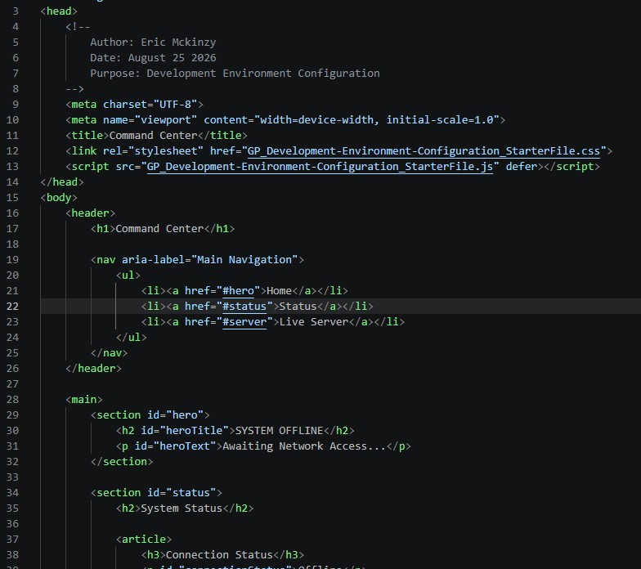

Screenshot 2: CSS and/or JavaScript Code
Paste your screenshot below this line:
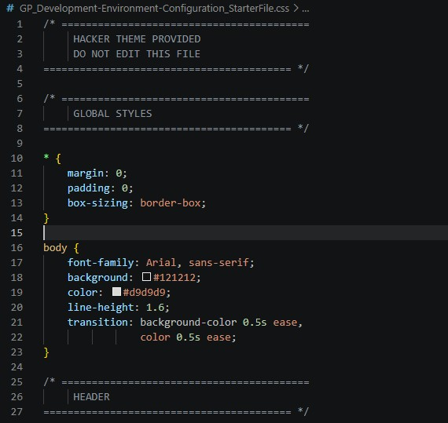

Webpage Evidence
Insert screenshots that show the webpage in both live and offline states. Make sure your screenshots are legible and contain the computer system date and time.

Screenshot 3: Webpage launched through Live Preview
Paste your screenshot below this line:
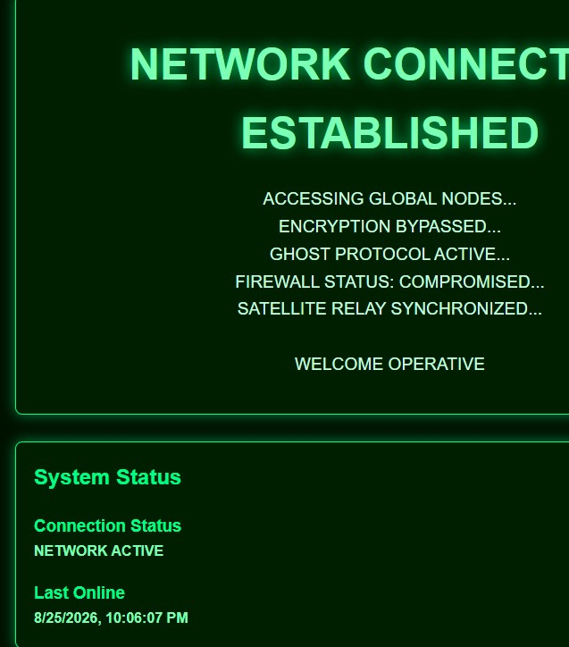

Screenshot 4: Webpage opened in offline/static-file mode
Paste your screenshot below this line:
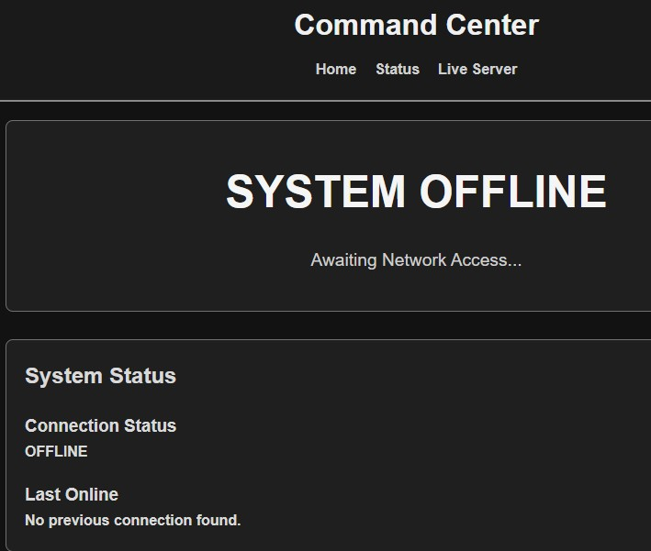

Screenshot 5: Last Online timestamp after page refresh
Paste your screenshot below this line: 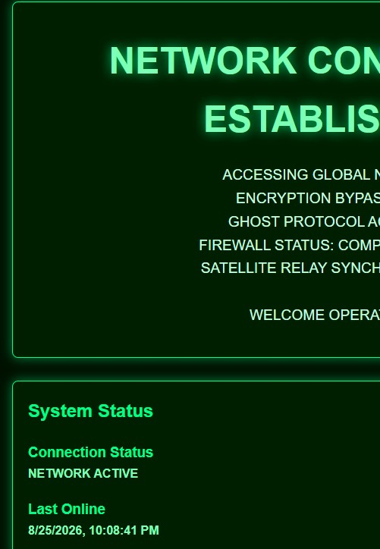

Testing Notes
Briefly describe how you tested the development environment and cookie functionality.
- What message and theme displayed when the page was launched through Live Preview?
Network connection established, in a hacker theme.
- What message and theme displayed when the page was opened as a regular static file?
System Offline, in a black and grey background.
- What happened to the Last Online timestamp after you refreshed the live page?
It gave me the most recent day and time.
- Did you encounter any setup or preview issues? If yes, how did you resolve them?
I did not, it displayed correctly the first time I previewed the file.

Reflection
In a few sentences, explain why developers use a local server or live preview tool while building websites. Then explain one reason it is important to test how a webpage behaves when opened as a static file compared with a locally hosted page.

Developers use local servers so their site doesn’t throw a security tantrum every time it tries to load an image, fetch data, or refresh the page. Testing as a static file is essential because your code might look flawless under a hosted server until someone double-clicks an index.html file off their desktop and half your scripts break due to strict browser security locks.

