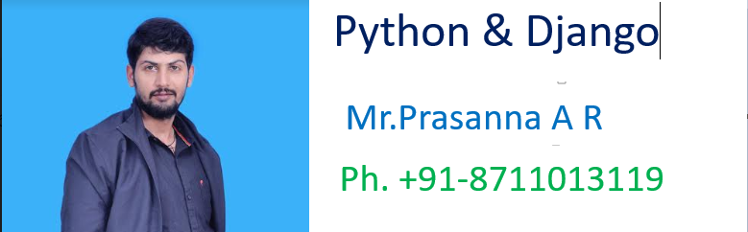

>>>>>>>>>>>>>>>>>>>>>>>>>>>>>>>>>>>>>>>>>>>>>>>>>>

***Full Stack Web Development with Python and DJango ***

**************************************************

***************1. HTML **************************:-

………………………………………………………………………………………………

-----------------------------Introduction----------------……..------------:-

………………………………………………………………………………..…………….

Full Stack Web Development with Python and DJango

………………………………………………………………………………………………

*************************Web Application:-**********

………………………………………………………………………………………………

The applications which will provide services over the web are called web applications.

Eg gmail.com, facebook.com, Flipkart.com et

…………………………………………………………………………………………

Every web application contains 2 main components

1. Front-End

2. Back-End

……………………………………………………………………………………………

1) Front-End:

It represents what user is seeing on the website

We can develop Front-End content by using the following technologies:

HTML, JS, CSS, JQuery and BootStrap

JQuery and Bootstrap are advanced front-end technologies, which are developed by using HTML, CSS and JavaScript only.

HTML: HyperText Markup Language :-

……………………………………………………………………………………………

Every web application should contain HTML. i.e HTML is the mandatory technology for web development.It represents structure of web page

………………………………………………………………………………………..

CSS: Cascading Style Sheets :-

……………………………………………….

It is optional technology; still every web application contains CSS.

The main objective of CSS is to add styles to the HTML Pages like colors,fonts,borders etc.

………………………………………………………………………………………………Java Script:-

……………………………….

It allows to add interactivity to the web application including programming logic.

The main objective of Java Script is to add functionality to the HTML Pages. ie to add dynamic nature to the HTML Pages.

HTML===>Meant for Static Responses

HTML+JS==>Meant for Dynamic Responses

Eg 1: To display "Welcome to Inventateq" response to the end user only HTML is enough, because it is static response.

Eg 2: To display current server date and time to the end user, only HTML is not enough we required to use some extra technology like JavaScript,JSP,ASP,PHP etc as it is dynamic response.

………………………………………………………………………………………….

Static Response vs Dynamic Response: -

………………………………………………………………..

If the response is not varied from time to time and person to person then it is considered as static response.

Eg login page of gmail

home page of icici bank

If the response is varied from time to time and person to person then it is considered as dynamic response.

Eg inbox page of gmail

balance page of icicibank

……………………………………………………………………………………………

2) Back End: -

………………………………..

It is the technology used to decide what to show to the end user on the Front-End.

ie Backend is responsible to generate required response to the end user,which is displayed by the Front-End.

……………………………………………………..

Back-End has 3 important components:

1. The Language like Java, Python etc

2. The Framework like DJango, Pyramid, Flask etc

3. The Database like SQLite, Oralce, MySQL etc

For the Backend language Python is the best choice because of the following reasons: Simple and easy to learn, libraries and concise code.

For the Framework DJango is the best choice because it is Fast, Secure and Scalable. Django is the most popular web application framework for Python.

DJango provides inbuilt database which is nothing but SQLite, which is the best choice for database.

The following are various popular web applications which are developed by using Python and DJango

YouTube, Dropbox, Quora, Instagram, Reddit, Yahoo Maps etc

…………………………………………………………………………………………….

HTML Basics: -

…………………………………

HTML stands for HyperText Markup language.

This is the most basic building block of every web application.Without using HTML we cannot build web applications. It is the mandotory technology.

We can use CSS to sstyle HTML Pages.

We can use Java Script to add functionality to the HTML pages.

In general we will add django template tags to HTML for generating dynamic content based on our requirement.

……………………………………………………………………………………………

Strcutre of HTML Page: -

………………………………………………………….

Every HTML page contains 2 parts

1. Head

2. Body

Head contains meta data like title of the page, keywords etc. CSS files and Java Script files information we have to specify in the Head Part only.

………………………………………………………………………………………….

Body contains actual content.

1) <!doctype html>// to indicate that it is HTML page

2) <html >

3) <head>

4) Meta Data like keywords,author,title...

5) css files information

6) js files information

7) </head>

8) <body>

9) Actual Data

10) </body>

11) </html>

……………………………………………………………………………………………

HTML Comment:

<!-- Anything here is considered as Comment -->

……………………………………………………………………………………………..

Title: -

1) <head>

2) <title>Basic HTML for DJango Classes</title>

3) </head>

………………………………………………………………………………………………Heading Tags:-

…………………………

HTML supports 6 heading tags

<h1>,<h2>,....

<h1>This is Heading1</h1>

<h2>This is Heading2</h2>

<h3>This is Heading3</h3>

<h4>This is Heading4</h4>

<h5>This is Heading5</h5>

<h6>This is Heading6</h6>

………………………………………………………………………………………………

Paragraph tag: <p>:

…………………………………..

We can use this tag to represent paragraph of text.

<p> This is first paragraph </p>

case-1:

1) <p>This is First Line

2) This is Second Line

3) This is Third Line

4) This is Four Line

5) </p>

Total Data will come in a single line, because we are using only one paragraph tag.

……………………………………………………………………………………………

Case-2:

1) <p>This is First Line</p>

2) <p>This is Second Line</p>

3) <p>This is Third Line</p>

4) <p>This is Fourth Line</p>

……………………………………………………

Output will come in 4 lines

……………………………………………………………………………………………

case-3:-

<p>This is First Line</p>

<p>This is Second Line</p>

……………………………….....

output will come in multiple lines

………………………………………………………………………..

Note: In HTML indentation is not important but tags are important. Blocking also takes care by html tags only.

1) <body>

2) <h1>This is HTML Demo Class</h1>

3) <p>This is First Line</p>

4) <p>This is Second Line</p>

5) <p>This is Third Line</p>

6) <p>This is Fourth Line</p>

7) </body>

………………………………………………………………………………………………

Bold and Italic: -

…………………………………

legacy tags:

<b> for bold

<i> for italic

These are old (lEgacy)html tags and not recommended to use.

Eg <p><b><i>This is First Line</i></b></p>

………………………………………………………………………………………………

advanced tags:

We can use the following HTML 5 advanced tags for bold and italic

<strong> for strong text(bold) <em> for emphasis (italic)

……………………………………………………………..

Eg <p><strong><em>This is Second Line</em></strong></p>

……………………………………………………………………………………………

************HTML Lists:***************:-

…………………………………………………………………………

There are 2 types of lists

1. ordered list

2. unordered list

1. ordered list:

………………………..

All list items will be displayed with numbers

1) <ol>

2) <li>Chicken</li>

3) <li>Mutton</li>

4) <li>Fish</li>

5) <li>Beer</li>

6) </ol>

………………………………………………………………………….

Output:

1. Chicken

2. Mutton

3. Fish

4. Beer

………………………………………………………………………………………………

2. unordered list:-

……………………………………

Instead of numbers bullet symbol will come. Here order is not important.

1) <ul>

2) <li>Chicken</li>

3) <li>Mutton</li>

4) <li>Fish</li>

5) <li>Beer</li>

6) </ul>

……………………………………………………………………………………………..Nested Lists:

………………………..

We can take list inside list, which are nothing but nested lists.

Eg:-

1) <ol>

2) <li>Chicken</li>

3) <li>Mutton</li>

4) <li>Fish</li>

5) <li>Beer</li>

6) <ul>

7) <li>KF</li>

8) <li>KO</li>

9) <li>RC</li>

10) </ul>

11) </ol>

……………………………………………………………………………………………..Note: For outer and inner lists we can take both ordered and unordered lists

……………………………………………………………………..

Eg we can take unordered list inside ordered list

<ul>

<li>Chicken</li>

<li>Mutton</li>

<li>Fish</li>

<li>Beer</li>

<ol>

<li>KF</li>

<li>KO</li>

<li>RC</li>

</ol>

</ul>

………………………………………………………………………………………………

***********Setting Image inside HTML:**************:-

…………………………………………………………………………………………..

<img src="guido.jpg" alt="OOPS Image is missing">

………………………………………………………………………………………

src means source where we have to specify the image source(complete location). We can take image address from the google also.

alt means alternate. If image is missing then broken link image will display.In this case if we want to display some meaningful text information then we should go for alt attribute.

Note: We have to open the tag and we are not responsible to close the tag,such type of tags are called self closing tags.

Eg <img> tag

…………………………………………………………………………………………

******Creating Hyperlinks by using anchor tag: <a>:*****

………………………………………………………………………………………..

<a href="second.html">Click Here to go Second Page</a> <a href="https://facebook.com">FaceBook</a>

……………………………………………………………………………………………

*******Prasanna Bar and Restaurant Application:********:-

……………………………………………………………………………………………

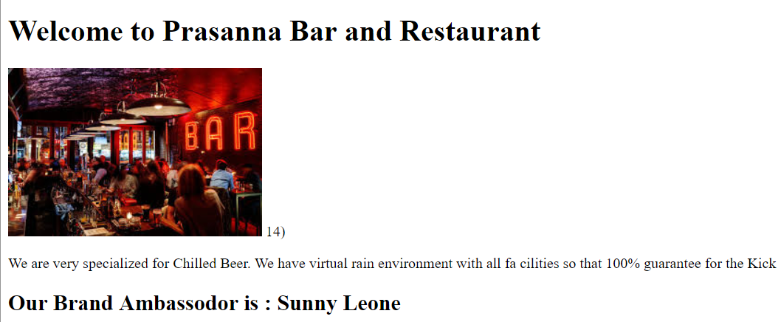

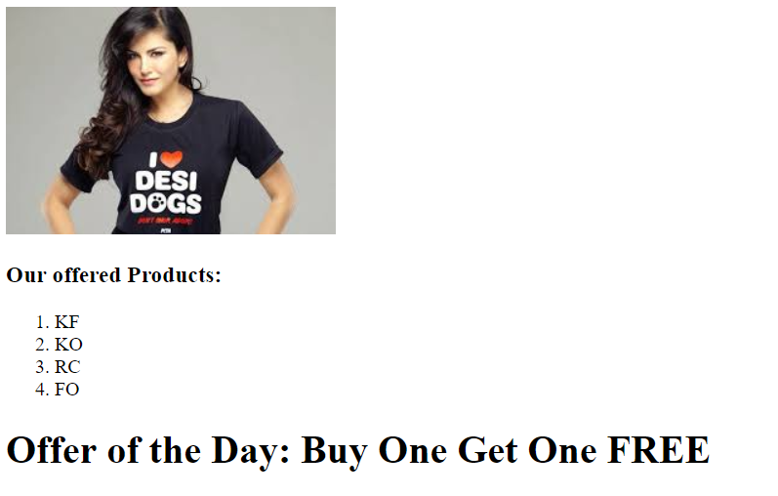

…………………………………………………………………………………………

1) <!doctype html>

2) <html lang="en">

3) <head>

4) <meta charset="UTF-8">

5) <meta name="Generator" content="EditPlus®">

6) <meta name="Author" content="">

7) <meta name="Keywords" content="">

8) <meta name="Description" content="">

9) <title>Prasanna Bar and Restaurant</title>

10) </head>

11) <body>

12) <h1>Welcome to Prasanna Bar and Restaurant</h1>

13) <img src="pbar.jpg" alt="image missing upload soon"> 14) <p>We are very specialized for Chilled Beer. We have virtual rain environment with all fa cilities so that 100% guarantee for the Kick</p>

15) <h2>Our Brand Ambassodor is : Sunny Leone</h2>

16) <img src="Sunny.jpg" alt="missing image"/>

17) <h3>Our offered Products:</h3>

18) <ol>

19) <li>KF</li>

20) <li>KO</li>

21) <li>RC</li>

22) <li>FO</li>

23) </ol>

24) <h1>Offer of the Day: Buy One Get One FREE</h1> 25) <p>View Our Profile:</p>

26) <a href="http://youtube.com">YouTube</a>

27) <a href="http://twitter.com">Twitter</a>

28) <a href="https://facebook.com">Facebook</a>

29) </body>

30) </html>

……………………………………………………………………………………………..*******************Table Creation:*****************:-

……………………………………………………………………………………………

We can use

<table> to create table

<thead> to specify head row

<th> to specify column data in head row(column name)

<tr> to insert row in the table

<td> to specify column data in the row/record

……………………………………………………….

We can use border attribute inside <table> tag

………………………

Eg

1) <table border="1">

2) <thead>

3) <th>ENO</th>

4) <th>ENAME</th>

5) <th>ESAL</th>

6) <th>EADDR</th>

7) </thead>

8) <tr>

9) <td>100</td>

10) <td>Prasanna</td>

11) <td>1000</td>

12) <td>Bangalore</td>

13) </tr>

14) <tr>

15) <td>200</td>

16) <td>SUNNY</td>

17) <td>2000</td>

18) <td>Mumbai</td>

19) </tr>

20) <tr>

21) <td>300</td>

22) <td>Bunny</td>

23) <td>3000</td>

24) <td>Chennai</td>

25) </tr>

26) </table>

…………………………………………………………………………………………….Oscar Awards Winners List 2018 Application(Assignment on tables):

1) <!doctype html>

2) <html lang="en">

3) <head>

4) <title>Oscar awards winners list</title>

5) </head>

6) <body>

7) <h1> Oscar Awards Winners List 2018</h1>

8) <table border="1">

9) <thead>

10) <th>S.No</th>

11) <th>Winner</th>

12) <th>Winner Pic</th>

13) <th>CatEgory</th>

14) <th>Country Log</th>

15) <th>View Profile</th>

16) </thead>

17) <tr>

18) <td>1</td>

19) <td>Sunny</td>

20) <td><img src="sunny.jpg" alt="Image not available"></td>

21) <td>Best Actress</td>

22) <td><img src="https://upload.wikimedia.org/wikipedia/en/thumb/4/41/Flag_of_Indi a.svg/255px-Flag_of_India.svg.png" alt="Image not available"></td>

23) <td><a href="http://youtube.com/Inventateqsoftware">View Info</a></td>

24) </tr>

25) </table>

26) </body>

27) </html>

…………………………………………………………………………………………….

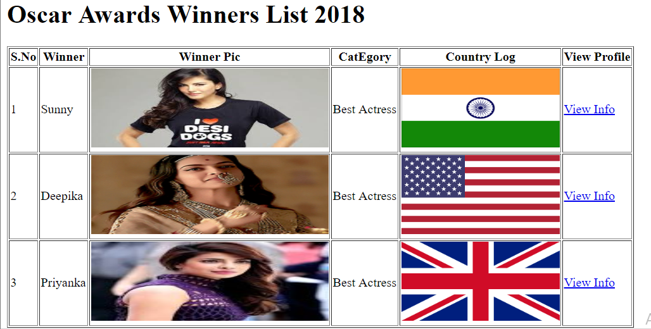

<!doctype html>

<html lang="en">

<head>

<title>Oscar awards winners list</title>

</head>

<body>

<h1> Oscar Awards Winners List 2018</h1>

<table border="1">

<thead>

<th>S.No</th>

<th>Winner</th>

<th>Winner Pic</th>

<th>CatEgory</th>

<th>Country Log</th>

<th>View Profile</th>

</thead>

<tr>

<td>1</td>

<td>Sunny</td>

<td><img src="Sunny.jpg" alt="Image not available" width="300" height="100"></td>

<td>Best Actress</td>

<td><img src="IndiaFlag.PNG" width="200" height="100"></td>

<td><a href="http://youtube.com/">View Info</a></td>

</tr>

<tr>

<td>2</td>

<td>Deepika</td>

<td><img src="Deepika.GIF" alt="Image not available" width="300" height="100"></td>

<td>Best Actress</td>

<td><img src="USFlag.PNG" width="200" height="100"></td>

<td><a href="http://youtube.com/">View Info</a></td>

</tr>

<tr>

<td>3</td>

<td>Priyanka</td>

<td><img src="Priyanka.JPG" alt="Image not available" width="300" height="100"></td>

<td>Best Actress</td>

<td><img src="UKFlag.PNG" width="200" height="100"></td>

<td><a href="http://youtube.com/">View Info</a></td>

</tr>

</table>

</body>

</html>

……………………………………………………………………………………………..*********Creation of HTML Forms: *****************:-

………………………………………………………………………………………

As the part of web application development, we have to develop several forms like login form, registration form etc

We can create Html form by using <form> tag.

<form class="" action="" method="">

.....

</form>

Within the form to collect end user input, we have to use <input> tag.

This <input> tag will play very important role in form creation.

syntax:- <input type="" name="" value=""/>

type attribute can be used to specify the type of input end user has to provide. The main important types are:

text

email

password

color

submit

checkbox

radio

etc

name attribute represents the name of input tag. By using this name,in the next target page we can access end user provided input value.

value attribute represents default value will be displayed in the form.

…………………………………………………………………………………………

Eg:-

<input type="text" name="username" value="Enter User Name"/>

<input type="email" name="mailid" value=""/>

<input type="password" name="pwd" value=""/>

<input type="checkbox" name="course" value=""/>

<input type="radio" name="married" value=""/>

…………………………………………………………………………………………

To provide default value it is highly recommended to use placeholder attribute because end user is not required to delete defualt value while entering data.

………………………………………………………………………………………

Eg: <input type="text" name="username" placeholder="Enter User Name"/>

…………………………………………………………………………………………

***********Creation of Labels for HTML Elements:*******

……………………………………………………………………………………….

We can define Label Text for our HTML Elements like Radio Buttons, Text Box etc by using <label> tag.

Syntax:<label for="name">Enter Name:</label>

…………………………………………………………………………

Eg1:

<p>Enter Name:</p>

<input type="text" name="username" placeholder="Enter Name">

…………………………………………………………………..

The result looks like

diagram

In this case there is no relation between text box and data.

To link data to text box,we have to use <label> tag.

<label for="name">Enter Name:</label>

<input id="name" type='text' name='username' placeholder='Name to Contact' >

…………………………………………………………………………………………….

The result looks like

Diagram

…………………………………………………………………………………

*************required attribute:-****************

……………………………………………………………………………………

If end user compulsory should required to provide input value then we should go for required attribute.

…………………………………………………..

Eg :-

<input id="name" type='text' name='username' placeholder='Name to Contact' required>

…………………………………………………………………………………

**************action attribute:*******************

…………………………………………………………………………………….

once we fill the form and click submit, then to which page it will go is decided by action attribute.The value of action attribute can be either local resource or web url.

Eg :-

<form action="target.html" >

<form action="https://facebook.com" >

………………………………………………………………………………………………Demo program:

Diagram

………………………………………………………………..

test.html

1) <!doctype html>

2) <html lang="en">

3) <head>

4) <title>Form Input</title>

5) </head>

6) <body>

7) <h1>User Contact Form</h1>

8) <form action="target.html">

9) <label for="name">Enter Name:</label>

10) <input id="name" type='text' name='username' placeholder='Name to Contact' required >

11) <input type="submit" value="ClickToContact">

12) </form>

13) </body>

14) </html>

…………………………………………………………………………………………….

target.html:

1) <!doctype html>

2) <html lang="en">

3) <head>

4) <title>Target HTML</title>

5) </head>

6) <body>

7) <h1>Thanks for Confirmation</h1>

8) </body>

9) </html>

………………………………………………………………………………………………************Implementing Radio Buttons:-************

…………………………………………………………………………………………….

1) <h3>Are you Married:</h3>

2) <label for='ma'>Yes</label>

3) <input id='ma' type='radio' name="married" value="">

4) <label for='ma1'>No</label>

5) <input id='ma1' type='radio' name="married" value="">

…………………………………………………………….

Eg2:

1) <h3>Gender:</h3>

2) <label for='m'>Male</label>

3) <input id='m' type='radio' name="gender" value="Male">

4) <label for='f'>Female</label>

5) <input id='f' type='radio' name="gender" value="Female"> 6) <label for='t'>Transgender</label>

7) <input id='t' type='radio' name="gender" value="Transgender">

…………………………………………………………………………………………

***Single Form but multiple submit buttons:-***********:-

……………………………………………………………………………………………

Ex-1:-

……………

<!doctype html>

<html lang="en">

<head>

<title>Form Demo</title>

</head>

<body>

<form action="Demo33_target.html">

Enter Some Thing<input type="text" name="username" >

<input type="submit" name="button" value="EDIT">

<input type="submit" name="button" value="DELETE">

<input type="submit" name="button" value="UPDATE">

</form>

</body>

</html>

………………………………..

Ex-2:-

……….

<!doctype html>

<html lang="en">

<head>

<title>Target HTML</title>

</head>

<body>

<h1>Thanks for Confirmation....These are Results</h1>

</body>

</html>

………………………………………………………………………………………………*****How to implement Drop down box/select box:*****:-

………………………………………………………………………………………………

1) <h3>Please Select Your Payment Mode:</h3>

2) <select name='pmode'>

3) <option value='ccard'>Credit Card</option>

4) <option value='dcard'>Dedit Card</option>

5) <option value='ppal'>Paypal</option>

6) <option value='otransfer'>OnlineTransfer</option>

7) </select>

…………………………………………………….

textarea element:

1) <h2>Enter Your FeedBack:</h2>

2) <textarea name="feedback" rows="8" cols="80">

…………………………………………………………………….

checkbox:

1) <form>

2) <h2>Choose Your Known Languages:</h2>

3) <input type="checkbox" name="languages" value="english" checked> English<br>

4) <input type="checkbox" name="languages" value="kannada"> Kannada<br>

5) <input type="checkbox" name="languages" value="hindi"> Hindi<br>

6) <input type="checkbox" name="languages" value="tamil"> Tamil<br>

7) </form>

……………………………………………………………………………………………

************************************************************************END**************************************************************************