

>>>>>>>>>>>>>>>>>>>>>>>>>>>>>>>>>>>>>>>>>>>>>>>>>>

***Full Stack Web Development with Python and DJango ***

*****************2. CSS **************************:-

………………………………………………………………………………………………

-----------------------------Introduction----------------……..------------:-

………………………………………………………………………………..…………….

Module-2: CSS (Cascading Style Sheets)

The main objective of CSS to add styles to HTML. CSS describes how HTML elements are displayed on a page.

Styling includes colors,fonts,size,borders etc

We can define CSS styling inside HTML. But it is highly recommended to define styling inside a seperate CSS file(.css extension) and link that file to HTML.

The power of CSS demo link: <https://www.w3schools.com/Css/css_intro.asp>

…………………………………………………………………………………………….

****Various ways to define Style for HTML Elements: *****:-

……………………………………………………………………………………………..

We can define style in 3 ways

1. In Line

2. By using style tag

3. By using css file

……………………………………………………………………………………………

1. In Line:-

……………………….

<h1 style="color:red">This is My First Part of Data</h1>

define style at tag level is not recommended b'z it increases complexity as every html page contains 1000s of tags

………………………………………………………………………………………….

2. By using style tag:-

……………………………………………………………………

<!DOCTYPE html>

<html lang="en" dir="ltr">

<style media="screen">

body

{

background: blue;

}

h1{

color: grey;

}

h2

{

color: red;

}

</style>

<head>

<meta charset="utf-8">

<title>Sample Style css</title>

</head>

<body>

<h1>This is My First Part of Data</h1>

<h1>This is My First Part of Data</h1>

<h2>This is My Second Part of heading</h2>

<h1>This is My First Part of Data</h1>

<h1>This is My First Part of Data</h1>

</body>

</html>

……………………………………………………………………………

1) <html >

2) <head>

3) ...

4) <style type="text/css">

5) h1{

6) color:blue;

7) }

8) </style>

9) </head>

10) ...

11) </html>

This way of defining style is not recommended because it is applicable only for current page but not for remaining pages.

…………………………………………………………………………………

3. By using css file:

………………………………….

style1.css :-

1) h1{

2) color:red;

3) }

4)

5) <head>

6) <link rel="stylesheet" href="style1.css">

7) </head>

We can reuse same css file for every html page so that we can promote code reusability. Hence this approach is highly recommended to use.

……………………………………………………………………………….

Basic Structure of CSS File:

1) tagname{

2) property:value;

3) }

………………………………………………

Eg:

1) h1{

2) color:red;

3) }

….…………………….

Once we defined css file, we can link it to html by using <link> tag inside <head> part of html.

1) <head>

2) <link rel="stylesheet" href="form.css">

3) </head>

………………………………………………………………………………………………How to define comments in css file:

/* This is CSS comment */

Demo Application-1:

1) <!DOCTYPE html>

2) <html lang="en" dir="ltr">

3) <head>

4) <meta charset="utf-8">

5) <link rel="stylesheet" href="style1.css">

6) <title>CSS Demo</title>

7) </head>

8) <body>

9) <h1>This is First CSS Example</h1>

10) <p>Here we are going to discuss just basics of css like how to define and how to link etc< /p>

11) <h2>The List of Topics are:</h2>

12) <ul>

13) <li>Topic-1</li>

14) <li>Topic-2</li>

15) <li>Topic-3</li>

16) <li>Topic-4</li>

17) <li>Topic-5</li>

18) </ul>

19) <h3>Soon we will discuss remaining things</h3>

20) </body>

21) </html>

…………………………………………………………………………..

style1.css:

1) h1{

2) color: red;

3) }

4) h2{

5) color: blue;

6) }

7) h3{

8) color:green;

9) }

10) p{

11) color:blue;

12) }

13) ul{

14) color:cyan;

15) }

……………………………………………………………………………………………..********Various possible ways to specify color:**********

……………………………………………………………………………………..

1. color:red;

2. color:rgb(244,66,220);

we have to collect values from google color picker

The allowed values are: 0 to 255

(0,0,0)--->black

(255,255,255)-->white

3. color:#f44e42

This 6-digit number represents hexa code of color

4. color:rgba(244,66,220,0.9)

a means alpha

The allowed values for a attribute are : 0.0 to 1.0

1.0 means full dark and 0.0 means full light(transparent)

http://www.december.com/html/spec/colorrgbadec.html

…………………………………………………………………………………….

Note: The most commonly used approach is: hexa code

……………………………………………………………………………..

********Setting Background and Borders:************:-

………………………………………………………………………………………

In CSS, we can set Background as follows:

1) body{

2) background-color:red;

3) }

……………………………………………

We can set Border as follows:-

…………………………………………..

1) div{

2) border-color:blue;

3) border-width:thick;

4) border-style:double;

5) }

……………………………….

The allowed values for border-width are:

……………………………..

medium,thin,thick.

We can also set our own width with pixels.

……………………………..

Eg: border-width:10px;

………………………..

The allowed values for border-style are:

dashed,dotted,groove,double etc

………………………………………………………………….

Eg:

1) span{

2) color:yellow;

3) background: green;

4) }

……………………………………………………………

color vs background:-

…………………………………….

color attribute meant for text color

background attribute meant for background color

1) h1{

2) color:white;

3) background:blue;

4) }

…………………………………………………….

**********How to Set Background Image:**********:-

…………………………………………………………………………………

1) body {

2) background:url(https://image.freepik.com/free-psd/abstract-background-design_129773.jpg);

3) }

……………………………………………………………………………………………..********Various properties while setting image:******:-

……………………………………………………………………………………….

1) body{

2) color:white;

3) background:url(https://images.pexels.com/photos/257360/pexels-photo257360.jpeg?auto=compress&cs=tinysrgb&h=350);

4) background-repeat: no-repeat;

5) background-size: cover;

6) }

By default background image will be repeated. If we don't want to repeat then we should specify: no-repeat

………………………………………………………………………………………

**********How to set border:*************:-

…………………………………………………………………………………….

Normal way:-

1) h1{

2) border-color: orange;

3) border-width: 5px;

4) border-style: solid;

5) }

………………………………………………………….

short-cut way:

1) h1{

2) border: solid red 5px; order is not important

3) }

…………………………………………………………………..

To set border for the image: -

………………………………………..

1) img{

2) border: groove 10px blue;

3) }

………………………………………………………………………………………..

***************Basic CSS Selectors:************

………………………………………………………………………………………..

1. Element Selectors:

select all instances of given element. i.e style is applicable for every tag of the specified type.

1) h1{

2) color:red;

3) }

This style applicable for every h1 tag of the html page.

……………………………………………………………………………………

2. ID Selectors: -

………………………

Selects an element with the given Id. But with in the HTML Page ID is always unique.

html:-

<h1 id="specialh1">Hello This is First Line</h1>

…………………………………………………………..

css:

1) #specialh1{

2) color:white;

3) background: blue;

4) }

………………………………………………………………………………..

3. Class Selector: -

……………………………

Select all elements with the given class.

html:

1) <body>

2) <h1 class="specialh1">Hello This is First Line</h1>

3) <h1>Hello This is Second Line</h1>

4) <h1 class="specialh1">Hello This is Third Line</h1>

5) </body>

………………………………….

css:

1) specialh1{

2) color:white;

3) background: blue;

4) }

………………………………………………………….

Note: element,id and class selectors are considered as basic css selectors.

……………………………………………………………………………………………

***************Advanced CSS Selectors:-**************

……………………………………………………………………………………………

The following are main important advanced selectors

1. * selector

2. Descendant Selector

3. Adjacent Selector

4. Attribute Selector

5. nth of type selector

………………………………………………………………………………………………

*****Demo HTML Page for CSS Selectors:-********

……………………………………………………………………………………………

1) <!DOCTYPE html>

2) <html lang="en" dir="ltr">

3) <head>

4) <meta charset="utf-8">

5) <title>CSS Demo</title>

6) <link rel="stylesheet" href="style1.css">

7) </head>

8) <body>

9) <h1>Advanced Selectors Demo</h1>

10) <a href="http://google.com">Click Here to go to Google</a>

11) <ul>

12) <li>CAT</li>

13) <li>RAT</li>

14) <li>DOG</li>

15) </ul>

16) <h4>List of Top Movies</h4>

17) <ul>

18) <li>Bahubali</li>

19) <li>MAHANATI</li>

20) <li>RANGASTALAM</li>

21) </ul>

22) <h4>List of Top Websites</h4>

23) <ul>

24) <li><a href="http://amazon.com">AMAZON</a> </li> 25) <li><a href="http://flipkart.com">FlipKart</a> </li> 26) <li><a href="http://paytm.com">PAYTM</a> </li>

27) </ul>

28) </body>

29) </html>

……………………………………………………………………………………………..1. * selector:-

……………………

* means everything. This style is applicable for every thing in the web page.

1) *{

2) color:blue;

3) }

………………………………………………………………………………………………2. Descendant Selector:

1) li a{

2) color:white;

3) background: blue;

4) }

li is considered as parent tag and a is considered as child tag. For every anchor tag present in li tag this style is applicable

……………………………………………………………………………………………..

3. Adjacent Selector:

1) a+ul{

2) color: red;

3) }

For every ul tag which is adjacent to a tag,this style is applicable.

1) div+p{

2) color:blue;

3) }

For every paragraph tag, which is adjacent to div tag this style is applicable.

……………………………………………………………………………………………

4. Attribute Selector:

……………………………..

We can define style based on attributes.

Eg 1:

1) a[href]{

2) color:red;

3) background: yellow;

4) }

………………………………………….

For all href attributes of anchor tag this style is applicable.

……………………………………………………………………………………………..Eg 2:

1) a[href="http://amazon.com"]{

2) color:red;

3) background: yellow;

4) }

……………………………….

If the value of href attribute is http://amazon.com then only this style is applicable.

1) input[type="password"]

2) {

3) background:red;

4) }

This style is applicable for all password fields of input tag.

…………………………………………………………………………………………….

5. nth of type selectors:

…………………………………………

1) li:nth-of-type(2){

2) color:red;

3) }

For every 2nd li tag this style is applicable.

…………………………………………………………………

1) ul:nth-of-type(2){

2) color:red;

3) background: yellow;

4) }

………………………………….

For every 2nd ul tag this style is applicable.

1) li:nth-of-type(even){

2) color:red;

3) }

For every even numbered li this style is applicable.

………………………………………………………………………………………………

**************CSS Inheritance:-****************:-

………………………………………………………………………………………………

All properties of the parent are by default available to the child and we are not required to redefine. This property is called inheritance.

Inheritance concept applicable for css styles also. i.e what every styles are defined for the parent automatically avilable to the child tags also.

……………………………………………………

Eg:

1) body{

2) color:red;

3) }

This style is applicable for all elements present in side body tag.

………………………………………………………………………………………………

Eg:

1) ul{

2) color:red;

3) }

This style is also applicable for all <li> tags inside <ul> tag.

……………………………………………………………………………………………

******************CSS Specificity:******************

………………………………………………………………………………………..

If multiple styles are available for element then most specific style will be considered.This property is called Specificity of CSS.

Eg:

1) body{

2) color:red;

3) }

4) ul{

5) color:blue;

6) }

7) li{

8) color:green;

9) }

For <li> tag 3 styles are avilable but css will consider most specific style from <li> tag which is nothing but green color.

……………………………………………………………………………………………..*****************CSS Styles Assignment-1:***********

…………………………………………………………………………………………..

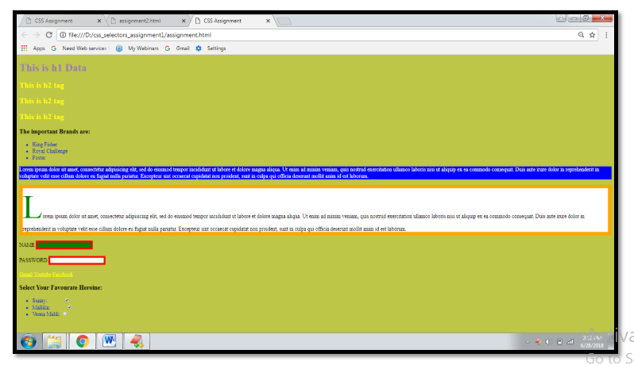

assignment.html:

1) <!DOCTYPE html>

2) <html lang="en" dir="ltr">

3) <head>

4) <meta charset="utf-8">

5) <title>CSS Assignment</title>

6) <link rel="stylesheet" href="assignment.css">

7) </head>

8) <body>

9) <h1>This is h1 Data</h1>

10) <h2>This is h2 tag</h2>

11) <h2>This is h2 tag</h2>

12) <h2>This is h2 tag</h2>

13) <h3>The important Brands are:</h3>

14) <ul>

15) <li>King Fisher</li>

16) <li>Royal Challenge</li>

17) <li>Foster</li>

18) </ul>

19) <p class="hello">Lorem ipsum dolor sit amet, consectetur adipisicing elit, sed do eiusmo d tempor incididunt ut labore et dolore magna aliqua. Ut enim ad minim veniam, quis nost rud exercitation ullamco laboris nisi ut aliquip ex ea commodo consequat. Duis aute irure dolor in reprehenderit in voluptate velit esse cillum dolore eu fugiat nulla pariatur. Excepteur sint occaecat cupidatat non proident, sunt in culpa qui officia deserunt mollit anim id e st laborum.</p>

20)

21) <p id="special">Lorem ipsum dolor sit amet, consectetur adipisicing elit, sed do eiusmod tempor incididunt ut labore et dolore magna aliqua. Ut enim ad minim veniam, quis nostr ud exercitation ullamco laboris nisi ut aliquip ex ea commodo consequat. Duis aute irure d olor in reprehenderit in voluptate velit esse cillum dolore eu fugiat nulla pariatur. Excepte ur sint occaecat cupidatat non proident, sunt in culpa qui officia deserunt mollit anim id es t laborum.</p>

22) <label for="name">Name</label>

23) <input type="text" id="name" name="username" value=""><br><br>

24) <label for="pwd">Password</label>

25) <input id="pwd" type="password" name="password" value=""><br><br>

26)

27) <a href="http://www.gmail.com">Gmail</a>

28) <a href="http://www.youtube.com">Youtube</a>

29) <a href="http://www.facebook.com">Facebook</a> 30)

31) <h3>Select Your Favourate Heroine:</h3>

32) <ul>

33) <li>Sunny: <input type="checkbox" name="" value="" checked> </li>

34) <li>Mallika: <input type="checkbox" name="" value="" checked> </li>

35) <li>Veena Malik: <input type="checkbox" name="" value="" > </li>

36) </ul>

37) </body>

38) </html>

……………………………………………………………..

assignment.css:

1) body{

2) background:#bdc646;

3) }

4) h1{

5) color:#9b79b8;

6) }

7) h2{

8) color:yellow;

9) }

10) li{

11) color:#0518c4;

12) }

13) p{

14) background:white;

15) }

16) input{

17) border:5px red solid;

18) }

19) .hello{

20) background:blue;

21) color:white;

22) }

23)

24) #special{

25) border: 10px orange solid;

26) }

27) input[type="text"]{

28) background:green;

29) }

30) input:checked{

31) margin-left:50px;

32) }

33)

34) label{

35) text-transform: uppercase;

36) }

37) #special:first-letter{

38) color:green;

39) font-size:100px;

40) }

41) h1:hover{

42) color:white;

43) border:10px red solid;

44) }

45) a:visited{

46) color:yellow;

47) }

……………………………………………………….

Notes:

1. Set body tag background color with #bdc646

1. body{

2. background:#bdc646;

3. }

…………………………………………………………..

2. Set h1 text color with #9b79b8

1) h1{

2) color:#9b79b8;

3) }

……………………………………………………………..

3. Make all h2 tags with yellow color

1) h2{

2) color:yellow;

3) }

…………………..…………………………………………………….

4. Make all <li> elements with blue color,but consider hexa code

1) li{

2) color:#0518c4;

3) }

…………………………………………………………………………………………

5. Change background for every paragraph with white color

1) p{

2) background:white;

3) }

……………………………………………………………………………………………

6. Make all inputs have a 5px border with red color

1) input{

2) border:5px red solid;

3) }

…………………………………………………………………………………………….

7. Set blue background with class attribute hello and text color as white

1) .hello{

2) background:blue;

3) color:white;

4) }

……………………………………………………………………………………………..8. Give 10px orange solid border for id attribute "special"

1) #special{

2) border: 10px orange solid;

3) }

……………………………………………………………………………………………

9. Make only inputs with type 'text' have a green background

1) input[type="text"]{

2) background:green;

3) }

………………………………………………………………………………………….

10. Make all "checked" check boxes have a left margin of 50px

1) input:checked{

2) margin-left:100px;

3) }

…………………………………………………………………………………………..

11. Make the <label> elements all UPPERCASE without changing in html

1) label{

2) text-transform:uppercase;

3) }

………………………………………………………………………………………………12. Make the first letter of the element with id "special" with green color and 100 px font-size

1) #special:first-letter{

2) color:green;

3) font-size:100px;

4) }

……………………………………………………………………………………………..13. Make <h1> element color change to white when hovered and give 10px solid red border

1) h1:hover{

2) color:white;

3) border:10px red solid;

4) }

………………………………………………………………………………………………14. Make all <a> elements that have been visited with yellow color

1) a:visited{

2) color:yellow;

3) }

……………………………………………………………………………………………..****************CSS Styles Assignment-2:************:-

…………………………………………………………………………………………….

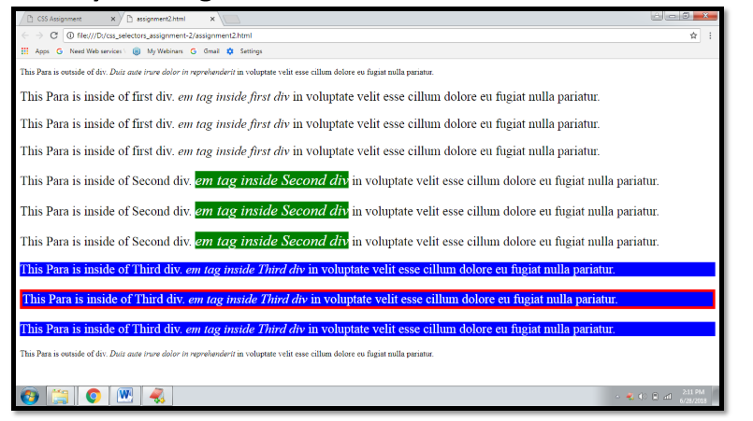

assignment2.html:

1) <!DOCTYPE html>

2) <html lang="en" dir="ltr">

3) <head>

4) <meta charset="utf-8">

5) <link rel="stylesheet" href="assignment2.css">

6) <title></title>

7) </head>

8) <body>

9) <p>This Para is outside of div. <em> Duis aute irure dolor in reprehenderit</em> in volu ptate velit esse cillum dolore eu fugiat nulla pariatur. </p>

10)

11) <div>

12) <p>This Para is inside of first div. <em> em tag inside first div</em> in voluptate velit e sse cillum dolore eu fugiat nulla pariatur. </p>

13)

14) <p>This Para is inside of first div. <em> em tag inside first div</em> in voluptate velit e sse cillum dolore eu fugiat nulla pariatur. </p>

15)

16) <p>This Para is inside of first div. <em> em tag inside first div</em> in voluptate velit e sse cillum dolore eu fugiat nulla pariatur. </p>

17) </div>

18)

19) <div>

20) <p>This Para is inside of Second div. <em> em tag inside Second div</em> in voluptate velit esse cillum dolore eu fugiat nulla pariatur. </p>

21)

22) <p>This Para is inside of Second div. <em> em tag inside Second div</em> in voluptate velit esse cillum dolore eu fugiat nulla pariatur. </p>

23)

24) <p>This Para is inside of Second div. <em> em tag inside Second div</em> in voluptate velit esse cillum dolore eu fugiat nulla pariatur. </p>

25) </div>

26)

27) <div>

28) <p>This Para is inside of Third div. <em> em tag inside Third div</em> in voluptate velit esse cillum dolore eu fugiat nulla pariatur. </p>

29)

30) <p>This Para is inside of Third div. <em> em tag inside Third div</em> in voluptate velit esse cillum dolore eu fugiat nulla pariatur. </p>

31)

32) <p>This Para is inside of Third div. <em> em tag inside Third div</em> in voluptate velit esse cillum dolore eu fugiat nulla pariatur. </p>

33) </div>

34) <p>This Para is outside of div. <em> Duis aute irure dolor in reprehenderit</em> in volu ptate velit esse cillum dolore eu fugiat nulla pariatur. </p>

35) </body>

36) </html>

………………………………………………………………………………………………

assignment2.css:

1) div p{

2) font-size: 25px;

3)

4) }

5)

6) div:nth-of-type(3) p{

7) background:blue;

8) color:white;

9) }

10)

11) div:nth-of-type(3) p:nth-of-type(2){

12) border: 5px red solid;

13) }

14)

15) div:nth-of-type(2) em{

16) color: white;

17) font-size:30px;

18) background:green;

19) }

………………………………………………………………………………………………

Notes:

……………

Case-1: Make all <p>s That are nested inside div with 25px font-size

1) div p{

2) font-size: 25px;

3)

4) }

……………………………………………………………………………………………..Case-2: Give all <p>s in side 3rd div blue background and text color is white

1) div:nth-of-type(3) p{

2) background:blue;

3) color:white;

4) }

……………………………………………………………………………………………..Case-3: Give 2nd <p> inside 3rd div, 5px red solid border

1) div:nth-of-type(3) p:nth-of-type(2){

2) border: 5px red solid;

3) }

……………………………………………………………………………………………..Case-4: Make <em> tag in the 2nd <div> with white color 30 px font-size and green background

1) div:nth-of-type(2) em{

2) color: white;

3) font-size:30px;

4) background:green;

5) }

……………………………………………………………………………………………..*************Fonts and Text in CSS:***************:-

………………………………………………………………………………………………

The following are very important properties related to fonts and text in css

1. font-family

2. font-size

3. font-weight

4. line-height

5. text-align

6. text-decoration

…………………………………………………………………………………………..

1. font-family:-

.......................

We can select desired font from default css system fonts in the following link

https://www.cssfontstack.com/

……………………………………..

Eg:

1) h1{

2) font-family: Arial Black;

3) }

…………………………………………………

Note: If we are not satisfied with default css system fonts, then we can use external fonts also.

……………………………………………………………………………………………

1. font-size: -

............................

1) p{

2) font-size: 20px;

3) }

We can also specify font-size in em units, which is also known as dynamic font-size (relative fontsize)

………………………………………………………………………………………………

Eg:

1) span{

2) font-size: 2.0em;

3) }

2.0em means double of parent tag font-size

……………………………………………………………………………………………..

1. font-weight: -

……………………………………………

1) p{

2) font-weight: 600;

3) }

something like bold font,light font etc

The different allowed values are:

bold,bolder,lighter,normal

100 to 900 where 100 means light and 900 means too much bold.

…………………………………………………………………………………….

4. line-height: -

………………………….

The space between 2 lines is called line height.

1) p{

2) line-height: 1.5;

3) }

……………………………………………………………………………………………..5. text-align:

1) p{

2) text-align:center;

3) }

The allowed values are: left,rigth,center,justify

………………………………………………………………………………………….

6. text-decoration:-

……………………………………..

like underlined,strike through

…………………

Eg:

1) p{

2) text-decoration: line-through;

3) }

The allowed values are: underline, overline, line-through

………………………………………………………………………………………………

*********How to use Custom Fonts in CSS:************

………………………………………………………………………………………………

Most of the times we can select custom fonts from the google.

https://fonts.google.com/

select required fonts and add that link in html header part.

Inside css file specify that font wint font-family attribute.

demo.html:

1) <!DOCTYPE html>

2) <html lang="en" dir="ltr">

3) <head>

4) <meta charset="utf-8">

5) <title>Demo for CSS</title>

6) <link rel="stylesheet" href="demo.css">

7) <link href="https://fonts.googleapis.com/css?family=Eater|Great+Vibes|Indie+Flower" rel="stylesheet">

8) </head>

9) <body>

10) <h1>This is Heading</h1>

11) <p>Lorem ipsum dolor sit amet, consectetur adipisicing elit, sed do eiusmod tempor incid idunt ut labore et dolore magna aliqua. <span>Ut enim ad minim veniam, quis nostrud exe rcitation ullamco laboris nisi ut aliquip ex ea commodo consequat</span>. Duis aute irure dolor in reprehenderit in voluptate velit esse cillum dolore eu fugiat nulla pariatur. Except eur sint occaecat cupidatat non proident, sunt in culpa qui officia deserunt mollit anim id e st laborum.</p> 12) </body>

13) </html>

…………………………………………………………..

demo.css:

1) body{

2) font-family: 'Great Vibes', cursive;

3) font-size:30px;

4) }

………………………………………………………………………………………………**********The Box Model:-***************

……………………………………………………………………………………………

In a document, each element is represented as a rectangular box. In CSS, each of these rectangular boxes is decribed by using the stanadard box model.

Each box has 4 edges:

1. Content Edge

2. Border Edge

3. Padding Edge

4. Margin Edge

………………………………………………………………………………………………

CSS Box Model Diagram -1 :-

…………………………………………………………..

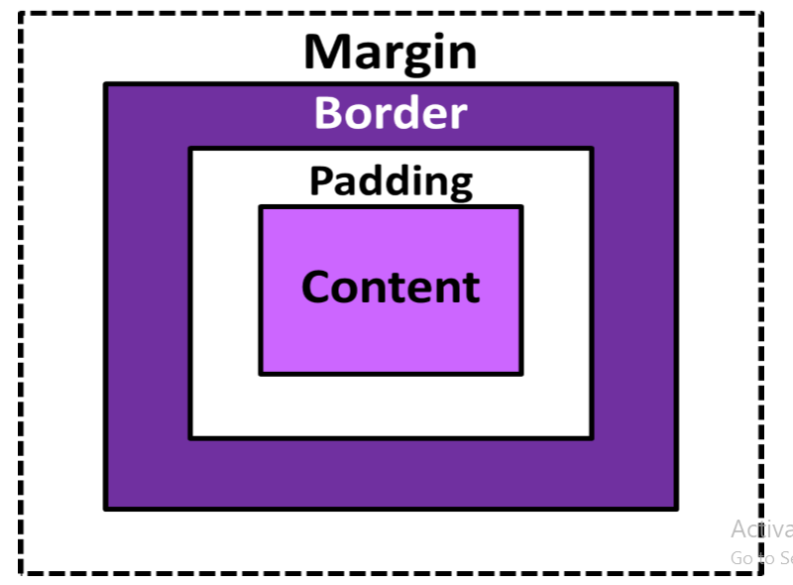

……………………………………………………………………………………………

CSS Box Model Diagram -2 :-

…………………………………………………

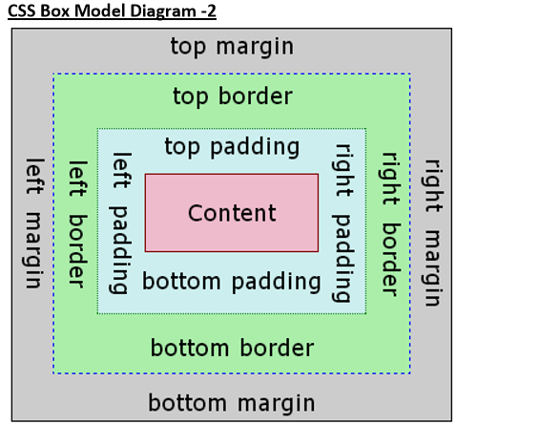

……………………………………………………………………………………………

Demo Program:

1) <p>This is Paragraph</p>

2) <p>This is Paragraph</p>

……………………………………………………………..

css:

1) p{

2) width: 200px;

3) border: 3px solid blue;

4) padding: 40px 50px 60px 70px;

5) margin:100px 5px 300px 400px;

6)

7) }

……………………………………………………………………………………………

**********Vibgyor Implementation:-************

………………………………………………………………………………………….

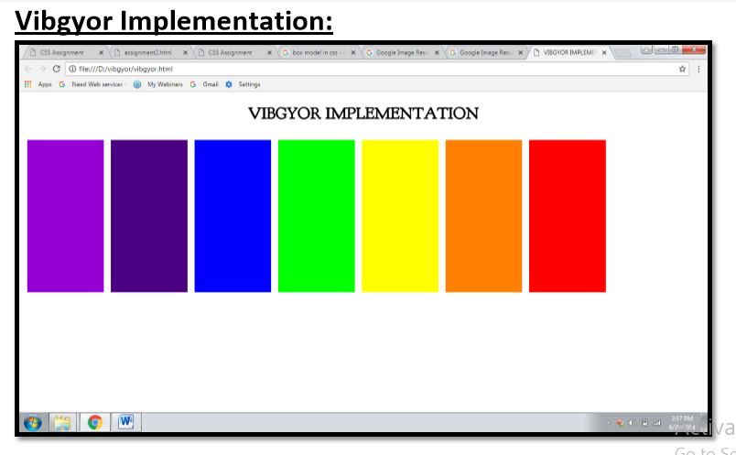

vibgyor.html:

1) <!DOCTYPE html>

2) <html lang="en" dir="ltr">

3) <head>

4) <meta charset="utf-8">

5) <title>VIBGYOR IMPLEMENTATION</title>

6) <link rel="stylesheet" href="vibgyor.css">

7) <link href="https://fonts.googleapis.com/css?family=Goudy+Bookletter+1911" rel="styl esheet">

8) </head>

9) <body>

10) <h1>VIBGYOR IMPLEMENTATION</h1>

11) <table class='tab'>

12) <tr>

13) <td id="one"></td>

14) <td id="two"></td>

15) <td id="three"></td>

16) <td id="four"></td>

17) <td id="five"></td>

18) <td id="six"></td>

19) <td id="seven"></td>

20) </tr>

21) </table>

22)

23) </body>

24) </html>

………………………………………………………………………………………..

vibgyor.css:

1) h1{

2) font-family: 'Goudy Bookletter 1911', serif;

3) text-align: center;

4) }

5)

6) td{

7) height:300px;

8) width:150px;

9) border: 6px solid white;

10)

11) }

12) #one{

13) background: #9400D3;

14) }

15) #two{

16) background: #4B0082;

17) }

18) #three{

19) background: #0000FF ;

20) }

21) #four{

22) background: #00FF00 ;

23) }

24) #five{

25) background: #FFFF00;

26) }

27) #six{

28) background: #FF7F00;

29) }

30) #seven{

31) background: #FF0000;

32) }

………………………………………………………………………………………………************Chess Board Implementation:-************

……………………………………………………………………………………………

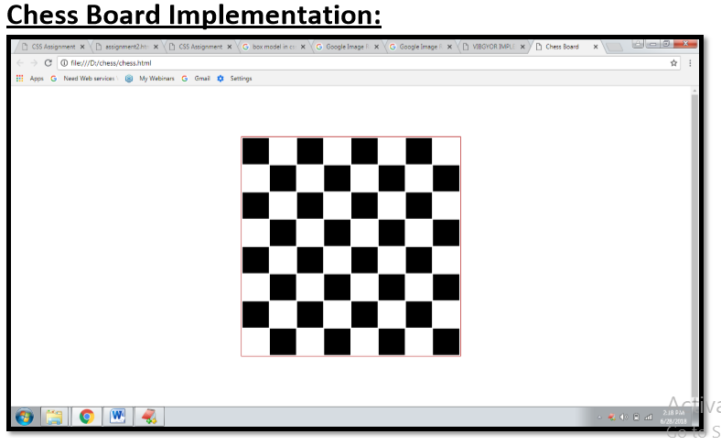

chess.html:

1) <!DOCTYPE html>

2) <html lang="en" dir="ltr">

3) <head>

4) <meta charset="utf-8">

5) <title>Chess Board</title>

6) <link rel="stylesheet" href="chess.css">

7) </head>

8) <body>

9) <table>

10) <tr>

11) <td id="black"></td>

12) <td id="white"></td>

13) <td id="black"></td>

14) <td id="white"></td>

15) <td id="black"></td>

16) <td id="white"></td>

17) <td id="black"></td>

18) <td id="white"></td>

19) </tr>

20) <tr>

21)

22) <td id="white"></td>

23) <td id="black"></td>

24) <td id="white"></td>

25) <td id="black"></td>

26) <td id="white"></td>

27) <td id="black"></td>

28) <td id="white"></td>

29) <td id="black"></td>

30) </tr>

31) <tr>

32) <td id="black"></td>

33) <td id="white"></td>

34) <td id="black"></td>

35) <td id="white"></td>

36) <td id="black"></td>

37) <td id="white"></td>

38) <td id="black"></td>

39) <td id="white"></td>

40) </tr>

41) <tr>

42)

43) <td id="white"></td>

44) <td id="black"></td>

45) <td id="white"></td>

46) <td id="black"></td>

47) <td id="white"></td>

48) <td id="black"></td>

49) <td id="white"></td>

50) <td id="black"></td>

51) </tr>

52) <tr>

53) <td id="black"></td>

54) <td id="white"></td>

55) <td id="black"></td>

56) <td id="white"></td>

57) <td id="black"></td>

58) <td id="white"></td>

59) <td id="black"></td>

60) <td id="white"></td>

61) </tr>

62) <tr>

63)

64) <td id="white"></td>

65) <td id="black"></td>

66) <td id="white"></td>

67) <td id="black"></td>

68) <td id="white"></td>

69) <td id="black"></td>

70) <td id="white"></td>

71) <td id="black"></td>

72) </tr>

73) <tr>

74) <td id="black"></td>

75) <td id="white"></td>

76) <td id="black"></td>

77) <td id="white"></td>

78) <td id="black"></td>

79) <td id="white"></td>

80) <td id="black"></td>

81) <td id="white"></td>

82) </tr>

83) <tr>

84)

85) <td id="white"></td>

86) <td id="black"></td>

87) <td id="white"></td>

88) <td id="black"></td>

89) <td id="white"></td>

90) <td id="black"></td>

91) <td id="white"></td>

92) <td id="black"></td>

93) </tr>

94) </table>

95)

96) </body>

97) </html>

………………………………………………………………………………………………chess.css:

1) table{

2) border:1px groove red;

3) margin: 100px auto;

4) }

5) td{

6) height:50px;

7) width:50px;

8) }

9) #white{

10) background: white;

11) }

12) #black{

13) background: black;

14) }

************************************************************************END**************************************************************************