PRACTICAL -3
OBJECTIVE- CREATE AN S3 BUCKET IN AWS
1. Log in to AWS Management Console
- Go to AWS Console.
- Sign in with your AWS account credentials.

2. Navigate to S3
- In the search bar at the top, type S3.
- Click on S3 (Scalable Storage in the Cloud).

3. Create a New Bucket
- Click on “Create bucket” button.
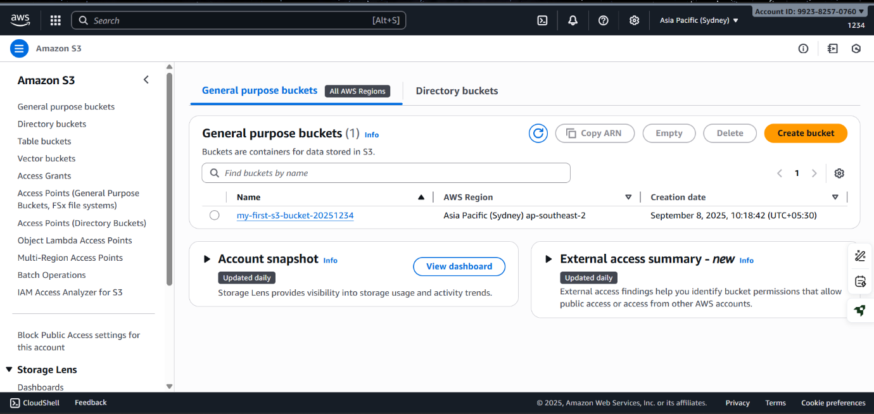

4. Configure Bucket Settings
- Bucket name: Enter a unique name (e.g., my-first-s3-bucket-2025).
Bucket names must be globally unique across AWS.
- AWS Region: Select a region (choose one closest to your users for better performance).
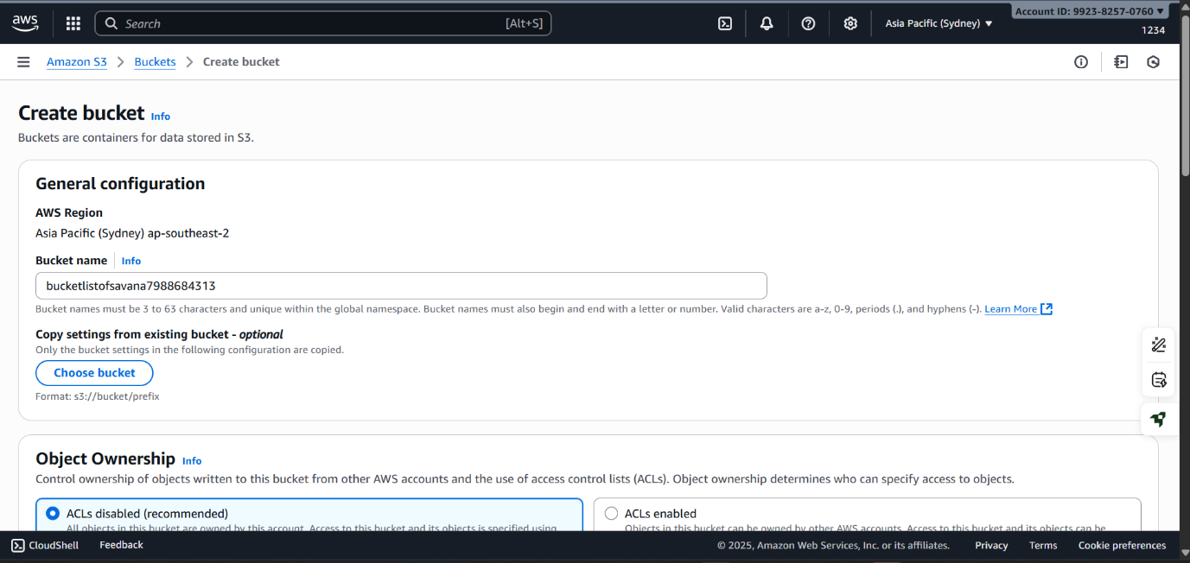

5. Set Bucket Options
- Object Ownership:
  - Choose ACLs disabled (recommended) for most use cases.
- Block Public Access:
  - By default, all public access is blocked (recommended for private buckets).
  - If you need a public bucket (for hosting static websites), uncheck the option and acknowledge the warning.

6. Configure Bucket Settings (Optional)
- Versioning: Enable if you want to keep multiple versions of an object.
- Encryption: Enable default encryption if required.
- Tags: Add key-value tags if you want to manage cost tracking or organization.

7. Review and Create
- Review your settings.
- Click Create bucket.
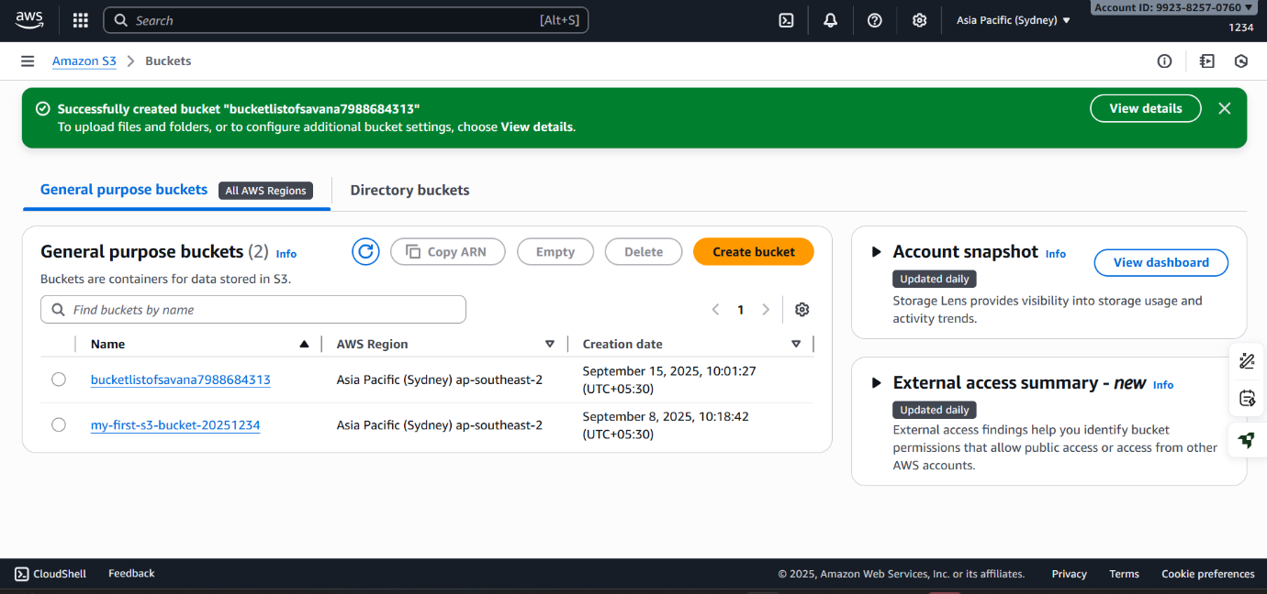

8. Upload Objects (Optional)
- After creation, open the bucket.
- Click Upload → Add files.
- Select your file(s), then click Upload.
