PRACTICAL-1

OBJECTIVE - TO CREATE EC2 INSTANCE
Steps to Create an EC2 Instance
- Login to AWS
  - Go to AWS Management Console.
  - Sign in with your credentials.
- Navigate to EC2
  - In the search bar, type EC2 and select it.
- Launch Instance
  - Click Instances → Launch Instance.
  - Give your instance a name.
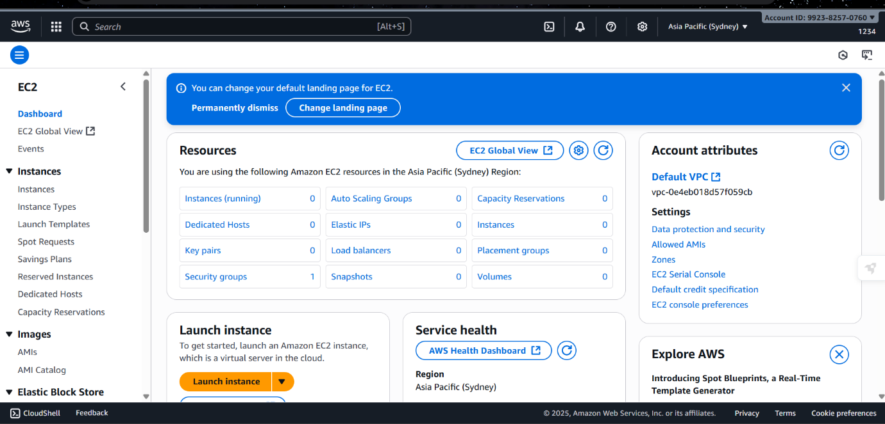
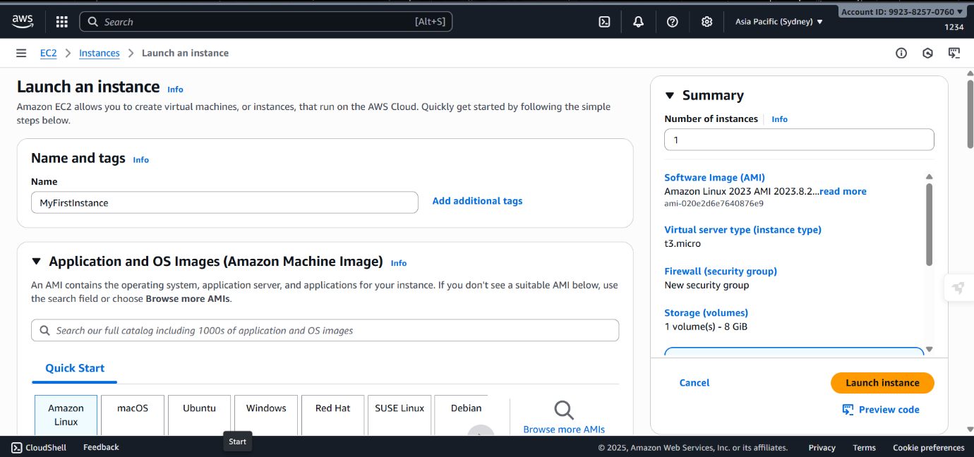

- Choose Amazon Machine Image (AMI)
  - Select an OS image (e.g., Amazon Linux 2, Ubuntu, Windows).
  - For beginners, choose Amazon Linux 2 (Free tier eligible).
- Choose Instance Type
  - Select t2.micro (free tier eligible).
- Configure Key Pair
  - Create a new key pair (RSA) and download the .pem file.
  - This will be used later to connect to your instance.
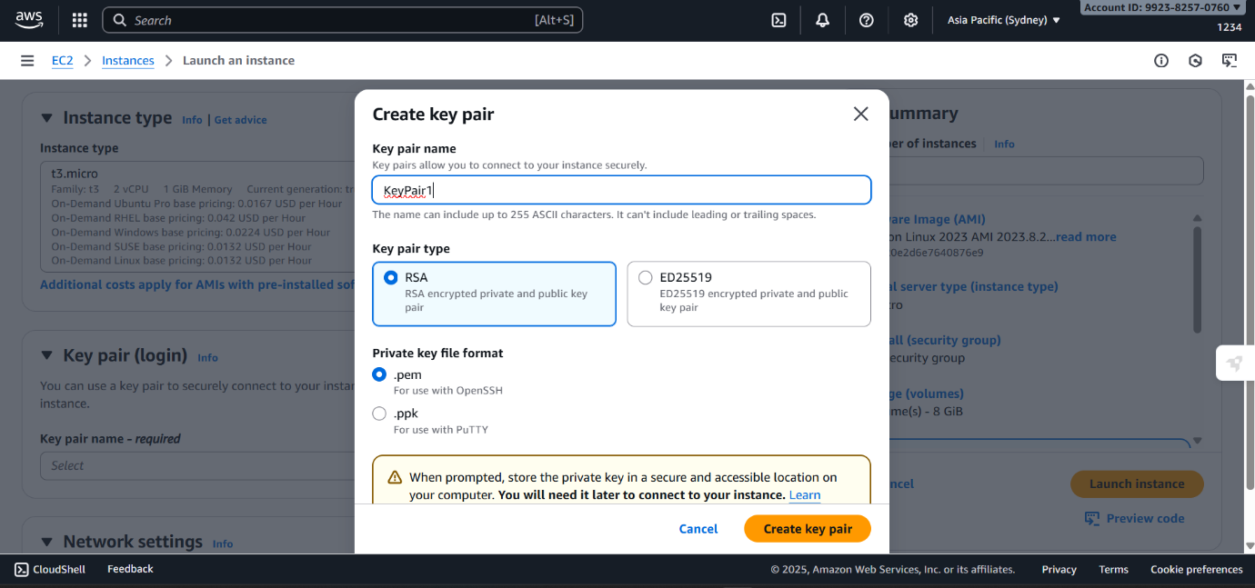

- Configure Network & Security
  - Leave default VPC and subnet (unless you want custom networking).
  - Under Security group, allow:
    - SSH (port 22) for Linux
    - RDP (port 3389) for Windows
    - HTTP/HTTPS if you’re hosting a website.
- Configure Storage
  - Default 8 GB is fine (increase if needed).
- Launch Instance
  - Click Launch Instance.
  - AWS will start your instance.
