**Erin Jones**

**Assignment 1.2**

**Link to GitHub repository**

<https://github.com/ErinJonesCode/csd-310.git>

**Screenshot of GitHub repository**

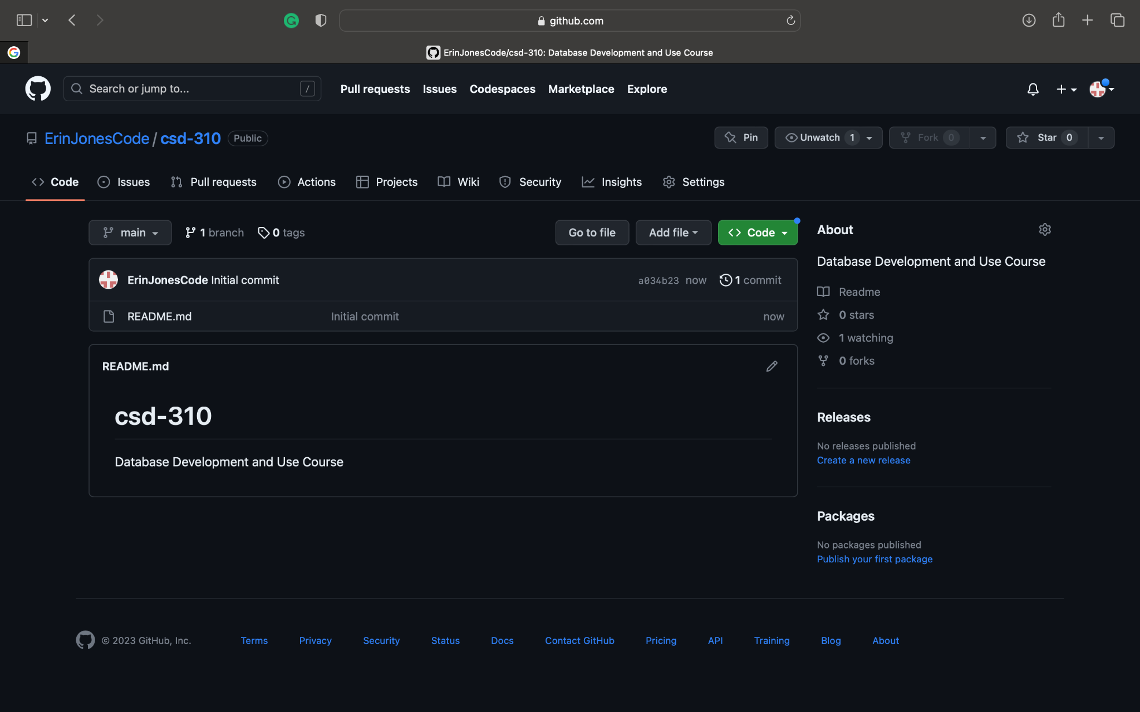

**Screenshot of local directory**

