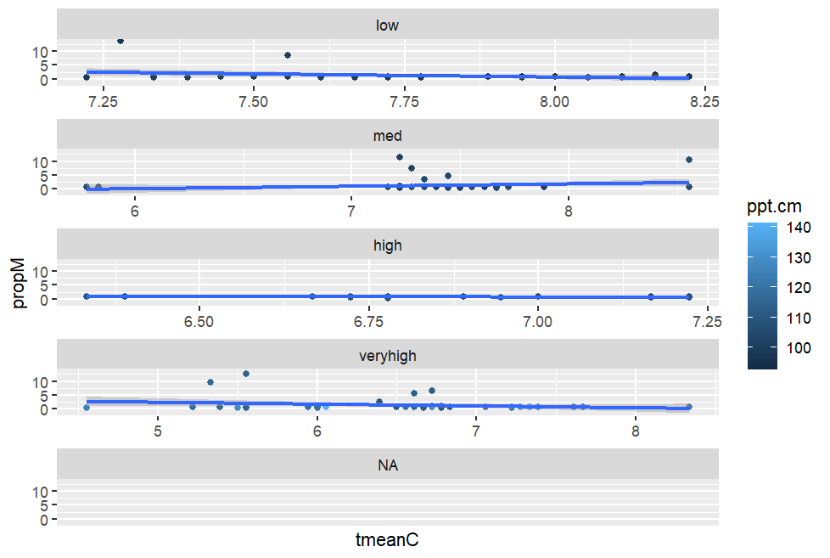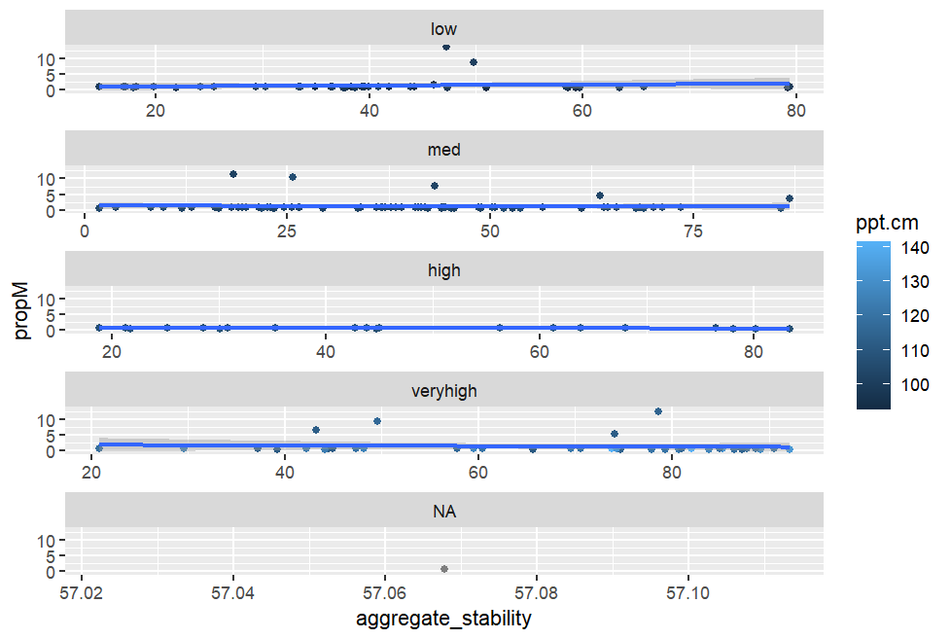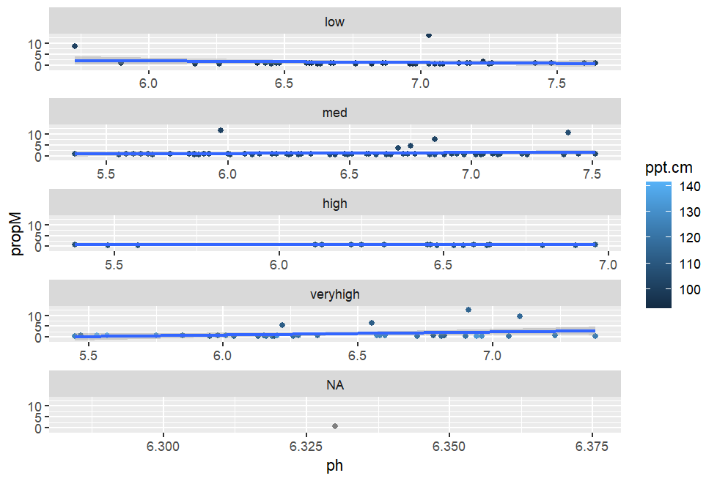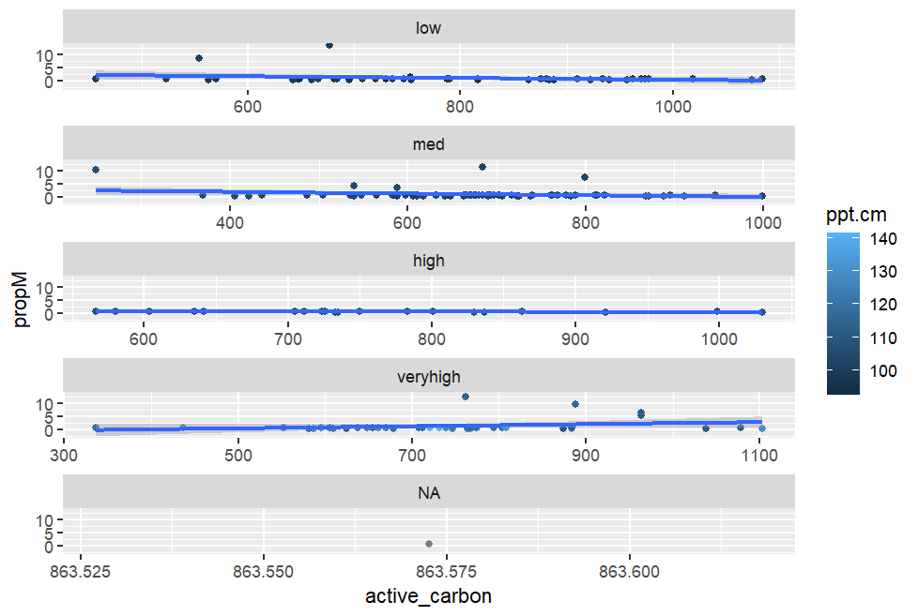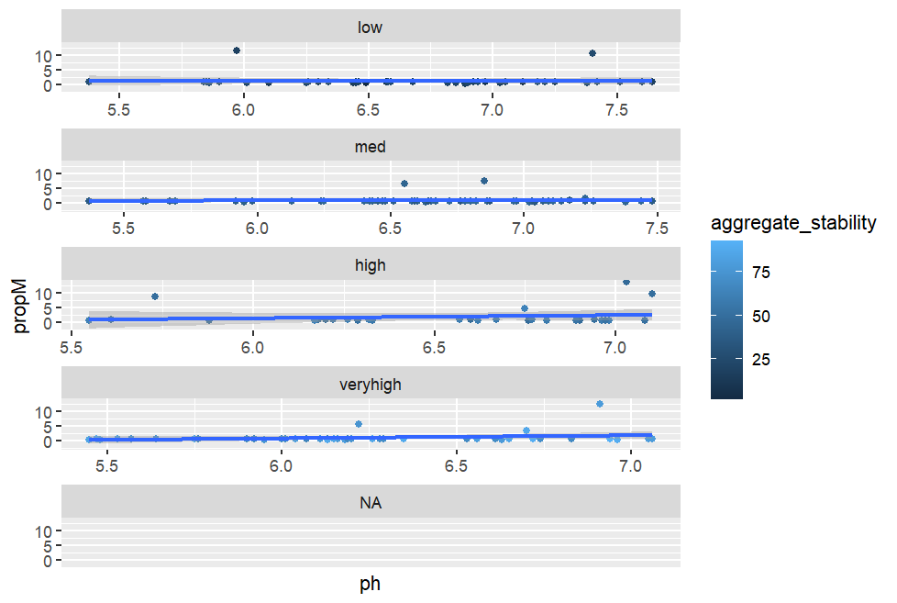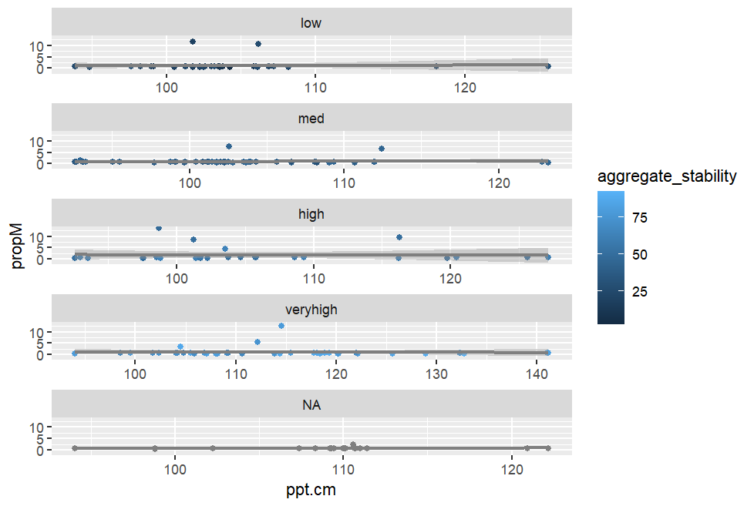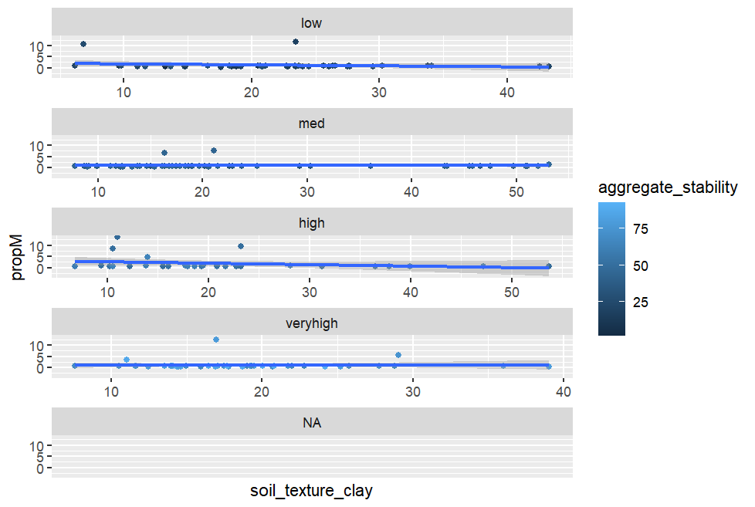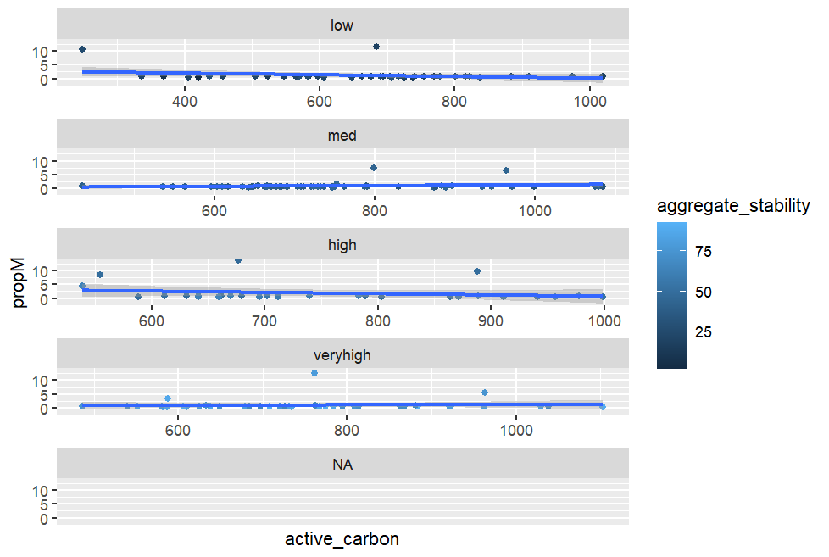

> cordata

propM ph ppt.cm tmeanC

propM 1.000000000 0.08607281 -0.007366885 -0.07050430

ph 0.086072806 1.00000000 -0.269410734 0.29673331

ppt.cm -0.007366885 -0.26941073 1.000000000 -0.59675970

tmeanC -0.070504303 0.29673331 -0.596759699 1.00000000

aggregate_stability 0.008326414 -0.28668284 0.478150191 -0.48201940

soil_texture_clay -0.098847663 0.20915982 -0.384000148 0.30338797

active_carbon -0.069070403 0.26576349 -0.052193611 -0.07188615

aggregate_stability soil_texture_clay active_carbon

propM 0.008326414 -0.09884766 -0.06907040

ph -0.286682844 0.20915982 0.26576349

ppt.cm 0.478150191 -0.38400015 -0.05219361

tmeanC -0.482019400 0.30338797 -0.07188615

aggregate_stability 1.000000000 -0.13085814 0.19375481

soil_texture_clay -0.130858143 1.00000000 0.35310211

active_carbon 0.193754808 0.35310211 1.00000000

No interactions. No significant correlations. And the model show no significant p values