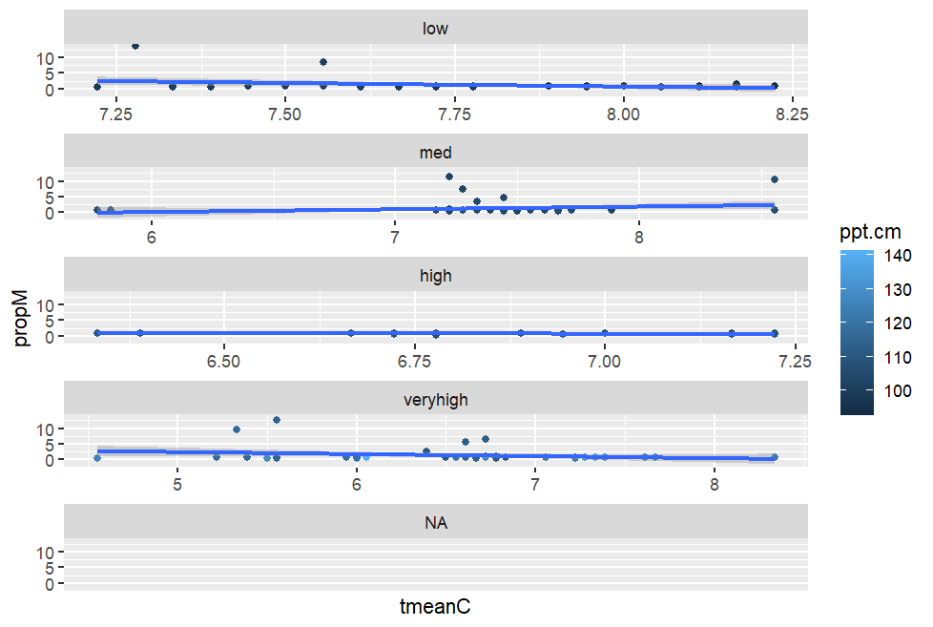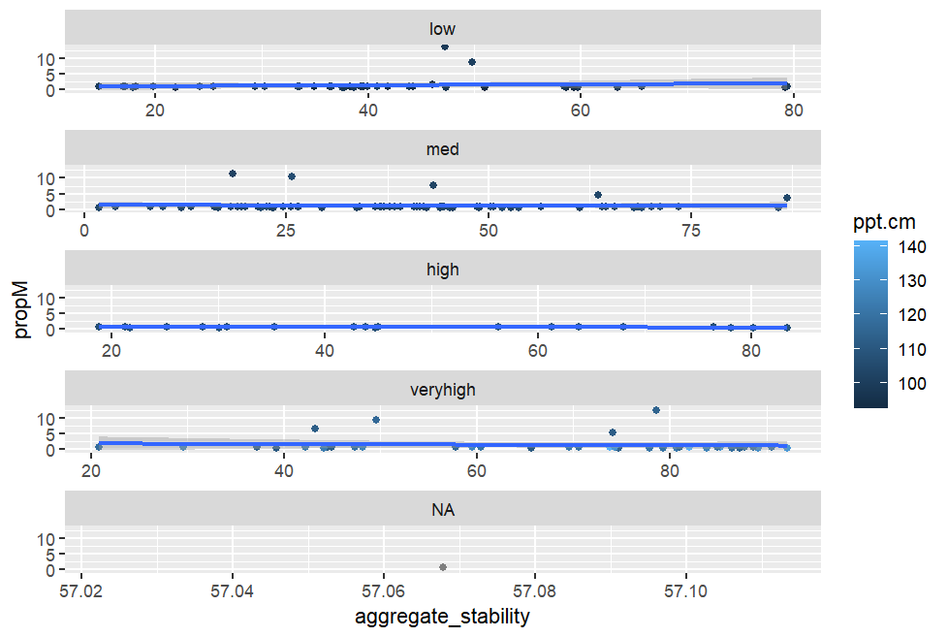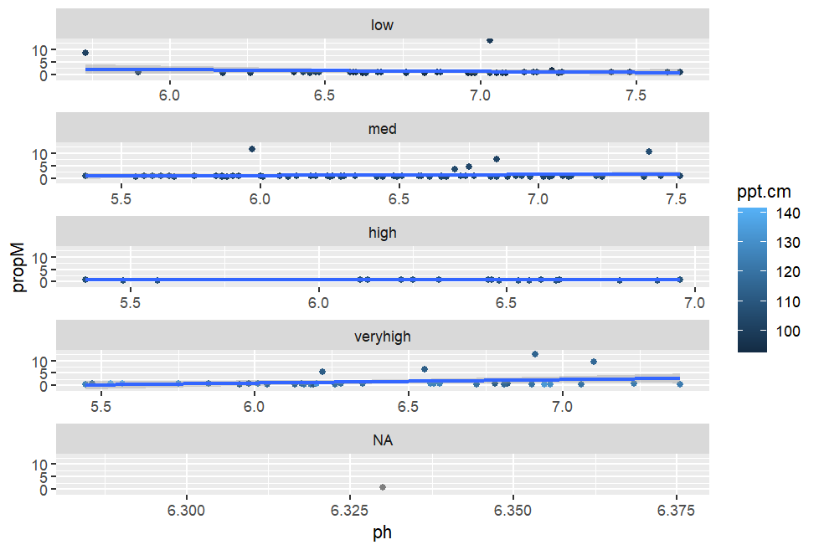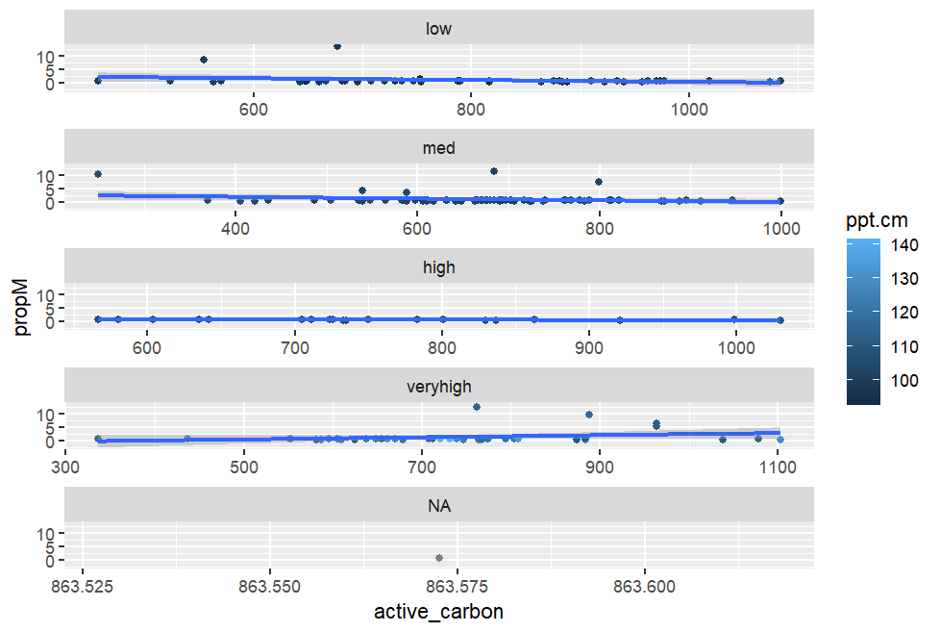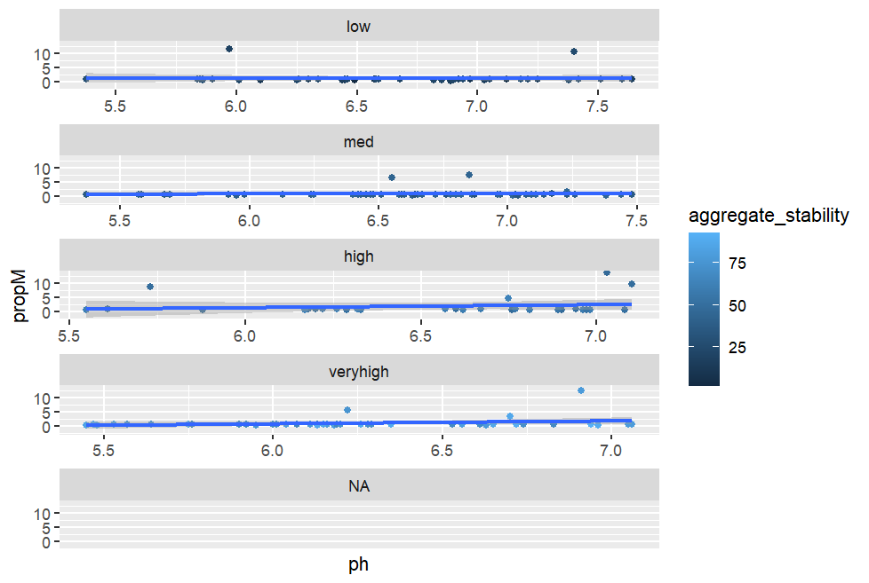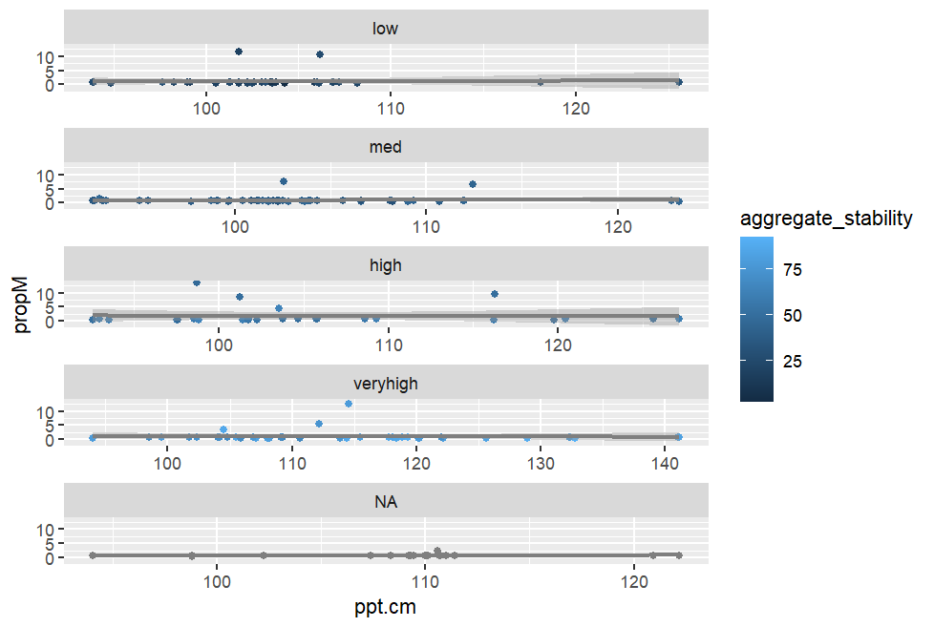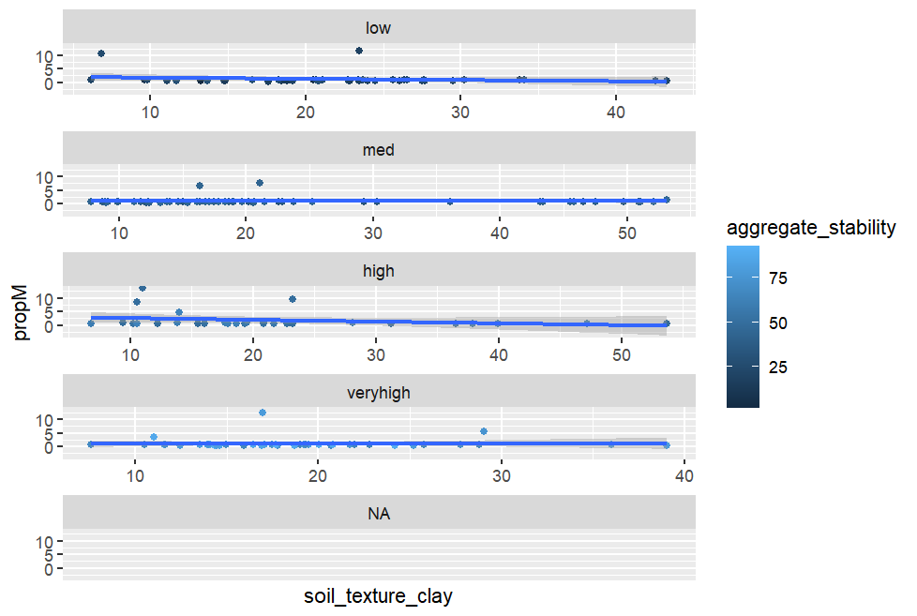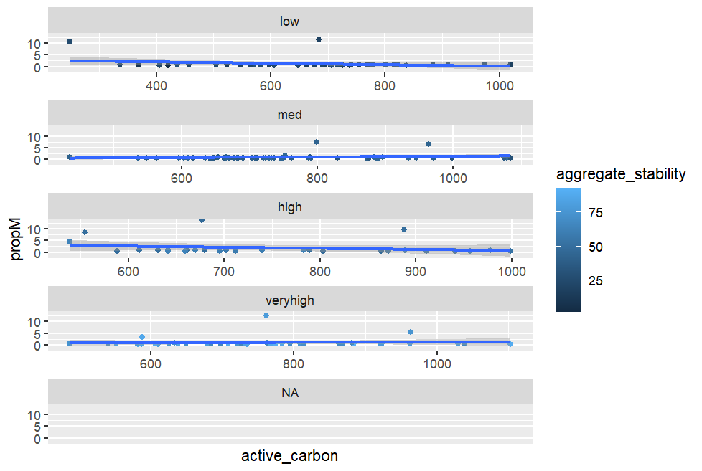

None of these see to show any interactions.

> cordata

propM ph ppt.cm tmeanC

propM 1.000000000 0.08607281 -0.007366885 -0.07050430

ph 0.086072806 1.00000000 -0.269410734 0.29673331

ppt.cm -0.007366885 -0.26941073 1.000000000 -0.59675970

tmeanC -0.070504303 0.29673331 -0.596759699 1.00000000

aggregate_stability 0.008326414 -0.28668284 0.478150191 -0.48201940

soil_texture_clay -0.098847663 0.20915982 -0.384000148 0.30338797

active_carbon -0.069070403 0.26576349 -0.052193611 -0.07188615

aggregate_stability soil_texture_clay active_carbon

propM 0.008326414 -0.09884766 -0.06907040

ph -0.286682844 0.20915982 0.26576349

ppt.cm 0.478150191 -0.38400015 -0.05219361

tmeanC -0.482019400 0.30338797 -0.07188615

aggregate_stability 1.000000000 -0.13085814 0.19375481

soil_texture_clay -0.130858143 1.00000000 0.35310211

active_carbon 0.193754808 0.35310211 1.00000000

Looking for .7 or greater. Nope. Nothing. The closest is ppt and tmean, which makes sense.

No interactions. No significant correlations. And the model show no significant p values

I ran many iterations of the model. No significant relationships were found. Here is the one with all the variables and no interactions:

m1M=gls(propM~ppt.cm+soil_texture_clay+

+ tmeanC+aggregate_stability+active_carbon+

+ ph, data=data, na.action=na.exclude, method="ML")

> summary(m1M)

Generalized least squares fit by maximum likelihood

Model: propM ~ ppt.cm + soil_texture_clay + tmeanC + aggregate_stability + active_carbon + ph

Data: data

AIC BIC logLik

743.6255 768.7118 -363.8127

Coefficients:

Value Std.Error t-value p-value

(Intercept) 4.303043 4.657908 0.9238144 0.3569

ppt.cm -0.026378 0.023949 -1.1014515 0.2723

soil_texture_clay -0.017501 0.017917 -0.9767966 0.3301

tmeanC -0.455448 0.319760 -1.4243407 0.1563

aggregate_stability 0.004497 0.009161 0.4908813 0.6242

active_carbon -0.001460 0.001240 -1.1773342 0.2408

ph 0.640303 0.349859 1.8301757 0.0691

Looking for patterns (above). I don’t have enough experience to know what I am looking for. Seems no pattern to me.

Red and green lines (below) do not match up very well, but maybe well enough??

Since none of the relationships were significant in the model, then it doesn’t make sense to make any of these graphs. However, I did anyway and they confirm the lack of significance.

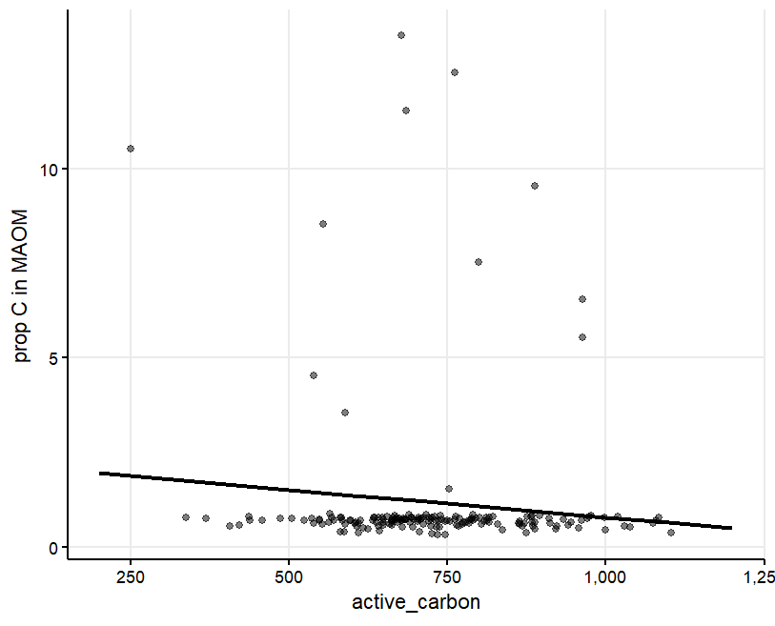

Why doesn’t this look right? Some sites have high proportions? It’s impossible to see anything here, so maybe Box plot isn’t the way to go.