Results Write-Up

The GLS results indicate that active carbon (p < 0.01) and aggregate stability (p < 0.01) are significant predictors of MAOM indicating that higher active carbon levels and more stable aggregates are associated with increased MAOM storage on these farms.

The interaction between mean annual precipitation, soil texture (clay content), and mean annual temperature is also a significant predictor for MAOM (p < 0.05). The effect of precipitation on MAOM varies with clay content and temperature. In clay-rich soils, MAOM increases with an increase in temperature, especially for farms with higher precipitation. However, this effect diminishes particularly in soils with lower clay content and especially where there is also higher precipitation and temperature does not have as much of an effect on MAOM. Get equations for the lines.

When the model is arranged to predict the proportion of MAOM, the GLS results show that clay texture and climate interactions with clay texture are significant predictors. Higher percentages of clay (p<0.05) is associated with greater proportions of MAOM. The interaction between annual precipitation, soil texture (clay content), and mean annual temperature is also a significant predictor (p<0.05) of proportion of MAOM. The effect of precipitation on MAOM varies with clay content and temperature. In clay-rich soils, MAOM significantly increases (equations for the line) with an increase in temperature, but this is only true for farms with higher precipitation.

With particulate organic matter (POM) as the response variable, the GLS indicates that aggregate stability, active carbon, and the interaction between temperature and precipitation are significant predictors. Increased active carbon or aggregate stability indicates higher concentration of POM. In lower temperature climates, an increase in precipitation shows an increase in POM.

Overall, our models explain a substantial portion of the variability in MAOM concentration (R-squared = [insert value]), highlighting the combined importance of soil properties and environmental factors.

Summary-

**MgMAOM**

(↑) Active carbon (↑) MAOM

(↑)Aggregate Stability (↑) MAOM

(↑) Temperature (↑) MAOM (only when (↑) clay and especially when (↑) precipitation)

**PropMAOM**

(↑) clay (↑) proportion of MAOM especially when (↑) temperature ( only at (↑) precipitation)

**POM**

(↑) Active carbon (↑) POM

(↑) Aggregate Stability (↑) POM

(↑) PPT (↑) POM (only in lower temperatures)

Discussion

These insights are crucial for predicting how MAOM levels respond to changing environmental conditions and for informing soil management strategies aimed at enhancing carbon sequestration.

• Discuss whether these significant predictors have a substantial effect size and practical importance in our context

**MgMAOM**

m3 = gls(mgCpergSoilM ~ ppt.cm * soil_texture_clay * tmeanC + ppt.cm * tmeanC +

active_carbon +aggregate_stability,

summary(m3)

Value Std.Error t-value p-value

(Intercept) -304.46540 179.32419 -1.697849 0.0912

ppt.cm 2.93276 1.59192 1.842273 0.0670

soil_texture_clay 14.43473 8.67702 1.663559 0.0979

tmeanC 39.75647 23.49932 1.691814 0.0924

active_carbon 0.01955 0.00289 6.769101 0.0000

aggregate_stability 0.10780 0.02510 4.294408 0.0000

ppt.cm:soil_texture_clay -0.14717 0.07837 -1.877838 0.0620

ppt.cm:tmeanC -0.38965 0.21091 -1.847499 0.0663

soil_texture_clay:tmeanC -1.99091 1.11733 -1.781844 0.0764

ppt.cm:soil_texture_clay:tmeanC 0.02043 0.01025 1.993944 0.0476

This is for model2

Coefficients:

Value Std.Error t-value p-value

(Intercept) -335.9355 183.90128 -1.826716 0.0694

active_carbon 0.0195 0.00312 6.231181 0.0000

ph -3.1962 2.43311 -1.313628 0.1906

soil_texture_clay 16.3116 8.97484 1.817482 0.0708

ppt.cm 3.3356 1.64223 2.031116 0.0437

tmeanC 46.4808 24.30597 1.912320 0.0574

aggregate_stability 0.1115 0.02694 4.140112 0.0001

ph:soil_texture_clay 0.1579 0.11413 1.383441 0.1682

ppt.cm:tmeanC -0.4406 0.21737 -2.026798 0.0441

soil_texture_clay:ppt.cm -0.1697 0.08207 -2.068327 0.0400

soil_texture_clay:tmeanC -2.3529 1.17624 -2.000388 0.0469

soil_texture_clay:ppt.cm:tmeanC 0.0232 0.01072 2.161280 0.0320

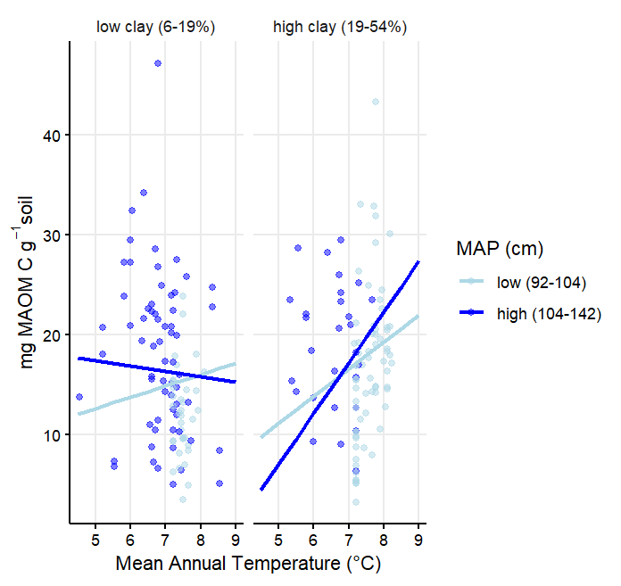

**Proportion**

> m4M=gls(logitpropM~ppt.cm * soil_texture_clay * tmeanC + ppt.cm * tmeanC +

+ active_carbon,

+ data=data, na.action=na.exclude, method="ML")

> summary(m4M)

Generalized least squares fit by maximum likelihood

Model: logitpropM ~ ppt.cm * soil_texture_clay * tmeanC + ppt.cm * tmeanC + active_carbon

Data: data

AIC BIC logLik

322.6137 355.2923 -151.3069

Coefficients:

Value Std.Error t-value p-value

(Intercept) -18.249930 15.381141 -1.186513 0.2369

ppt.cm 0.190465 0.137114 1.389098 0.1665

soil_texture_clay 1.655525 0.734499 2.253951 0.0254

tmeanC 2.443272 2.011490 1.214658 0.2260

active_carbon -0.000377 0.000253 -1.491681 0.1375

ppt.cm:soil_texture_clay -0.016208 0.006646 -2.438706 0.0157

ppt.cm:tmeanC -0.024487 0.018115 -1.351732 0.1781

soil_texture_clay:tmeanC -0.216579 0.094394 -2.294416 0.0229

ppt.cm:soil_texture_clay:tmeanC 0.002141 0.000868 2.466960 0.0145

**Particulate Organic Matter MgPOM**

m3P=gls(mgCpergSoilP~ppt.cm*tmeanC

+aggregate_stability+active_carbon,

data=data, na.action=na.exclude, method="REML")

summary(m3P)

Coefficients:

Value Std.Error t-value p-value

(Intercept) -107.92525 30.235191 -3.569524 0.0005

ppt.cm 0.96799 0.266994 3.625507 0.0004

tmeanC 13.32734 4.087531 3.260486 0.0013

aggregate_stability 0.06799 0.013840 4.912782 0.0000

active_carbon 0.01317 0.001581 8.333649 0.0000

ppt.cm:tmeanC -0.12585 0.036424 -3.455111 0.0007

**Location**

**In a correlation plot longitude is correlated (.7+) with tmeanC.**

**Graph residuals of the models used to see if latitude or longitude explain some of the variability.**



