

Data Conclusions, Limitations, and   
Other Potential Visualizations

Created by: Erin Lampa 11/12/2018

Contents

Data Conclusions 2

**Status of Kickstarter Campaign per Category 2009-2017** 2

**Status of Kickstarter Campaign per Sub-Category 2009-2017** 3

**Status of Kickstarter Campaign per Month 2009-2017** 4

**Success by Goal Amount 2009-2017** 5

Data Limitations 6

Other Potential Visualizations 6

# Data Conclusions

## **Status of Kickstarter Campaign per Category 2009-2017**

<Citation needed>

* Theater is the most successful campaign category overall, and in general, the arts fare pretty well (music, film & video also have several successful campaigns)
* Technology projects are have a 33% chance of succeeding. The remaining projects fail or are canceled.
* Journalism is a very unsuccessful category on Kickstarter
* Photography projects have a 50% chance of succeeding
* More than 50% of the film & video projects are successful and funded

## **Status of Kickstarter Campaign per Sub-Category 2009-2017**

<Citation needed>

* Plays, the sub-category having the most campaigns, are the most successful.
* Rock music campaigns, although small in number, are extremely successful as are tabletop games, shorts, television, non-fiction, radio/podcasts and Metal.
* Very few Wearables campaigns are successful

## **Status of Kickstarter Campaign per Month 2009-2017**

* Campaign success peaks in July
* Campaigns tend to fail more often in August
* Campaigns are canceled fairly evenly throughout the year

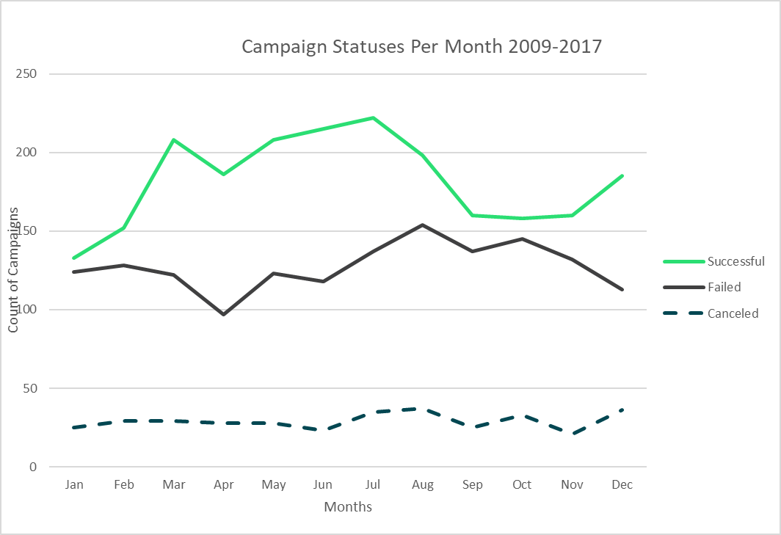

<Citation needed>

## **Success by Goal Amount 2009-2017**

* 70%+ of campaigns with small goals successful
* Fewer than 20% of goals >$50K are successful
* The larger the goal, the higher the percentage that the project will be canceled before being funded

<Citation needed>

# Data Limitations

* Not all categories of Kickstarter campaigns are represented
* Full amount of Kickstarter campaigns are not represented
* Do not know starting budget for projects (i.e. is there capital behind the project which allows for a “better” presentation of the project, better rewards, etc.)

# Other Potential Visualizations

* Status by length of campaign (which category did well w/short vs. longer campaigns)
* Amount of funding per category
* Amount of backers per category/sub-category
* Goal to achieve vs. Funded amount
* Does campaign outcome depend on whether campaign is a “Staff Pick”
* Number of backers/Avg donatoin per campaign receiving Spotlight or Staff Picks
* Does Campaign outcome depend on whether the campaign was in the “Spotlight”
* Average donation per category