FINAL EXAM

Erika Vargas

March 15, 2019

# PROBLEM 1

## covariance matrix  
s <- rbind(c(5,0,0),c(0,9,0), c(0,0,8))  
  
## a. eigen values and eigen vectors of S  
eigen.s <- eigen(s)  
eigen.s

## eigen() decomposition  
## $values  
## [1] 9 8 5  
##   
## $vectors  
## [,1] [,2] [,3]  
## [1,] 0 0 1  
## [2,] 1 0 0  
## [3,] 0 1 0

## b. percentage of variance explained  
prop.var <- eigen.s$values[1:3] / sum(eigen.s$values)  
round(prop.var,3)

## [1] 0.409 0.364 0.227

cumsum(prop.var)

## [1] 0.4090909 0.7727273 1.0000000

## c. how many components to retain  
plot(cumsum(prop.var), xlab = "Principal Component", ylab = "Cumulative Proportion of Variance Explained", type = "b")

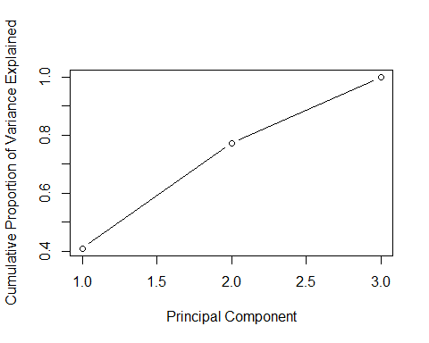

*For the example data, the scree plot markers for components 1–3 are non-linear, so components 1–3 should be kept.even though the first two components explain 77% of the data, 80% of variance explained would be better. It seem that the third component adds value.*

# PROBLEM 2

## building the correlation matrix  
R <- matrix(rep(0,6*6), nrow=6, dimnames = list(c("French", "English", "History", "Arithmetic", "Algebra", "Geometry")))  
diag(R) <- 1  
R[lower.tri(R)] <- c(0.44,0.41,0.29,0.33,0.25,0.35,0.35  
 ,0.32,0.33,0.16,0.19,0.18,0.59,0.47,0.46)   
R

## [,1] [,2] [,3] [,4] [,5] [,6]  
## French 1.00 0.00 0.00 0.00 0.00 0  
## English 0.44 1.00 0.00 0.00 0.00 0  
## History 0.41 0.35 1.00 0.00 0.00 0  
## Arithmetic 0.29 0.35 0.16 1.00 0.00 0  
## Algebra 0.33 0.32 0.19 0.59 1.00 0  
## Geometry 0.25 0.33 0.18 0.47 0.46 1

## Principal component loadings for 3 factors  
library(psych)

## Warning: package 'psych' was built under R version 3.5.2

solution<- principal(R, nfactors = 3, rotate = 'none', covar = FALSE)

## Warning in log(det(r)): NaNs produced

## In factor.stats, the correlation matrix is singular, an approximation is used

## Warning in fa.stats(r = r, f = f, phi = phi, n.obs = n.obs, np.obs =  
## np.obs, : In factor.stats, the correlation matrix is singular, and we could  
## not calculate the beta weights for factor score estimates

## Warning in principal(R, nfactors = 3, rotate = "none", covar = FALSE): The  
## matrix is not positive semi-definite, scores found from Structure loadings

solution$loadings

##   
## Loadings:  
## PC1 PC2 PC3   
## [1,] -0.843 -0.513 -0.132  
## [2,] 0.843 -0.510  
## [3,] 0.413 0.903  
## [4,] 0.761 -0.217   
## [5,] 0.680 -0.316   
## [6,] 0.552 -0.151   
##   
## PC1 PC2 PC3  
## SS loadings 2.074 1.314 1.105  
## Proportion Var 0.346 0.219 0.184  
## Cumulative Var 0.346 0.565 0.749

**First Principal Component Analysis - PCA1** The first principal component is a measure of the scores in French, Arithmetic, Algebra, and Geometry. As we can see this component is associated with low scores in french, moderately high scores in Arithmetic and Algebra.They are positively related to PCA1 because they all have positive signs*

**Second Principal Component Analysis - PCA2** The second principal component is a measure of the scores for all 6 school subjects. PCA2 is associated with moderately high scores in English, and moderately low scores in History. It also shows low scores fro French and algebra.

**Third Principal Component Analysis - PCA3** The third principal component is a measure of the scores in French, English, and History. we can see very high scores in History, and moderately low scores in English and French

# PROBLEM 3

## loading FoodStuff dataset  
dataset_3 <- read.csv("~/Desktop/WINTER 2019/DA410-MULTIVARIATE-CHENG/final/data_3.csv", header= TRUE, sep=" ", skipNul = T)  
head(dataset_3,5)

## ÿþFOOD Energy Protein Fat Calcium Iron  
## 1 BB 340 20 28 9 2.6  
## 2 HR 245 21 17 9 2.7  
## 3 BR 420 15 39 7 2.0  
## 4 BS 375 19 32 9 2.5  
## 5 BC 180 22 10 17 3.7

str(dataset_3)

## 'data.frame': 27 obs. of 6 variables:  
## $ ÿþFOOD : Factor w/ 27 levels "AC","AR","BB",..: 3 14 6 7 4 9 10 5 16 17 ...  
## $ Energy : int 340 245 420 375 180 115 170 160 265 300 ...  
## $ Protein: int 20 21 15 19 22 20 25 26 20 18 ...  
## $ Fat : int 28 17 39 32 10 3 7 5 20 25 ...  
## $ Calcium: int 9 9 7 9 17 8 12 14 9 9 ...  
## $ Iron : num 2.6 2.7 2 2.5 3.7 1.4 1.5 5.9 2.6 2.3 ...

FoodStuff <- dataset_3[,2:6] #taking food name off   
str(FoodStuff)

## 'data.frame': 27 obs. of 5 variables:  
## $ Energy : int 340 245 420 375 180 115 170 160 265 300 ...  
## $ Protein: int 20 21 15 19 22 20 25 26 20 18 ...  
## $ Fat : int 28 17 39 32 10 3 7 5 20 25 ...  
## $ Calcium: int 9 9 7 9 17 8 12 14 9 9 ...  
## $ Iron : num 2.6 2.7 2 2.5 3.7 1.4 1.5 5.9 2.6 2.3 ...

View(FoodStuff)  
## correlation matrix  
cor <-cor(FoodStuff)  
round(cor,3)

## Energy Protein Fat Calcium Iron  
## Energy 1.000 0.174 0.987 -0.320 -0.100  
## Protein 0.174 1.000 0.025 -0.085 -0.175  
## Fat 0.987 0.025 1.000 -0.308 -0.061  
## Calcium -0.320 -0.085 -0.308 1.000 0.044  
## Iron -0.100 -0.175 -0.061 0.044 1.000

## principal component analysis function  
# to decide the number of factors i used prcomp(). Performs a principal components analysis on the given data matrix and returns the results as an object of class prcomp.  
food.pca <- prcomp(FoodStuff,  
 center = TRUE,  
 scale. = TRUE)   
## a. NUMBER OF FACTORS  
eigenfood <-eigen(cor)  
round(eigenfood$values,3) #first two factors have lambda > 1

## [1] 2.198 1.144 0.849 0.808 0.002

summary(food.pca)

## Importance of components:  
## PC1 PC2 PC3 PC4 PC5  
## Standard deviation 1.4825 1.0697 0.9212 0.8988 0.04000  
## Proportion of Variance 0.4396 0.2288 0.1697 0.1616 0.00032  
## Cumulative Proportion 0.4396 0.6684 0.8381 0.9997 1.00000

plot(food.pca, type= "l")

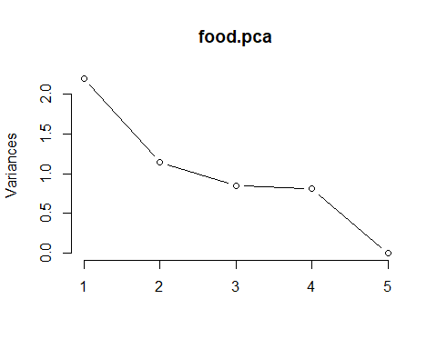

*The second method says to retain the components whose eigen values are greater than the average of the eigen values (for correlation matrix, this average is 1).* *Since lambda for the first and second component is greater than 1, I am keeping those components. However, the total of variance explained with just two components is only 67%, so keeping the third component with eigen value of 0.85 would give us an 84% of variance explained. This satisfies the first method of keeping factors that explain at least 80% of total variance.*

#PRINCIPAL COMPONENT Analysis  
pca_food<- principal(FoodStuff, nfactors = 3, rotate = 'none', covar = FALSE)  
  
# b. LOADINGS  
round(pca_food$loadings,3)

##   
## Loadings:  
## PC1 PC2 PC3   
## Energy 0.969 0.137  
## Protein 0.224 -0.739 -0.426  
## Fat 0.948 0.216 0.199  
## Calcium -0.526 0.601  
## Iron -0.181 0.737 -0.497  
##   
## PC1 PC2 PC3  
## SS loadings 2.197 1.145 0.848  
## Proportion Var 0.439 0.229 0.170  
## Cumulative Var 0.439 0.668 0.838

**Loadings interpretation**

**First Principal Component Analysis - PCA1** The first principal component is a measure of high amount of Energy, fat, and the moderately low amount of calcium. It associates all 5 variables.

**Second Principal Component Analysis - PCA2** The second principal component is a measure of the low amount of protein, and high amount of Iron.

**Third Principal Component Analysis - PCA3** The third principal component associates all variables and it measures the high amount of calcium, and the moderately low amount of protein and Iron.

# C. VARIANCE EXPLAINED AND FACTORES SCORES  
pca_food

## Principal Components Analysis  
## Call: principal(r = FoodStuff, nfactors = 3, rotate = "none", covar = FALSE)  
## Standardized loadings (pattern matrix) based upon correlation matrix  
## PC1 PC2 PC3 h2 u2 com  
## Energy 0.97 0.09 0.14 0.97 0.033 1.1  
## Protein 0.22 -0.74 -0.43 0.78 0.222 1.8  
## Fat 0.95 0.22 0.20 0.98 0.015 1.2  
## Calcium -0.53 -0.01 0.60 0.64 0.363 2.0  
## Iron -0.18 0.74 -0.50 0.82 0.177 1.9  
##   
## PC1 PC2 PC3  
## SS loadings 2.20 1.14 0.85  
## Proportion Var 0.44 0.23 0.17  
## Cumulative Var 0.44 0.67 0.84  
## Proportion Explained 0.52 0.27 0.20  
## Cumulative Proportion 0.52 0.80 1.00  
##   
## Mean item complexity = 1.6  
## Test of the hypothesis that 3 components are sufficient.  
##   
## The root mean square of the residuals (RMSR) is 0.15   
## with the empirical chi square 11.86 with prob < NA   
##   
## Fit based upon off diagonal values = 0.83

prop.var.food <- (eigenfood$values[1:3] / sum(eigenfood$values) )*100

round(prop.var.food,3) **#percent of variance explained for each factor**

## [1] 43.956 22.884 16.971

pca_food$fit #Fit of the model to the correlation matrix

## [1] 0.9131254

summary(pca_food)

##   
## Factor analysis with Call: principal(r = FoodStuff, nfactors = 3, rotate = "none", covar = FALSE)  
##   
## Test of the hypothesis that 3 factors are sufficient.  
## The degrees of freedom for the model is -2 and the objective function was 2.93   
## The number of observations was 27 with Chi Square = 62.99 with prob < NA   
##   
## The root mean square of the residuals (RMSA) is 0.15

#plot for the factors scores  
biplot(pca_food, scale = 0)

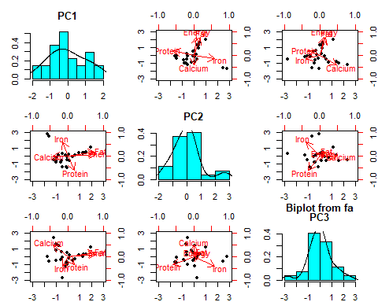

*The first component explained 43.9% of variance, the second component explained 22.9% of variance, and the third component explained 17% of variance. I decided to retain 3 components because they explained more than 80% of variance.*

# PROBLEM 4

Problem4_dataset <- read.file("~/Desktop/WINTER 2019/DA410-MULTIVARIATE-CHENG/final/dataset_4.csv", sep=" ", skipNul = T, header = FALSE, col.names= c("patient #","y1","y2","x1","x2","x3"))

## Data from the .csv file ~/Desktop/WINTER 2019/DA410-MULTIVARIATE-CHENG/final/dataset_4.csv has been loaded.

head(Problem4_dataset,5)

## patient.. y1 y2 x1 x2 x3  
## 1 ÿþ1 0.81 80 356 124 55  
## 2 2 0.95 97 289 117 76  
## 3 3 0.94 105 319 143 105  
## 4 4 1.04 90 356 199 108  
## 5 5 1.00 90 323 240 143

patients <- Problem4_dataset[,2:6] # taking the patient number off  
   
patients.std <-sweep(patients, 2, sqrt(apply(patients,2,var)), FUN="/")  
major.variables<-patients.std[,1:2]  
major.variables

## y1 y2  
## 1 7.147090 12.27481  
## 2 8.382389 14.88321  
## 3 8.294154 16.11069  
## 4 9.176510 13.80916  
## 5 8.823568 13.80916  
## 6 6.705911 13.19542  
## 7 8.029446 15.34351  
## 8 9.705924 13.04199  
## 9 8.735332 14.88321  
## 10 6.882383 14.88321  
## 11 7.941211 13.96260  
## 12 6.441204 13.34886  
## 13 8.470625 11.96794  
## 14 7.411797 13.80916  
## 15 6.529440 13.19542  
## 16 8.647096 12.27481  
## 17 9.705924 13.80916  
## 18 7.500032 15.19008  
## 19 7.323561 13.04199  
## 20 8.205918 13.80916  
## 21 8.382389 13.80916  
## 22 6.529440 13.50229  
## 23 8.382389 14.57634  
## 24 8.558861 13.80916  
## 25 6.352969 14.11603

minor.variables <- patients.std[,3:5]  
minor.variables

## x1 x2 x3  
## 1 10.625966 2.880459 1.636545  
## 2 8.626135 2.717853 2.261407  
## 3 9.521582 3.321820 3.124313  
## 4 10.625966 4.622672 3.213579  
## 5 9.640975 5.575082 4.255017  
## 6 11.372172 3.647033 4.909634  
## 7 10.446877 5.133721 3.540888  
## 8 8.984314 4.320689 3.124313  
## 9 11.312475 3.298590 2.916025  
## 10 8.835073 3.043066 2.797004  
## 11 10.536422 5.133721 1.577034  
## 12 9.133555 4.134853 1.963854  
## 13 8.655984 3.159213 4.225261  
## 14 11.073690 4.645902 2.767249  
## 15 9.312645 4.831738 2.023365  
## 16 11.730350 4.692361 3.035047  
## 17 10.864752 3.530885 2.261407  
## 18 10.715511 4.297459 1.100948  
## 19 8.835073 2.694623 1.785322  
## 20 10.297636 2.857230 1.487768  
## 21 11.282627 3.159213 1.398502  
## 22 9.073859 3.112754 1.487768  
## 23 10.357332 4.274230 2.707738  
## 24 9.760368 4.460066 3.689665  
## 25 11.521413 6.481033 2.201897

# a. canonical correlations between (y1,y2) and (x1,x2,x3)  
#install.packages("CCA")  
library(CCA)

results <-cc(major.variables, minor.variables)  
canoni.cor <-results$cor  
canoni.cor

## [1] 0.34192472 0.05719007

# b. Test the significance of each canonical correlation  
library("yacca")

## Warning: package 'yacca' was built under R version 3.5.2

cca2 <- cca(major.variables, minor.variables)  
F.test.cca(cca2)

##   
## F Test for Canonical Correlations (Rao's F Approximation)  
##   
## Corr F Num df Den df Pr(>F)  
## CV 1 0.34192 0.43922 6.00000 40 0.8482  
## CV 2 0.05719 NA 2.00000 NA NA

**Canonical correlations** *r1 = 0.341 and r2 = 0.057*

**Test of Significance.**

*Ho: all canonical correlations r1,r2 are NOT significant*

*Ha: all canonical correlations r1,r2 are significant*

At alpha = 0.05 we DO NOT reject Ho for the first canonical correlation (r1). Because p- value 0.8482 is greater than 0.05. hence, we conclude that r1 is NOT significant

At alpha =0.05 we reject Ho for the second correlation (r2). Because p-value 0 is less than 0.05. Hence, we conclude that R2 is significant.

# PROBLEM 5

library(lavaan)

## a. syntax for the model  
HS.model<-'  
 # three-factor model  
 visual =~ x1 + x2   
 textual =~ x3 + x4 + x5 + x6  
 speed =~ x7 + x8 + x9  
 # orthogonal factors  
 visual ~~ 0*textual  
 '  
fit<- sem(HS.model, data=HolzingerSwineford1939)  
summary(fit, standardized=TRUE)

## lavaan 0.6-3 ended normally after 53 iterations  
##   
## Optimization method NLMINB  
## Number of free parameters 20  
##   
## Number of observations 301  
##   
## Estimator ML  
## Model Fit Test Statistic 200.854  
## Degrees of freedom 25  
## P-value (Chi-square) 0.000  
##   
## Parameter Estimates:  
##   
## Information Expected  
## Information saturated (h1) model Structured  
## Standard Errors Standard  
##   
## Latent Variables:  
## Estimate Std.Err z-value P(>|z|) Std.lv Std.all  
## visual =~   
## x1 1.000 1.093 0.938  
## x2 0.341 0.222 1.537 0.124 0.373 0.317  
## textual =~   
## x3 1.000 0.190 0.168  
## x4 5.193 1.878 2.765 0.006 0.985 0.848  
## x5 5.846 2.113 2.766 0.006 1.109 0.861  
## x6 4.816 1.743 2.763 0.006 0.914 0.835  
## speed =~   
## x7 1.000 0.626 0.579  
## x8 1.176 0.170 6.915 0.000 0.736 0.735  
## x9 1.012 0.145 7.001 0.000 0.634 0.633  
##   
## Covariances:  
## Estimate Std.Err z-value P(>|z|) Std.lv Std.all  
## visual ~~   
## textual 0.000 0.000 0.000  
## speed 0.216 0.056 3.886 0.000 0.316 0.316  
## textual ~~   
## speed 0.019 0.011 1.745 0.081 0.164 0.164  
##   
## Variances:  
## Estimate Std.Err z-value P(>|z|) Std.lv Std.all  
## .x1 0.163 0.754 0.216 0.829 0.163 0.120  
## .x2 1.243 0.134 9.284 0.000 1.243 0.900  
## .x3 1.239 0.101 12.222 0.000 1.239 0.972  
## .x4 0.380 0.049 7.811 0.000 0.380 0.281  
## .x5 0.429 0.059 7.278 0.000 0.429 0.259  
## .x6 0.361 0.044 8.270 0.000 0.361 0.302  
## .x7 0.777 0.082 9.502 0.000 0.777 0.665  
## .x8 0.461 0.078 5.926 0.000 0.461 0.460  
## .x9 0.599 0.071 8.429 0.000 0.599 0.599  
## visual 1.195 0.761 1.570 0.116 1.000 1.000  
## textual 0.036 0.026 1.383 0.167 1.000 1.000  
## speed 0.392 0.088 4.454 0.000 1.000 1.000

## b. representation of the 3-factor model  
lavaan.diagram(fit, main = "Three-factor Model")

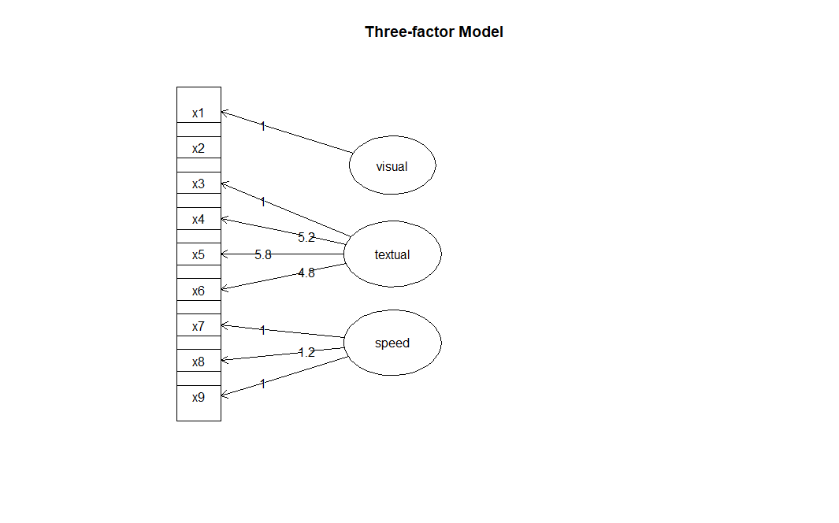

library(semPlot)

semPaths(fit,"std", title = FALSE, edge.color = "purple", color = "grey", rotation = 4)

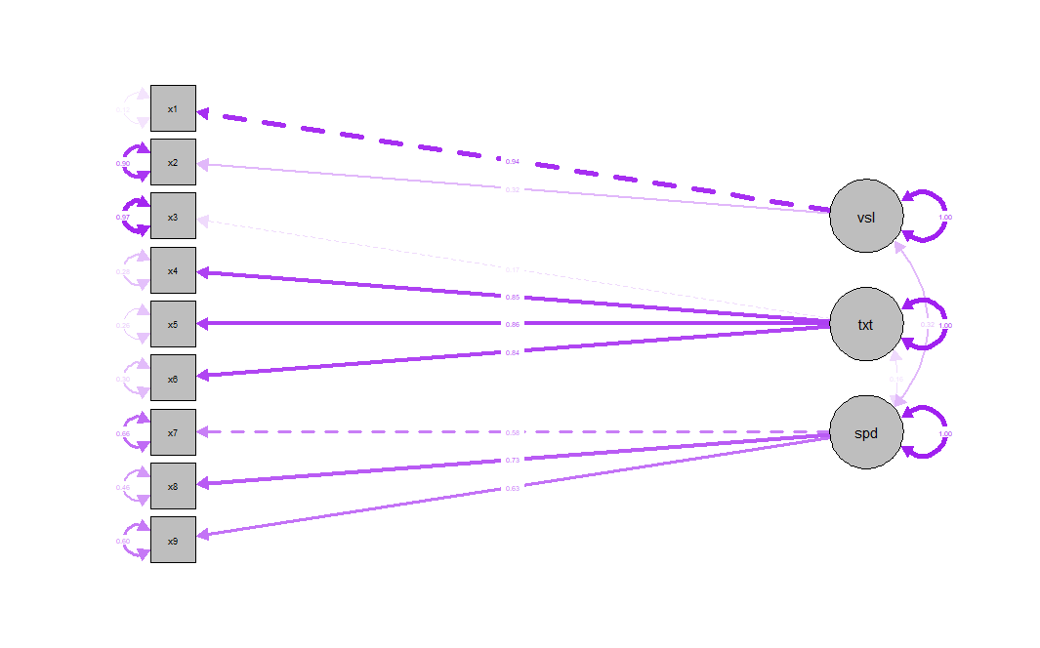

on the second graph we can see that the visual factor and the textual factor have zero correlation

# PROBLEM 6

**a. How many models you have learned?**  
I have learned about 5-6 models.

MANOVA is simply an ANOVA with several dependent variables. That is to say, ANOVA tests for the difference in means between two or more groups, while MANOVA tests for the difference in two or more vectors of means.

LDA models the distribution of predictors separately in each of the response classes, and then it uses Bayes’ theorem to estimate the probability.

K-Means Clustering. Simple and elegant algorithm to partition a dataset into K distinct, non-overlapping clusters. We can use MSE to determine which cluster assignment is better.

Hierarchical clustering. Another clustering algorithm that does not require us to commit to a particular K. one of its advantages is that it results in a nice visualization called a dendogram.

PCA or Principal Component Analysis. This model allows us to summarize a set of correlated variables with a smaller set of variables that collectively explain most of the variability in the original set.  
  
**b. Which one really impressed me when you learned and why?**  
  
K-Means Clustering because is probably the most well know clustering algorithm. It’s easy to understand and implement in code. K-Means has the advantage that it’s pretty fast. All we’re really doing is computing the distances between points and group centers; very few computations. It thus has a linear complexity O(n).

However, K-Means has a couple of disadvantages. Firstly, you have to select how many groups/classes there are. And for this I think experience would help a lot when deciding the number of clusters to work with.   
  
**c. Which one is your favorite and why?**  
  
My favorite was principal component analysis. I feel I should have learned that long time ago. I love the logical behind it. It makes analysis faster and less redundant. Being able to have the amount of variance explained we want with less variables, increases my ability to analyze and interpret deeply and carefully those features variables. The code implementation is easy and R libraries give a nice output to interpret the model.   
  
**d. two models comparison. differences and similarities.**

|  |  |  |
| --- | --- | --- |
|  | K-Means clustering | Principal Component Analysis (PCA) |
| Goal | K-Means algorithm searches out the **most effective division of n entities in k groups**, in order to find the total distance of the group's members to its corresponding centroid, representative of the cluster, is reduced. | mathematical technique for reducing the dimensionality of data, while keeping as much variation as possible. |
| Advantages | * Simple * Fast for low dimensional data * It can find pure sub clusters if large number of clusters is specified. * With a large number of variables, K-Means may be viewed as computationally faster than hierarchical clustering. * K-Means is expected produce tighter clusters than hierarchical clustering | * Lack of redundancy of data given the orthogonal components * low noise sensitivity, * decreased requirements for capacity and memory * increased efficiency given the processes taking place in a smaller dimension * PCA shows a visual representation of the dominant patterns in a data set. * it provides a synchronized low-dimensional representation of the variables. |
| Disadvantages | * K-Means cannot handle non-globular data of different sizes and densities * K-Means will not identify outliers * K-Means is restricted to data which has the notion of a center (centroid) | * The covariance matrix is difficult to be evaluated in an accurate manner * Even the simplest invariance could not be captured by the PCA unless the training data explicitly provides this information. |
| Example | This clustering algorithm serves as a good benchmark to monitor the progression of students’  performance in higher institution. It also enhances the decision  making by academic planners to monitor the candidates’  performance semester by semester by improving on the future  academic results in the subsequence academic session.  k-means algorithm is very popular and used in a variety of applications such as market segmentation, document clustering, image segmentation. | PCA applications in the significant  fields of criminal investigation are  beneficial. The statistical information published in the area of facial recognition technology utilizing the PCA method reveals  the significance of using this method for identifying and  verifying facial features. |

**e. Project with a real problem. what model would I use? What kind of project would I like to build?**

I would like to use the principal component analysis. I have a current real problem example. I happened to know one of the VP at an insurance company, He was telling me of the need of knowing what specific characteristics of their advisors drive sales up (high performance). The need to collect the data on the time the spent talking with a specific client, the message they deliver, years of experience, age and maybe gender and other variables such as demographic data. Since there are too many variables that could explain the high or low performance of advisors. I would use principal component analysis to narrow down the number of variables so that when I create a training and testing dataset and run another analysis such as regression, the interpretation would be easy and faster.