**Homework Assignment #3**

**Name:** Erivelton Gualter dos Santos

**Win Numer:** 143101929

Dr. Janos L. Grantner

**Task 1:**

Develop a behavioral VHDL program for a **synchronous (clocked) 2-digit, modulo-32 binary-coded-decimal (BCD) up counter.** The counter should **count from 0 up to 31** and then continue from 0 again. The counter should have an **active high CLR** signal to reset its contents to 0 at any time. The counter's state should be displayed on the **7-segment display module** of the Nexys 3 Board. Both the CLK and the CLR signals should be mapped to pushbuttons, respectively. You should pick a push button for the CLK signal that is connected to a **GCLK pin** of your FPGA. You should implement this counter using the FPGA, the 7-segment display and push-buttons on your Nexys 3 Board. Note: you should use the 100MHz clock available on the Nexys 3 Board for creating the required signal timings for the 7-Segment Display module. Introduce a **suitable delay** to make the CLK signal **bounce free, if needed**.

# Task

The task of “synchronous (clocked) 2-digit, modulo-32, binary-coded-decimal (BCD) up counter” is a counter 0-31 that shows in the display of 7-segment LEDS. The Nexys3 board contains four-digit; however, for this activity will be utilized only 2 display.

Check above the connection of seven-segment:

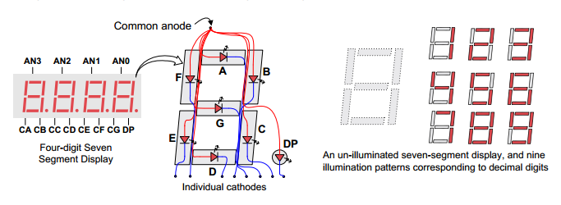

The problem to work with the seven-segment led is the fact that is necessary small frequency; however, the FPGA board work with the frequency of the crystal oscillator around Mhz. It boils down to the fact that we need to convert this frequency to a low frequency.

Another point we need to take care is about the multiplexed display. It means that we need to set high signal in the inputs AN3, AN2, AN1, or AN0; however, we just can set one per time. Therefore, with the main to illuminate more than on display, we need divide the clock for a frequency that allow the human see all display illuminate because it is so fast that the human vision cannot see the display change. Check above the illustration of the clock:

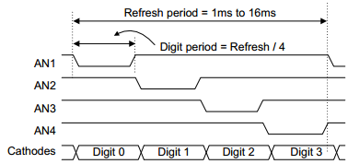

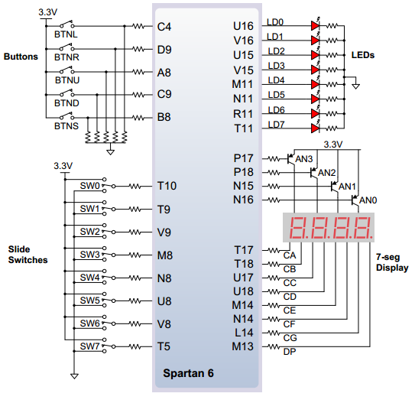

An un-illuminated seven-segment display, and 10 patterns corresponding to decimal digits

|  |  |
| --- | --- |
| **Numeric Number** | **CA CB CC CD CE CF CG DP** |
| 0 | 00000011 |
| 1 | 10011111 |
| 2 | 00100101 |
| 3 | 00001101 |
| 4 | 10011001 |
| 5 | 01001001 |
| 6 | 01000001 |
| 7 | 00011111 |
| 8 | 00000001 |
| 9 | 00001001 |

# Wave

The simulation has adapt for the simulation because the frequency is too low.

