**Assignment #4**

**STOPWATCH USING NEXYS3**

**By:**

Erivelton Gualter dos Santos

**1.Introduction**

A stopwatch is an instrument to measure the amount of time. Generally, there are differences scales of range; however, I am using a range of 1 minute. The scale of the stopwatch is 0.01s. The first digit in the left shows, leftmost, shows hundredth of second, the second digit shows the tenth of a second, and the first and second; rightmost, shows the seconds.

Our stopwatch is controlled by a push buttons PB0 and a slid switches SW1. When SW1 is switched the watch resets and starts to count from 0. When SW1 is low-level, the watch stops and the final time is displayed. The function of the push button is to frozen the display, but the watch is not stoped; therefore, when PB0 is released, the display shows the current time.

**2.FMS**

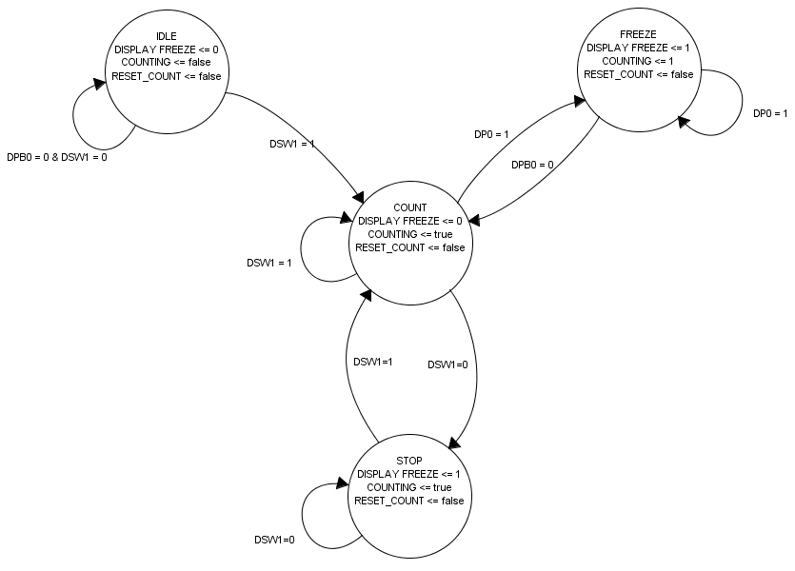

**3. File.do**

**restart**

**force CLK 0 0, 1 10ns -r 20ns**

**force PB0 0**

**force SW1 1**

**force SW1 0 @5000ns**

**force SW1 1 @7000ns**

**force PB0 1 @14000ns**

**force PB0 0 @17000ns**

**run 25000ns**

In this simulation, there is a different clock signal because is not viable to work with real clock. Also, it is testing the all conditions of the STOPWATCH.

Initially, the slide switch is turn ON (SW1) and the watch is initialized. You can see in the signals DIG4, DIG3, DIG2, DIG1 the corresponding values: 0000, 0001, 0002, 0003, 0004, 0005, and 0006. I can continue until 5999 because the next value is 0000. However, the SW1 is turn OFF for a short time, then turn ON. Note that the value was frozen and when SW1 was turned ON, the watch started to work from the 00.00.

Also, I simulated the push button PB0 that has the function to fix the value on the display when pushed. Therefore, in the moment that the PB0 is pressed the last value in the displayed is showed; in this case is 0007. However, the watch is working normally, and when it is released the display shows the current time; in this case is 00.10.