Homework 6

Nonlinear System

Erivelton Gualter dos Santos | 4/19/2019

# Question 1

# Question 2

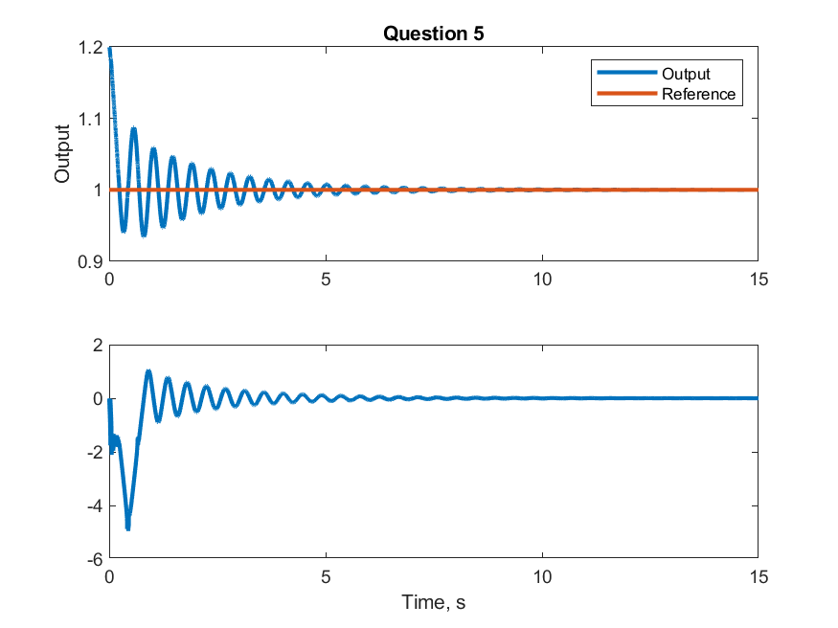

# Question 3

# Question 4

# Question 5

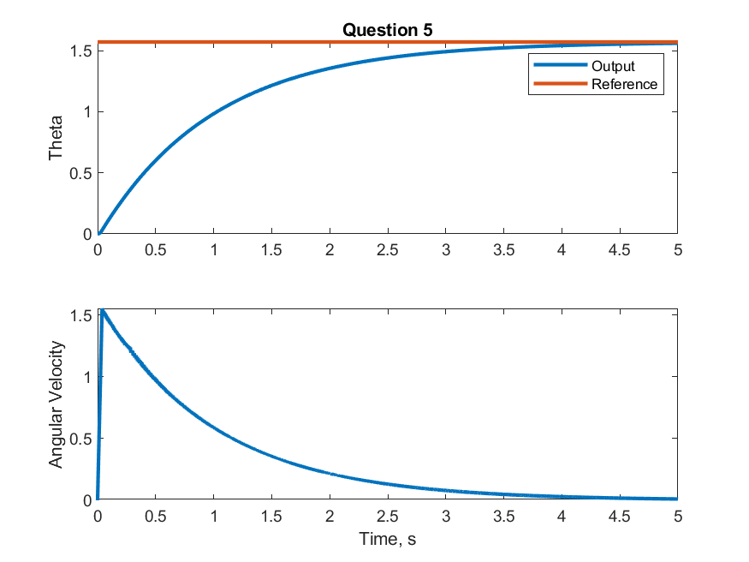

# Codes

## Question 2

X0 = [1.2; 0];  
Kp = 200;  
Kd = 1;  
  
fun = @(t, X) (fcnODE2(t, X, Kp, Kd));  
[t,X] = ode45(fun,[0 15], X0);  
  
subplot(211); hold on; box on;  
 plot(t, X(:,1), 'LineWidth', 2);  
 plot(t, ones(size(t)), 'LineWidth', 2);  
 legend('Output', 'Reference');  
 ylabel('Output');  
 title('Question 5');  
  
subplot(212); box on;  
 plot(t, X(:,2), 'LineWidth', 2);  
 xlabel('Time, s');  
  
print('fig_question2', '-dpng');  
  
function dxdt = fcnODE2(t, X, Kp, Kd)  
 % Unpack  
 x1 = X(1);  
 x2 = X(2);  
  
 % Desired Trajectory  
 ydddot = 0;  
 yddot = 0;  
 yd = 1;  
  
 % Error  
 e = (X(1) - yd);  
 edot = (X(2) - yddot);  
  
 % Controller  
 global U  
 v = ydddot - Kd*edot - Kp*e;  
 u = v/cos(x2) - x1^4*cos(x2);  
 U = [U u];  
  
 % Plant  
 xd1 = sin(x2);  
 xd2 = x1^4*cos(x2)+u;  
  
 dxdt = [xd1; xd2];  
end

## Question 5

X0 = [0; 0];  
  
fun = @(t, X) (fcnODE5(t, X));  
[t,X] = ode45(fun,[0 5], X0);  
figure;  
subplot(211); hold on; box on;  
 plot(t, X(:,1), 'LineWidth', 2);  
 plot(t, pi/2*ones(size(t)), 'LineWidth', 2);  
 legend('Output', 'Reference');  
 ylabel('Theta');  
 title('Question 5');  
  
subplot(212); box on;  
 plot(t, X(:,2), 'LineWidth', 2);  
 xlabel('Time, s');  
 ylabel('Angular Velocity');  
  
print('fig_question5', '-dpng');  
  
  
function dxdt = fcnODE5(t, X)  
  
 % References  
 delta = pi/2;  
  
 % Parameters  
 k = 4;  
 a1 = 1;  
 m = 0.1;  
 l = 1;  
 ko = .02;  
 go = -9.81;  
  
 % Unpack  
 x1 = X(1) - delta;  
 x2 = X(2);  
  
 % Control  
 u = -k*sign(a1*x1+x2);  
  
 x1d = x2;  
 x2d = -(go/l)*sin(x1+delta) - ko*x2/m + u/(m*l^2);  
  
 dxdt = [x1d; x2d];  
end