Controle de um Braço Robótico usando RNA
Erivelton Gualter dos Santos
erivelton.gualter@gmail.com, 11.210.368-4
clear
clc
close all
sim('GenerareData.slx'); % Open Simulink "Generate Data"
save % Save file
net = feedforwardnet(6); % Classification algorithm
%load('matlab.mat') % Load created data
load('treinamento_moodle.mat') % Load Data from Moodle
net = train(net,teta',torque'); % Train network
gensim(net,-1) % Generate block
out = sim(net,teta'); % Recall
% Plot
plot(out(1,:),'x')
hold on
plot(torque(:,1),'ro')
Saving to: C:\Users\EriveltonDell\Documents\Centro Universitário da FEI\10 ciclo\ICAC\github\Pendulum\matlab.mat
ans =
untitled2
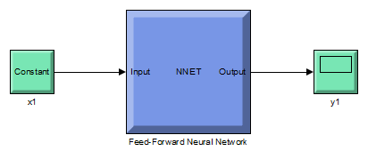
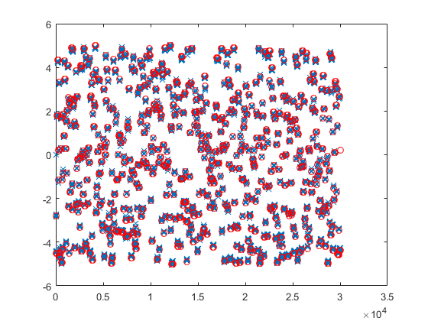
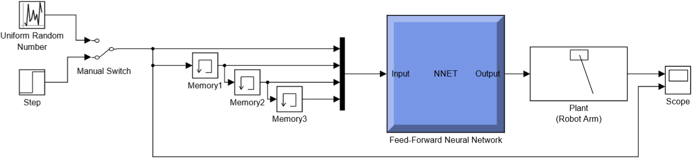
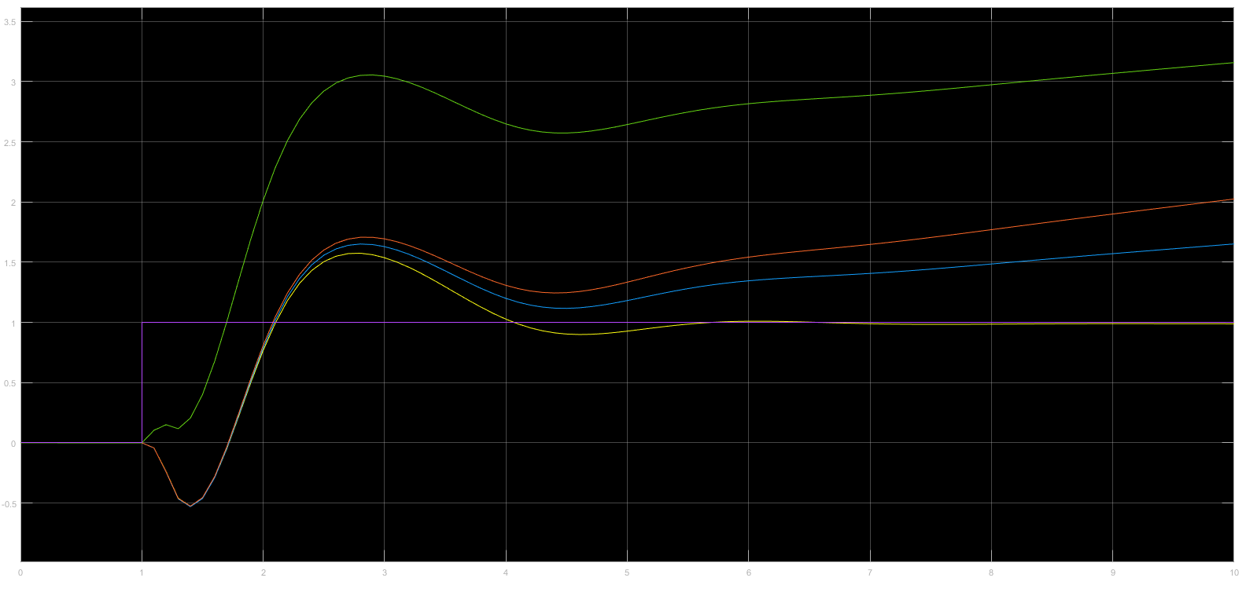
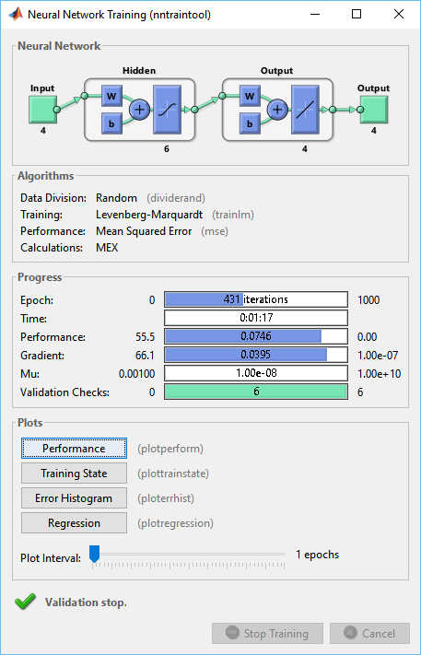

Published with MATLAB® R2015b

