EMG – Driven Wheelchair Project

Erivelton Gualter dos Santos
Fei University

“Hello everyone,Today I will be presenting my work about wheelchair that I have done before I arrived in Cleveland during my undergraduate in Brazil.
The main goal of this project was to build a prototype driven wheelchair that can be used for several studies. Such as applying control techniques to control the wheelchair as a purely motorized wheelchair or even as a hybrid wheelchair, where the user still must apply some force in the push-rim to propel the device. This last application is really useful for the wheelchair user because it can maintain the physical activity that is really important and helps prevent injury from the excessive effort on arms and shoulders”.

Overview

- B.S. Automation and Control Engineer at FEI University;
- Tutoring Experience in Physics I and Differential and Integral Calculus II;
- Undergraduate Researcher at Robotic and Artificial Intelligence Laboratory.
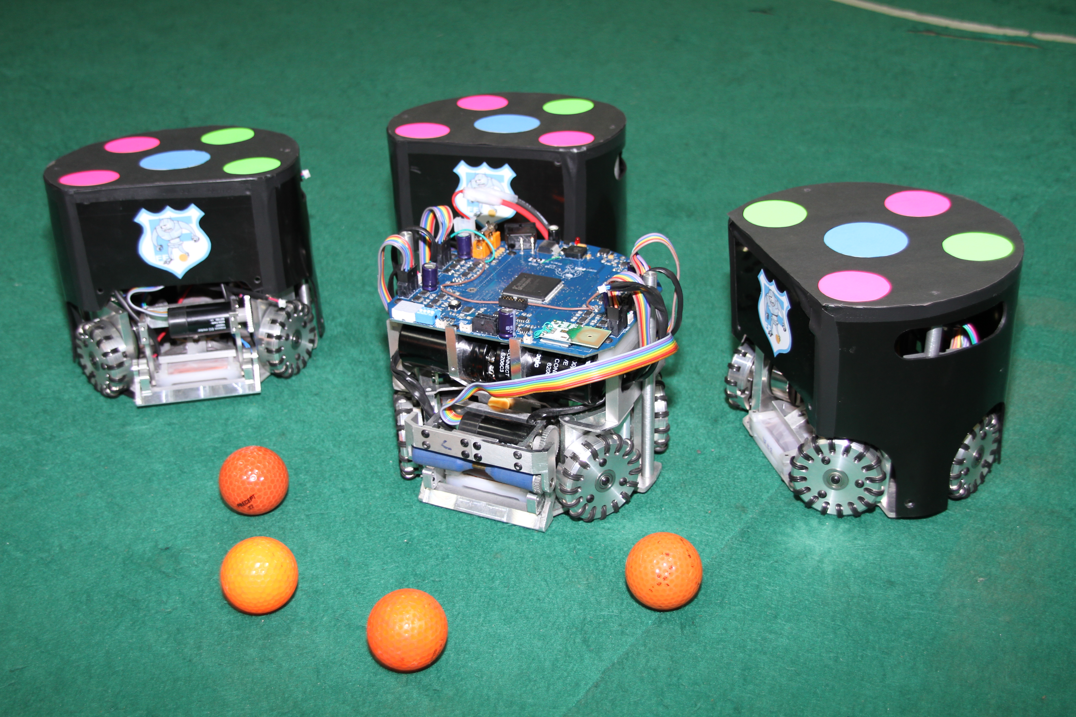

But before going into details I want to take the opportunity and briefly mention some of the projects I have been working on and also talk about our research group in Brazil called Assistive Technology Research Center at FEI University.
So, I graduated in Automation and Control Engineer last year in a 5 year undergraduate program and I explored all the opportunities related to research and academic life during college.
In my second year of college I tutored some classes such as Physics I and Calculus II. Also, I worked in the Artificial Intelligence and Robotics {robótics} laboratory developing robots to play soccer in a competition called Robocup. I worked there for two years, my main role in the team was developing software. I developed the strategy of pass system and also designed the kicker mechanism. This project was really complex, we actually built everything, mechanical design, electronic boards and software. The main goal of this competition is to solve problems of intelligent multi-agent cooperation and control in a highly dynamic environment. The robots move without any human {riuman} interference {interfiurence}, so the robots take their own decision about when they can attack or be in defense and other game strategies.
Here is a video of the robots interecpeting and kicking the ball. In this case the goalkeeper is static because the goal was just to evaluate a new interception algorithm techquique. This video is from 2013, so the strategy and control of the robots are much better nowadays.
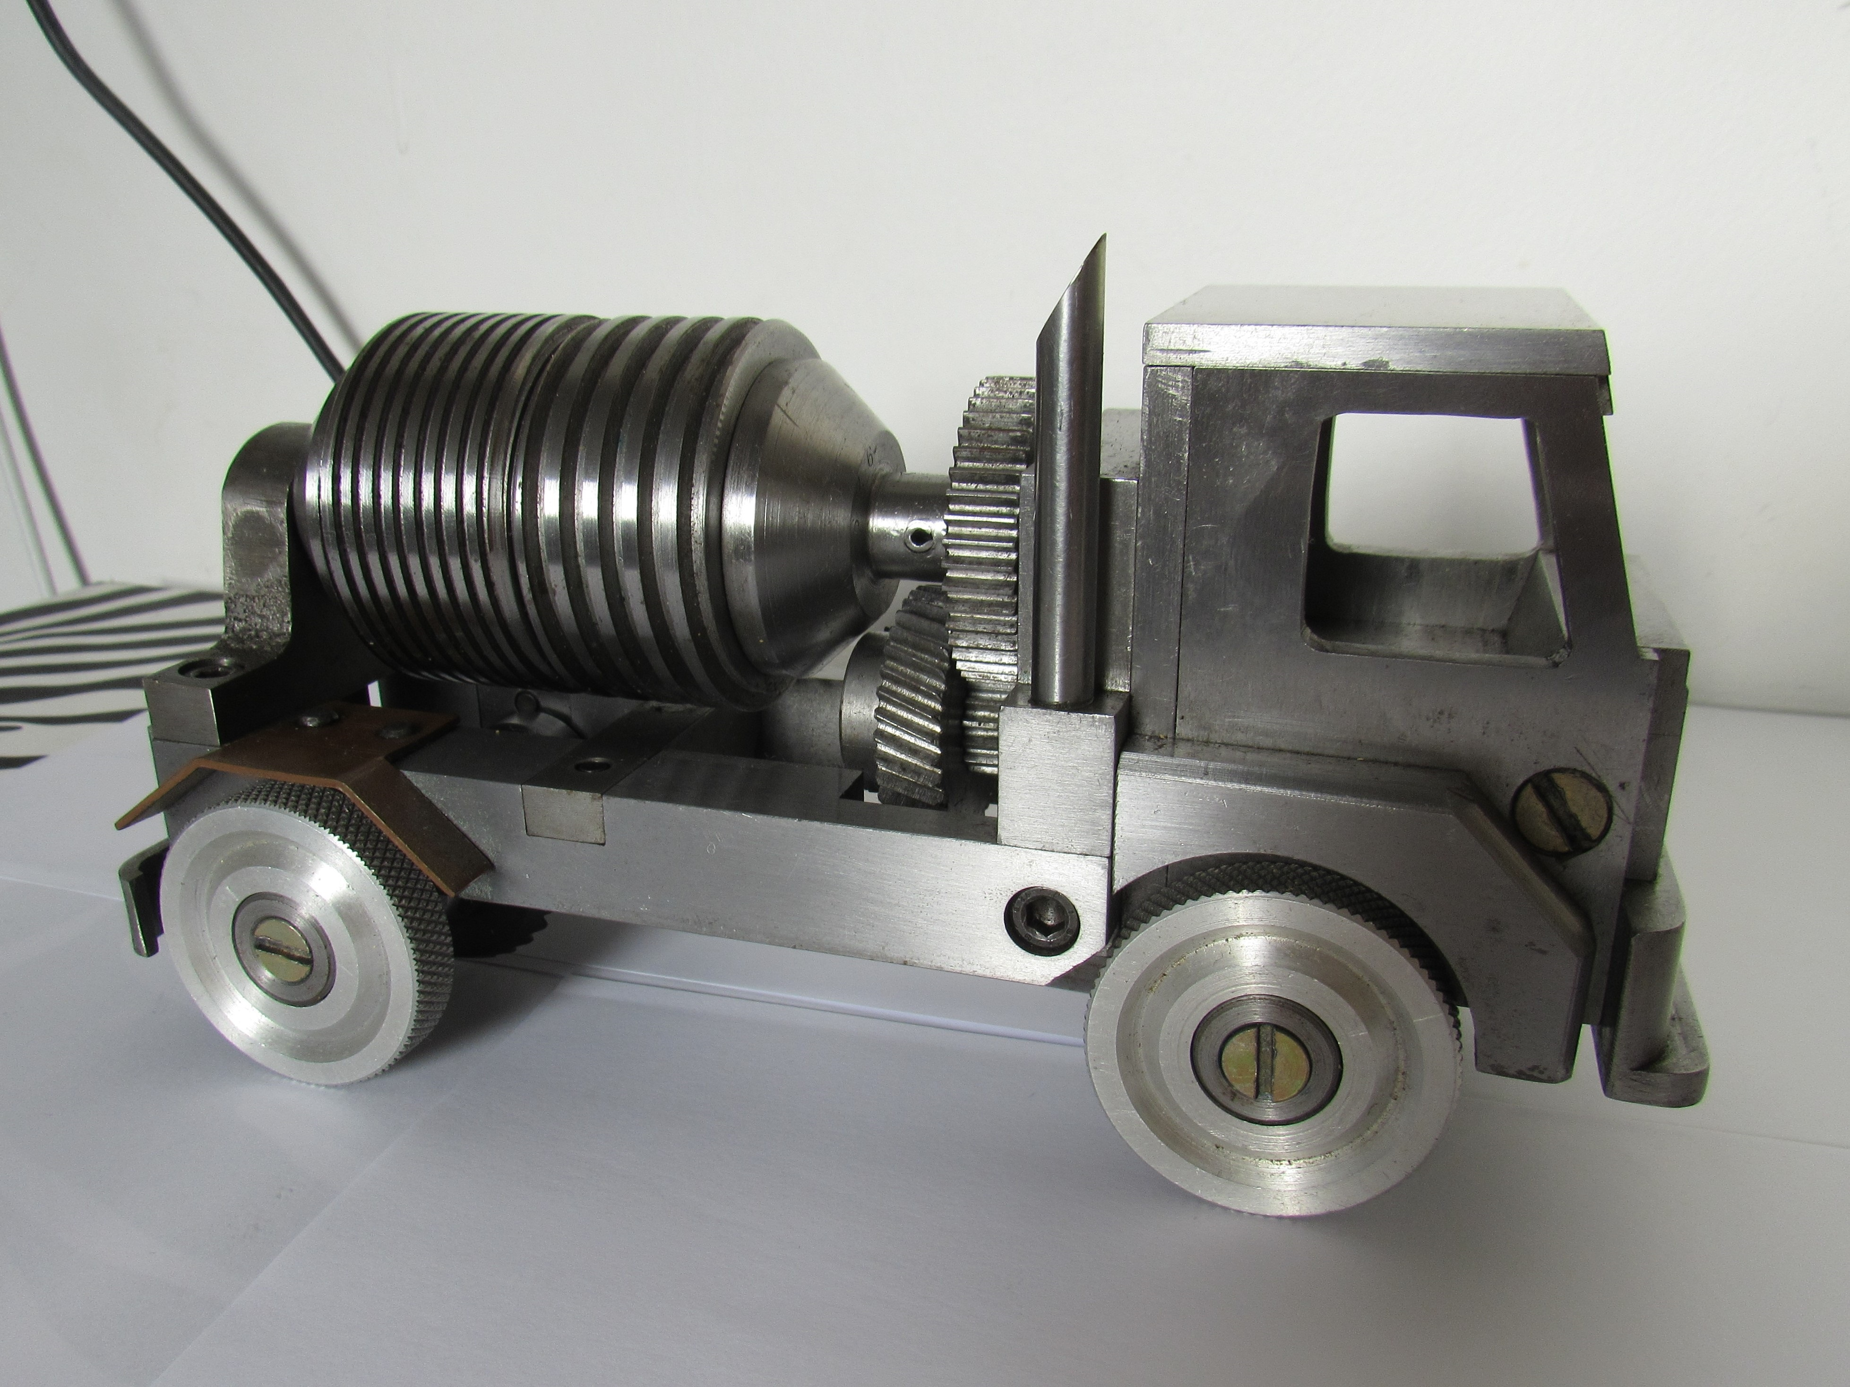
Also, I have an extensive machining and fabrication experience: milling, turning and welding.

I have been working with other projects realated to Robotics. Such as path planning and obstacle avoidance algorithm, such as Dijkstra and AStarGrid Planner to find a shorthesd path for the robot to move.

Assistive Technology Research Center
( NTA - “Nucleo de Tecnologia Assistiva” )

- The group is formed by different departments, such as mechanical, electrical and computer science department.
- Also, has collaborations with biomedical departments from Federal University of ABC (BMClab – Biomehanics and Motor Control Laboratory) .
- One of the main goals of the group is create national assistive tecnology aimed the power-assisted wheelchair.

But before, jump in the driven wheelchair subject I will talk a bit more about our research group related to wheelchair technology and the goal to study wheelchairs.
The group was established in 2013. So it is pretty young. It is composed by different engineering areas, such as mechanical, electrical and computer science department and other facilities from UFABC which is another university that collaborates with us and allow the group to use their facilities to study the motor control of propulsion movement.

Actually, I was one of the sample to study the wheelchair propulsion.

Motivation

- 45.6 million people have some kind of disability.
- 14 million Brazilians have some kind of motor deficiency.
- 5 million are wheelchair users.
- 1 to 2% of the planet's population depends on a wheelchair.

According to the Brazilian Institute of Geography and Statistics there are 45.6 million people in Brazil that have some kind of disability, including motor, hearing, visual and mental, among others.
14 million have some kind o motor deficiency {deficianci}
Among them, 5 million are wheelchair users.
It is a lot of people.
Most of the wheelchair users are those who suffered a Spinal cord injury, Multiple sclerosis, Amputation of lower limbs, Polio, Arthritis, Advanced age among other complications.

Therefore, since it is a big issue in every part of the world, In Brazil it is no different. Actually, it is worse, because as the nice wheelchairs are made overseas, the price to import one of this product are extremely {extremili} expensive. So, the NTA group focus is to develop a national advanced wheelchair.
Since the group was established, we have already completed some master thesis, conference papers and we still have several students working in this subject.

The research subject of the group’s focus is: Assistive Technology, {Technólogy} Motion with power assistance, modeling and simulation of the wheelchair propulsion.

So, my main role in the group was to actually build a driven wheelchair prototype to test our research.

Wheelcahirs

- Manual;
- Motorized;
- Hybrid.

So basically the wheelchairs are divided in three categories:
Manual, Motorized, and Hybrid wheelchair.

The manual wheelchairs are mechanically simpler, lighter, generally easier to carry, mainly when folding, and provide the user with the possibility of performing physical activity of the upper limbs during propulsion, which has several benefits such as feelings of well-being, reduction of anxiety {engizaiet}, improvement of the musculoskeletal {musculo-skeletal} and cardiovascular condition.

The Motorized Wheelchair are generally used by those who also have motor disabilities in the upper body. Mainly these users are those who suffered a high injury in the spinal cord. Usually these wheelchair is heavy, not easy to carry and expensive.

The hybrid wheelchair or Power Assisted Wheelchair are those that have a motor to reduce the inertia of the system. In this case the user still must perform the propulsion and the motor will amplify the force. So, the user still can perform some activities and avoid injuries.

Design

- Set the goals of the wheelchair
- Estimate motor characteristics
- CAD
- Build
- Electronic board
- Controller
- EMG

So, before we executed the project we did some brainstorming and set some goals of what we would like to do with the wheelchair.
Basically, the group proposed some ideas, such as:
- control theories to compensate the force of gravity on a hill, so the wheelchair will not slide backwards when the user is not holding the push-rim;
- Propose new control techniques for the power-assisted wheelchair;
- Wheelchair wheelie which is a maneuver employed to overcome obstacles and descend ramps.

So, between these ideas, the most challenging task is to maintain the wheelchair in equilibrium on back wheels. So, I started my research in this point. The goals was to try model and simulate the wheelchair wheelie. Then, I could estimate the motor effort and wheelchair characteristics to build a design.

SO, what is wheelie and why it is important?
It is a maneuver where the user lifts the front wheels, maintaining the wheelchair in balance. Then, the user moves the wheelchair until the front wheels are over the obstacle. So, the user can apply a force and incline the upper body to overcome the steps.
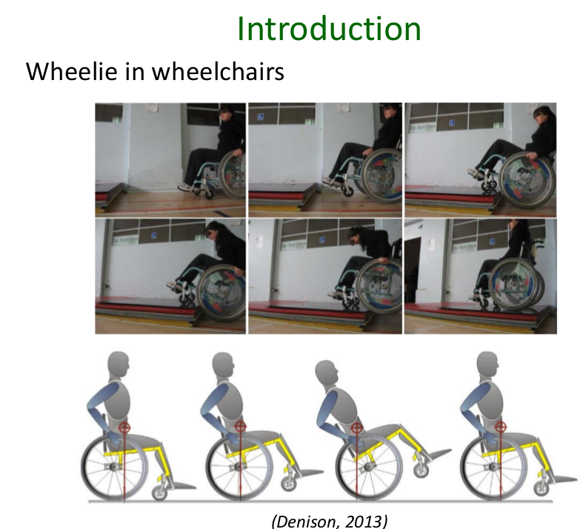
Also, the user can perform the same maneuver to descend stairs and going down irregular surface.
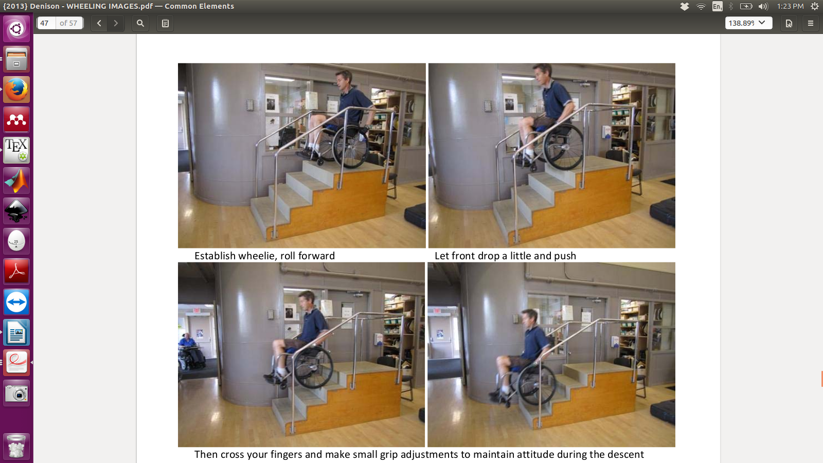

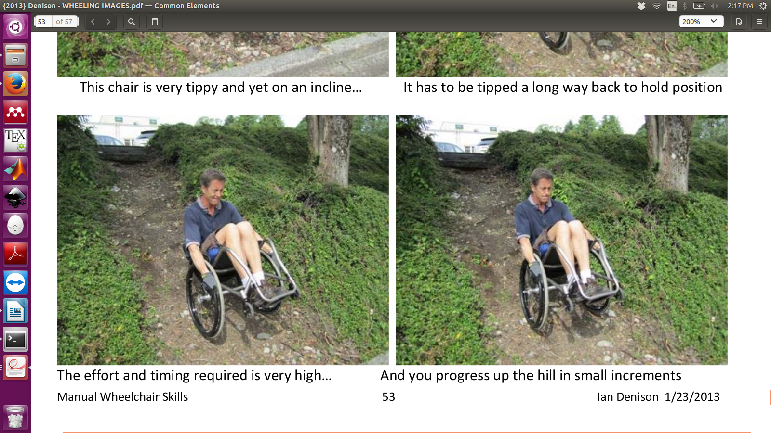

Here, it is an example of a power-assisted wheelchair from a startup group in France.

https://www.youtube.com/watch?v=RNgmWS5dtYE

This maneuver is really important for the wheelchair user, to overcome obstacles, such as a single steps on streets, descend ramps and drive over irregular terrain, such as grass.
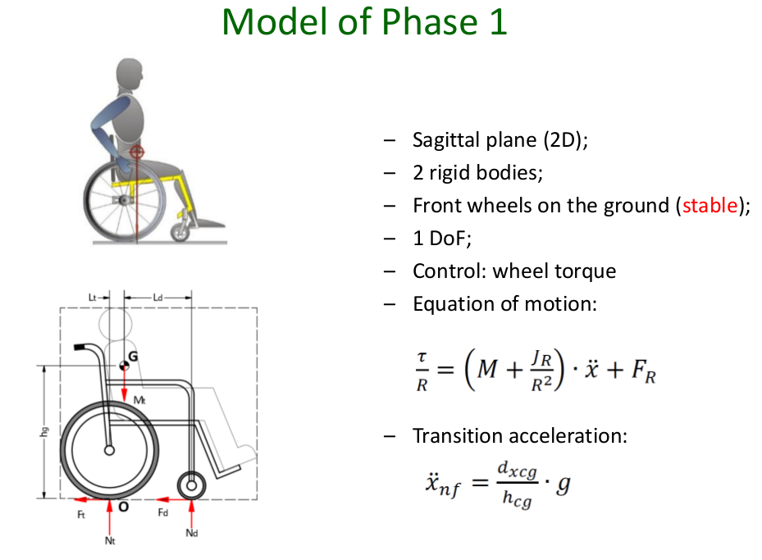
EXPLAIN it .
So .. First, I modeled the wheelchair in the Sagittal plane. In this case, the wheelchair is stable and has only a single degree of freedom. The control input is the wheel torque and we have the following equation of motion. Also I know the transition acceleration, that is the acceleration the system must reach to switch from the stable system to the unstable system on two wheels. It was obtained considering a null normal force in the front wheel.
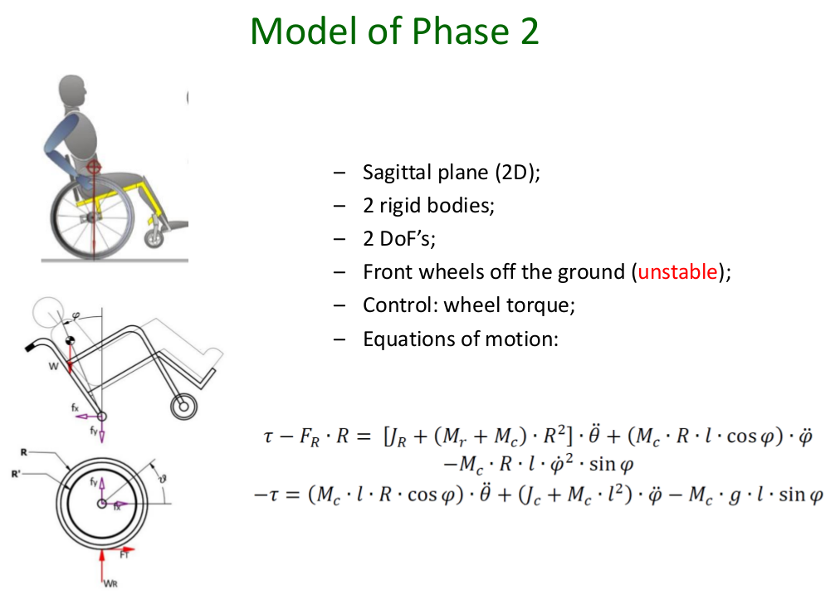
Here I have the model of phase 2, the equations of motion also was observed in the Sagittal plane. You can verify that the equations of motion is similar to the stabilization problem of an inverted pendulum that is well described in the control theory literature.

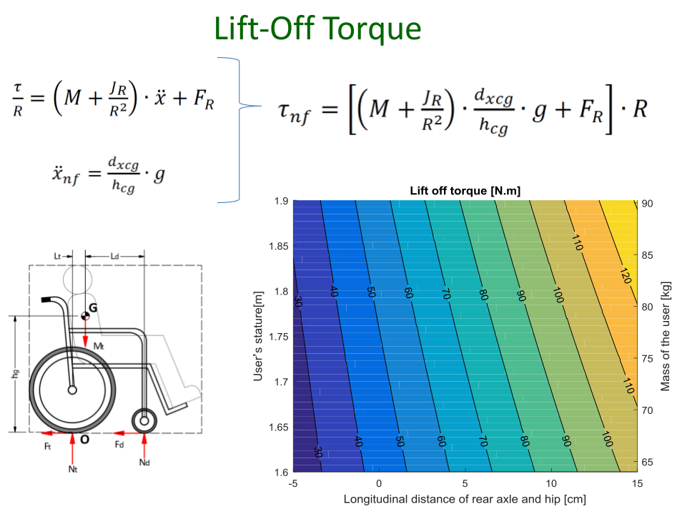
So, using the transition acceleration and the parameters from the experiments, which I will talk about in the following slides. I could find the lift-off torque necessary to perform the wheelie maneuver {manuver}. This graph shows the lift off torque relating to the users height, mass and distance from the rear axle and hip. You can see that if we change 5 cm it can add around 20 Nm of torque.

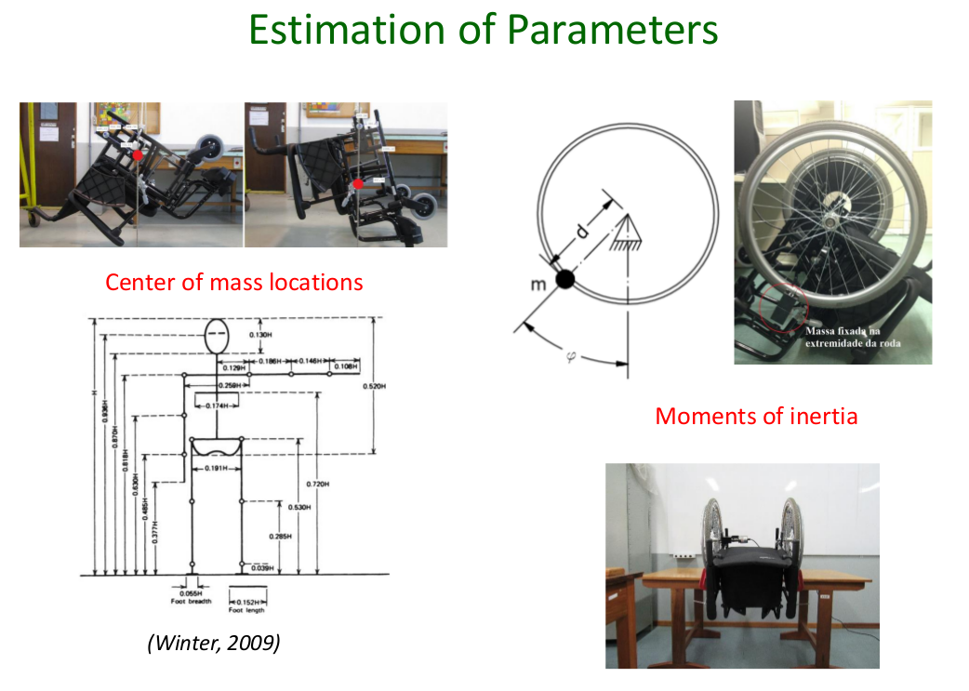
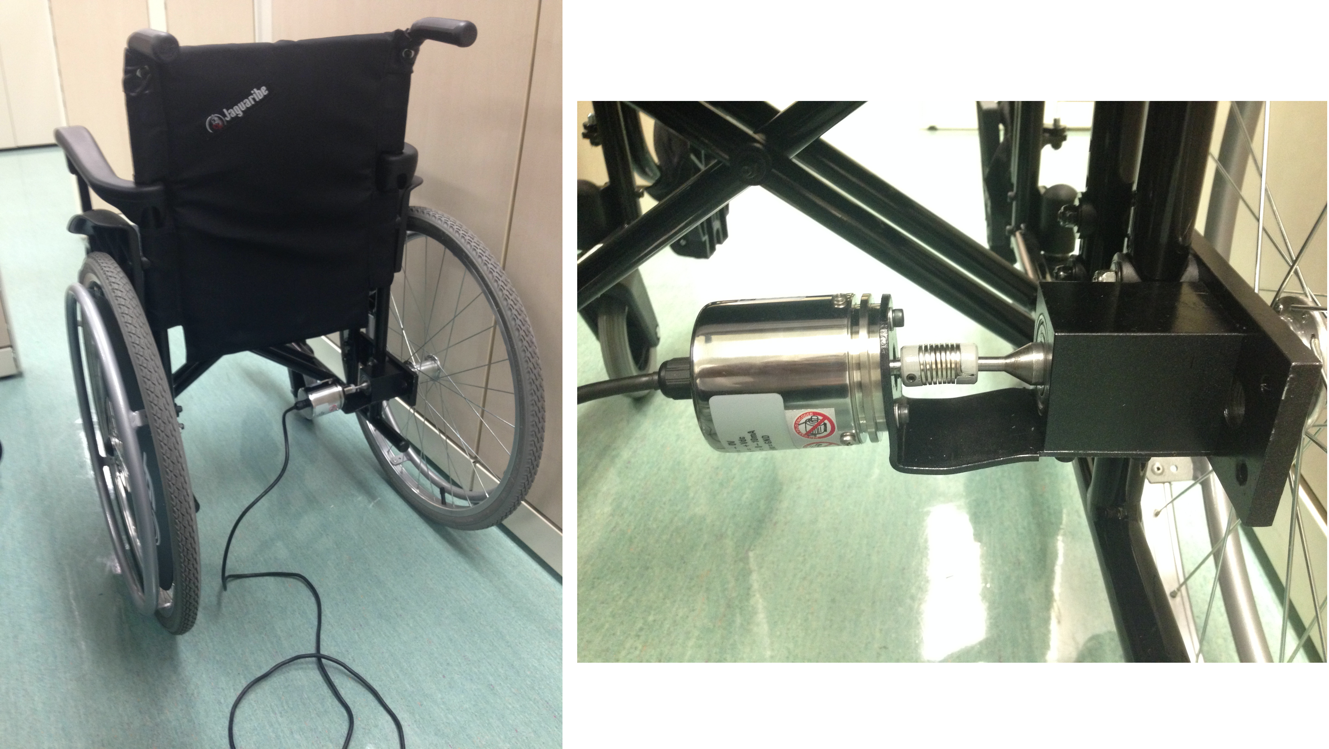
So, to obtain the parameters of the wheelchair it was necessary to perform some experiments.
To find the center of mass, I suspended the wheelchair in different positions and used Image Processing to intercept the lines in the Sagittal Plane. For the Center of Mass of the user, I used the Anthropometric table from Winters. To find the moment of inertia I attached an encoder in the axle and a well know mass in the wheel. Then, from the oscillation of tis mass I could find the natural frequency and finally the moment of inertial. I used this same procedure to obtain the moment of inertial of the wheelchair using a pendulum movement to obtain these values.

CAD Design and Control

So, with the identification of the parameters of our wheelchair it was possible to start the design and the construction of the wheelchair. So, first we have here the CAD model. The motor that we choose was a Brushless Motor from an electric bicycle.
One disadvantage to use this motor is because it needs to be have a structure as a fork. So, how to attach it in the wheelchair? Here you can see that we added a fork with a certain angle so that the user can also have the option to use the chair as a hybrid wheelchair.

The chosen motor drivers was from the Roboteq. They are pretty expensive, but they are really nice. They have a micro-controller inside that is fully programmable. We can actually program in C language using just this driver. Or, we can connect any other robust micro-controller or even raspberryPi or Arduino. In our case, we choose the Arduino as the initial prototype. But the goal is to add a micro-controller that is more robust.

We also, added an IMU – Inertial Measurement Unit and a Gyroscope to measure the angle of the wheelchair.

HMI

- There are several approaches of Human-Machine Interfaces to control a wheelchair using electro-biological signals.
- Examples: EMG, EEC and EOC.

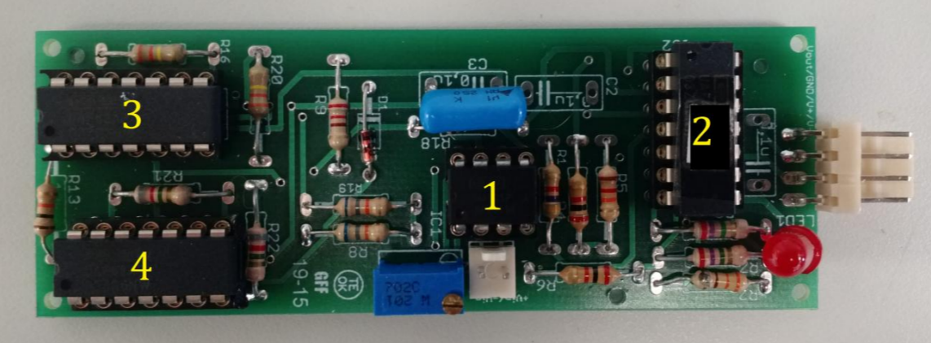
The myoelectric signal (EMG) originates in the region of the brain called the
primary motor cortex, and is transmitted through the central and peripheral nervous system to
the muscles that will be contracted.
EMG is the sum of these signals that perform the activation of the muscles of the body. So from the contraction of the voluntary muscles we can control our device.
We developed this circuit based in the traditional instrumentation amplifier for biomedical applications. We used the amplifier INA121 capable of high gains, UFA42 as high pass filter(Cut-off frequency 20 Hz), low pass filter (500 Hz cut-off frequency) and as Notch 60 Hz.
During the experiments using the breadboard and simulation it worked fine. However, after we built the final board we found some issues and we decided to switch to a commercial board called MyoWare Muscle Sensor which performs the same tasks as our original board.
This sensor will measure the filtered and rectified electrical activity of a muscle and the output will be an analog signal from 0 to 5 volts for example which depends on the power supply.
Therefore, to control the wheelchair we carried out some experiments in different muscles and we chose the biceps because it provided the best signal.
So, the most common EMG pattern classification procedure is based in the data acquisition, then a preprocessing to filter the signal, feature extraction, learning pattern and then classification.
Since I had a good signal I classified the muscle contraction as logical high and low for the status of the muscle contraction. So, after that I could use a heuristic {riustic} to control the wheelchair. To identify when the muscle was contracted we used a threshold as a reference.

EMG Control

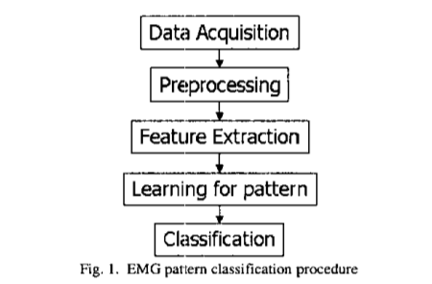

Here is the final prototype. I also have a video that briefly summarizes what I have talked about.

VIDEOOOOOOOOOOOOOOOOOOOOOO show

In conclusion, I have all the information about this project in my personal webpage. You can find very detailed drawings, codes and experiments used in this project.
There you can also find other projects that I have worked on.

Thank you.

