Prelim Lab Activity #2
Constants.sol
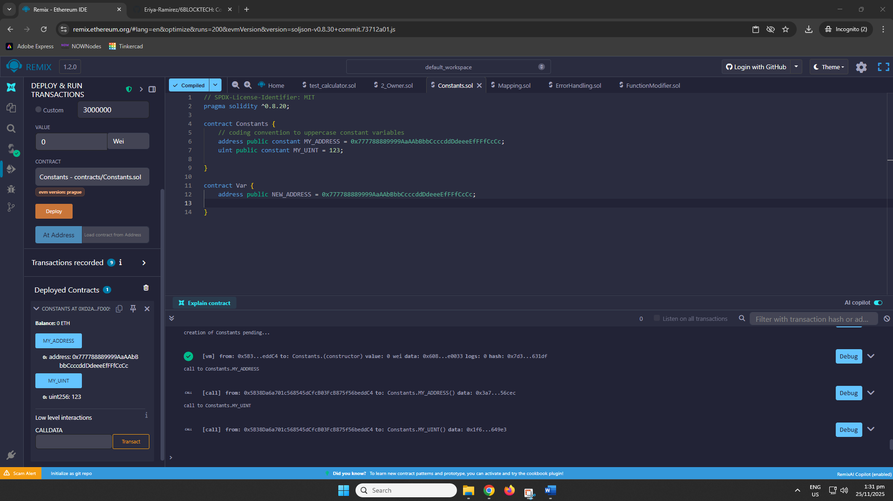
ErrorHandling.sol
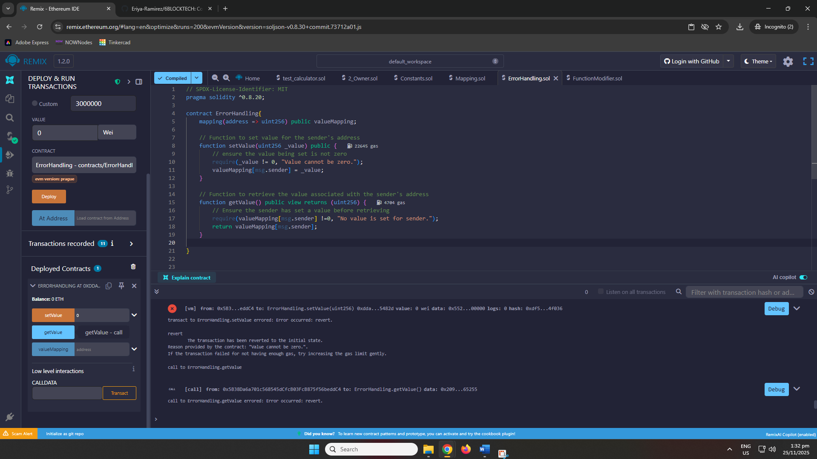

Mapping.sol
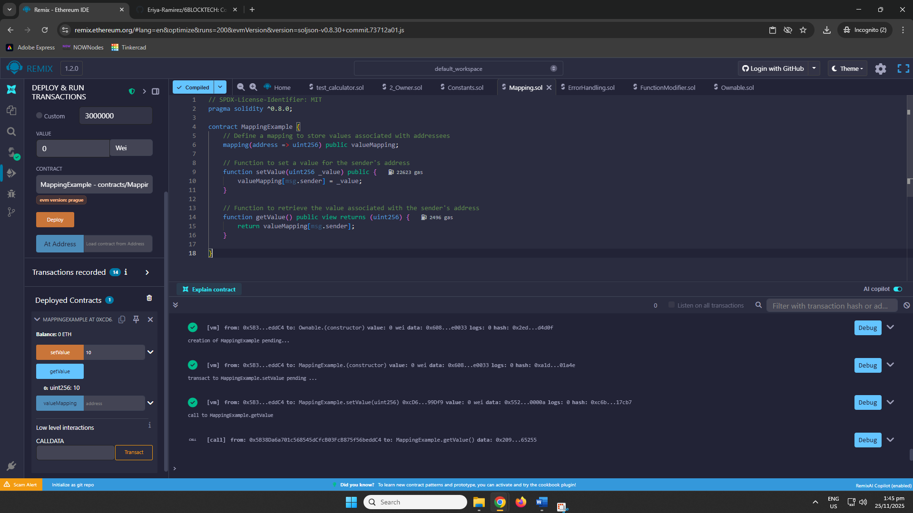

FunctionModifier.sol
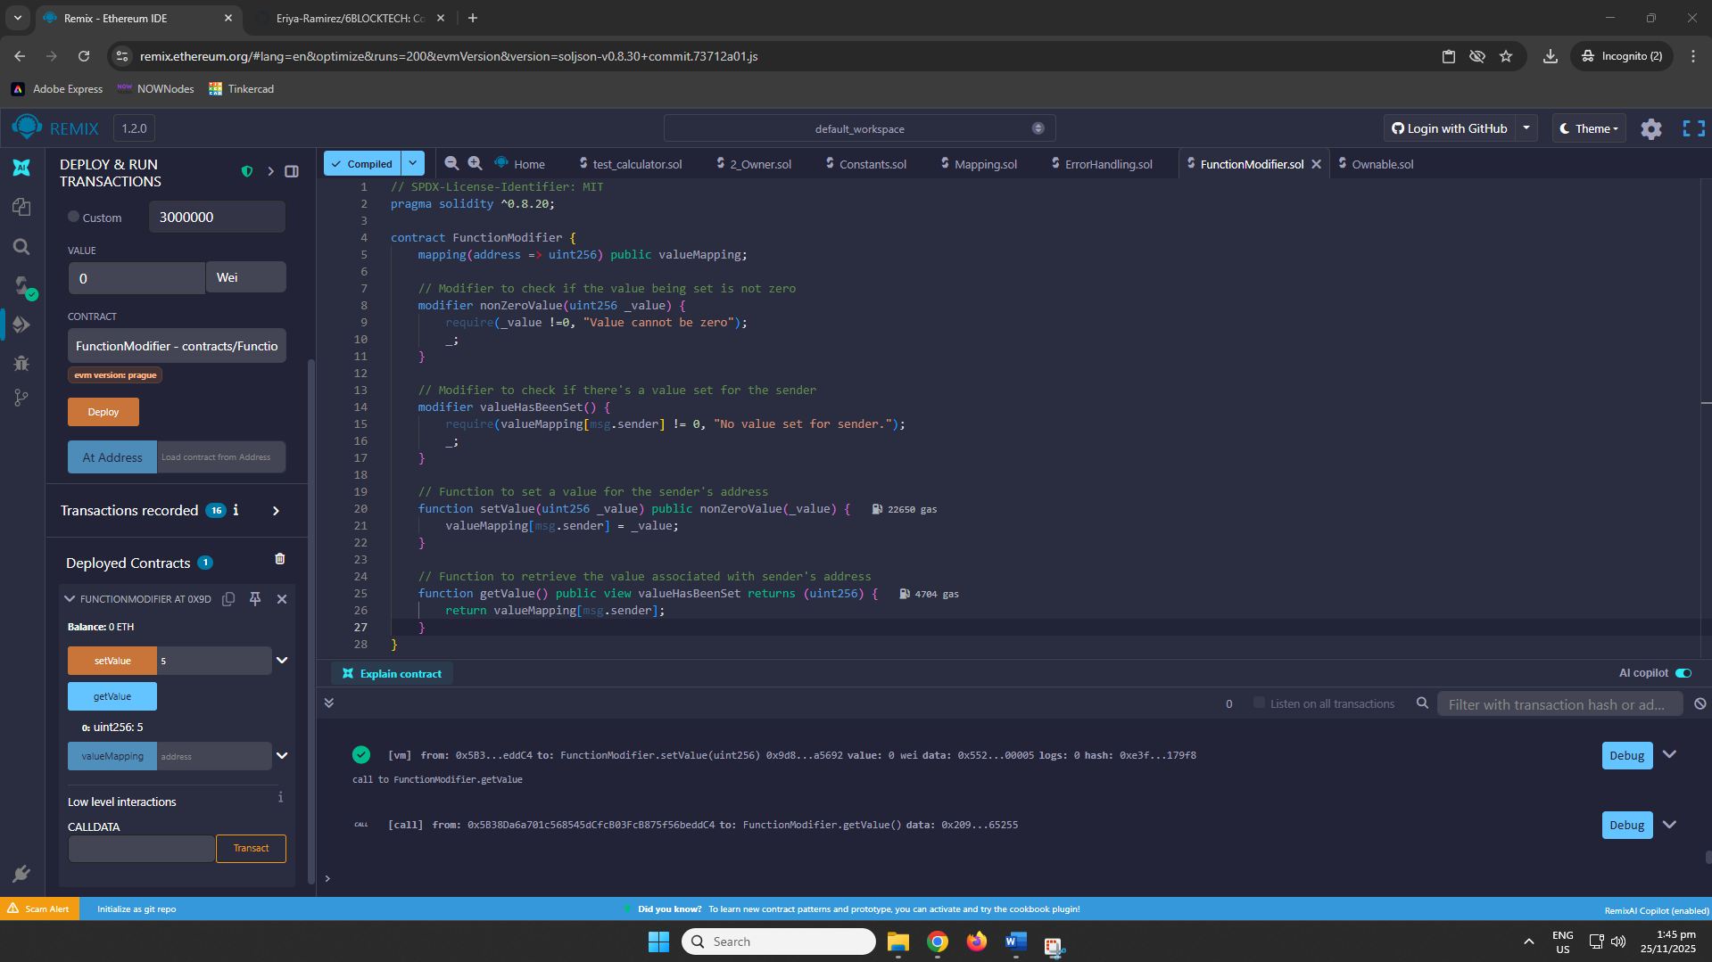
Ownable.sol (with constructor)
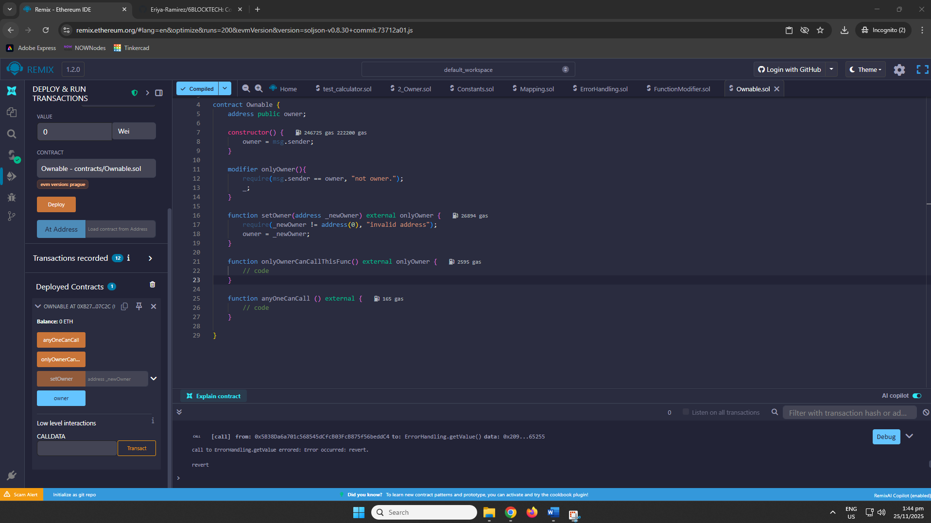

REFLECTION QUESTIONS
- Function Modifiers & Ownable
When should you use a modifier like onlyOwner instead of inline checks, and what risks arise if ownership isn’t managed properly?
  - When the same ownership restriction applies to several functions, use 'onlyOwner' modifiers instead of inline checks; this keeps code DRY, reduces human error, and makes access control crystal clear at a look. Modifiers are cleaner and less prone to errors (for example, neglecting to check in one function). However, if ownership is never properly transferred or renounced, the deal may become permanently locked under a dead, compromised, or lost private key; a single point of failure that can prevent upgrades, withdrawals, or emergency actions indefinitely. Poor ownership management is one of the leading causes of failed multimillion-dollar contracts.
- Error Handling
How do you choose between require, revert, and assert, and why might custom errors be better than error strings?
  - In Solidity, use 'require' to validate inputs and expected errors (it's inexpensive and permits custom errors), 'revert' when you need precise control inside complex logic, and 'assert' only for invariants that should never fail, because 'assert' consumes all remaining gas if triggered. Custom errors outperform string messages by saving up to 90% gas and displaying neatly in wallets and tools. For everyday checks, use 'require' with custom errors—it's the cheapest, safest, and most readable option.
- Constants & Variables
When should a value be constant, immutable, or mutable, and how does that choice affect gas cost and flexibility?
  - Use 'constant' for values that are fixed permanently at compile time (such as PI or a token name) as it requires no gas to read and are baked into bytecode. Use 'immutable' for values set once in the constructor (such as owner or maximum supply) they also require no gas to read but allow for one-time setup. Use normal mutable variables only if the value changes frequently. Choosing 'constant' or 'immutable' saves enormous deployment and runtime gas while slightly lowering flexibility, but it also avoids costly mistakes and keeps your contract cheaper and safer.

