Solidity Basics
Hello World Sample
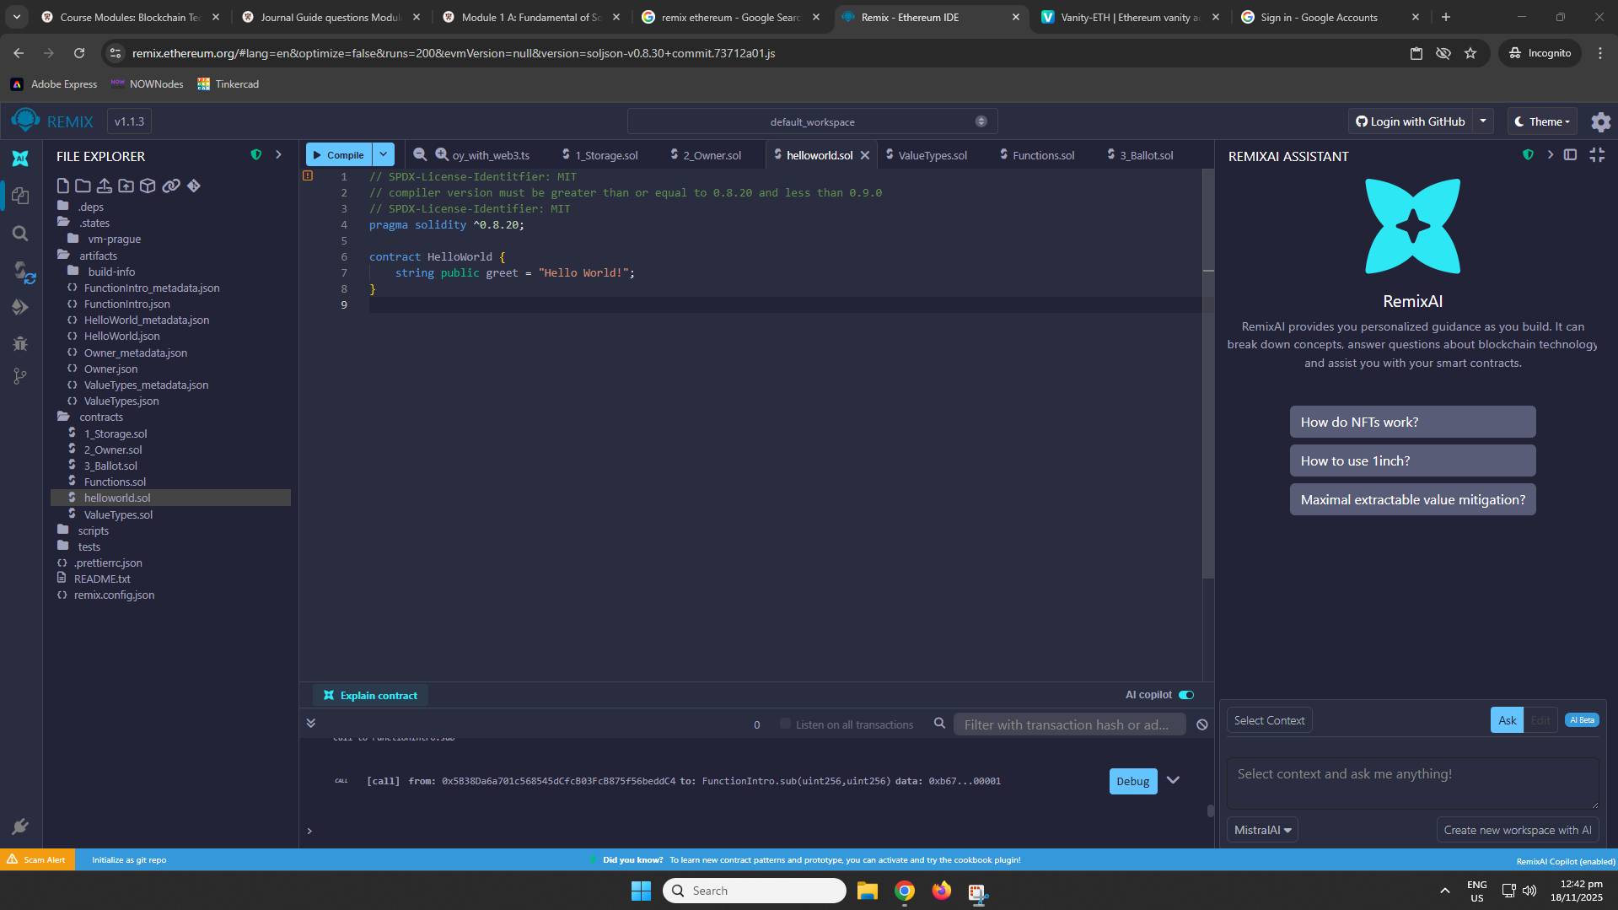
Value Types Demonstration:
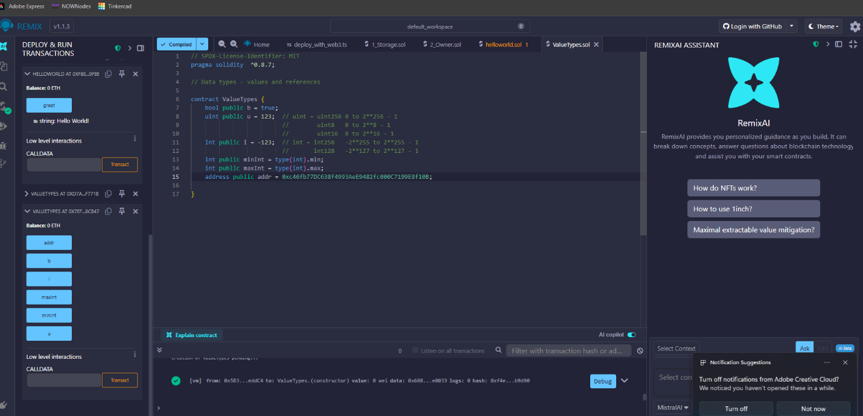
Insights:
For this demonstration, we copied the code, compiled it and then deployed it to demonstrate how value types in solidity work.
Function Demonstration
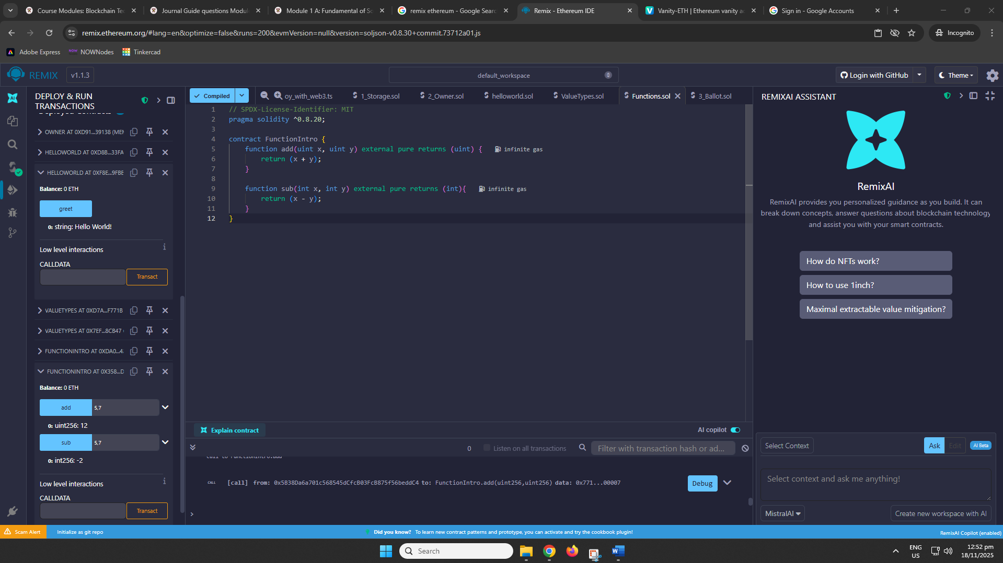
Insights:
For this code, we demonstrated how functions work in solidity by typing this code, compiling it and then deploy it. After deploying it, we demonstrated it by putting 5 in ‘x’ and ‘7’ in ‘y’. It didn’t work on the first try for the subtraction because the value type is set to “uint”, so we changed it to “int” and the function worked.
Local Variables
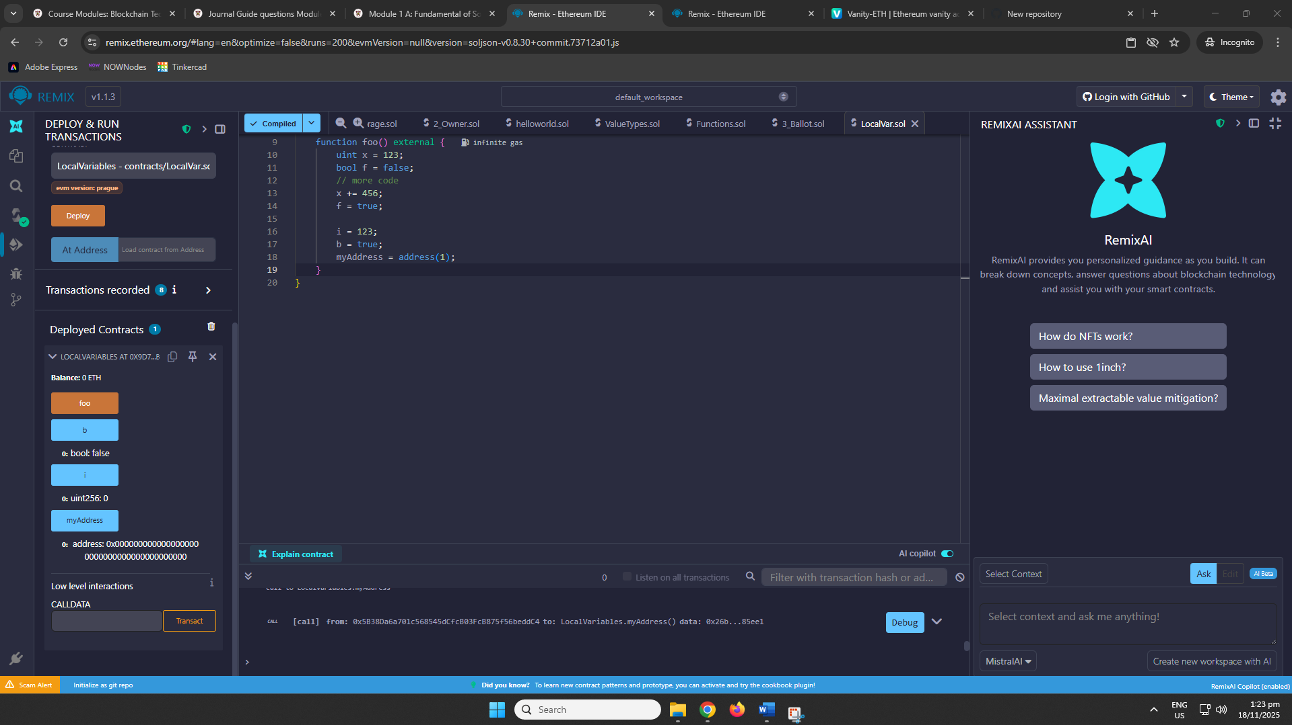
Insights:
x and f are function-local, which means they exist just within foo and are not recorded on the blockchain. Changes to them (e.g., x += 456 or f = true) do not survive outside the function. However, i, b, and myAddress are state variables, which means their values are recorded on the blockchain and accessible to other functions or external contracts. This demonstrates the distinction between local and state variables in Solidity.
Global Variables
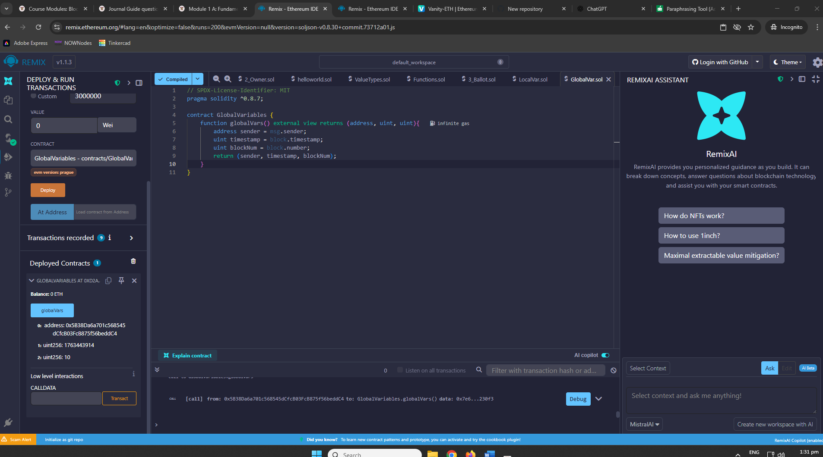
Insights:
In this example, we demonstrate how Solidity's global variables provide important blockchain information within a function. Here, msg.sender is the address that called the function, block.timestamp is the current block's timestamp, and block.number is the block number. These values are not declared in your contract, but rather are built-in global variables provided by the Ethereum ecosystem, demonstrating how smart contracts can access contextual blockchain information.
View and Pure Functions
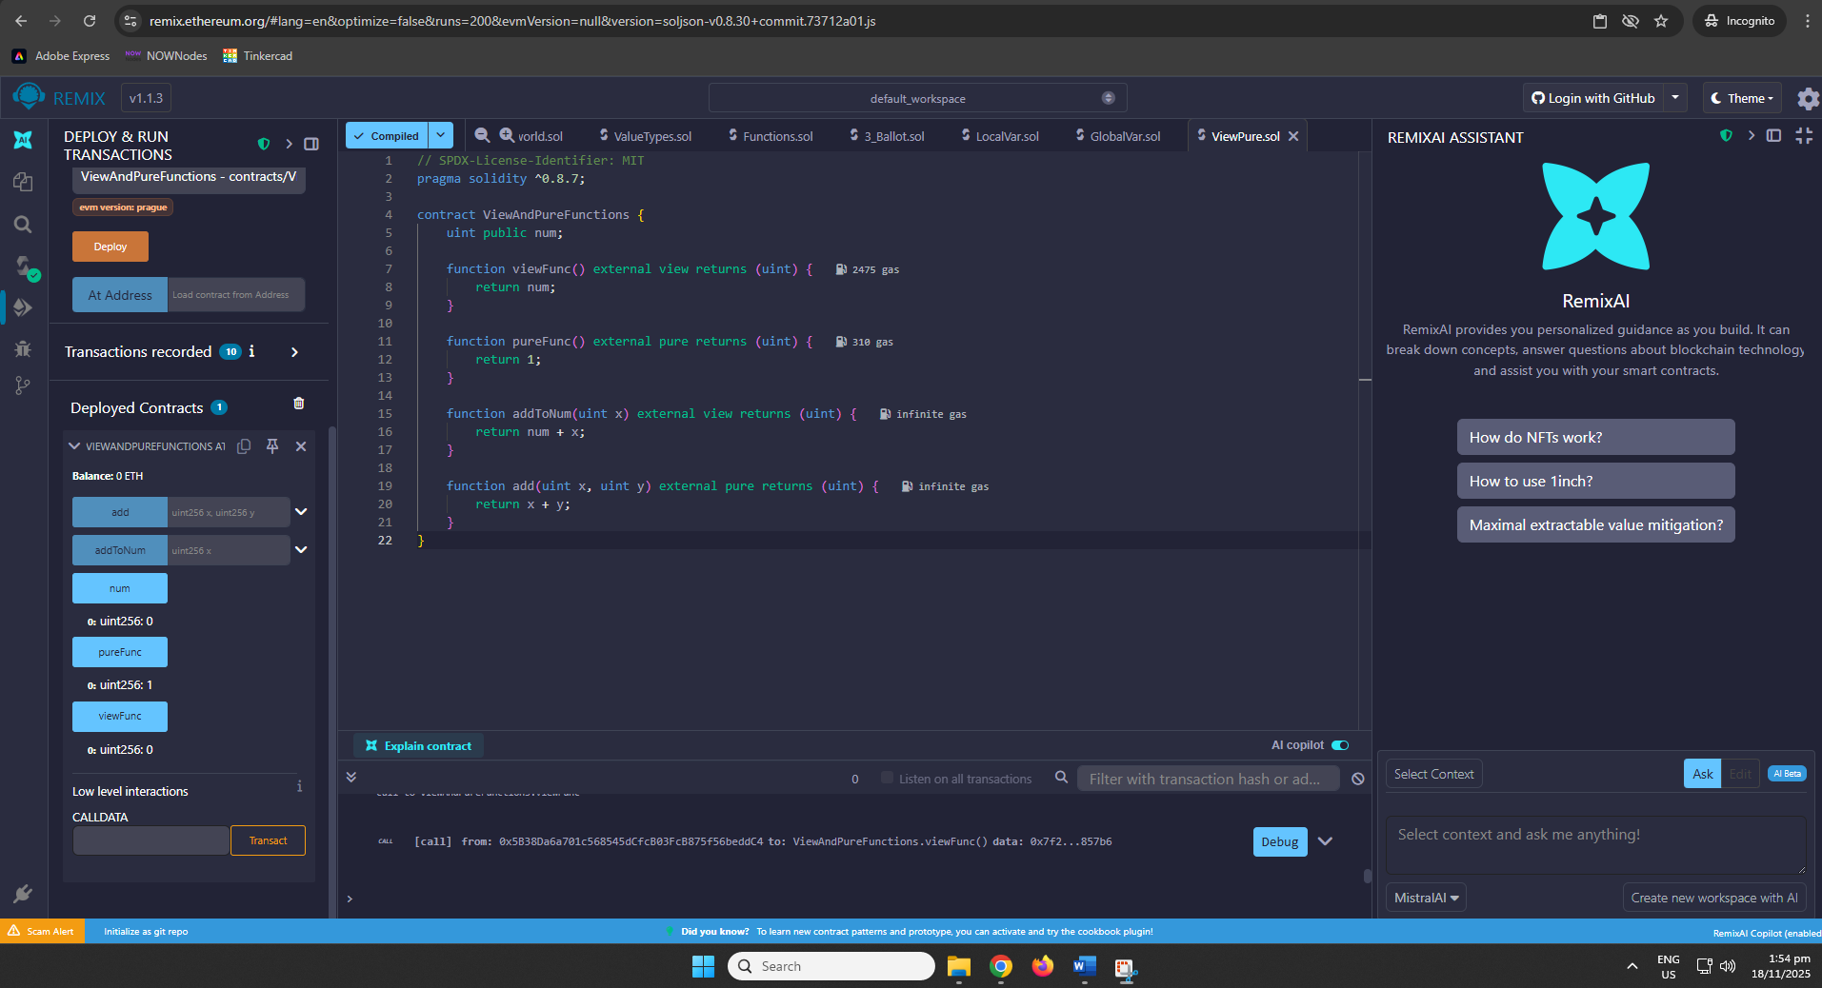
Insights:
In this example, you show the distinction between the 'view' and 'pure' functions in Solidity. The 'view' functions, such as 'viewFunc' and 'addToNum', can read but not modify state variables (such as 'num'). These routines are important when you need to extract data from the blockchain without affecting its status. On the other hand, 'pure' functions such as 'pureFunc' and 'add' do not interact with the blockchain state at all. They just use the input parameters to do calculations and deliver a result. This demonstrates how 'view' functions provide state access, whereas 'pure' functions are self-contained and not dependent on any contract state.
Review Questions:
Identify if view or pure.
- For the first function, it does not deal with any state variables or blockchain data. It only conducts a computation using the function's parameters (a and b), making it a pure function.
- For the second function, it returns the account balance, which is a state variable (or the state of an external contract). Because it reads the state but does not change it, this is a view function.
- For the last function, it is similar to the first, this just conducts a computation based on the input values (a and b), making it a pure function that does not interact with the blockchain state.

