3.1 Text Collection and Cleaning process.

E-books in modern Uzbek literature, a national database of legislation, and big information web portals are used in order to gather textual information in the Uzbek language. Search crawlers (web crawlers) were used to automate the process of extracting text from these websites. The collected texts were cleared of words in other languages, users ’personal information, political issues, violence, and other inappropriate content. Texts consist of mixed Uzbek and ather foreign utterances, because there are many borrowed words from other languages in Uzbek, and it is common practice among Uzbek speakers to code-switch between Uzbek and Russian. After that, we divided the texts into sentences. In the text, those with a sentence length of more than 15 words and numbers were removed.

3.2 Converting texts to sounds and checking.
A bot has been developed on the social network Telegram which converts text into sound.A special BotFather robot page on Telegram allows users to create personal bot applications.This is based on processing requests to it on another server based on API technology.This bot allows you to record sound on smartphones and computers.The bot registers the user and receives information such as age range, gender and geographical location.The bot provides the reader with the least read text in sequence.If more than one user is using the bot at the same time, it gives them all the same text (Figure 1.a).
On this page, control buttons were reflected that allow you to save or rewrite an audio file in the absence of errors, there is a statistic of the number of texts read by the announcer.
Announcers were attracted to the sound conversion project by announcing on websites and telegram groups.Announcers at least 18 years of age were included to participate in the data collection legally.
Checking the quality of audio recordings, which is the other side of the issue, is also an important part of the job.Several Uzbek volunteers were called in to check the quality of the recorded voices.A special page has also been created in the telegram messenger to check the audio recording and the correspond of it to text. This page transmits to the examiners (Transkribery) the audio segment read by the announcers and the corresponding sentence. The task of the transcribers is to check that the audio information read by the announcers corresponds to its text and to record them if there are errors (Figure 1.b).

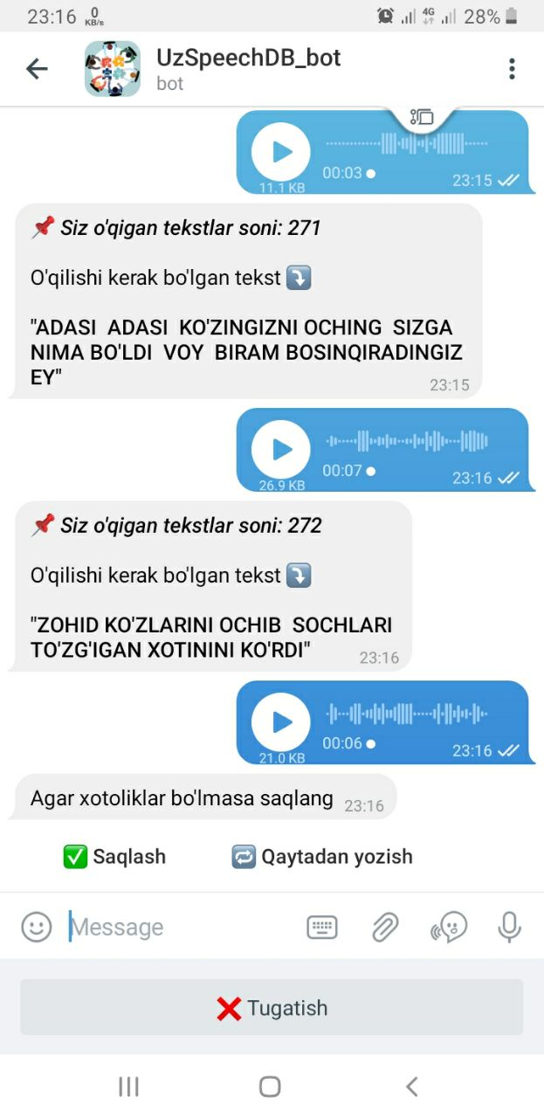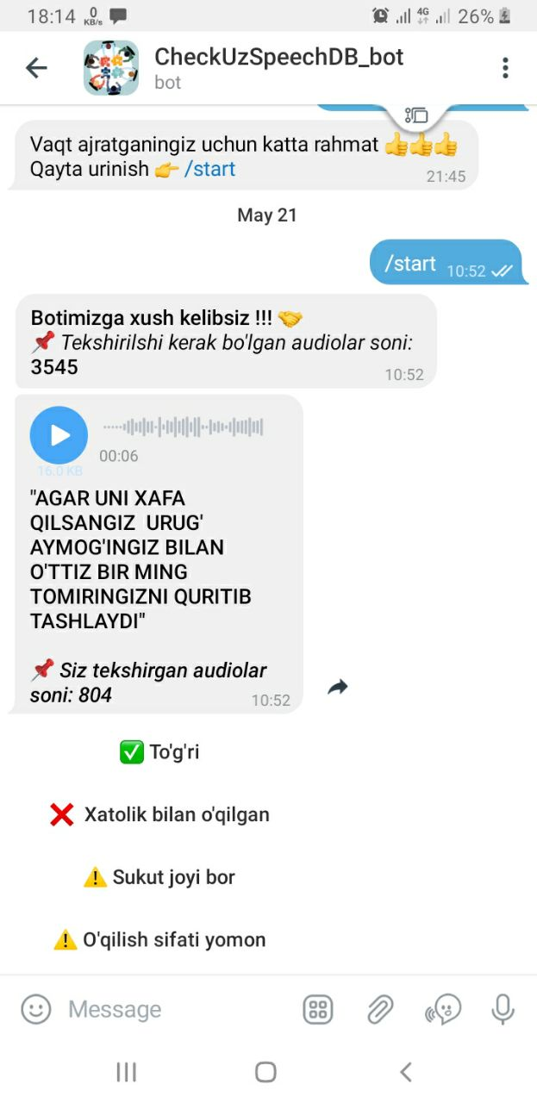
Figure 1. a) Speech recording bot page, b) Audio recording quality check page
This page also has control buttons that determine the quality of the audio recording, which can be categorized as read correctly, read incorrectly, have areas there is no voice, and are of poor quality. It deletes the audio of those read by mistake, and its text is transferred to the database for re-reading. Audios that have areas there is no voice and are of poor quality, quality improvement procedures are applied and then inserted into the speech corpus. In addition to the telegram messenger, audio books were used in the preparation of the speech corpus. Books which were read by different 20 announcers were selected. A 30-minute portion was taken from each audio book so that it would not become dependent on the announcer.In this case, the text of the audiobook was first cleaned (from unknown characters, such as brackets, quotation marks, hyphens, colons, semicolons, etc.). Only characters such as points, questions, exclamations, and commas remained in the text. Because these punctuation marks indicate that the sentence or sentence is partially or completely complete in content.The text was segmented on the basis of punctuation marks and divided into separate lines.
Python's aeneas library was used to synchronize the audio book and its text.Aeneas automatically generates a synchronization map between the list of text fragments and the audio file containing the narration of the text [8].A speech corpus was formed using the generated synchronization map.
8. https://pypi.org/project/aeneas/1.4.0.0/

