SOFTWARE DESIGN PATTERNS

ASSIGNMENT #6
VISITOR PATTERN
File System Visitor | Java JDK 17

Course | ShP-2216 — Software Design Patterns
Institution | Astana IT University
Student | [Enter full name]
Group | [Enter group]
Submission | [Enter date]

1. Introduction
This project implements the behavioral Visitor design pattern on an in-memory file system. The object structure contains immutable FileElement leaves and DirectoryElement composites, including nested directories. Each element declares accept(FileSystemVisitor), while the Visitor interface defines one method per concrete element type.
The solution demonstrates two required independent operations: SizeCalculatorVisitor computes the sum of file sizes and SearchVisitor locates filenames containing a case-insensitive search term. A third operation, FileCountVisitor, counts files and directories without editing either element class.

1.1 Sample object structure
project/
├── src/
│ ├── Main.java 1200 B
│ ├── Visitor.java 800 B
│ └── tests/
│ └── VisitorTest.java 1500 B
├── README.md 500 B
└── docs/
├── design.pdf 2500 B
└── notes.txt 200 B
Expected results for this one structure: total size 6,700 bytes, three matching .java files, six files and four directories.

2. UML Class Diagram
The diagram identifies both abstraction contracts, their concrete implementations, and the Visitor methods used for double dispatch. DirectoryElement owns a read-only list of FileSystemElement children, which forms the hierarchical object structure.
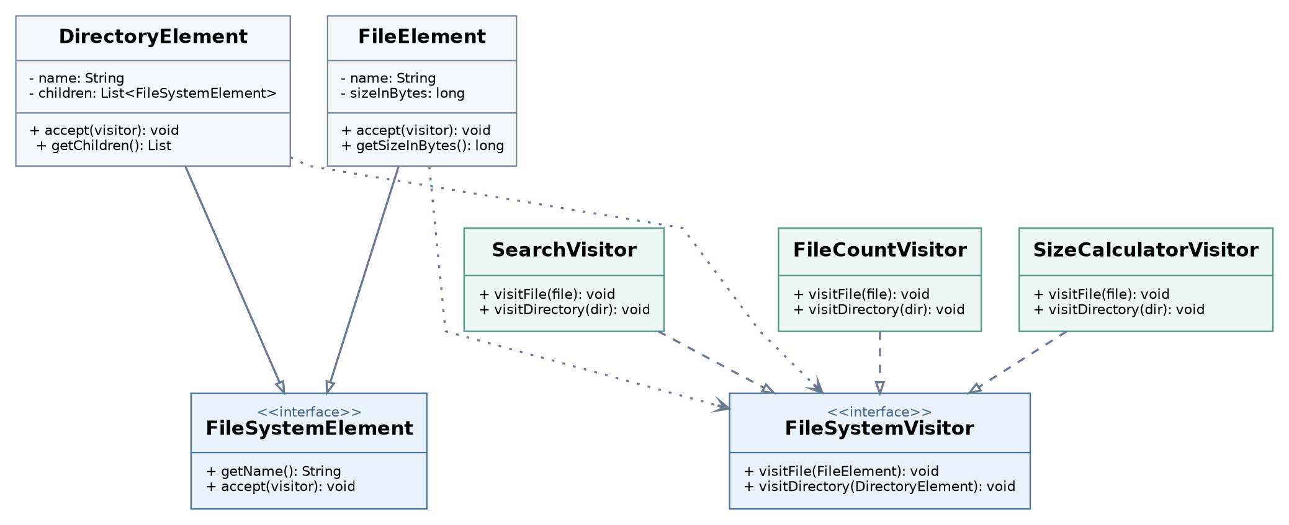
Figure 1. File System Visitor class relationships (editable source: docs/Visitor_UML.puml).

2.1 Double dispatch — execution walkthrough
First dispatch: the runtime element selects its own accept() implementation (FileElement or DirectoryElement). Second dispatch: that implementation calls the correct overloaded visit method and passes this, whose compile-time type is the concrete element class.
FileSystemElement item = new FileElement("report.txt", 100);
FileSystemVisitor visitor = new SizeCalculatorVisitor();
item.accept(visitor); // dispatch #1: FileElement.accept
// inside FileElement.accept:
visitor.visitFile(this); // dispatch #2: visitFile(FileElement)
A DirectoryElement first calls visitor.visitDirectory(this) and then invokes child.accept(visitor) for every child. As a result, the entire structure is processed recursively without instanceof checks.

2.2 Structure and responsibilities
Role | Implementation / responsibility
Element | FileSystemElement declares accept(visitor)
Concrete elements | FileElement (leaf); DirectoryElement (composite + traversal)
Visitor contract | FileSystemVisitor declares visitFile and visitDirectory
Concrete visitors | SizeCalculatorVisitor; SearchVisitor; FileCountVisitor

3. Clean Code Principles
The “before” snippets in this section are illustrative anti-patterns, not earlier versions of the committed implementation. The “after” snippets are drawn from the solution.

3.1 Meaningful names and intention-revealing APIs
FileSystemElement and FileSystemVisitor describe distinct responsibilities. Methods such as getSizeInBytes() and getMatches() communicate exact units and return values instead of ambiguous names.
// Illustrative before: vague roles
interface Item { void run(Handler h); }
// After: explicit role and intent
interface FileSystemElement {
String getName();
void accept(FileSystemVisitor visitor);
}

3.2 Replace type checks with polymorphism
A type-checking chain forces client code to know every concrete element. Double dispatch selects the appropriate visit method without any instanceof or if/switch statements on element types.
// Illustrative before
if (element instanceof FileElement) { /* file handling */ }
else if (element instanceof DirectoryElement) { /* folder handling */ }
// After: FileElement.accept(...)
visitor.visitFile(this);
// After: DirectoryElement.accept(...)
visitor.visitDirectory(this);

3.3 Single Responsibility Principle
Each concrete visitor implements one operation. Computing size and searching filenames are separate classes with independent state, so changing search criteria does not require modifying size calculation.
// Illustrative before: one procedure handles unrelated tasks
void processTree(boolean sumSizes, boolean searchNames) { /* ... */ }
// After: dedicated operations
project.accept(new SizeCalculatorVisitor());
project.accept(new SearchVisitor(".java"));

3.4 Encapsulation and defensive copies
File sizes and child collections remain private. The DirectoryElement constructor uses List.copyOf to prevent an external mutable list from changing the tree; getChildren() returns the same unmodifiable list.
// Illustrative before: internal mutable list exposed
public List<FileSystemElement> children;
// After: controlled, immutable child collection
private final List<FileSystemElement> children;
this.children = List.copyOf(children);

3. Clean Code Principles (continued)

3.5 Open/Closed Principle: add operations, not element edits
A new FileCountVisitor was added by implementing the existing FileSystemVisitor interface. Neither FileElement nor DirectoryElement needed to change. This is the key extensibility benefit of the Visitor pattern.
// Added operation: no edits to existing element classes
public final class FileCountVisitor implements FileSystemVisitor {
private int fileCount;
private int directoryCount;
public void visitFile(FileElement file) { fileCount++; }
public void visitDirectory(DirectoryElement dir) { directoryCount++; }
// public read-only getters omitted here
}

3.6 DRY: centralize tree traversal
The traversal code is inside DirectoryElement.accept(). Visitors implement only their own algorithms and do not copy recursive directory-walking loops. All visitors therefore traverse the same element order.
// Illustrative before: each visitor has its own recursion
for (FileSystemElement child : directory.getChildren()) {
child.accept(this);
}
// After: DirectoryElement.accept(visitor), shared by all visitors
visitor.visitDirectory(this);
for (FileSystemElement child : children) {
child.accept(visitor);
}

3.7 Design safeguards
Constructors reject blank names, null arguments, and negative file sizes. SizeCalculatorVisitor uses Math.addExact to reject long overflow instead of silently producing an incorrect total. SearchVisitor returns List.copyOf(matches) so callers cannot modify the result collection.

3.8 Design limitation
Visitor favors adding operations while the element hierarchy stays stable. Adding a new element type (such as SymbolicLinkElement) would require a corresponding visitSymbolicLink() method and updates to all existing concrete visitors. The in-memory tree is intentionally modeled as an immutable, acyclic structure.

4. Sample Output and Testing
Actual console output after compiling with javac --release 17 and running Main on the shared sample tree:
=== File System Visitor Pattern ===
Root directory: project
Total size: 6700 bytes
Directories visited: 4

Search query: .java
Matching files:
- Main.java (1200 bytes)
- Visitor.java (800 bytes)
- VisitorTest.java (1500 bytes)

Count visitor: 6 files, 4 directories

4.1 Verification
Test category | Expected result
Nested folder size calculation | 6,700 bytes
Case-insensitive .JAVA search | 3 matching filenames
Search with no matches | Empty matches list
Empty directory | 0 bytes; 0 files; 1 directory
New visitor, count files and folders | 6 files; 4 directories
Independent visitors | No cross-contamination of results
Defensive copy and invalid arguments | No external mutation; rejected invalid inputs
Long addition overflow | ArithmeticException instead of wrong total

Test command: ./test.sh on Linux/macOS or .\test.ps1 in PowerShell. Verified result: PASS: 9 tests.

5. Conclusion
The solution fulfills the Visitor pattern requirements with two concrete elements and three concrete visitors. Double dispatch isolates element-specific behavior in visitFile()/visitDirectory() instead of conditionals. Reusing the same object structure with different visitors demonstrates operation extensibility.
Encapsulation is preserved through narrow read-only getters rather than direct field access. The main trade-off is the cost of adding a new element type: every visitor would need a new visit method. For a stable file-system model with frequently added operations, this is an appropriate design choice.

6. GitHub Repository
[INSERT YOUR ACTUAL GITHUB REPOSITORY URL BEFORE SUBMISSION]
Submission note: add your full name, group, date and GitHub URL; run the project yourself and be prepared to explain the accept()/visit() call chain.

