GTU Department of Computer Engineering
CSE 222/505 - Spring 2023
Homework 3 – Report
Erkut Dere – 1801042646

Running command and results

Basic Array Structure:

TestClass1:
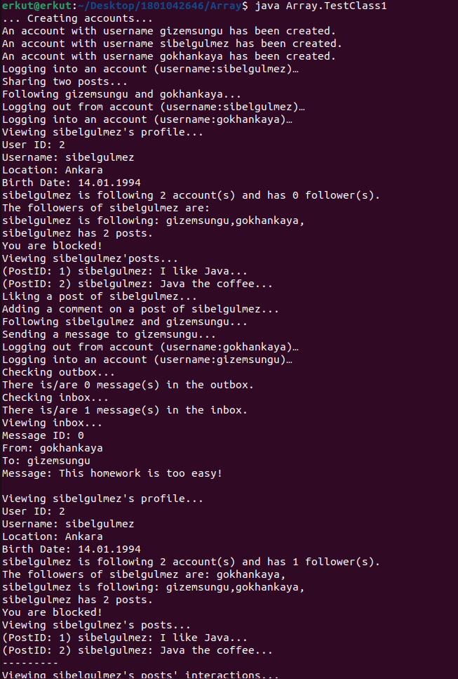

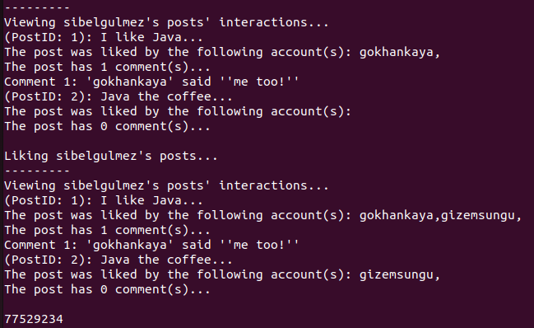

TestClass2:
Running command:
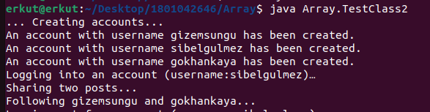

Result:
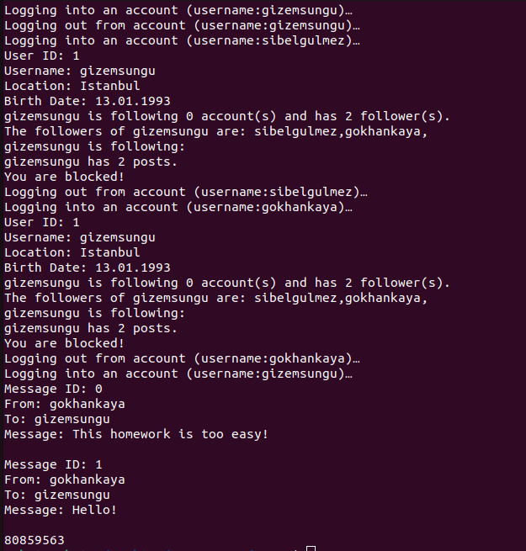

TestClass3:

Running Command:
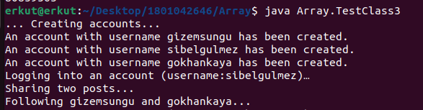

Result:
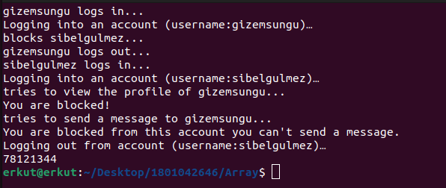

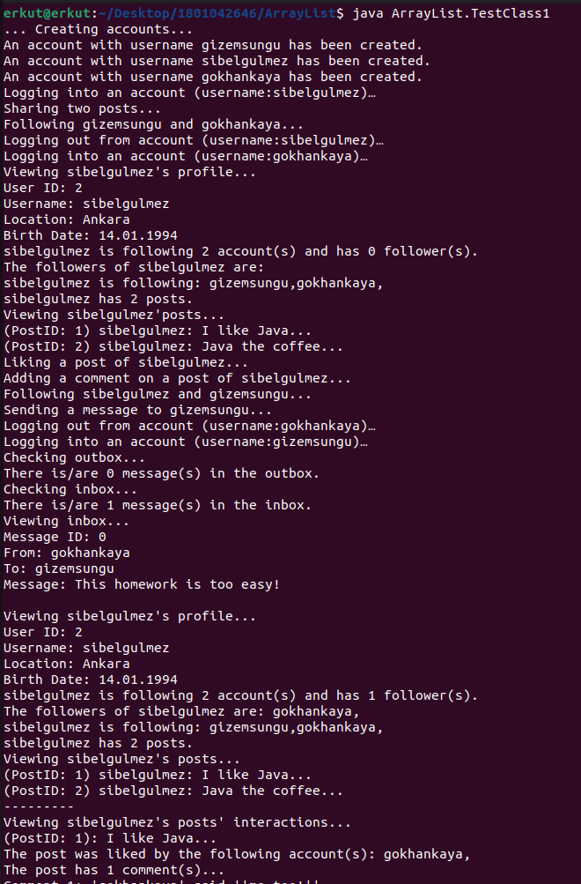
Array List Structure:
TestClass1:

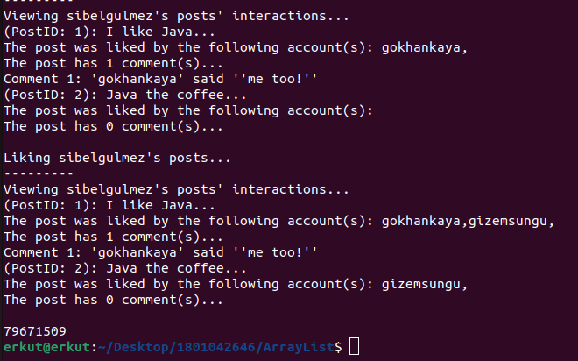

TestClass2:

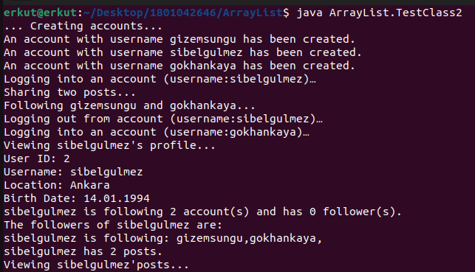
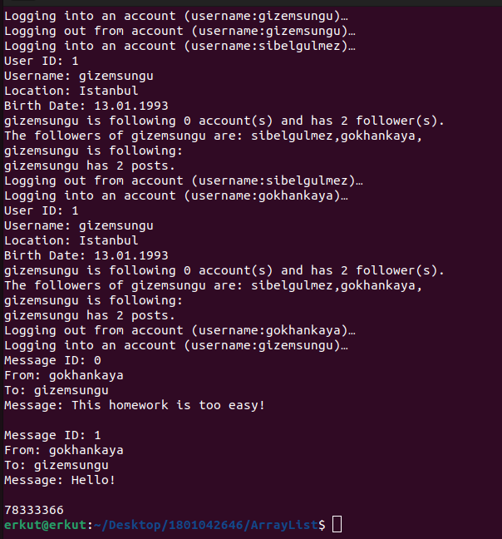

TestClass3:

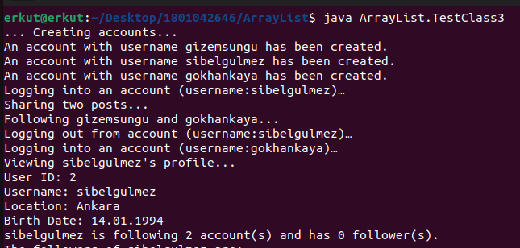

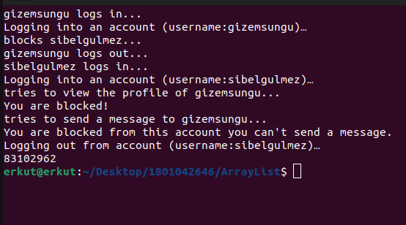

TestClass4:

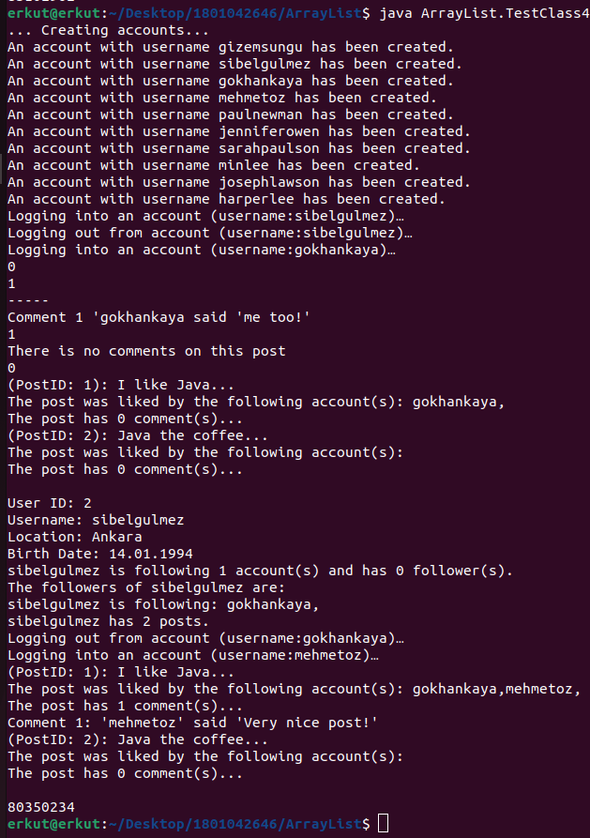

Experimental running time analysis (with the table):

Implementation Type | Scenario 1 | Scenario 2 | Scenario 3 | Scenario 4
Basic Array Structure (HW1) | 77529234 ns | 80859563 ns | 78121344 ns | Not available
Array List Structure (a) | 79671509 ns | 78333366 ns | 83102962 ns | 80350234 ns
Linked List Structure (b) | - | - | - | -
LD Linked List Structure (c) | - | - | - | -

“-” means: not implemented

Time complexity analysis

Basic Array Structure:

View methods:

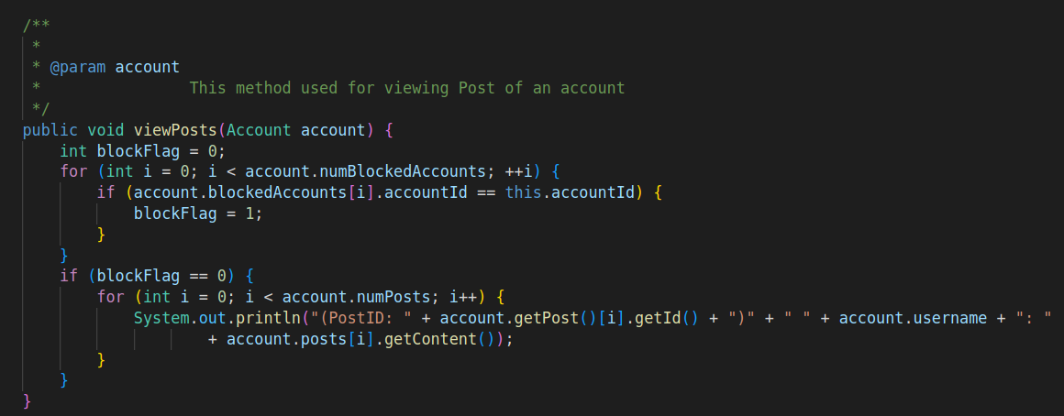
Most of the view methods includes loops so that this methods must have O(n) time complexity, In this example (viewPosts) we have two loops but the first loop is not dependent on the number of posts in the account object, so the time complexity is:
O(n) where n = account.numPosts.
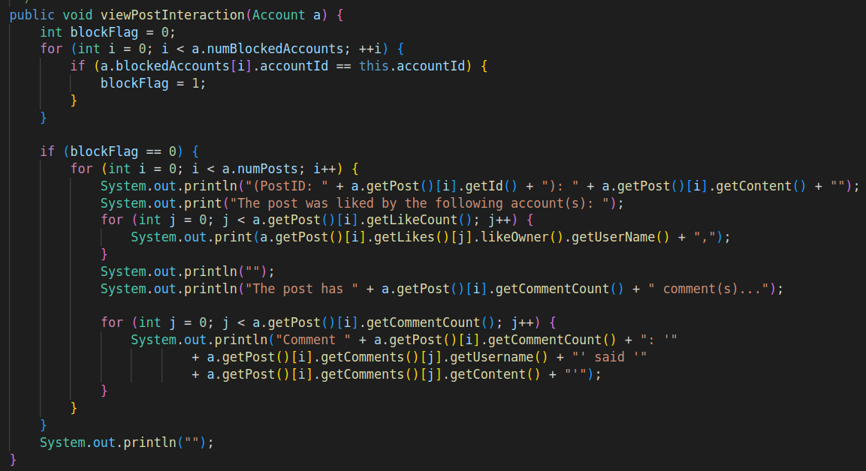
In this example the time complexity is: O(n^2)

Add methods:
Here is an example of one of my add methods. Here I have helper variable (numPosts) which is incremented every time. So I don’t have to use loops to get to end of an array.
This type of methods have O(1) time complexity.
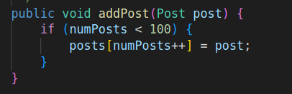

Array List Structure:

Get Methods:
These methods have O(1) time complexity.

View Methods:
View methods’ time complexity are similar with the basic array structure one which is O(n),most of the time. In some situations I have to use nested loops, in those situations we have O(n^2) time complexity.

Add Methods:
Add methods also have O(1) constant time complexity similarly with basic array structure.

Remove Methods:
Some of the methods includes remove method, this methods have the time complexity of O(n) where n is the dependent of the size of the Array List object’s size. Here is the example of one of the remove method:
