CURRICULUM VITAE – ERLE KONT
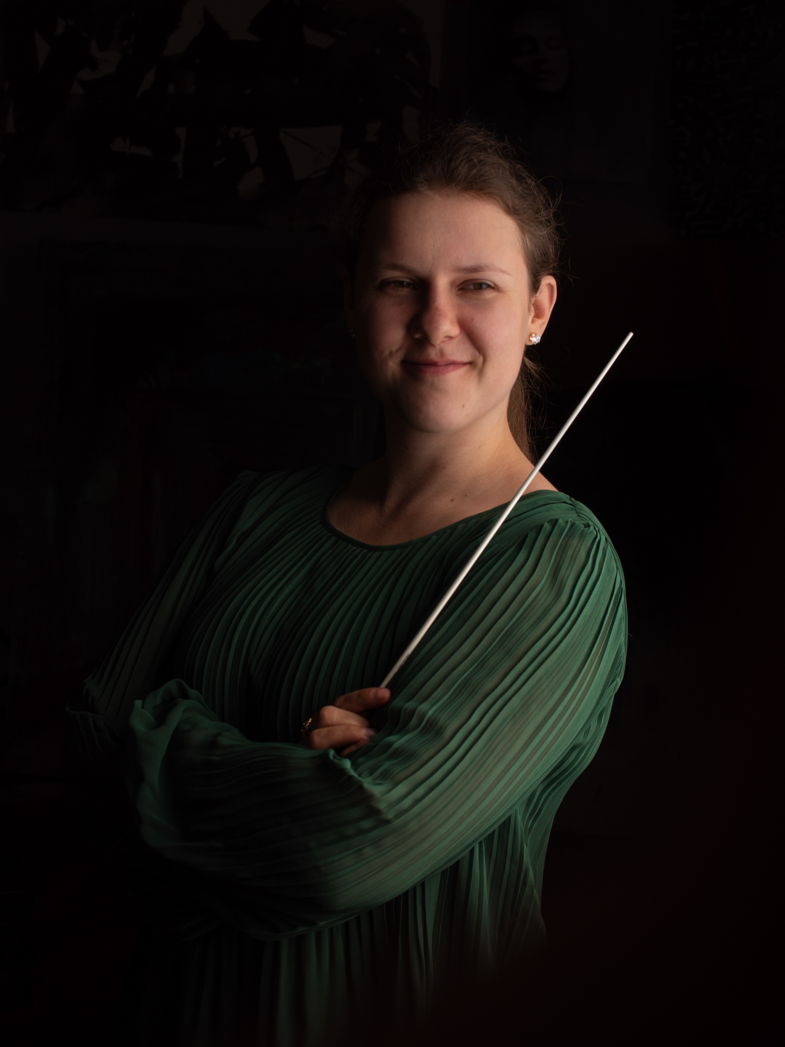

„Kont got the orchestra to play with burning passion
and charming warmth. A great promise!“
Aamulehti

„Kont drew an intensely moving slow movement
and conjured up a sparklingly vital finale“
Hufvudstadsbladet

“Conductor Kont brought out a rich palette of orchestral colors
from the Pori Sinfonietta“
Satakunnan Kansa

“She has everything!“
Paavo Järvi

UPCOMING CONDUCTING ENGAGEMENTS

2025 Tapiola Sinfonietta (re-invitation) – Pärt, Adams, Cage, Byrd

2024 Lahti Symphony Orchestra (re-invitation) – Blake
Jyväskylä Sinfonia (re-invitation) – Blake
Seinäjoki City Orchestra (debut, Artist In Focus) –
Mahler, Kont, Debussy, Shostakovich

CONDUCTED PROFESSIONAL ORCHESTRAS

2024 Tampere Philharmonic Orchestra - Sibelius
Turku Philharmonic Orchestra - Sibelius, Copland, Gorecki
Lappeenranta City Orchestra - Klami, Haydn, Rantala, Beriot
Allegra Festival Orchestra – Dvorak, Mozart, Brahms

2023 Lahti Symphony Orchestra – Britten, Rimsky-Korsakov etc
Helsinki Philharmonic Orchestra - Mielck
Finnish Radio Symphony Orchestra – Mendelssohn, Brahms
Joensuu City Orchestra – Mahler, Mussorgsky
Jyväskylä Sinfonia – Mahler, Mussorgsky
Ploiesti Philharmonic Orchestra – Mendelssohn, Bartok etc
Helsinki Cellofest Orchestra – Vivaldi, Tchaikovsky, Lanzetti

2022 BBC Scottish Symphony Orchestra – Elgar, Bartok
Tapiola Sinfonietta – Poulenc
Jyväskylä Sinfonia – Mozart
Joensuu City Orchestra – Beethoven
Oulu Sinfonia – Johann Strauss I
Pori Sinfonietta – Prokofiev, Beethoven

2021 Tapiola Sinfonietta - Beethoven
Vaasa City Orchestra – Schumann
Joensuu City Orchestra – Prokofiev
EDUCATION

2021 – 2024 Sibelius Academy, symphony orchestra conducting master
degree, Sakari Oramo
2020 – 2021 Sibelius Academy, wind orchestra conducting master degree,
Petri Komulainen
2014 – 2020 Sibelius Academy, bachelor and master of clarinet degrees,
Kari Kriikku and Harri Mäki

CONDUCTING MASTERCLASSES

Esa-Pekka Salonen, Paavo Järvi, Neeme Järvi, Jukka-Pekka Saraste, Eva Ollikainen, Jorma Panula, Johannes Schlaefli, Nicolas Pasquet, Dalia Stasevska, Antony Hermus, Bjarte Engeset, Nicholas Collon, Leo McFall and others.

FOUNDER AND ARTISTIC DIRECTOR
TARTU SOUND

Kont is the founder and artistic director of the contemporary music organisation Tartu Sound (2017), which unites composers, musicians and audience members from Tartu region, Estonia. Tartu Sound helps young composers start their professional careers by organising concerts of their music and makes contemporary music accessible in Tartu around the year. The organisation works with musicians of the highest caliber from Estonia and internationally such as

2021 Ensemble Itineraire

2019 Far(away) Ensemble – a Finnish based group with production
One Act On Identity. It is a largely improvised concept show
involving musicians and dancers, a choreographer and a
composer

2018 Bara Gisladottir – an Icelandic composer/double bassist

CLARINET

AWARDS

2018 Special prize for the best interpretation of Tõnis Kaumann's
new piece and
overall diploma from the national clarinet competition of
Estonia

2017 2nd prize in Sibelius Academy clarinet soloists competition

2015 Finalist in international clarinet competition in Italy Chieri
Finalist in international clarinet competition „Czech clarinet
art“ in Czech Teplice
1st prize in Viktor Kalabis competition as a duo in ISA festival
1st prize in Bohuslav Martinu competition in ISA festival

2014 2nd prize in international Eduard Medinš competition among
woodwinds
2nd prize in Estonian Music Highschools competition among
clarinetists

2013 2nd prize in international Eduard Medinš competition among
woodwinds
2nd prize in Estonian Music Highschools competition among
woodwinds

2012 3rd prize in Estonian Music Highschools competition among
woodwinds

2011 2nd prize in international Eduard Medinš competition among
woodwinds
1st prize in Estonian young clarinetists competition

2010 1st prize in international Eduard Medinš competition among
woodwinds

2009 1st prize in Estonian young clarinetists competition
1st prize in David Otto Wirkhaus clarinet competition in
Estonia

2008 1st prize in David Otto Wirkhaus clarinet competition in
Estonia

