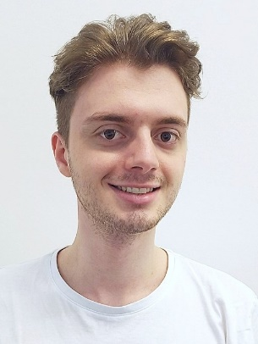
Erlind Sejdiu
Hagenschießstraße 3, 75175 Pforzheim
ErlindAmProgrammieren@gmail.com
+49 1573 5474746

Pforzheim University of Applied Sciences, Faculty of Engineering

Application for an internship semester as a software developer

Dear Recruiting Team,

As a student who is planning his internship semester in the coming winter semester and is looking for the opportunity to gain valuable experience, the job advertisement "Internship" caught my attention. The automatic test systems and software development with C++ sound very exciting, which is why I would like to apply for an internship.

I have experience with C++ and especially in the lecture Software Engineering 2 I discovered the joy of understanding and developing different design patterns in C++. As part of this, an Abstract Factory and an Observer Pattern were implemented and extended. With the help of this knowledge, I was able to create a chess engine in C++ in my spare time, which contains individual movement patterns in addition to the various chess pieces. With the Framework CMake and Googletest multiple tests were written for the lecture, which means that I also have practical experience in the field of testing.

Through the internship I hope to get closer to my academic goals, to enrich companies in a positive way and to be able to grow as a person. Thank you for considering my application and I will be happy to provide you with further information or a personal interview.

Best Regards

Erlind Sejdiu

